Lab(3)
Kingdom: Protista
Subkingdom: Protozoa
Phylum:Sarcomastigophora
2-Subphylum: Ciliophora
Class: Ciliata
Order: Euciliata
Genus: Balantidium coli
3- Subphylum:Mastigophora (Flagellates)
Class:Zoomastigophora
Order: Diplomonadida
Genus: Giardia lamblia ,Trichomonasvaginalis
Balantidium coli
Disease name: Balantidiasis ,Balantidil dysentery
Site of infection: Large intestine, cecum and terminal ileum

Morphology of trophozoite
They are covered in cilia and have boring or rotary motility. Balantidium coli is known for being the largest protozoan parasite of humans , the two nuclei are clearly visible. The macronucleus is long and kidney-shaped, and the spherical micronucleus is nestled next to it.
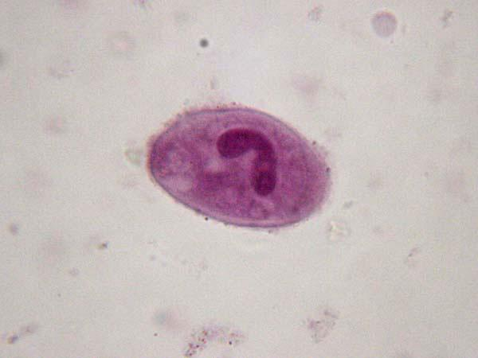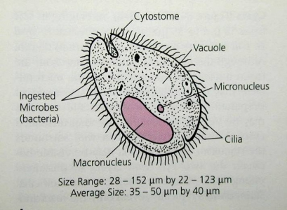
Cyst
Cysts are smaller than trophozoites, measuring Cysts are round and have a tough, heavy cyst wall made of one or two layers. Usually only the macronucleus and perhaps cilia and contractile vacuoles are visible in the cyst
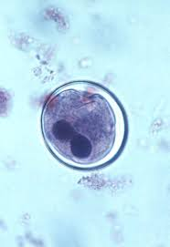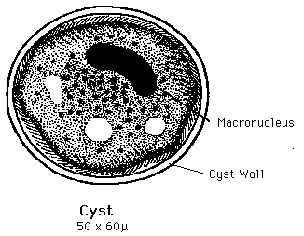
Life cycle
Infective stage:Cyst Diagnostic stage: Cyst,trophozoite
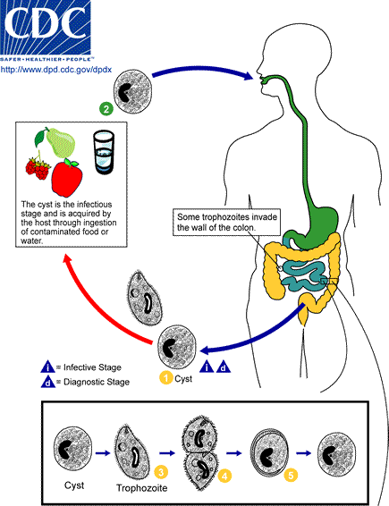
Symptoms:
who are infected with B. coli remain asymptomatic. trophozoites can invade the mucosa of the large intestine (cecum and colon) and cause ulcerations. Other bacteria in the intestine may enter the ulcer leading to secondary infections. Common symptoms chronic diarrhea, occasional dysentery (diarrhea with passage of blood or mucus), nausea, foul breath, colitis (inflammation of the colon), abdominal pain, weight loss, deep intestinal ulcerations, and possibly perforation of the intestine.
Diagnosis
Examination of stool samples, looking for trophozoites and cysts ,Trophozoites are readily identified because of their large size and the fact that B. coli is the only ciliate that parasitizes humans.
Giardia lambilia
Disease name :Giardiasis
Site of infection: small intestine
Morphology:
Trophozoite: It is flattened pear shaped with two nuclei ,two slender axostyles and eight flagella (four pairs of flagella).They attach themselves to the surface of jejuna or duodenal mucosa by their disc like suckers wich are found on their ventral surface.

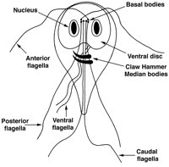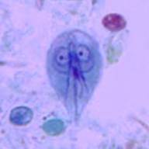

Cyst: It is ellipsoid in shape,contain four nuclei. Longitudinal fibrils consisting of the remains of axone smesandparabasal bodies may also seen.

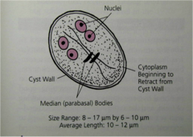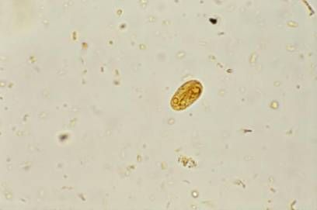
Giardia lambliacyst stained with iodine

life cycle

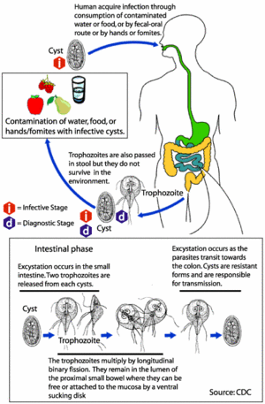
Symptoms: are abdominal pain, flatulence and watery diarrhea no blood no mucus is normally seen.
Laboratory diagnosis
1-Trophozoites and cyst are found by examination of saline wet preparation of fresh diarrheic stool.
2- duodenal or jejuna aspirate
3-Elisa to detect IgMin serum provides the evidence of current infection.
4- Biobsy from the upper intestine
3-Trichomonas vaginalis
It existsonly in trophozoite form
Transmission is by sexual intercourse
Disease name: Trichomoniasis
Site of infection: the urethra &vagina of women and the urethra & prostate gland of man
Morphology:
Pear shaped organisimwith central nucleus and four anterior flagella and
Undulating membrane extends about two-thirds of its length.
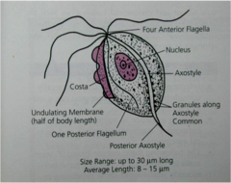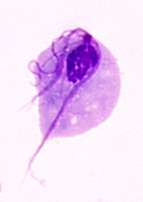
Trichomonasvaginalistrophozoite
Life cycle:
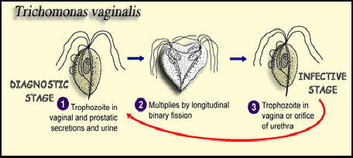
Symptoms:

Women
- A vaginal discharge is common. This is typically greeny-yellow and may be 'frothy'. The discharge usually has an unpleasant smell.
- vaginaiching and uncomfortable.
- It may be sore when you pass urine.
- No symptoms occur in some women. However, they can still pass on the infection even if you have no symptoms.

Men
- Discharge from the penis is common.
- It may be sore when you pass urine.
- You may pass urine frequently (due to irritation inside the penis).
- No symptoms occur in most infected men. However, you can still pass on the infection even if you have no symptoms.
Diagnosis:
cell cultures
antigen tests (antibodies bind if theTrichomonas parasite is present, which causes a color change that indicates infection)
tests that look for Trichomonas DNA
examining samples of vaginal fluid (for women) or urethral discharge (for men) under a microscope

