Multiplexers (MUX):
Multiplexer is a combinational circuit that selects one of many input lines and direct it to a single output line. The selection of a particular input line is controlled by a set of select variables. Normally there are ( 2^{n} ) input lines and ( n) select variables whose bit combination determines which input is selected. The 4-to-1 multiplexer is shown below:
S1 S0 Y
0 0 D0
0 1 D1
1 0 D2
1 1 D3
S_{o} S₁ D₀ D₁ D₂ D₃
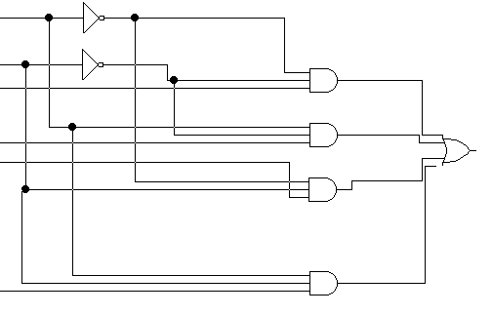
Y
There are: 2-to-1 MUX with 1 select variable
4-to-1 MUX with 2 select variable.
8-to-1 MUX with 3 select variable.
. 16-to-1 MUX with 4 select variable

The circuit above can be implemented as an MSI chip, such a chip has four data inputs, two select variables and one output.

4-to-1 MUX
D0
D1 Y
D2
D3
S1 S0
Boolean function implementation using MUX :
Boolean function of ( n )variables can be implemented with a multiplexer of either n, n-1, n-2…… select variables.
Ex: Implement the following function with (8-to1) and (4-to-1) MUX:
F(X,Y,Z)= ∑(1,2,6,7).
First: by using (8-t0-1) MUX:
S₂ S₁ S₀
X Y Z F
0 0 0 0 D0=0
D0
D1
D2
D3 8-to-1
D4 Mux F
D5
D6
D7
S2 S1 S0

0 1
0 0 1 1 D1=1
0 1 0 1 D2=1
0 1 1 0 D3=0
1 0 0 0 D4=0
1 0 1 0 D5=0
1 1 0 1 D6=1
1 1 1 1 D7= 1
X Y Z

Second: by using (4-t0-1) MUX:
X Y Z F
0 0 0 0
Z Z 0 1
D0
D1
D2 4-to-1
D3 MUX
S1 S0
0 0 1 1 D0=Z
0 1 0 1
O 1 1 0 D1=Z
1 0 0 0
1 1 0 1
1 1 1 1 D3=1
X Y

