Combinational circuits:
A combinational circuit consists of logic gates whose output at any time are determined directly from the values of the present inputs.
Combinational
circuit
inputs outputs

Design procedure:
The procedure involves the following steps:
1-Determine the required number of inputs and outputs.
2-Drive the truth table.
3-Obtain the simplified Boolean function for each output.
4-Draw the logic diagram.

Half adder (H.A.):
To design a circuit that adds two numbers each of one bit for example:
Two inputs 1 0 1 0
1 + 0 + 0 + 1 +
Two output 1 0 0 1 1

A B C S
0 0 0 0
0 1 0 1 S= A B + A B
1 0 0 1 C= A B
1 1 1 0
S inputs C
A B

output
A S
H.A. B C

Using NAND gates only :
S = A B + A B
S = A B + A B = A B . A B = X . Y
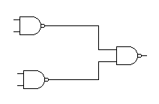
C
S
A B
A B A B
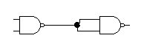 C= C = A B = A B

Full adder (F. A):
في حالة جمع عددين كل واحد مكون من 2-bit أي لتصميم دائرة تجمع ال bits في المرحلة الثانية و ما بعدها:
C_{i} 1
A 0 1
A S
B F.A.
Ci Co
B 1 1 +
1 0 0
Carry sum

