Cascading Style Sheets (CSS)

CSS is a language that describes the style of an HTML document.

CSS describes how HTML elements should be displayed.

- Style Sheets used for years in Desktop Publishing
- apply typographical styles and spacing to printed media

CSS

  - provides the functionality of style sheets (and much more) for web developers

  - a flexible, cross-platform, standards-based language developed by the W3C.

CSS Advantages

- Greater typography and page layout control

- Style is separate from structure

- Styles can be stored in a separate document and linked to from the web page

- Potentially smaller documents

- Easier site maintenance

Types of Cascading Style Sheets

- Inline Styles
- Embedded Styles
- External Styles
- Imported Styles

Types of Cascading Style Sheets

- Inline Styles
  - Configured in the body of the Web page

  - Use the style attribute of an XHTML tag

  - Apply only to the specific element

Embedded Styles

Configured in the header section of a Web page.

  - Use the XHTML <style> element

  - Apply to the entire Web page document 3- External Styles

Configured in a separate text file with .css file extension

  - The XHTML <link /> element in the header section of a Web page associates it with the .css file

- Imported Styles

  - Similar to External Styles

- We’ll concentrate on the other three types of styles

CSS Syntax

- Style sheets are composed of “Rules" that describe the styling to be applied.

- Each Rule contains a Selector and a Declaration

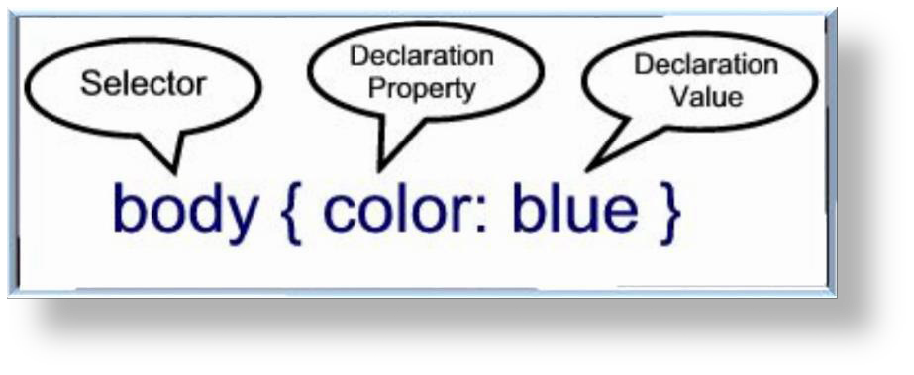

Syntax Sample

Configure a Web page to display blue text and yellow background.

body { color: blue; background-color: yellow; }

This could also be written using hexadecimal color values as shown below.

body { color: #0000FF; background-color: #FFFF00; }

Common Formatting CSS Properties

- background-color

- color

- font-family

- font-size

- font-style

- font-weight

- line-height

- margin

- text-align 10.text-decoration 11.width

CSS Example

<html>
<head>
<style>
body {
background-color: lightblue;
}

h1 {
color: white;
text-align: center;
}
p {
font-family: verdana; font-size: 20px;
}
</style>
</head>
<body>
<h1>My First CSS Example</h1>
<p>This is a paragraph.</p>

</body>
</html>

