Title tool : Label

And this element is used to put titles or texts fixed on the form, or to identify the elements that do not feat .Caption usually used this tool in Mtalzim with the text box (it is possible to use this tool Azھar output of a particular too). The most important feature is the instrument title feature event Caption default for this element is .click
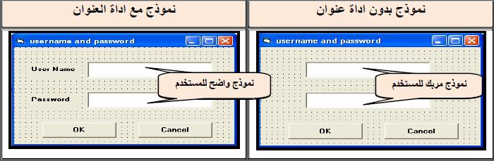

The most important characteristics of this element:

  - Name is placed from the name, during which.

  - Caption and text mode is to be submitted on the form.

  - BackColor and used to set the background color

  - ForeColor and used to select the font color for the written text.

  - Auto Size is from this feature to choose one of two values:

- True to allow change size directly

- False the change using .Mouse

- The most important events associated with the element Address:

  - Click

  - DB Click

- The text of the title is placed as follows:

Label1 .Caption = "Text"

Accounting for Text any text that is placed in this feature.

- Setting the color of the background is as follows:

Label1.ForeColor = QBColor (Number)

Example : Designed window containing a third of the text boxes and a single control typeCommand Button collects two entrances to the two numbers first and second text and displays the output in the third fund.

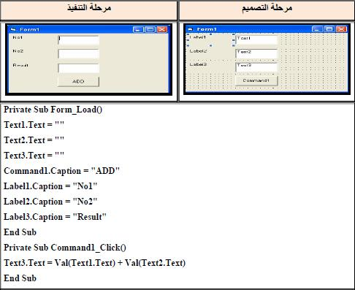

Assigment 6:

Design a GUI in V. B and write aprogram to perform accoriding to the following fgure:
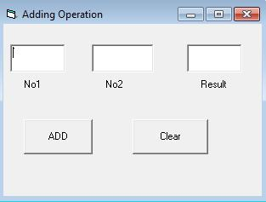

Selection buttons : (Option Buttons)

m uses a range of options for the user and these buttons are mutually exclusive in any case there is more than a choice of Val button can be selected more than one of these buttons simultaneously (choose any one of these buttons eliminates the selection of the remainder).
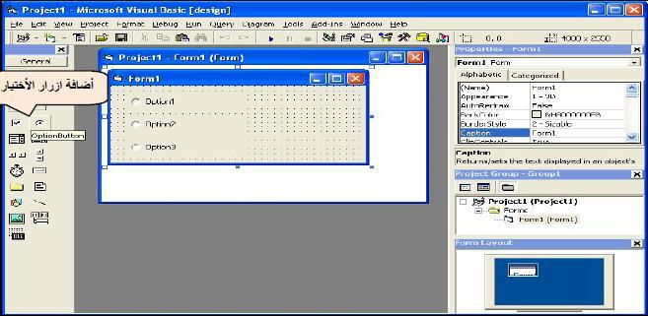

Click which starts as soon as you click on the item.

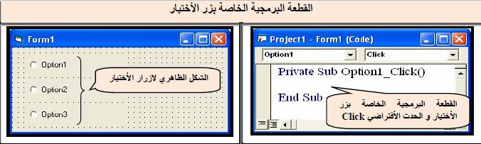

In addition Alaھa also has some characteristics of the other task as there are in the following table:

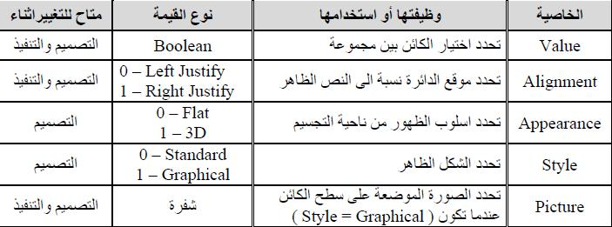

- Style When you are 0 -Standard be Epeshklھa traditional) circuit Belarus (either when Tkon- 1 Graphical be a rectangle similar Command when you do not choose and pull towards the inside when the selection is given when this choice Graphical -1 ability to put an image on the surface of the rectangle, and is selected image by feature . Picture

- The value of the property Picture is the code that is obtained through .LoadPicture function

- Feature-: Value

This function takes the value logic : True, False

- Value = True Activating the selection (enabled the implementation of the sentences associated with the selection of the software component and not to enable the implementation of the rest of the sentences related to the rest of the code buttons choose).
- -: Value = False Not to activate the selection.

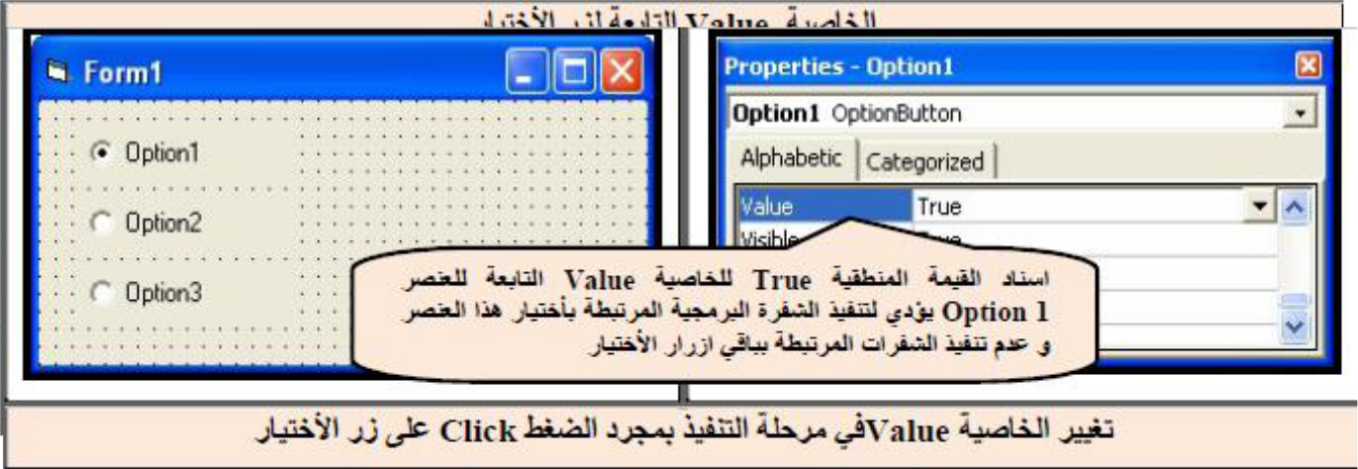

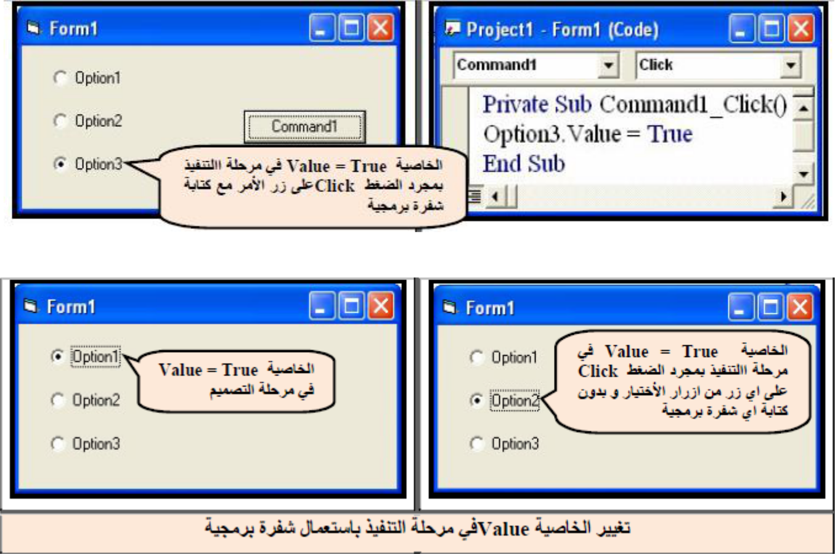

Example -: Window is designed to change the background color of the form to red and blue and green using only three buttons to choose.

HW

Assigment 7: Write a V. B program according to the following GUI:
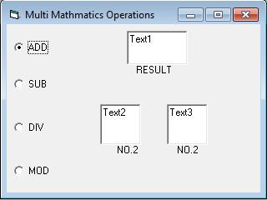

Clarification:

Private Sub Option1_Click) (

Text3.Text = Val (Text1.Text) + Val (Text2.Text ( // adding operation

End Sub

Private Sub Option2_Click) (

Text3.Text = Val (Text1.Text) - Val (Text2 .Text ( // subtracting operation End Sub

Check boxes ) Check Box)

s provided verification set of options for the user and are different from the selection Bikua button does not work interactively any possible select more than one option at the Ahd of the controls, which have been addressed L in detail previously, and of these Properties . (Fore color, font, height, width, top, name, back color) (left, caption, enabled

❖ Feature Value in a Check Box
This feature takes the following values:

- Value = 0 Unchecked indicates lack of choice.

- Value = 1Checked indicate choice.

- Value = 2 Grayed indicate choice while allowing change it) when Ktaptھa in the code (.

Click which starts as soon as you click on the item.
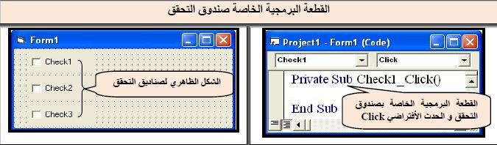

The most important events of the model : Form

In addition to joint events, there are special events occur from the beginning of the model loading window until Agalqھa namely as follows:

- : Load is triggered as soon as you start download and execute the window Form usually learned from this event to put the values ​​of a primary variables or arrays, or even the properties of tools, and can be used orders of the Wagھh like SetFocus or drawing (Pset ways, Line and Circle) Vیھ.

- : Resize is triggered immediately after an event Load ie, when the window appears as when a user is triggered by any change in the size of the window. This event is frequently used to align the instruments or change their size whenever the user changes the size of the form.

- : Activate Once activated or is triggered activation window. That this is the event and Quaھ AL when you move between windows where the project is useful in changing the contents of the window as an update data as soon as the user changes the contents of another window in the same project.

- : Deactivate is the opposite event is triggered Activate as soon move to another window within the same project, any process deactivating) activation (of the window. As the current happens when using the Hide with Form or when you become a feature Visible = False

- : Unload before emptying memory is triggered from the window when you press the button closure model.

