1-Blind search
This type of search takes all nodes of tree in specific order until it reaches to goal .The order can be in the breath and the strategy will be called breadth–first–search, or srategy will be called depth first search

- Depth First Searh
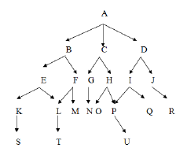
Suppose start is A and goal is N
Open close

[A] []
[BCD] [A]
[EFCD] [AB]
[KLFCD] [ABE]
[SLFCD] [ABEK]
[LFCD] [ABEKS]
[TFCD] [ABEKSL]
[FCD] [ABEKSLT]
[LMCD] [ABEKSLT] DELET L
[CD] [ABEKSLTM]
[GHD] [ABEKSLTMC]
[NHD] [ABEKSLTMCG]

Depth first search use stack data structure.

2-Breadth First search
Suppose start is A and goal is N

Open close
[A] []
[BCD] [A]
[CDEF] [AB]
[DEFGH] [ABC]
[EFGHIJ] [ABCD]
[FGHIJKL] [ABCDE]
[GHIJKLM] [ABCDEF]
[HIJKLMN] [ABCDEFG]
[IJKLMNOP] [ABCDEFGH]
[JKLMNOPQ] [ABCDEFGHI]
[KLMNOPQR] [ABCDEFGHIJ]
[LMNOPQRS] [ABCDEFGHIJK]
[MNOPQRST] [ABCDEFGHIJKL]
[NOPQRST] [ABCDEFGHIJKLM]

Breadth first use queue data structure

