Lecture 4: Heuristic Search
Introduction
- AI problem solvers employ heuristics in two situations:
  - A problem may not have an exact solution because of the ambiguities in the problem statement or available data.
  - A problem may have an exact solution, but the computational cost is high.
- A heuristic is an informed estimate of the next step to be taken in solving a problem.
- A heuristic is based on the experience and intuition. In other words, it is based on the knowledge of the present and current situation.
- It sometimes leads to suboptimal solution or it fails to find a solution at all.
Examples: Consider the game of tic-tac-toe.
- The complexity of this game is 9! = 9 ∗ 8 ∗ 7 ∗ 6 ∗ 5 ∗ 4 ∗ 3 ∗ 2 ∗ 1
- By using symmetry reduction heuristic, many configurations are actually equivalent.
- By applying a heuristic function which is Move to the board where X has most win line. (if there are two or more boards have the same number of win lines chose the first one found)
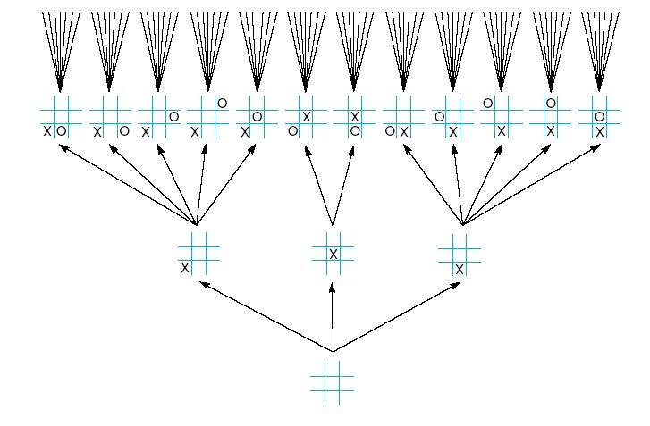
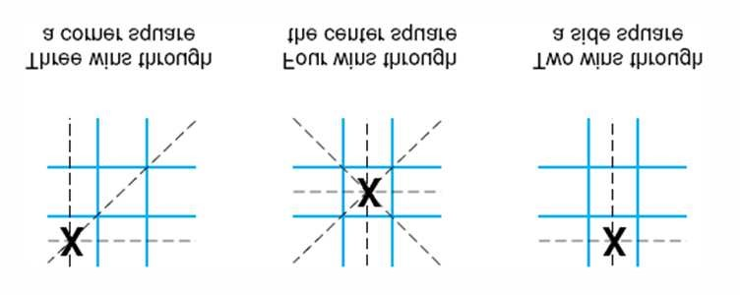
Figure 1: The “most wins” heuristic applied to the first children in tic−tac−toe.
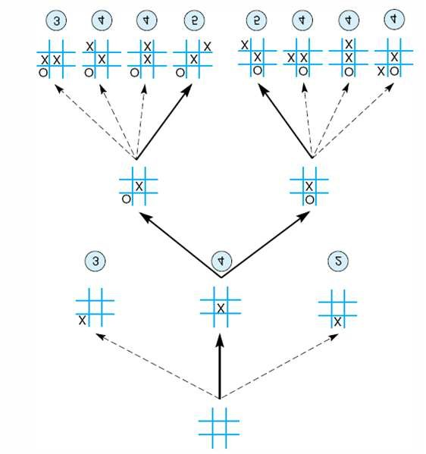4
Figure 2: Heuristically reduced state space for tic−tac−toe.

- The Best first Search Algorithm
The goal of the best-first search algorithm is to find the goal state by looking at as few states as possible. The more informed heuristic, the fewer states are processed in finding the goal
  - This algorithm expands current node in the search space and evaluates heuristically its children.
  - The best child is selected for further expansion, neither its sibling nor its parents are retained.
  - The search halts, when we reach state which has better heuristic than any of its children.
  - This strategy can mainly fail because of two main factors:-
    - It does not keep history, therefore it may go on an infinite loop.
    - It can stuck at local maxima, when it reaches state with better evaluation than all of its children. Then the algorithm halts, if such state is local maximum.
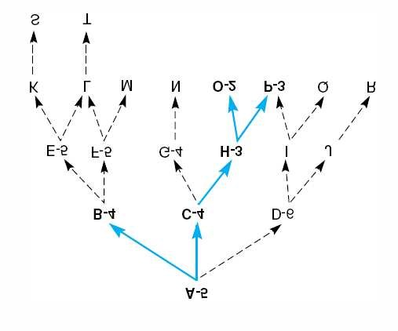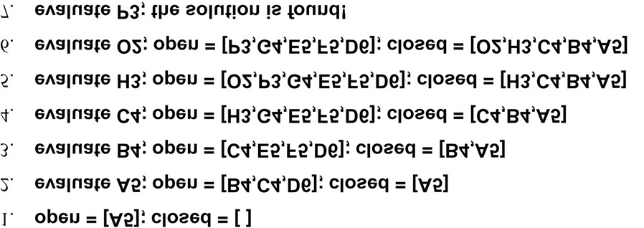

- Implement Heuristic Evaluation Function
Here we want to evaluate performance of several heuristics to solve the 8-puzzle game.
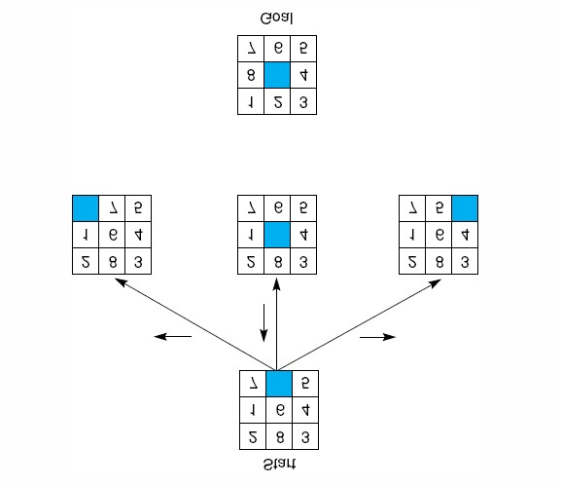
- Count the tiles out of place: In each state we compare the position of all tiles with respect to the goal board (State with fewest tiles out of place is closer to the desired goal).
- Distance Summation: Sum all the distance by which the tiles are out of +place (State with the shortest distance is closer to the desired goal).
- Count reversal Tiles: If two tiles are next to each other, and the goal requires their position to be swapped. The heuristic takes this into account by evaluating the expression (2 ∗ number of direct tiles reversal)
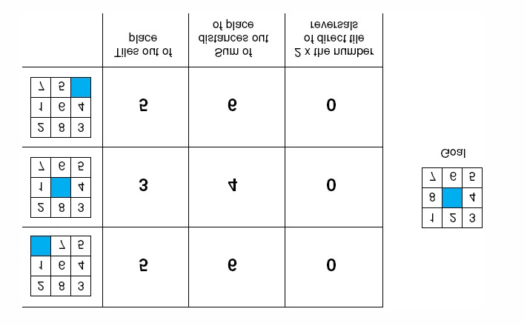
- Heuristics might be wrong:
The search could continue down a wrong path
- Solution:
Maintain depth count, i.e., give preference to shorter paths
Modified evaluation function f:
f(n) = g(n) + h(n)
- f(n) estimate of total cost along path through n
- g(n) actual cost of path from start to node n
- h(n) estimate of cost to reach goal from node n
Example:-
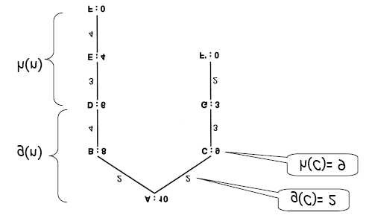
- Best first search: ABDEF with cost = 13 = (2 + 4 + 3 + 4)
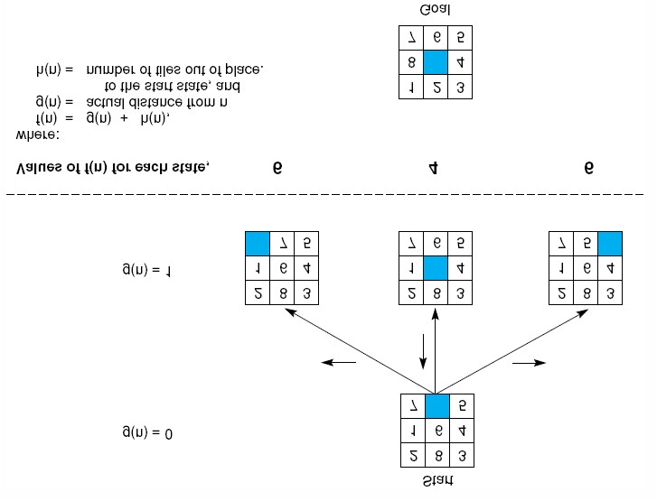
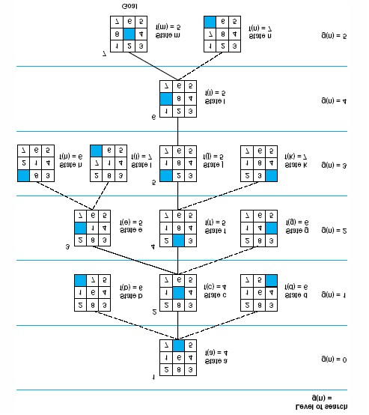

Games in general are ideal fields to explore and design behavior of heuristic because of many reasons:-
- Search space is very large, therefore, we need heuristic techniques.
- Games are complex, so It has many heuristic evaluations.
- Games do not involve with a complex representation, so It does not focus on knowledge representation problem.
- We can easily apply heuristic techniques because all nodes have a common representation.
- Hill-Climbing
Hill-climbing is similar to the best first search. while the best first search considers states globally, hill-climbing considers only local states. The application of the hill-climbing algorithm to a tree that has been generated prior to the search is illustrated in the Figure above:
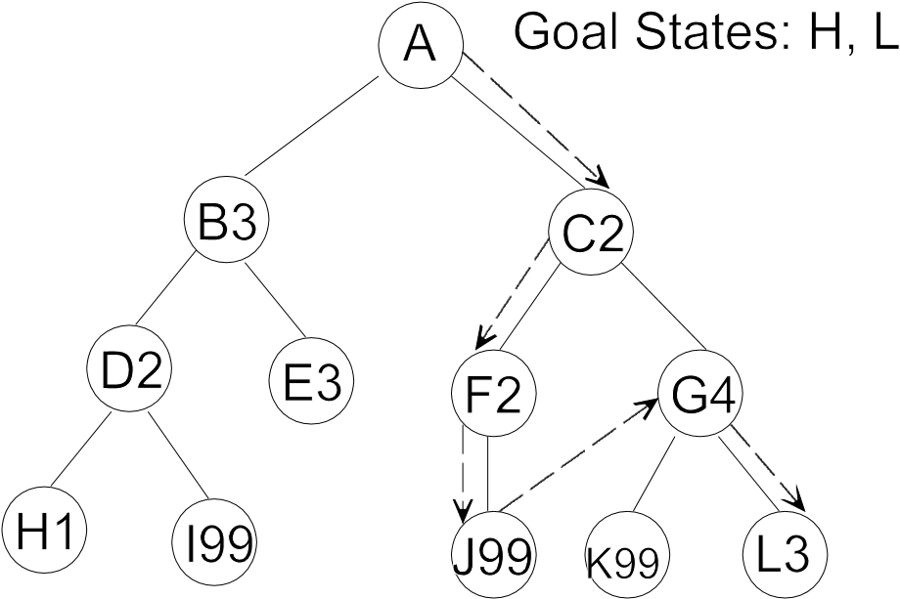
Example 1: Suppose that each of the letters represent a state in a state space representation. Legal moves:
A to B3 and C2
B3 to D2 and E3
C2 to F2 and G4
D2 to H1 and I99
F2 to J99
G4 to K99 and L3
Start state: A when Goal states: H, L
The result of applying the hill-climbing algorithm to this problem is illustrated in the table below.
OPEN | CLOSED
[A] | -
[C2, B3] | [A]
[F2, G4, B3] | [A, C2]
[J99, G4, B3] | [A, C2, F2]
[G4, B3] | [A, C2, F2, J99]
[L3,K99, B3] | [A, C2, F2,J99, G4]
4. A* Algorithm
A* Algorithm extends the path that minimizes the following function-
f(n) = g(n) + h(n)
Here,
- ‘n’ is the last node on the path
- g(n) is the cost of the path from start node to node ‘n’
- h(n) is a heuristic function that estimates cost of the cheapest path from node ‘n’ to the goal node

Algorithm-

- The implementation of A* Algorithm involves maintaining two lists- OPEN and CLOSED.
- OPEN contains those nodes that have been evaluated by the heuristic function but have not been expanded into successors yet.
- CLOSED contains those nodes that have already been visited.

The algorithm is as follows-

Step-01:

- Define a list OPEN.
- Initially, OPEN consists solely of a single node, the start node S.

Step-02:

If the list is empty, return failure and exit.

Step-03:

- Remove node n with the smallest value of f(n) from OPEN and move it to list CLOSED.
- If node n is a goal state, return success and exit.

Step-04:

Expand node n.

Step-05:

- If any successor to n is the goal node, return success and the solution by tracing the path from goal node to S.
- Otherwise, go to Step-06.

Step-06:

For each successor node,
- Apply the evaluation function f to the node.
- If the node has not been in either list, add it to OPEN.

Step-07:

Go back to Step-02

Example:

Consider the following graph-

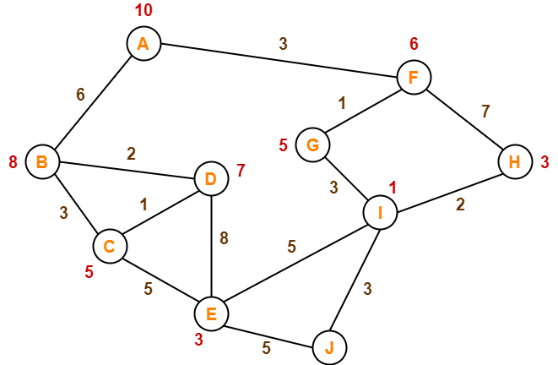

The numbers written on edges represent the distance between the nodes.
The numbers written on nodes represent the heuristic value.
Find the most cost-effective path to reach from start state A to final state J using A* Algorithm.

Solution-
A is the start state and J is the Goal state.
open | Close
[ A ] | [ ]
[ F9 B12 ] | [ A ]
[ G9 H13 B14 ] | [ A F9 ]
[ I8 H13 B14 ] | [ A F9 G9 ]
[ J10 E15 H13 B14 ] | [ A F9 G9 I8]

Step-01:

We start with node A.
- Node B and Node F can be reached from node A.

A* Algorithm calculates f(B) and f(F).
- f(B) = 6 + 8 = 14
- f(F) = 3 + 6 = 9

Since f(F) < f(B), so it decides to go to node F.
Path- A → F

Step-02:

Node G and Node H can be reached from node F.
A* Algorithm calculates f(G) and f(H).
- f(G) = (3+1) + 5 = 9
- f(H) = (3+7) + 3 = 13

Since f(G) < f(H), so it decides to go to node G.

Path- A → F → G
Step-03:
Node I can be reached from node G.
A* Algorithm calculates f(I).
f(I) = (3+1+3) + 1 = 8
It decides to go to node I.
Path- A → F → G → I

Step-04:

Node E, Node H and Node J can be reached from node I.
A* Algorithm calculates f(E), f(H) and f(J).
- f(E) = (3+1+3+5) + 3 = 15
- f(H) = (3+1+3+2) + 3 = 12
- f(J) = (3+1+3+3) + 0 = 10
Since f(J) is least, so it decides to go to node J.
Path- A → F → G → I → J

This is the required shortest path from node A to node J.
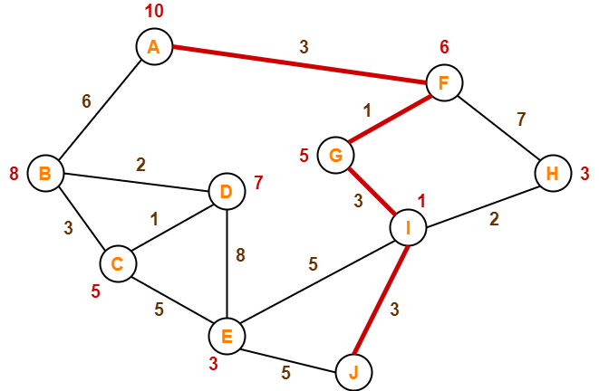
Example:

Start State is A and F is the Goal.
Open | Close
[ A ] | [ ]
[ B10 C11] | [ A]
[ C11 D12 ] | [ A B]
[ G8 D12 ] | [ A B C ]
[ F7 D12 ] | [ A B C G ]

Important Note-
It is important to note that-
- A* Algorithm is one of the best path finding algorithms.
- But it does not produce the shortest path always.
- This is because it heavily depends on heuristics.

