1.1 DATA COMMUNICATIONS

- Network: Is two or more devices connected through links.

- When we communicate, we are sharing information. This sharing can be local or remote. Between individuals, local communication usually occurs face to face, while remote communication takes place over distance. The term telecommunication, which includes telephony, telegraphy, and television, means communication at a distance.

- Data communications are the exchange of data between two devices via some form of transmission medium such as a wire cable. For data communications to occur, the communicating devices must be part of a communication system made up of a combination of hardware (physical equipment) and software (programs).

- Network computer devices that originate, route and terminate the data are called network nodes. Nodes can include hosts such as personal computers, phones, servers as well as networking hardware. Two such devices are said to be networked together when one device is able to exchange information with the other device, whether or not they have a direct connection to each other.

- Computer networks support applications such as access to the World Wide Web, shared use of application and storage servers, printers, and fax machines, and use of email and instant messaging applications. Computer networks differ in:-
1.The physical media used to transmit their signals
2.The communications protocols to organize network traffic
3.The network's size, topology and organizational intent.

- The effectiveness of a data communications system depends on four fundamental characteristics: delivery, accuracy, timeliness, and jitter.
1. Delivery: The system must deliver data to the correct destination. Data must be received by the intended device or user and only by that device or user.
2. Accuracy: The system must deliver the data accurately. Data that have been altered in transmission and left uncorrected are unusable.
3. Timeliness: The system must deliver data in a timely manner. Data delivered late are useless. In the case of video and audio, timely delivery means delivering data as they are produced, in the same order that they are produced, and without significant delay. This kind of delivery is called real-time transmission.
4. Jitter: Jitter refers to the variation in the packet arrival time. It is the uneven delay in the delivery of audio or video packets. For example, let us assume that video packets are sent every 3D ms. If some of the packets arrive with 3D-ms delay and others with 4D-ms delay, an uneven quality in the video is the result.

A data communications system has five components (see Figure 1.1).
Figure 1.1 Five components of data communication
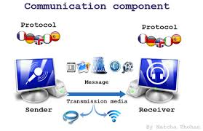

1. Message: The message is the information (data) to be communicated. Popular forms of information include text, numbers, pictures, audio, and video.
2. Sender: The sender is the device that sends the data message. It can be a computer, workstation, telephone handset, video camera, and so on.
3. Receiver: The receiver is the device that receives the message. It can be a computer, workstation, telephone handset, television, and so on.
4. Transmission medium: The transmission medium is the physical path by which a message travels from sender to receiver. Some examples of transmission media include twisted-pair wire, coaxial cable, fiber-optic cable, and radio waves.
5. Protocol: A protocol is a set of rules that govern data communications. It represents an agreement between the communicating devices. Without a protocol, two devices may be connected but not communicating.
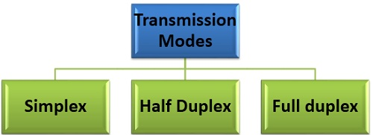
1.2 Data Flow (Data Transmission Modes)

Communication between two devices can be simplex, half-duplex, or full-duplex:
1. Simplex: In simplex mode, the communication is unidirectional, as on a one-way street. Only one of the two devices on a link can transmit; the other can only receive
Keyboards and traditional monitors are examples of simplex devices. The keyboard can only introduce input; the monitor can only accept output. The simplex mode can use the entire capacity of the channel to send data in one direction.
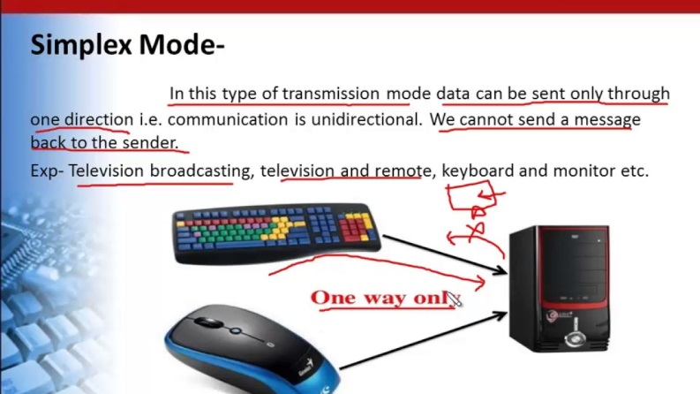

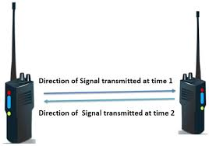
2. Half-Duplex: In half-duplex mode, each station can both transmit and receive, but not at the same time. When one device is sending, the other can only receive, and vice versa (see Figure 1.2b). Walkie-talkies and CB (citizens band) radios are both half-duplex systems. The half-duplex mode is used in cases where there is no need for communication in both directions at the same time.

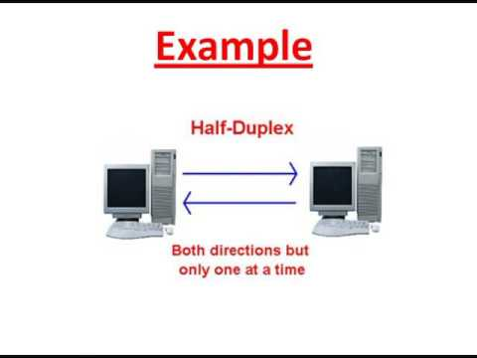

3.Full-Duplex: In full-duplex mode (also called duplex), both stations can transmit and receive simultaneously (see Figure 1.2c). In full-duplex mode, signals going in one direction share the capacity of the link with signals going in the other direction.
One common example of full-duplex communication is the telephone network. When two people are communicating by a telephone line, both can talk and listen at the same time. The full-duplex mode is used when communication in both directions is required all the time. The capacity of the channel, however, must be divided between the two directions.
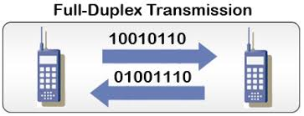

1.3 Type of Connection
A network is two or more devices connected through links. A link is a communications pathway that transfers data from one device to another. For communication to occur, two devices must be connected in some way to the same link at the same time.
There are two possible types of connections: point-to-point and multipoint.
1. Point-to-Point: A point-to-point connection provides a dedicated link between two devices. The entire capacity of the link is reserved for transmission between those two devices. Most point-to-point connections use an actual length of wire or cable to connect the two ends, but other options, such as microwave or satellite links, are also possible (see Figure 1.3a). When you change television channels by infrared remote control, you are establishing a point-to-point connection between the remote control and the television's control system.
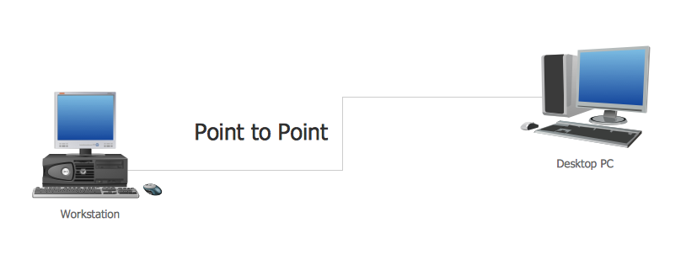
(Figure 1.3a)

2. Multipoint: A multipoint (also called multidrop) connection is one in which more than two specific devices share a single link (see Figure 1.3b). In a multipoint environment, the capacity of the channel is shared.

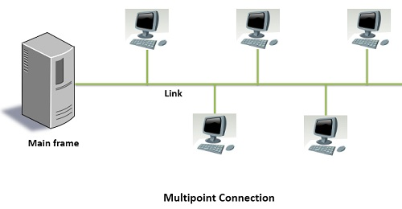

(Figure 1.3b)

- Advantages of Computer Networks

- File sharing:– become easily share data between different users, or access it remotely if you keep it on other connected devices.
- Resource sharing:– using network-connected peripheral devices like printers, scanners and copiers, or sharing software between multiple users, saves money.
- Sharing a single internet connection:– it is cost- efficient and can help protect your systems if you properly secure the network.
- Increasing storage capacity:– you can access files and multimedia, such as images and music, which you store remotely on other machines or network-attached storage devices.
- Disadvantages of Computer Networks
Following are some of the major disadvantages of computer networks

- Security Issues: One of the major drawbacks of computer networks is the security issues involved. If a computer is a standalone, physical access becomes necessary for any kind of data theft. However, if a computer is on a network, a computer hacker can get unauthorized access by using different tools. In case of big organizations, various network security software are used to prevent the theft of any confidential and classified data.
- Rapid Spread of Computer Viruses: If any computer system in a network gets affected by computer virus, there is a possible threat of other systems getting affected too. Viruses get spread on a network easily because of the interconnectivity of workstations. Such spread can be dangerous if the computers have important database which can get corrupted by the virus.
- Expensive Set Up: The initial set up cost of a computer network can be high depending on the number of computers to be connected. Costly devices like routers, switches, hubs, etc., can add up to the bills of a person trying to install a computer network. He will also have to buy NICs (Network Interface Cards) for each of the workstations, in case they are not inbuilt.
- Dependency on the Main File Server: In case the main File Server of a computer network breaks down, the system becomes useless. In case of big networks, the File Server should be a powerful computer, which often makes it expensive.

