Pipeline Hazards
- Data Hazards – an instruction uses the result of the previous instruction. A hazard occurs exactly when an instruction tries to read a register in its ID stage that an earlier instruction intends to write in its WB stage.
- Control Hazards – the location of an instruction depends on previous instruction For example Branch instruction affects PC(program counter) contents .
- Structural Hazards – two instructions need to access the same resource

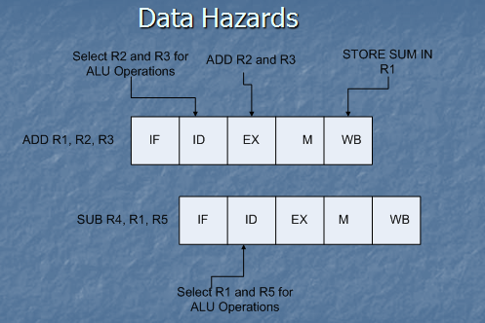
Stalling:
- Stalling involves halting the flow of instructions until the required result is ready to be used. However stalling wastes processor time by doing nothing while waiting for the result.
