**Exercises**

Q1) Find the limits

1. 
2. 
3. 

Q2) Calculate limits using the limit laws

1. 
2. 
3. 
4. 
5. 

Q3) Using 

Show that a) 

b) 

**Trigonometry function**

**Chapter Two**

Basic Algebra, Geometry and Trigonometry formulas

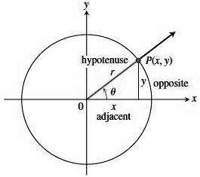Trigonometry formulas

Definitions and fundamental identities

Sine 

Cosine 

Tangent 

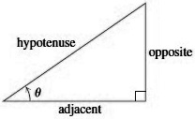







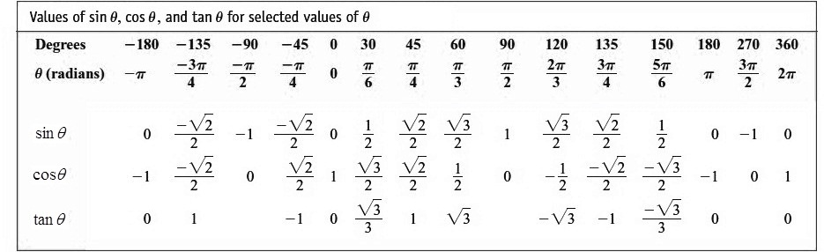

**The Basic Trigonometry function**

 

|  |  |
| --- | --- |
| Even | odd |
|  |  |

 (1)

This equation, true for all values of  is the most frequently used identity in trigonometry. Dividing this identity in turn by  and gives



Addition formulas

 (2)

Double –Angle Formulas

 (3)

Additional formulas come from combining the equations  and  we add the two equations to get and subtract the second from the first to get . This results in the following identities, which are useful in integral calculus.

 (4)

 (5)

**DEFINITION Periodic Function**

A functionis **periodic** if there is a positive numbersuch that for every value of . The smallest such value of is the period of.

|  |  |
| --- | --- |
| **Periodic Trigonometric function** | |
| **Periodic**  **Periodic** |  |

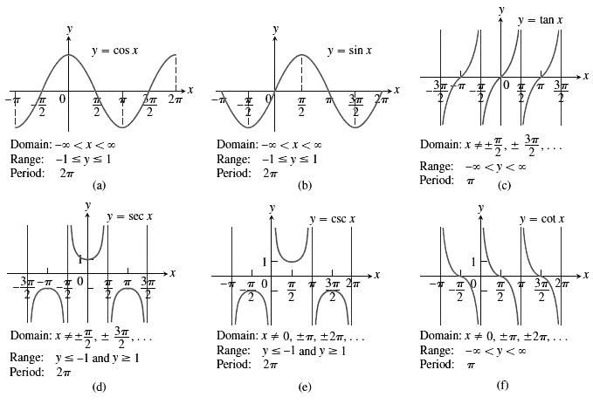

Graphs of the (a) cosine, (b) sine, (c) tangent, (d) secant, (e) cosecant, and (f) cotangent functions using radian measure. The shading for each trigonometric function indicates its periodicity.

**Identities**

 

  

 

 









 

 

 















**Algebra**

**Arithmetic operations**

  

**Law of sings**

 

**Zero Division by zero not defined**

If : 

For any number  

**Law of exponents**



If ,



The Binomial Theorem for any positive integer 

For instant





**Factoring the Deference of Like Integer Power **



For instant







**Completing the Square**

If 









This is



**The Quadratic Formula**

If and 



**EXAMPLE 1:** Prove the following identities 

Sol

L.H.S 







R.H.S

**EXAMPLE 2:** Prove that 

Sol

L.H.S 









R.H.S

**EXAMPLE 3:** Prove that

Sol









Prove that  (H.W)