A
Q1: Encrypt with playfair algorithm the following plain text " please meet me tomorrow " using the key word WELCOM
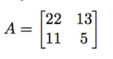
Q2: Encrypt with hill cipher algorithm the following plain text " meet me here " using the key

B
Q1: Q1: Encrypt with playfair algorithm the following plain text "MUST SEE YOU HERE" using the key word LARGEST
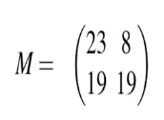
Q2: Encrypt with hill cipher algorithm the following plain text " FRIDAY " using the key

C
Q1: Q1: Encrypt with playfair algorithm the following plain text "CRYPTO IS TOO EASY" using the key word INFOSEC
Q2: Encrypt with hill cipher algorithm the following plain text " BOOK CLDS " using the key

