Four class Computer security exam 2

Q1) Encrypt message =" enemy attack tonight", using :
- Columnar transposition cipher.
- Vigenere Cipher .
( key= german)
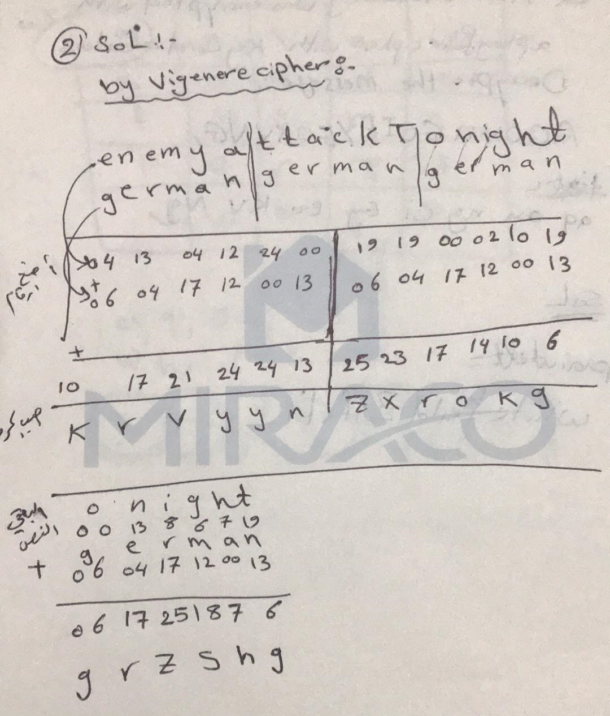

Q2) Decrypt the following message “FAXAEYMQLWXO” where it encrypts using multiplication cipher and using the encryption key 19(key⁻¹=11).

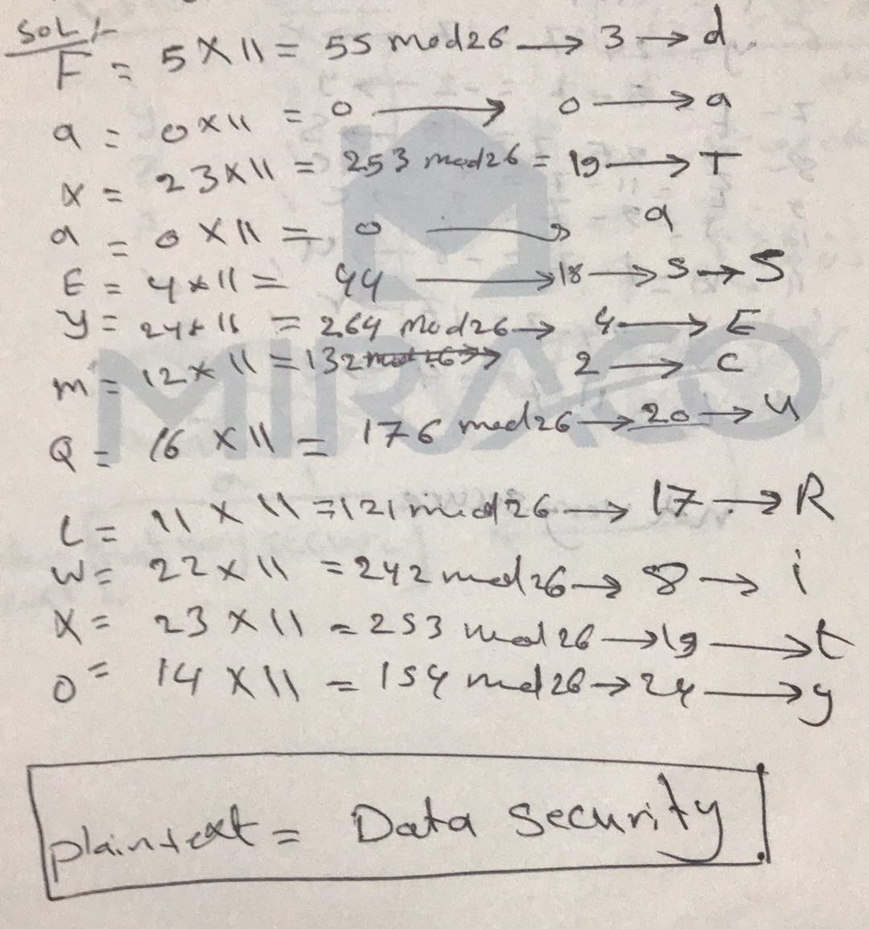

C=p*k
P=c*k⁻¹

Q3/ The following was encrypted with a Playfair Cipher with keyword Galois. Decrypt the message.
AQOUNGCIEYEOKVNG,BIMEHOTUEUNBCLOKIH

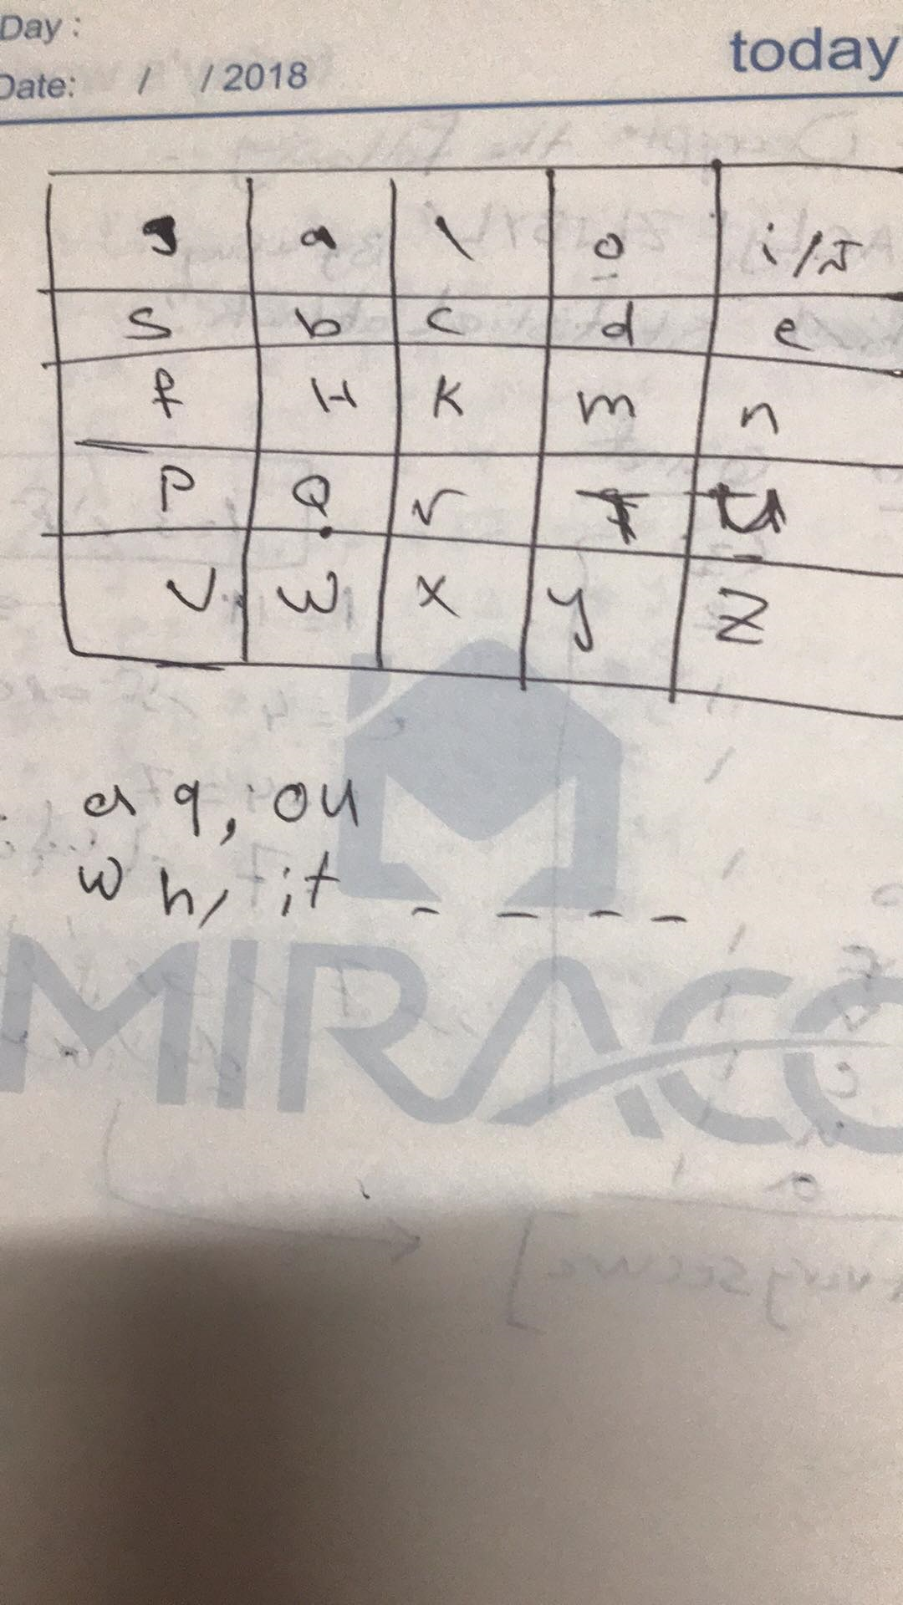

Q4/ Decrypt the following message “UVACLYFZLJBYL”.
By using statistical attack?
---------------------------------------------------------------------

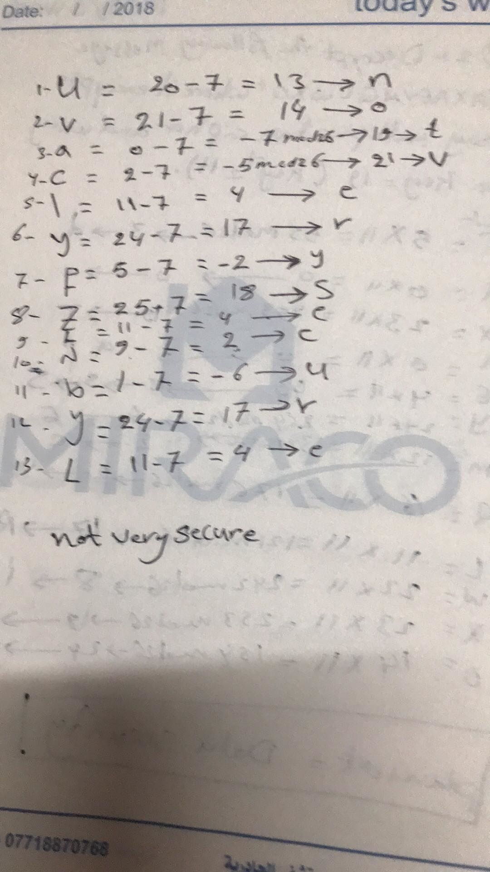
sol:-

