Introduction

- Data Communication
- Networks
- Protocols and Standards
- Standard Organizations

Definitions

-Computer Network: an interconnected collection of autonomous computers, printers, peripherals, etc

- Distributed system: a software system built on top of a network.

Distributed Systems Vs. Computer Networks

- In Distributed Systems
  - Computers are transparent to the user.
  - Everything is handled automatically by the system.
- In Computer Networks
  - Users must explicitly supply addresses, explicitly submit jobs, move files around, …etc..

Why Computer Networks

- Resource Sharing
- High Reliability
- Access to Remote Information
- Communication
- Interactive Entertainment
- Saving Money: Client-Server Model

Data Communication System Components

Data Representation

- Text – represented as a bit pattern; codes often used:
  - ASCII; Extended ASCII; Unicode; ISO
- Numbers – represented by binary equivalent
- Images – bit patterns representing pixels
- Audio
- Video

Data Communication Network Criteria

-Performance
-liability
-Security

Performance

- Number of Users
- Type of Transmission Medium
- Hardware
- Software

Reliability

- Frequency of Failure
- Recovery Time
- Catastrophe

Security

- Unauthorized access
- Viruses

Applications

- Home Application
- Business Application
- Mobile Applications

Protocols

- Protocol: a set of rules that govern data communication.
- It defines
  - What is communicated
  - How it is communicated
  - When it is communicated

Protocol Elements

- Syntax: the structure or format of the data, meaning the order in which they are presented.
- Semantics: the meaning of section of bits.
- Timing: refers to when data should be sent and how fast it can be sent.

Why Standards ?

To guarantee interoperability and compatibility of networks.

Standards Organizations

- International Standards Organization (ISO): dedicated to worldwide agreement on international standards in a variety of fields.

- International Telecommunication Union-Telecommunication Sector (ITU-T): Develop standards for telecommunications.

- American National Standards Institute (ANSI): U.S. voting representative to both ISO and ITU-T.

- Institute of Electrical and Electronics Engineers (IEEE): the largest national professional group in developing standards for computing, communication, electrical engineering, and electronics.

- Electronic Industries Association (EIA): an association of electronics manufacturers in the U.S.

Chapter 3: Open Systems Interconnection (OSI) Model

- The Model
- Functions of the layers

The OSI Model

- Developed by the ISO in 1984 to open communication between different systems without changing the logic of the underlying hardware or software
- Vendor-specific protocols close off communication between unrelated systems
- The OSI model is a model for understanding and designing a network architecture that is flexible, robust, and interoperable
- ISO is an organization. OSI is a model
- A model is a way of picturing how information travels through networks
- The OSI model divides the flow of information into seven smaller and more manageable problems
- Each of the seven problem areas is solved by a layer of the model
- The seven layers of the OSI reference model are: the physical layer, the data link layer, the network layer, the transport layer, the session layer, the presentation layer, and the application layer

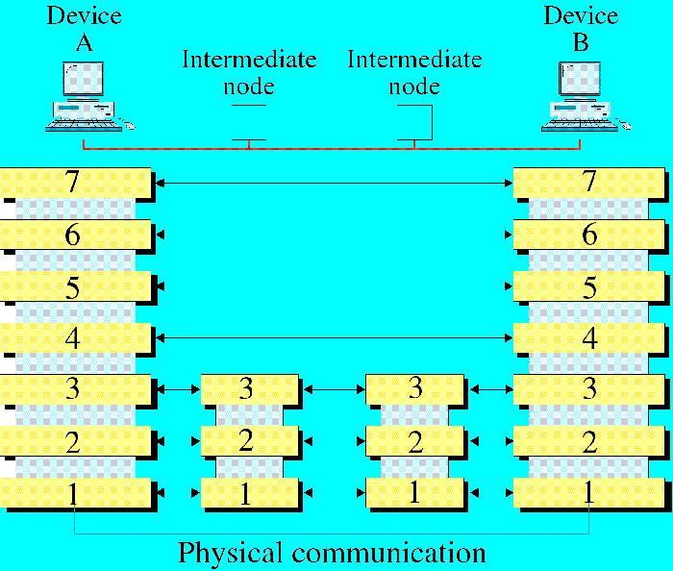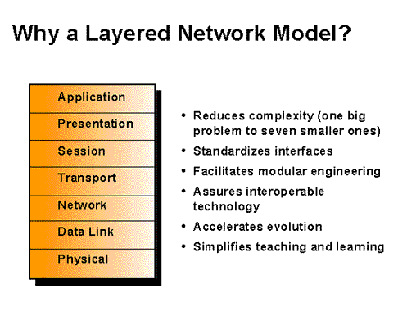

OSI Layers

Peer-to-Peer Communication

- A layer on one machine communicates with the same layer on another machine
- The processes on each machine that communicate at each layer are called peer-to-peer processes
- Data Encapsulation: The wrapping of data in a particular protocol header
- Headers are added to the data at layers 6,5,4,3, and 2. Trailers are usually added at layer 2
- An interface defines what information and services a layer must provide for the layer above it

An Exchange Using the OSI Model

Media and Host Layers

- Media layers are network support layers
- Host layers are user support layers
- The transport layer is sometimes excluded from the user support layers and links the two groups

The Physical Layer

- Coordinates the functions required to transmit a bit stream over a physical medium
- The physical layer defines the electrical, mechanical, procedural, and functional specifications for activating, maintaining, and deactivating the physical link between end systems

Physical Layer Considerations

- Line configuration: shared or point-to-point, availability of link
- Data transmission mode: unidirectional or bi-directional
- Topology: how are devices arranged? Path selection
- Signals: Type of signals
- Encoding: How data are represented by signals
- Interface: What information must be shared between linked devices? What is the most efficient way to communicate?
- Medium

Data Link Layer

- It provides reliable transmit of data across a physical link. The data link layer is concerned with:
  - physical addressing,
  - network topology,
  - line discipline,
  - error notification,
  - ordered delivery of frames, and
  - flow control
- The IEEE has divided this layer into two sublayers:
  - the Media Access Control (MAC) sublayer, and
  - the Logical Link Control (LLC) sublayer
- The data unit at this layer is called frame
(H + L3 data + T)
- The header and trailer carry information about synchronization, sequencing, and acknowledgments

Responsibilities

- Node-to-node delivery
- Addressing: physical addresses of the most recent node and the intended node
- Access control: which device has control over the line at any given line
- Flow control: to avoid overwhelming the receiver
- Error handling
- Synchronization: Headers contain bits to alert the receiving station that a frame is arriving. Also, these bits allow the receiver to synchronize its timing

Data Link Layer

Data Link Layer Example

Network Layer

- Responsible for the Source-to-Destination (end-to-end) delivery
- The connectivity is achieved using two services:
  - Routing: Selecting the best path (best effort)
  - Switching: temporary connections between links
- Routing uses logical addresses which are assigned by the network’s administrator
- The data link header contains physical addresses of the current and next node only
- The network header contains the logical addresses of the source and the destination

Network Layer

Responsibilities

- Source-to-destination delivery
- Logical addressing
- Routing
- Address transformation: Logical to physical addresses
- Multiplexing: Using a single link to carry data between many devices at the same time

Network Layer Example
Network Layer Example

Transport Layer

- Responsible for reliable source-to-destination delivery of the entire message.
- The transport layer gets the entire message to the correct application, while the network layer gets each packet to the correct computer.
- Need another level of addressing for applications: service-point or port address or socket address
- The transport layer header contains segment number (sequencing)
- Responsible for connection between two end ports (establish, transfer, release)
- Sequencing, flow control, error detection and correction

Responsibilities

- End-to-end message delivery
- Service-point (port) addressing
- Segmentation and reassembly
- Connection control: deciding whether or not to send all packets by a single path

Session Layer

- It is the network dialog controller: who sends and when
- Establishes, maintains,and synchronizes sessions between applications
- Ensures that each session closes appropriately
- Validates and establishes connections between users
- Controls direction of the exchange of data
- Reliability by dividing the session into subsessions using checkpoints inserted into the stream. This allows a session to backtrack a certain distance without starting over
- Header contains control information: type of data unit and synchronization point information

Responsibilities

- Session Management: dividing the session into subsessions called dialog units
- Synchronization: order of passing the dialog units and when to request an acknowledgement
- Dialog Control: who sends and when
- Graceful Close: ensures that the exchange has been completed appropriately before the session closes

Session Layer

Presentation Layer

- Ensures interoperability among applications.
- Provides translation of different control codes, character sets, graphics format, etc.
- Responsible for encryption and decryption of data as well as compression and expansion of data.
- Header includes information on type and parameters of the transmission and length of the transmission.

Responsibilities

- Translation
- Encryption
- Compression
- Security: user authentication

Presentation Layer

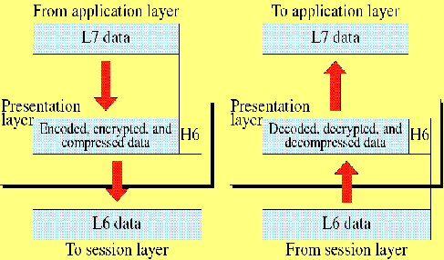

Application Layer

- Provides network services to application processes. Services include the following:
  - Network virtual terminal: allows you to log on to a remote host
  - File access, transfer, and management
  - Mail service
  - Directory services
Application Layer

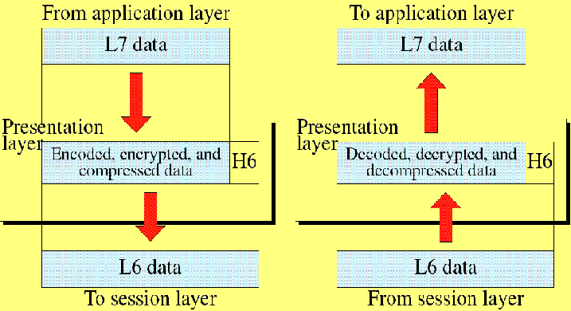

Summary of Layer Functions


