2.1 The OSI Model
Established in 1947, the International Standards Organization (ISO) is a multinational body dedicated to worldwide agreement on international standards. An ISO standard that covers all aspects of network communications is the Open Systems Interconnection (OSI) model. It was first introduced in the late 1970s.
أَسّسَ في 1947، منظمة المعايير الدولية (ISO) a جسم دولي كرّسَ إلى حول العالم اتفاقية على المستويات الدولية. معيار منظمةِ مستويات دولية الذي يَغطّي كُلّ جوانب اتصالات الشبكةِ ترابطُ الأنظمةِ المفتوحِ (OSI) نموذج. هو قُدّمَ أولاً في أواخر السبعيناتِ.
Note : ISO is the organization , OSI is the model
The functions of each layer in the OSI model is briefly described.
Physical Layer
The physical layer is responsible
for the movement of individual bits from one hop (node) to the next.
إنّ الطبقةَ الطبيعيةَ مسؤولة عن حركةِ القطعِ الفرديةِ مِنْ قفزةِ واحدة (عقدة) إلى العقدة التالية
Data Link Layer
The data link layer is responsible for moving frames from one hop (node) to the next.
إنّ طبقة وصل البياناتَ مسؤولة عن الإطاراتِ المتحركة مِنْ قفزةِ واحدة (عقدة) إلى التالية.
Network Layer
The network layer is responsible for the delivery of individual packets from the source host to the destination host.
إنّ طبقةَ الشبكةَ مسؤولة عن تسليمِ رُزَم فردية مِنْ المضيف المصدر إلى المضيّف المرسل اليه.
Transport Layer
The transport layer is responsible for the delivery of a message from one process to another.
إنّ طبقة الإرسال مسؤولة عن تسليم رسالة من عملية إلى أخرى.
Session Layer
Presentation Layer
Application Layer
Summary of Layers

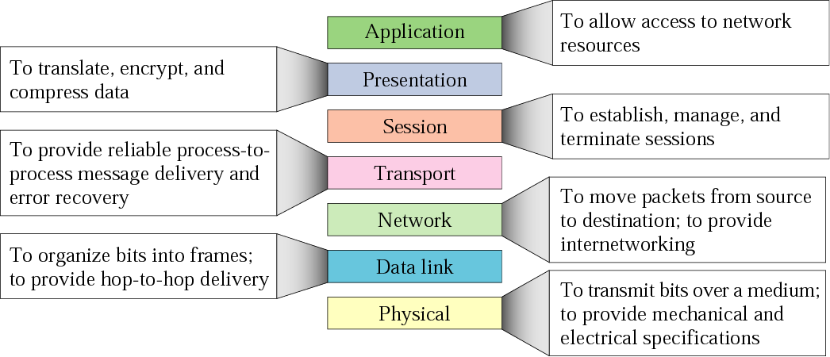
2.3 TCP/IP Protocol Suite
The TCP/IP protocol suite is made of five layers: physical, data link, network, transport, and application. The first four layers provide physical standards, network interface, internetworking, and transport functions that correspond to the first four layers of the OSI model. The three topmost layers in the OSI model, however, are represented in TCP/IP by a single layer called the application layer.
نظام السيطرة على الارسال / بروتكول الانترنت جناح نظامِ يُصْنَعُ من خمس طبقاتِ: فيزيائية، رابط بيانات، شبكة، نقل، وتطبيق. تُزوّدُ الطبقاتُ الأولى الأربع معاييرُ طبيعيةُ، واجهة شبكةِ , تشبيك داخلي، وتَنْقلُ الوظائفَ التي تُقابلُ الأولى الأربعة مِنْ طبقاتِ نموذجِ OSI. إنّ الطبقاتَ الأعلى الثلاث في نموذجِ OSI، على أية حال، مُمَثَّل في TCP/IP مِن قِبل طبقة وحيدة دَعيتْ طبقةَ البرامج.
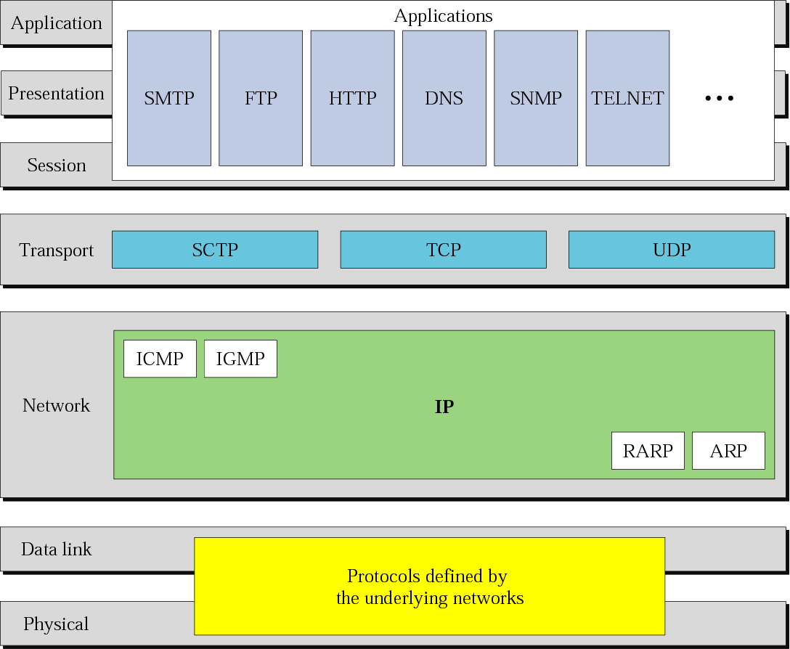
2.4 Addressing
Three different levels of addresses are used in an internet using the TCP/IP protocols: physical (link) address, logical (IP) address, and
port address.
ثلاثة مستويات مختلفةِ مِنْ العناوينِ مستعملة في الإنترنتِ تَستعملُ نظام اتفاقيات TCP/IP: الطبيعية (وصلة) عنوان، منطقيّ (IP) عنوان، وعنوان منفذ.
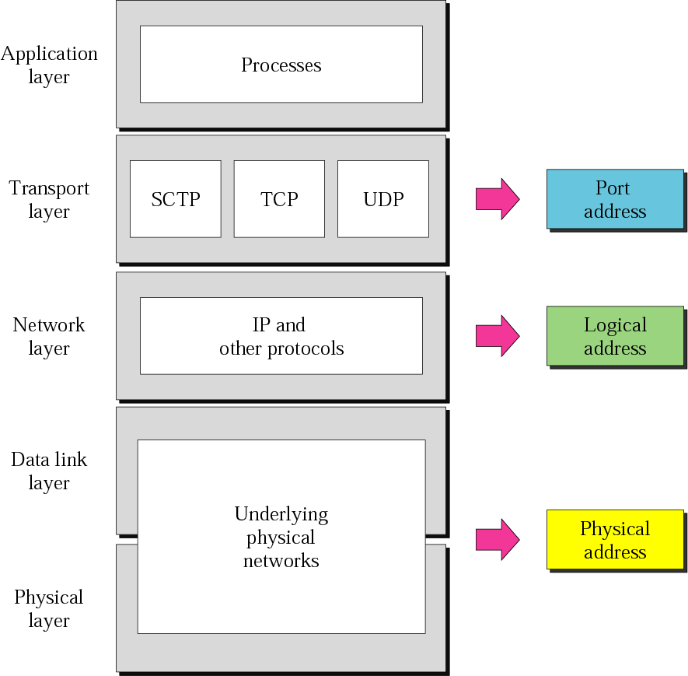
Example 1
In Figure 2.18 a node with physical address 10 sends a frame to a node with physical address 87. The two nodes are connected by a link. At the data link level this frame contains physical (link) addresses in the header. These are the only addresses needed. The rest of the header contains other information needed at this level. The trailer usually contains extra bits needed for error detection.
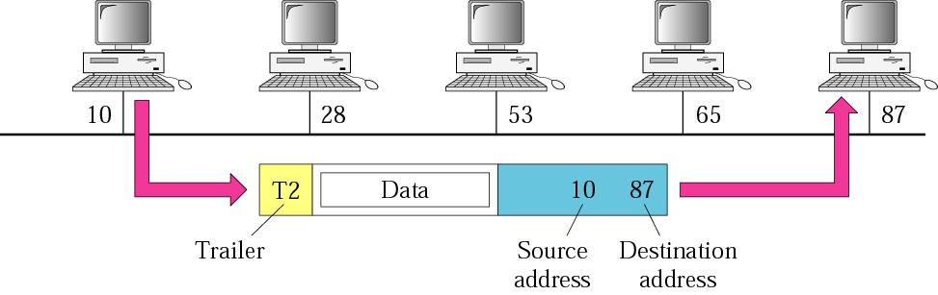

Example 2
As we will see in Chapter 3, most local area networks use a 48-bit (6 bytes) physical address written as 12 hexadecimal digits, with every 2 bytes separated by a colon as shown below:

07:01:02:01:2C:4B
A 6-byte (12 hexadecimal digits) physical address.
Example 3
In Figure 2.19 we want to send data from a node with network address A and physical address 10, located on one LAN, to a node with a network address P and physical address 95, located on another LAN. Because the two devices are located on different networks, we cannot use link addresses only; the link addresses have only local jurisdiction. What we need here are universal addresses that can pass through the LAN boundaries. The network (logical) addresses have this characteristic.
The packet at the network layer contains the logical addresses, which remain the same from the original source to the final destination (A and P, respectively, in the figure). They will not change when we go from network to network. However, the physical addresses will change as the packet moves from one network to another. The boxes labeled routers are internetworking devices, which we will discuss in Chapter 3.
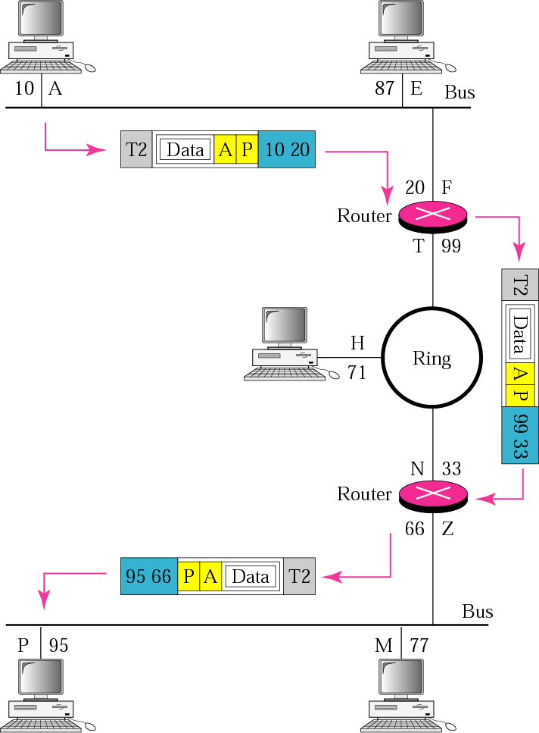

Example 4
As we will see in Chapter 4, an Internet address (in IPv4) is 32 bits in length, normally written as four decimal numbers, with each number representing 1 byte. The numbers are separated by a dot. Below is an example of such an address.

132.24.75.9
An internet address in IPv4 in decimal numbers

Example 5
Figure 2.20 shows an example of transport layer communication. Data coming from the upper layers have port addresses j and k ( j is the address of the sending process, and k is the address of the receiving process). Since the data size is larger than the network layer can handle, the data are split into two packets, each packet retaining the service-point addresses ( j and k). Then in the network layer, network addresses (A and P) are added to each packet.
The packets can travel on different paths and arrive at the destination either in order or out of order. The two packets are delivered to the destination transport layer, which is responsible for removing the network layer headers and combining the two pieces of data for delivery to the upper layers.

