Function modules and Header Additions
・・・・・・・・・・・・・・・・・・・・・・・・・・・・・
In the OSI 7-layer model, the source and destination exchange with the function modules which realize each layer. The following figure shows the data unit on the moment.
Figure1 Names of data in Layer 1 to 4
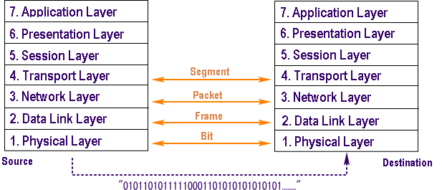
For example, the data created by the transport layer of the source is called a segment. In the processing in the source of figure 2, a header is added whenever going through each function module.
A function module adds the unique data when it is given a data from the upper function module. At this time, it is not involved in the content of the data given from the upper layer.
The following figure shows the aspect of adding headers.

Figure 2 Header additions
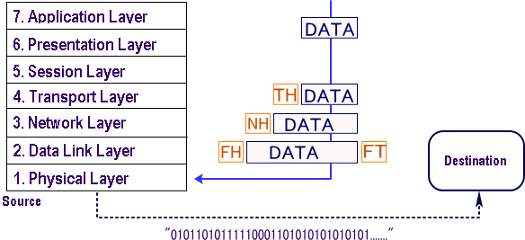

The data which the transport layer is given from the session layer is placed on the transport layer, added TH (TransportHeader -- TCP Header, UDP Header) and passed to the network layer.The data on the moment is called a segment.
The data which the network layer is given from the transport layer is placed on the network layer, added NH (Network Header -- IP Header) and passed to the data link layer.The data on the moment is called a packet.
The data which the data link layer is given from the network layer is placed on the data link layer, added FH (Frame Header) and FT (Frame Trailer) and passed to the physical layer. The data on the moment is called a frame.
The following figure shows the aspect when the data arrives at the destination.

Figure 3 Header deletions
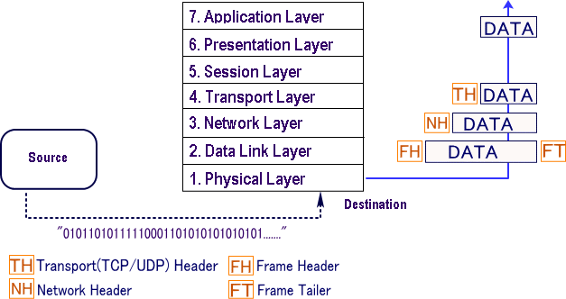

As shown in the above figure, the headers added in the source are deleted and analyzed by the function module corresponding to each header, in the destination. Then, the data is passed to the upper layer.
The important point to understand the foundation of communication is as follows: While the source adds a header each time the data goes through a function module, the destination processes the data, removing headers added to the data.
Data Link Layer - Creating a Frame
The description of a frame is a key element of each Data Link layer protocol. Data Link layer protocols require control information to enable the protocols to function. Control information may tell:
- Which nodes are in communication with each other
- When communication between individual nodes begins and when it ends
- Which errors occurred while the nodes communicated
- Which nodes will communicate next
The Data Link layer prepares a packet for transport across the local media by encapsulating it with a header and a trailer to create a frame. The Data Link layer frame includes:
- Data - The packet from the Network layer
- Header - Contains control information, such as addressing, and is located at the beginning of the PDU
- Trailer - Contains control information added to the end of the PDU (Protocol Data Units are added to each frame by each communications layer.)

Formatting Data for Transmission
When data travels on the media, it is converted into a stream of bits, or 1s and 0s. If a node is receiving long streams of bits, how does it determine where a frame starts and stops or which bits represent the address?
Framing breaks the stream into decipherable groupings, with control information inserted in the header and trailer as values in different fields. This format gives the physical signals a structure that can be received by nodes and decoded into packets at the destination.
Typical field types include:
- Start and stop indicator fields - The beginning and end limits of the frame
- Naming or addressing fields
- Type field - The type of PDU contained in the frame
- Quality - control fields
- A data field -The frame payload (Network layer packet)
Fields at the end of the frame form the trailer. These fields are used for error detection and mark the end of the frame. Not all protocols include all of these fields.

Framing - Role of the Header
The frame header contains the control information specified by the Data Link layer protocol for the specific logical topology and media used. Frame control information is unique to each type of protocol. It is used by the Layer 2 protocol to provide features demanded by the communication environment.
Typical frame header fields include:
- Start Frame field - Indicates the beginning of the frame
- Source and Destination address fields - Indicates the source and destination nodes on the media
- Priority/Quality of Service field - Indicates a particular type of communication service for processing
- Type field - Indicates the upper layer service contained in the frame
- Logical connection control field - Used to establish a logical connection between nodes
- Physical link control field - Used to establish the media link
- Flow control field - Used to start and stop traffic over the media
- Congestion control field - Indicates congestion in the media

Framing - Role of the Trailer
Data Link layer protocols add a trailer to the end of each frame. The trailer is used to determine if the frame arrived without error. This process is called error detection. Note that this is different from error correction. Error detection is accomplished by placing a logical or mathematical summary of the bits that comprise the frame in the trailer.
Frame Check Sequence
The Frame Check Sequence (FCS) field is used to determine if errors occurred in the transmission and reception of the frame. Error detection is added at the Data Link layer because this is where data is transferred across the media. The media is a potentially unsafe environment for data. The signals on the media could be subject to interference, distortion, or loss that would substantially change the bit values that those signals represent. The error detection mechanism provided by the use of the FCS field discovers most errors caused on the media. To ensure that the content of the received frame at the destination matches that of the frame that left the source node, a transmitting node creates a logical summary of the contents of the frame. This is known as the cyclic redundancy check (CRC) value. This value is placed in the Frame Check Sequence (FCS) field of the frame to represent the contents of the frame. When the frame arrives at the destination node, the receiving node calculates its own logical summary, or CRC, of the frame. The receiving node compares the two CRC values. If the two values are the same, the frame is considered to have arrived as transmitted. If the CRC value in the FCS differs from the CRC calculated at the receiving node, the frame is discarded. There is always the small possibility that a frame with a good CRC result is actually corrupt. Errors in bits may cancel each other out when the CRC is calculated. Upper layer protocols would then be required to detect and correct this data loss. The protocol used in the Data Link layer, will determine if error correction will take place. The FCS is used to detect the error, but not every protocol will support correcting the error.

1-"OSI model and transmission path", http://markun.cs.shinshu-u.ac.jp/learn/osi/e_learn-a.htm.
2- http://10.31.38.1/login?dst=http%3A%2F%2Fwww.blurtit.com
%2Fq5915894.html.
3-" Data link layer ", http://www.highteck.net/EN/DataLink/
Data_Link_Layer.html.

