Chapter Twelve
The Mobile Telephone System
Computer Networks, Fourth Edition
By Andrew S. Tanenbaum

Contents:
12.1 First-Generation Mobile Phones: Analog Voice
12.2 Second-Generation Mobile Phones: Digital Voice
12.2 1 D-AMPS—The Digital Advanced Mobile Phone System
12.2.2 GSM—The Global System for Mobile Communications
12.2.3 CDMA—Code Division Multiple Access
12.3 Third-Generation Mobile Phones: Digital Voice and Data

Wireless telephones come in two basic varieties:
- cordless phones and
- mobile phones (sometimes called cell phones).
Cordless phones are devices consisting of a base station and a handset sold as a set for use within the home. These are never used for networking. Mobile system is used for wide area voice and data communication.
Mobile phones have gone through three distinct generations, with different technologies:
- Analog voice.
- Digital voice.
- Digital voice and data (Internet, e-mail, etc.).
The first mobile system was devised in the U.S. by AT&T As a result, the entire U.S. had a single (analog) system. .When mobile came to Europe, every country devised its own system, which resulted in a fiasco.
Europe learned from its mistake and when digital came around, the government-run PTTs got together and standardized on a single system (GSM), so any European mobile phone will work anywhere in Europe. By then, the U.S. had decided that government should not be in the standardization business, so it left digital to the marketplace. This decision resulted in different equipment manufacturers producing different kinds of mobile phones. As a consequence, the U.S. now has two major incompatible digital mobile phone systems in operation (plus one minor one).

12.1 First-Generation Mobile Phones: Analog Voice

In 1946, the first system for car-based telephones was set up in St. Louis. This system used a single large transmitter on top of a tall building and had a single channel, used for both sending and receiving. In the 1960s, IMTS (Improved Mobile Telephone System) was installed. It, too, used a high-powered (200-watt) transmitter, on top of a hill, but now had two frequencies, one for sending and one for receiving, so the push-to-talk button was no longer needed. Since all communication from the mobile telephones went inbound on a different channel than the outbound signals, the mobile users could not hear each other (unlike the push-to-talk system used in taxis).
IMTS supported 23 channels spread out from 150 MHz to 450 MHz. Due to the small number of channels, users often had to wait a long time before getting a dial tone. Also, due to the large power of the hilltop transmitter, adjacent systems had to be several hundred kilometers apart to avoid interference. All in all, the limited capacity made the system impractical.
All that changed with AMPS (Advanced Mobile Phone System), invented by Bell Labs and first installed in the United States in 1982. It was also used in England, where it was called TACS, and in Japan, where it was called MCS-L1. Although no longer state of the art, we will look at it in some detail because many of its fundamental properties have been directly inherited by its digital successor, D-AMPS, in order to achieve backward compatibility.
In all mobile phone systems, a geographic region is divided up into cells, which is why the devices are sometimes called cell phones. In AMPS, the cells are typically 10 to 20 km across; in digital systems, the cells are smaller. Each cell uses some set of frequencies not used by any of its neighbors. The key idea that gives cellular systems far more capacity than previous systems is the use of relatively small cells and the reuse of transmission frequencies in nearby (but not adjacent) cells. Whereas an IMTS system 100 km across can have one call on each frequency, an AMPS system might have 100 10-km cells in the same area and be able to have 10 to 15 calls on each frequency, in widely separated cells. Thus, the cellular design increases the system capacity by at least an order of magnitude, more as the cells get smaller. Furthermore, smaller cells mean that less power is needed, which leads to smaller and cheaper transmitters and handsets. Hand-held telephones put out 0.6 watts; transmitters in cars are 3 watts, the maximum allowed by the FCC.
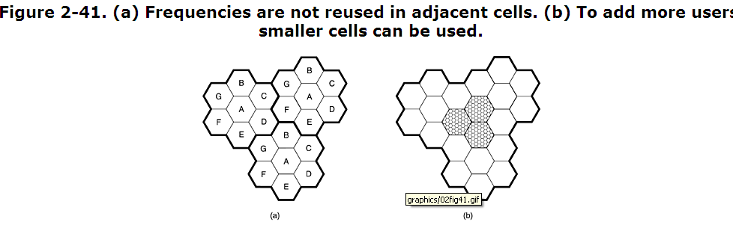

At the center of each cell is a base station to which all the telephones in the cell transmit. The base station consists of a computer and transmitter/receiver connected to an antenna. In a small system, all the base stations are connected to a single device called an MTSO (Mobile Telephone Switching Office) or MSC (Mobile Switching Center). In a larger one, several MTSOs may be needed, all of which are connected to a second-level MTSO, and so on. The MTSOs are essentially end offices as in the telephone system, and are, in fact, connected to at least one telephone system end office. The MTSOs communicate with the base stations, each other, and the PSTN using a packet-switching network.
At any instant, each mobile telephone is logically in one specific cell and under the control of that cell's base station. When a mobile telephone physically leaves a cell, its base station notices the telephone's signal fading away and asks all the surrounding base stations how much power they are getting from it. The base station then transfers ownership to the cell getting the strongest signal, that is, the cell where the telephone is now located. The telephone is then informed of its new boss, and if a call is in progress, it will be asked to switch to a new channel (because the old one is not reused in any of the adjacent cells). This process, called handoff, takes about 300 msec. Channel assignment is done by the MTSO, the nerve center of the system. The base stations are really just radio relays.
Handoffs can be done in two ways. In a soft handoff, the telephone is acquired by the new base station before the previous one signs off. In this way there is no loss of continuity. The downside here is that the telephone needs to be able to tune to two frequencies at the same time (the old one and the new one). Neither first nor second generation devices can do this.
In a hard handoff, the old base station drops the telephone before the new one acquires it. If the new one is unable to acquire it (e.g., because there is no available frequency), the call is disconnected abruptly. Users tend to notice this, but it is inevitable occasionally with the current design.
The AMPS system uses 832 full-duplex channels, each consisting of a pair of simplex channels. There are 832 simplex transmission channels from 824 to 849 MHz and 832 simplex receive channels from 869 to 894 MHz. Each of these simplex channels is 30 kHz wide. Thus, AMPS uses FDM to separate the channels.
In the 800-MHz band, radio waves are about 40 cm long and travel in straight lines. They are absorbed by trees and plants and bounce off the ground and buildings. It is possible that a signal sent by a mobile telephone will reach the base station by the direct path, but also slightly later after bouncing off the ground or a building. This may lead to an echo or signal distortion (multipath fading). Sometimes, it is even possible to hear a distant conversation that has bounced several times.
The 832 channels are divided into four categories:
- Control (base to mobile) to manage the system.
- Paging (base to mobile) to alert mobile users to calls for them.
- Access (bidirectional) for call setup and channel assignment.
- Data (bidirectional) for voice, fax, or data.
Twenty-one of the channels are reserved for control, and these are wired into a PROM in each telephone. Since the same frequencies cannot be reused in nearby cells, the actual number of voice channels available per cell is much smaller than 832, typically about 45.

12.2 Second-Generation Mobile Phones: Digital Voice

The first generation of mobile phones was analog; the second generation was digital.
Four systems are in use now: D-AMPS, GSM, CDMA, and PDC.

12.2.1 D-AMPS—The Digital Advanced Mobile Phone System
The second generation of the AMPS systems is D-AMPS and is fully digital. It is described in International Standard IS-54 and its successor IS-136. D-AMPS was carefully designed to co-exist with AMPS so that both first- and second-generation mobile phones could operate simultaneously in the same cell. In particular, D-AMPS uses the same 30 kHz channels as AMPS and at the same frequencies so that one channel can be analog and the adjacent ones can be digital. Depending on the mix of phones in a cell, the cell's MTSO determines which channels are analog and which are digital, and it can change channel types dynamically as the mix of phones in a cell changes.
When D-AMPS was introduced as a service, a new frequency band was made available to handle the expected increased load. The upstream channels were in the 1850–1910 MHz range, and the corresponding downstream channels were in the 1930–1990 MHz range, again in pairs, as in AMPS. In this band, the waves are 16 cm long, so a standard ¼-wave antenna is only 4 cm long, leading to smaller phones. However, many D-AMPS phones can use both the 850-MHz and 1900-MHz bands to get a wider range of available channels.

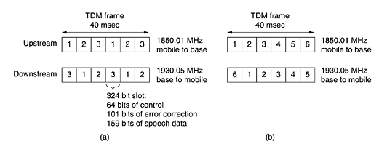
Figure 2-42. (a) A D-AMPS channel with three users. (b) A D-AMPS channel with six users.

12.2.2 GSM—The Global System for Mobile Communications
D-AMPS is widely used in the U.S. and (in modified form) in Japan. Virtually everywhere else in the world, a system called GSM (Global System for Mobile communications) is used, and it is even starting to be used in the U.S. on a limited scale. To a first approximation, GSM is similar to D-AMPS. Both are cellular systems. In both systems, frequency division multiplexing is used, with each mobile transmitting on one frequency and receiving on a higher frequency (80 MHz higher for D-AMPS, 55 MHz higher for GSM). Also in both systems, a single frequency pair is split by time-division multiplexing into time slots shared by multiple mobiles. However, the GSM channels are much wider than the AMPS channels (200 kHz versus 30 kHz) and hold relatively few additional users (8 versus 3), giving GSM a much higher data rate per user than D-AMPS.
Each frequency band is 200 kHz wide, as shown in Fig. 2-43. A GSM system has 124 pairs of simplex channels. Each simplex channel is 200 kHz wide and supports eight separate connections on it, using time division multiplexing. Each currently active station is assigned one time slot on one channel pair. Theoretically, 992 channels can be supported in each cell, but many of them are not available, to avoid frequency conflicts with neighboring cells. In Fig. 2-43, the eight shaded time slots all belong to the same connection, four of them in each direction. Transmitting and receiving does not happen in the same time slot because the GSM radios cannot transmit and receive at the same time and it takes time to switch from one to the other. If the mobile station assigned to 890.4/935.4 MHz and time slot 2 wanted to transmit to the base station, it would use the lower four shaded slots (and the ones following them in time), putting some data in each slot until all the data had been sent.

Figure 2-43. GSM uses 124 frequency channels, each of which uses an eight-slot TDM system.
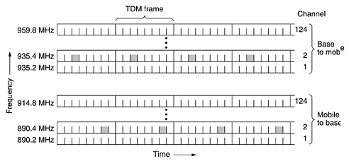

Figure 2-44. A portion of the GSM framing structure.

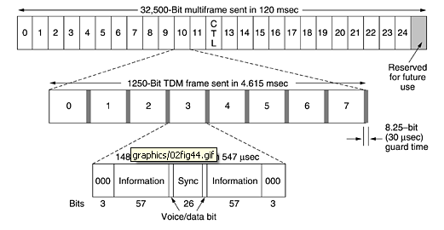

12.2.3 CDMA—Code Division Multiple Access
D-AMPS and GSM are fairly conventional systems. They use both FDM and TDM to divide the spectrum into channels and the channels into time slots. However, there is a third kid on the block, CDMA (Code Division Multiple Access), which works completely differently. When CDMA was first proposed, the industry gave it approximately the same reaction that Columbus first got from Queen Isabella when he proposed reaching India by sailing in the wrong direction. However, through the persistence of a single company, Qualcomm, CDMA has matured to the point where it is not only acceptable, it is now viewed as the best technical solution around and the basis for the third-generation mobile systems. It is also widely used in the U.S. in second-generation mobile systems, competing head-on with D-AMPS. For example, Sprint PCS uses CDMA, whereas AT&T Wireless uses D-AMPS. CDMA is described in International Standard IS-95 and is sometimes referred to by that name. The brand name cdmaOne is also used.
CDMA is completely different from AMPS, D-AMPS, and GSM. Instead of dividing the allowed frequency range into a few hundred narrow channels, CDMA allows each station to transmit over the entire frequency spectrum all the time. Multiple simultaneous transmissions are separated using coding theory. CDMA also relaxes the assumption that colliding frames are totally garbled. Instead, it assumes that multiple signals add linearly.

12.3 Third-Generation Mobile Phones: Digital Voice and Data
What is the future of mobile telephony? Let us take a quick look. A number of factors are driving the industry. First, data traffic already exceeds voice traffic on the fixed network and is growing exponentially, whereas voice traffic is essentially flat. Many industry experts expect data traffic to dominate voice on mobile devices as well soon. Second, the telephone, entertainment, and computer industries have all gone digital and are rapidly converging. Many people are drooling over a lightweight, portable device that acts as a telephone, CD player, DVD player, e-mail terminal, Web interface, gaming machine, word processor, and more, all with worldwide wireless connectivity to the Internet at high bandwidth. This device and how to connect it is what third generation mobile telephony is all about. For more information, see (Huber et al., 2000; and Sarikaya, 2000).
Back in 1992, ITU tried to get a bit more specific about this dream and issued a blueprint for getting there called IMT-2000, where IMT stood for International Mobile Telecommunications. The number 2000 stood for three things: (1) the year it was supposed to go into service, (2) the frequency it was supposed to operate at (in MHz), and (3) the bandwidth the service should have (in kHz).
It did not make it on any of the three counts. Nothing was implemented by 2000. ITU recommended that all governments reserve spectrum at 2 GHz so devices could roam seamlessly from country to country. China reserved the required bandwidth but nobody else did. Finally, it was recognized that 2 Mbps is not currently feasible for users who are too mobile (due to the difficulty of performing handoffs quickly enough). More realistic is 2 Mbps for stationary indoor users (which will compete head-on with ADSL), 384 kbps for people walking, and 144 kbps for connections in cars. Nevertheless, the whole area of 3G,asitis called, is one great cauldron of activity. The third generation may be a bit less than originally hoped for and a bit late, but it will surely happen.
The basic services that the IMT-2000 network is supposed to provide to its users are:
- High-quality voice transmission.
- Messaging (replacing e-mail, fax, SMS, chat, etc.).
- Multimedia (playing music, viewing videos, films, television, etc.).
- Internet access (Web surfing, including pages with audio and video).

Additional services might be video conferencing, telepresence, group game playing, and m-commerce (waving your telephone at the cashier to pay in a store). Furthermore, all these services are supposed to be available worldwide (with automatic connection via a satellite when no terrestrial network can be located), instantly (always on), and with quality-of-service guarantees.
Several proposals were made, and after some winnowing, it came down to two main ones. The first one, W-CDMA (Wideband CDMA), was proposed by Ericsson. This system uses direct sequence spread spectrum of the type we described above. It runs in a 5 MHz bandwidth and has been designed to interwork with GSM networks although it is not backward compatible with GSM. It does, however, have the property that a caller can leave a W-CDMA cell and enter a GSM cell without losing the call. This system was pushed hard by the European Union, which called it UMTS (Universal Mobile Telecommunications System).
While waiting for the fighting over 3G to stop, some operators are gingerly taking a cautious small step in the direction of 3G by going to what is sometimes called 2.5G, although 2.1G might be more accurate. One such system is EDGE (Enhanced Data rates for GSM Evolution), which is just GSM with more bits per baud. The trouble is, more bits per baud also means more errors per baud, so EDGE has nine different schemes for modulation and error correction, differing on how much of the bandwidth is devoted to fixing the errors introduced by the higher speed.
Another 2.5G scheme is GPRS (General Packet Radio Service), which is an overlay packet network on top of D-AMPS or GSM. It allows mobile stations to send and receive IP packets in a cell running a voice system. When GPRS is in operation, some time slots on some frequencies are reserved for packet traffic. The number and location of the time slots can be dynamically managed by the base station, depending on the ratio of voice to data traffic in the cell.
The available time slots are divided into several logical channels, used for different purposes. The base station determines which logical channels are mapped onto which time slots. One logical channel is for downloading packets from the base station to some mobile station, with each packet indicating who it is destined for. To send an IP packet, a mobile station requests one or more time slots by sending a request to the base station. If the request arrives without damage, the base station announces the frequency and time slots allocated to the mobile for sending the packet. Once the packet has arrived at the base station, it is transferred to the Internet by a wired connection. Since GPRS is just an overlay over the existing voice system, it is at best a stop-gap measure until 3G arrives.

