Chapter 10: Applications
  - Data Link Layer
10.1.1 Segmentation
10.1.2 Bridge
10.1.3 Switch
10.1.4 Bridging versus LAN Switching
10.1.5 The MAC Address Format
10.2 Network Layer
10.2.1 Internetworking
10.2.2 How Networks Differ
10.2.3 The IP Protocol
10.2.4 IP Addresses
10.2.5 Subnets
Private IP Addresses
  - Data Link Layer
10.1.1 Segmentation
Dividing up a LAN into smaller collision domains (segments) is called segmentation. General benefits of LAN segmentation:
• Increased bandwidth per user • Keeping local traffic local • Reduced broadcasts • Decreased collisions
10.1.2 Bridge
A bridge is used to break larger network segments into smaller network segments. It works much like a repeater, but because a bridge works solely with Layer 2 protocols and layer 2 MAC sublayer addresses, it operates at the Data Link layer. A bridge uses the MAC address to perform its tasks, including:
• Monitoring network traffic
• Identifying the destination and source addresses of a message
• Creating a routing table that identifies MAC addresses to the network segment on which they' relocated
• Sending messages to only the network segment on which its destination MAC address is located

Know the following about bridges:
• Bridges operate at Layer 2 and usually do not reduce broadcasts because bridge forwards broadcast packets to all of its ports except the port on which the broadcast packet arrived. On the other hand, a router usually blocks broadcast packets.
• Bridges expand the distance of an Ethernet network because each segment can be built /
• Bridges filter some traffic based upon MAC addresses.
• Bandwidth is used more efficiently.
• Local traffic is kept local.

10.1.3 Switch
In networking, a switch is a device responsible for multiple functions such as filtering, flooding, and sending frames. Broadly, a switch is any electronic/mechanical device allowing connections to be established as needed and terminated if no longer necessary.
Layer-2 switching is shardware based, which means it uses the MAC address from the host's NIC cards to filter the network. Layer-2 switches are fast because they do not look at the Network layer header information, looking instead at the frame's hardware addresses before deciding to either forward the frame or drop it.
Three Switch Functions at layer 2
1. Address learning - Layer-2 switches and bridges remember the source hardware address of each frame received on an interface and enter this information into a MAC database
2. Forward/filter decisions - When a frame is received on an interface, the switch looks at the destination hardware address and finds the exit interface in the MAC database
3. Loop avoidance - If multiple connections between switches are created for redundancy, network loops can occur. The Spanning-Tree Protocol (STP) is used to stop network loops and allow redundancy.
10.1.4 Bridging versus LAN Switching
Layer-2 switches are really just bridges with more ports. However, there are some important differences you should be aware of:
1. Bridges are software based, while switches are hardware based.
2. Bridges can only have one spanning-tree instance per bridge, while switches can have many.
3. Bridges can only have up to 16 ports, whereas a switch can have hundreds.
Five steps of Encapsulation
1. User information is converted into data.
2. Data is converted into segments for transport across the network.
3. Segments are converted into segments for transport across the network.
4. Packets and datagram’s are converted into frames and the Data Link header is added.
5. The data in the frames is converted into bits for transmission over the physical media.
Five steps of encapsulation that occurs when a user uses a browser to open a Web page:
1. The user requests that the browser open a Web page.
2. The transport layer adds a header indicating that an HTTP process is requested.
3. The Network layer puts a source and destination address into its packet header that helps indicate the path across the network.
4. The Data Link layer frame puts in the hardware addresses of both the source node and the next
directly connected network device.
5. The frame is converted into bits for transmission over the media.
10.1.5 The MAC Address Format
The MAC header of a frame contains the destination and source MAC addresses for the interfaces involved in the communication stream. Figure below shows the 48 bits that make up the MAC address.
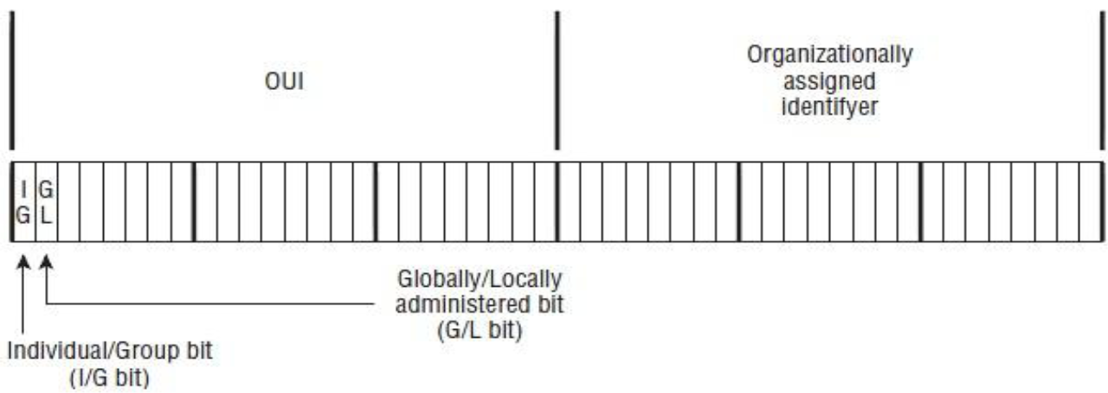
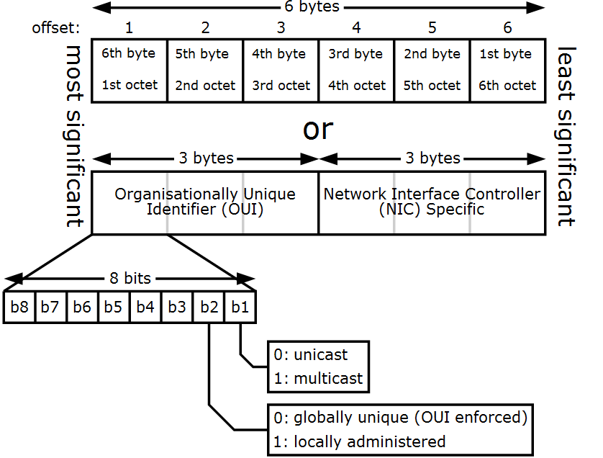

The first bit (the I/G bit) identifies whether the source/destination target is an individual (unicast) or a group (multicast). The second bit in the source and destination address field indicates whether the address is globally or locally unique. This bit is called the G/L bit and it identifies whether the organizational assigned identifier is globally unique (G/L bit set to 0) or locally unique (G/L bit set to 1). If it is a locally unique identifier, then the address is unique only to the LAN.

10.2 Network Layer
10.2.1 Internetworking
Many different networks exist, including LANs, MANs, and WANs. Numerous protocols are in widespread use in every layer. In the following sections we will take a careful look at the issues that arise when two or more networks are connected to form an internet.
As an example of how different networks might be connected, consider the example of Fig. 6. Here we see a corporate network with multiple locations tied together by a wide area ATM network. At one of the locations, an FDDI optical backbone is used to connect an Ethernet, an 802.11 wireless LAN, and the corporate data center's SNA mainframe network.
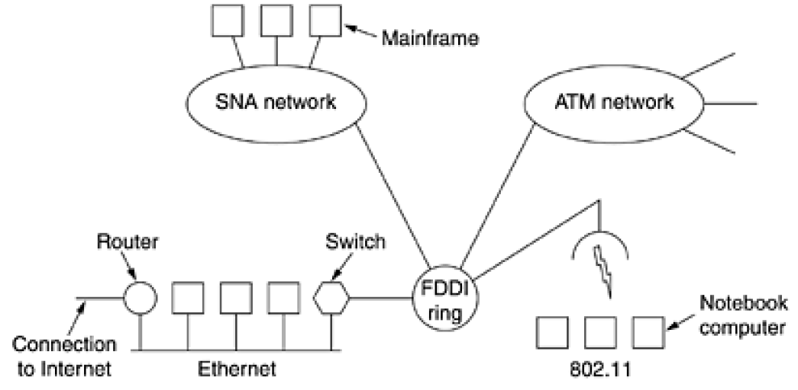

Figure 6. A collection of interconnected networks.

10.2.2 How Networks Differ
Networks can differ in many ways. Some of the differences, such as different modulation techniques or frame formats, are in the physical and data link layers. In Fig.7 we list some of the differences that can occur in the network layer
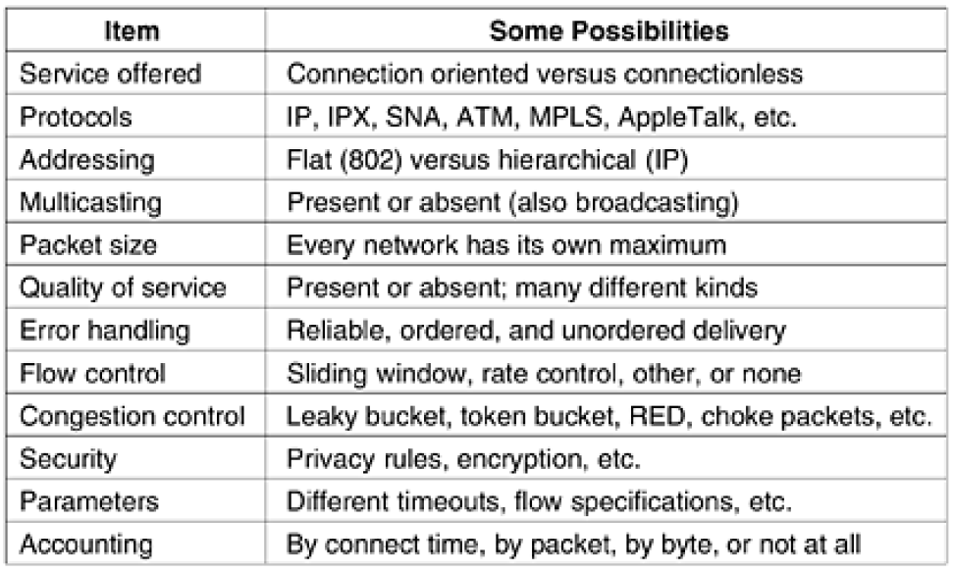
Figure 7. Some of the many ways networks can differ.
10.2.3 The IP Protocol
An appropriate place to start our study of the network layer in the Internet is the format of the IP datagrams themselves. An IP datagram consists of a header part and a text part. The header has a 20 byte fixed part and a variable length optional part. The header format is shown in Fig. 8. It is transmitted in big-endian order: from left to right, with the high-order bit of the Version field going first. On little endian machines, software conversion is required on both transmission and reception.
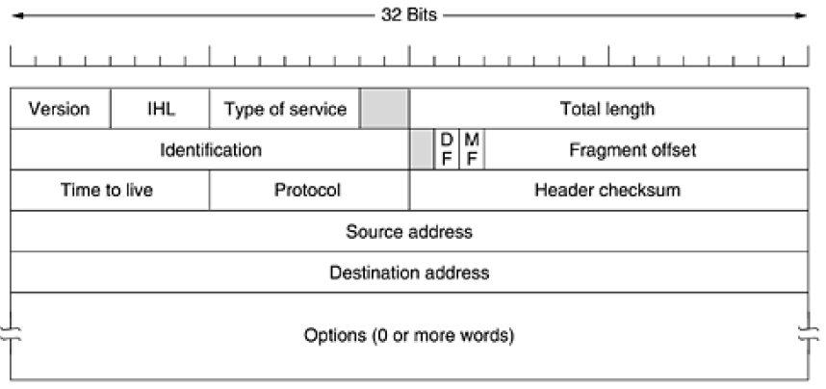
Figure 8. The IPv4 (Internet Protocol) header.
10.2.4 IP Addresses
Every host and router on the Internet has an IP address, which encodes its network number and host number. The combination is unique: in principle, no two machines on the Internet have the same IP address. All IP addresses are 32 bits long and are used in the Source address and Destination address fields of IP packets. It is important to note that an IP address does not actually refer to a host. It really refers to a network interface, so if a host is on two networks, it must have two IP addresses. However, in practice, most hosts are on one network and thus have one IP address.
For several decades, IP addresses were divided into the five categories listed in Fig. 9. This allocation has come to be called classful addressing. It is no longer used, but references to it in the literature are still common. We will discuss the replacement of classful addressing shortly.
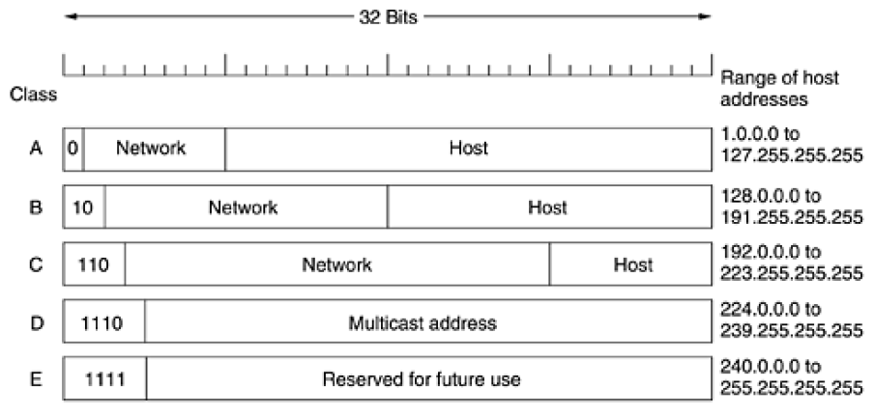
Figure 9. IP address formats.

The class A, B, C, and D formats allow for up to 128 networks with 16 million hosts each, 16,384 networks with up to 64K hosts, and 2 million networks (e.g., LANs) with up to 256 hosts each (although a few of these are special). Also supported is multicast, in which a datagram is directed to multiple hosts. Addresses beginning with 1111 are reserved for future use. Over 500,000 networks are now connected to the Internet, and the number grows every year. Network numbers are managed by a nonprofit corporation called ICANN (Internet Corporation for Assigned Names and Numbers) to avoid conflicts.
Network addresses, which are 32-bit numbers, are usually written in dotted decimal notation. In this format, each of the 4 bytes is written in decimal, from 0 to 255. For example, the 32-bit hexadecimal
address C0290614 is written as 192.41.6.20. The lowest IP address is 0.0.0.0 and the highest is 255.255.255.255.
The values 0 and -1 (all 1s) have special meanings, as shown in Fig. 10. The value 0 means this network or this host. The value of -1 is used as a broadcast address to mean all hosts on the indicated network.
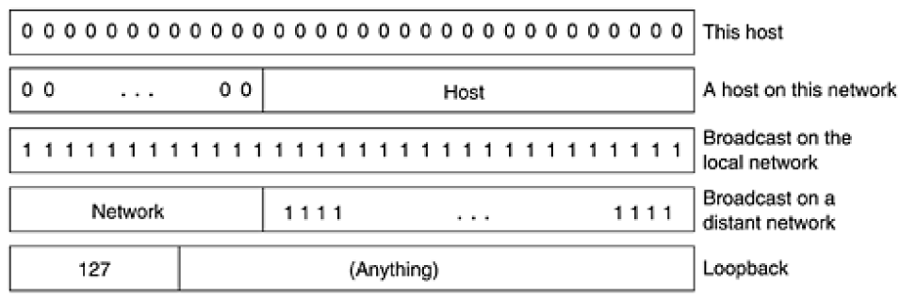
Figure 10. Special IP addresses.
The IP address 0.0.0.0 is used by hosts when they are being booted. IP addresses with 0 as network number refer to the current network. These addresses allow machines to refer to their own network without knowing its number (but they have to know its class to know how many 0s to include). The address consisting of all 1s allows broadcasting on the local network, typically a LAN. The addresses with a proper network number and all 1s in the host field allow machines to send broadcast packets to distant LANs anywhere in the Internet (although many network administrators disable this feature).
Finally, all addresses of the form 127.xx.yy.zz are reserved for loopback testing. Packets sent to that address are not put out onto the wire; they are processed locally and treated as incoming packets. This allows packets to be sent to the local network without the sender knowing its number.
10.2.5 Subnets
As we have seen, all the hosts in a network must have the same network number. This property of IP addressing can cause problems as networks grow. For example, consider a university that started out with one class B network used by the Computer Science Dept. for the computers on its Ethernet. A year later, the Electrical Engineering Dept. wanted to get on the Internet, so they bought a repeater to extend the CS Ethernet to their building. As time went on, many other departments acquired computers and the limit of four repeaters per Ethernet was quickly reached. A different organization was required.
Getting a second network address would be hard to do since network addresses are scarce and the university already had enough addresses for over 60,000 hosts. The problem is the rule that a single class A, B, or C address refers to one network, not to a collection of LANs. As more and more organizations ran into this situation, a small change was made to the addressing system to deal with it.
The solution is to allow a network to be split into several parts for internal use but still act like a single network to the outside world. A typical campus network nowadays might look like that of Fig.11, with a main router connected to an ISP or regional network and numerous Ethernets spread around campus in different departments. Each of the Ethernets has its own router connected to the main router (possibly via a backbone LAN, but the nature of the interrouter connection is not relevant here).
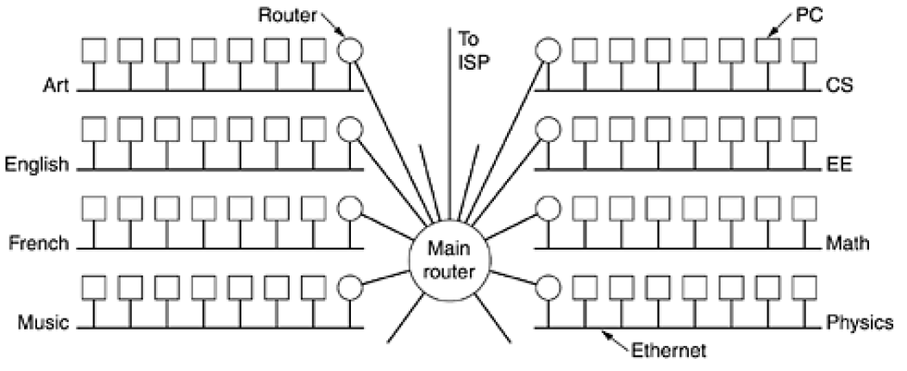
Figure 11. A campus network consisting of LANs for various departments.
Before we get into the more complicated aspects of IP addressing, you need to understand some of the basics. First I’m going to explain some of the fundamentals of IP addressing and its terminology.
Then you’ll learn about the hierarchical IP addressing scheme and private IP addresses.
Private IP Addresses
The people who created the IP addressing scheme also created what we call private IP addresses. These addresses can be used on a private network, but they’re not routable through the Internet.
This is designed for the purpose of creating a measure of well-needed security, but it also conveniently saves valuable IP address space.
If every host on every network had to have real routable IP addresses, we would have run out of IP ddresses to hand out years ago. But by using private IP addresses, ISPs, corporations, and home users only need a relatively tiny group of bona fide IP addresses to connect their networks to the Internet. This is economical because they can use private IP addresses on their inside networks and get along just fine.
To accomplish this task, the ISP and the corporation—the end user, no matter who they are—need to use something called Network Address Translation (NAT), which basically takes a private IP address and converts it for use on the Internet. Many people can use the same real IP address to transmit out onto the Internet. Doing things this way saves megatons of address space—good for us all!
TABLE 2 . 5 Reserved IP Address Space
Address Class Reserved Address Space
Class A 10.0.0.0 through 10.255.255.255
Class B 172.16.0.0 through 172.31.255.255
Class C 192.168.0.0 through 192.168.255.255

