Chapter Nine
Switching

Contents:
8.1- Circuit Switching (C.S) :
8.1-1 Advantage and disadvantage of circuit switching:
8.2- Packet Switching :
8.2.1- Datagram Switching :
8.2-2 Virtual circuit approach:
8.3- Message Switching :

Switching is the property of being able to vary the bath (routing) followed by the users. It is the possibility to rout the bits of one user to any one of a large number of other users. There are three basic methods that are used for switching bits in communication networks:
- Circuit Switching
- Packet Switching
* Virtual-Circuit Packet-Switching
* Datagram Packet-Switching

a switched network consist of a series of interlinked nodes ,called switches . switches are devices capable of creating temporary connections between two or more devices linked to the switch but not to each other .
In a switched network ,some of these nodes are connected to the communicating devices .others are used only for routing .
Three methods of switching have been important
:
- circuit switching
- packet switching
switching
message
packet
circuit
Virtual circuit switching
Datagram switching
Time-Division
Space-Division
Fig (1)
- message switching

8.1- Circuit Switching (C.S) :
it's creates a direct physical connection between two devices such as phone or computers fig (2) to connect three computers on the left A,B,C to four computers on the right D,E,F ,G. requiring 12 links ,we can use (4) switches to reduce the number and the total length of the links.
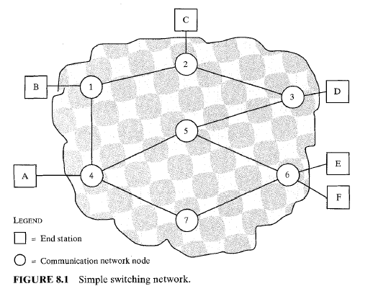

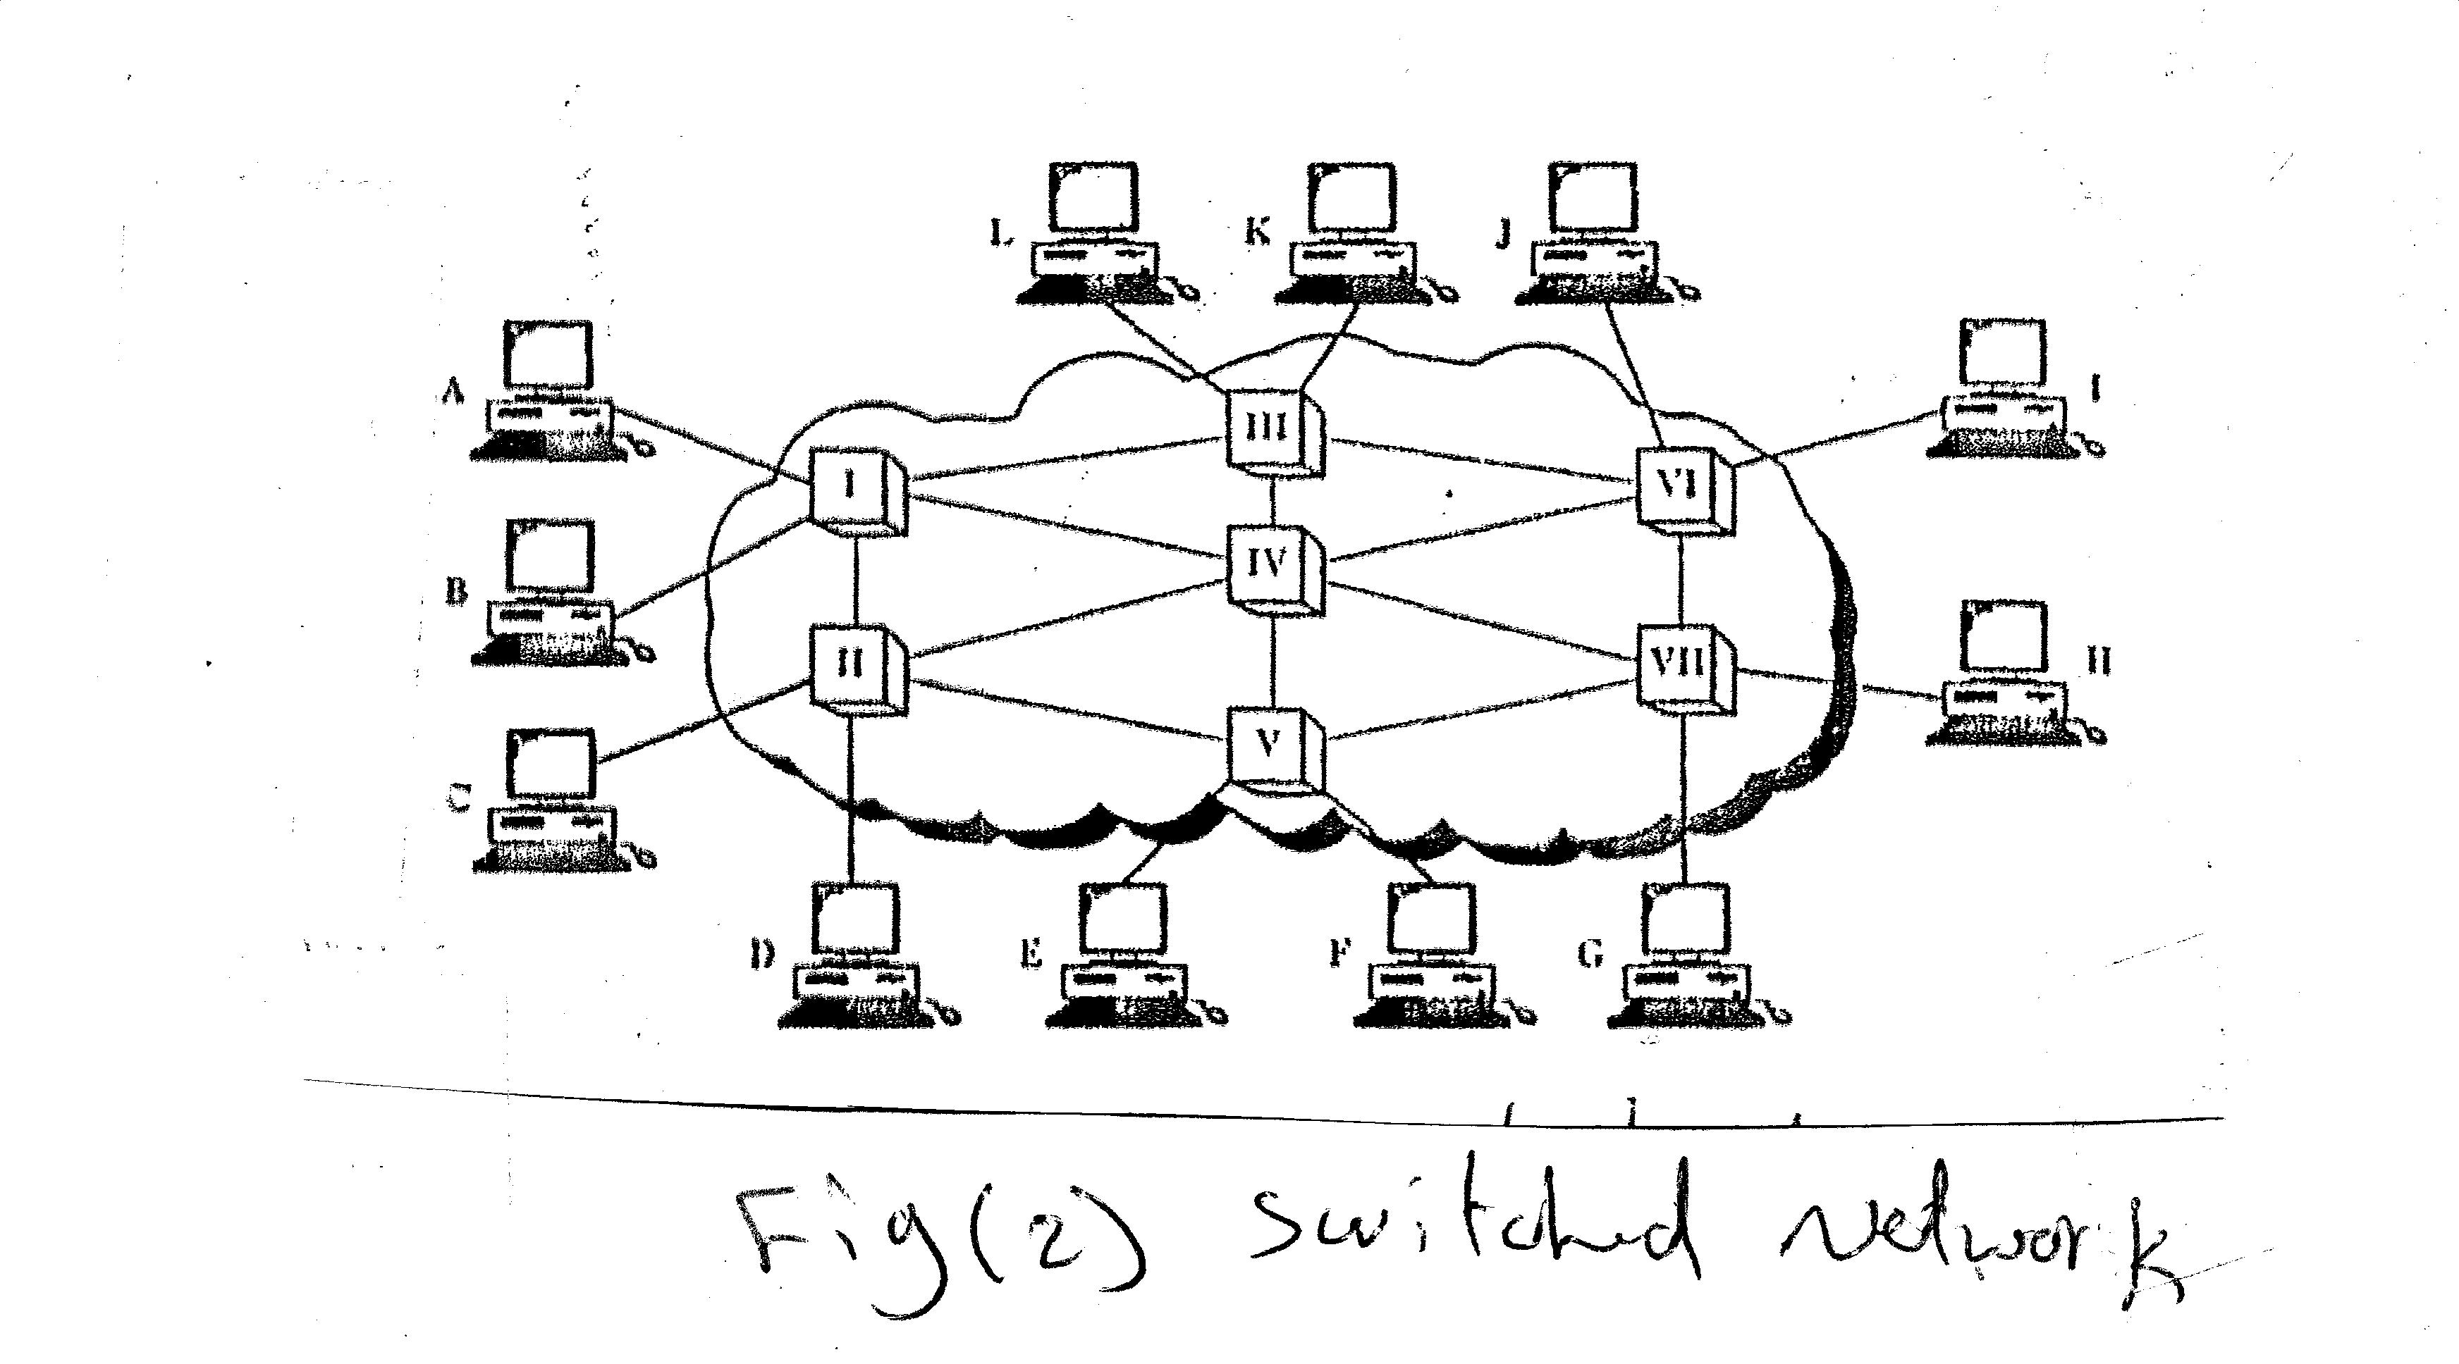
Communication via circuit switching involves three phases, which can be
explained with reference to Figure (2):

- Circuit Establishment :
- end-to-end( station to station) circuit must be established .
1-station A sends a request to node (I) requesting to station F connection from A to I as dedicated line.
2- node (I) must find the next leg in a route leading to node (V) . based on routing information and measures of availability and cost :node (I) select the link to node (IV) ,then send a message requesting connection to F.
3-node (IV) dedicates a channel to node (V) and internally ties that channel to the channel from node I,IV,V complete the connection to F .
4- In completely connection a test is made to accept the connection determine if F is busy or is prepared to accept the connection.

- Data Transfer:
Information transmitted from A to F through the network .Date analog or digital ,depending on the nature of the network and the connection is full duplex.
c-Circuit Disconnect
After some period of data transfer, the connection is terminated, usually by the action of one of the two stations.

A public telecommunications network can be described using four generic architectural components:
- * Subscribers: means The devices that attach to the network. It is still the case that most subscriber devices to public telecommunications networks are telephones, but the percentage of data traffic increases year by year.

- Local loop: The link between the subscriber and the network, also referred to as the subscriber loop. Almost all local loop connections used twisted-pair wire. The length of a local loop is typically in a range from a few kilometers to a few tens of kilometers.

- Exchanges: The switching centers in the network. A switching center that directly supports subscribers is known as an end office. Typically, an end office will support many thousands of subscribers in a localized area. There are over
- 19,000 end offices in the United States, so it is clearly impractical for each end office to have a direct link to each of the other end offices; this would require on the order of 2 X 10' links. Rather, intermediate switching nodes are used.

- * Trunks: The branches between exchanges. Trunks carry multiple voice-frequency circuits using either FDM or synchronous TDM. Earlier, these were referred to as carrier systems.

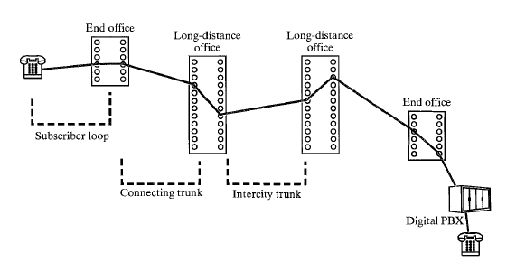

8.1-1 Advantage and disadvantage of circuit switching:
-Circuit switching was designed for voice communication .
- it's less well suited (inefficient) to data and other non conversational transmissions.
- creates the equivalent of a single cable between two devices and there by assumes a single data rate for both devices.
- limit the flexibility (is inflexible) and usefulness of a connection for networks interconnecting a variety of digital devices.
- non voice transmissions tend to be bursty ,meaning that data come in spurts with idle gaps between them .

- multiplexing improve line utilization but is only minimally effective unless transmission is predictable and every user is transmitting at essentially the same rate.
-it sees all transmissions as equal .(no a priority ).
- when traffic becomes have on (C.S) network some calls are blocked (refused).

8.2- Packet Switching :
A key characteristic of circuit-switching networks is that resources within the network are dedicated to a particular call. For voice connections, the resulting circuit will enjoy a high percentage of utilization because, most of the time, one party or the other is talking. However, as the circuit-switching network began to be used increasingly for data connections, two shortcomings became apparent: In a typical user/host data connection (e.g., personal computer user logged on to a database server), much of the time the line is idle. Thus, with data connections, a circuit-switching approach is inefficient.
In a circuit-switching network, the connection provides for transmission at constant data rate. Thus, each of the two devices that are connected must transmit and receive at the same data rate as the other; this limits the utility of the network in interconnecting a variety of host computers and terminals.
To understand how packet switching addresses these problems, let us briefly summarize packet-switching operation. Data are transmitted in short packets. A typical upper bound on packet length is 1000 octets (bytes). If a source has a longer
message to send, the message is broken up into a series of packets (Figure 1). Each packet contains a portion (or all for a short message) of the user's data plus some control information. The control information, at a minimum, includes the information that the network requires in order to be able to route the packet through the network and deliver it to the intended destination. At each node en route, the packet is received, stored briefly, and passed on to the next node.
Let us return to Figure 1, but now assume that it depicts a simple packets witching network. Consider a packet to be sent from station A to station E. The packet will include control information that indicates that the intended destination
is E. The packet is sent from A to node 4. Node 4 stores the packet, determines the next leg of the route (say 5), and queues the packet to go out on that link (the 4-5 link). When the link is available, the packet is transmitted to node 5, which will forward the packet to node 6, and finally to E. This approach has a number of advantages over circuit switching:
* Line efficiency is greater, as a single node-to-node link can be dynamically shared by many packets over time. The packets are queued up and transmitted as rapidly as possible over the link. By contrast, with circuit switching time on a node-to-node link is preallocated using synchronous time-division multiplexing. Much of the time, such a link may be idle because a portion of its time is dedicated to a connection which is idle.
A packet-switching network can perform data-rate conversion. Two stations of different data rates can exchange packets because each connects to its node at its proper data rate.
When traffic becomes heavy on a circuit-switching network, some calls are blocked; that is, the network refuses to accept additional connection requests until the load on the network decreases. On a packet-switching network packets are still accepted, but delivery delay increases.
* Priorities can be used. Thus, if a node has a number of packets queued for transmission, it can transmit the higher-priority packets first. These packets will therefore experience less delay than lower-priority packets.
*the information is decomposed into packets.

*Each packet is labeled with the address of the destination and with the sequence number.

*Each packet-switching nodes (PSN) uses the packet destination address to determine the next (PSN) to which it should it will send the packet.

*the sequence number is used by the destination to reassemble the information or the file.

*Packet-switching can use two methods: Datagram and virtual circuit .
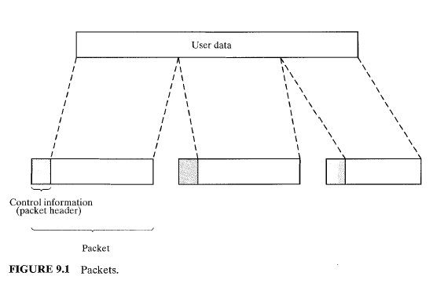

Each packet is treated independently .
The packets are send independently of one another .it's possible for different packets .from the same file to follow different paths .in the network and for these packets to arrive in an order that differs from that in which they were transmitted .
Ex: 4 packets from station A sends to station X .all packets belong to the same message but may go by different paths to reach a destination.

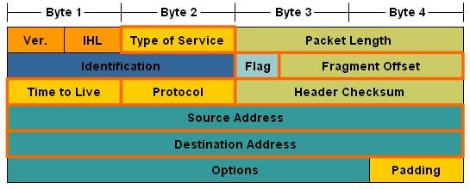

IP packet fields:
Protocol field : TCP or UDP used in Transport layer.
Time to Live: Reduced by 1 at each router. Packet dropped if it goes to 0
Type of service : Priority
Fragment offset : to split a packet, this gives order for putting pieces together.
IHL Header length
Packet length Length of whole packet

8.2.1- Datagram Switching :

Each packet is treated independently . The packets are send independently of one another .it's possible for different packets .from the same file to follow different paths .in the network and for these packets to arrive in an order that differs from that in which they were transmitted .
Ex: 4 packets from station A sends to station X .all packets belong to the same message but may go by different paths to reach a destination.
advantage of the datagram approach is that the call setup phase is avoided. Thus, if a station wishes to send only one or a few packets, datagram delivery will be quicker. Another advantage of the datagram service is that, because it is more primitive, it is more flexible. For example, if congestion develops in one part of the network, incoming datagrams can be routed away from the congestion. With the use of virtual circuits, packets follow a predefined route, and it is thus more difficult for the network to adapt to congestion. A third advantage is that datagram delivery is inherently more reliable. With the use of virtual circuits, if a node fails, all virtual circuits that pass through that node are lost. With datagram delivery, if a node fails, subsequent packets may find an alternate route that bypasses that node.
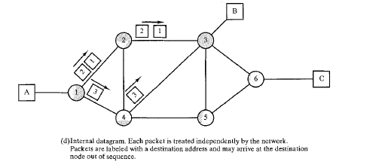

8.2-2 Virtual circuit approach:
A single route is chosen between sender and receiver at the beginning of the session .when the data is sent ,all packets of the transmission travel one after another along that route.
The transmission of packets without error is implemented by each node checking the correctness of packets it receives and by asking the previous node along the path to transmit incorrect packets. Nodes verify correctness by using an error-detection code.
main characteristic of the virtual-circuit technique is that a route between stations is set up prior to data transfer. Note that this does not mean that this is a dedicated path, as in circuit switching. A packet is still buffered at each node, and queued for output over a line. The difference from the datagram approach is that, with virtual circuits, the node need not make a routing decision for each packet; it is made only once for all packets using that virtual circuit. If two stations wish to exchange data over an extended period of time, there are certain advantages to virtual circuits. First, the network may provide services related to the virtual circuit, including sequencing and error control. Sequencing refers to the fact that, because all packets follow the same route, they arrive in the original order. Error control is a service that assures not only that packets arrive in proper sequence, but that all packets arrive correctly. For example, if a packet in a sequence from node 4 to node 6 fails to arrive at node 6, or arrives with an error, node 6 can request a retransmission of that packet from node 4. Another advantage is that packets should transit the network more rapidly with a virtual circuit; it is not necessary to make a routing decision for each packet at each node.

Comparison of Circuit Switching and Packet Switching

8.3Message Switching
An alternative switching strategy is message switching, illustrated in Fig. 2-39(b). When this form of switching is used, no physical path is established in advance between sender and receiver. Instead, when the sender has a block of data to be sent, it is stored in the first switching office (i.e., router) and then forwarded later, one hop at a time. Each block is received in its entirety, inspected for errors, and then retransmitted. A network using this technique is called a store-and-forward network, as mentioned in Chap. 1.
The first electromechanical telecommunication systems used message switching, namely, for telegrams. The message was punched on paper tape (off-line) at the sending office, and then read in and transmitted over a communication line to the next office along the way, where it was punched out on paper tape. An operator there tore the tape off and read it in on one of the many tape readers, one reader per outgoing trunk. Such a switching office was called a torn tape office. Paper tape is long gone and message switching is not used any more, so we will not discuss it further in this book.

Comparison of Circuit Switching and Packet Switching
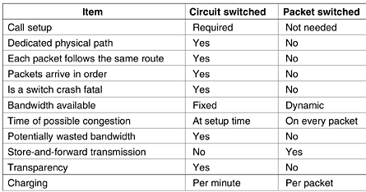

Packet Routing

1.9.4 Subnet Mask The size of a network is defined by the class of the network. A class "C" network has a maximum of 256 nodes on the network and a subnet mask of 255.255.255.0. A class "B" network has over 64,000 nodes and a subnet mask of 255.255.0.0. Comparison of a computer's network address and the destination address happens with the use of a subnet mask. A subnet mask in the network is for determining which part of the IP address is the network address and which part is the location and node address.
A Subnet mask is a 32-bit number that masks an IP address, and divides the IP address into network address and host address. Subnet Mask is made by setting network bits to all "1"s and setting host bits to all "0"s. Within a given network, two host addresses are reserved for special purpose. The "0" address is assigned a network address and "255" is assigned to a broadcast address, and they cannot be assigned to a host.
Applying a subnet mask to an IP address separates network address from host address. The network bits are represented by the 1's in the mask, and the host bits are represented by 0's. Performing a bitwise logical AND operation on the IP address with the subnet mask produces the network address. For example, applying the Class C subnet mask to our IP address 216.3.128.12 produces the following network address:
IP: 1101 1000 . 0000 0011 . 1000 0000 . 0000 1100 (216.003.128.012)
Mask: 1111 1111 . 1111 1111 . 1111 1111 . 0000 0000 (255.255.255.000)
---------------------------------------------
1101 1000 . 0000 0011 . 1000 0000 . 0000 0000 (216.003.128.000)

1.9.5 Backbone A network backbone connects LANs around wide areas. It utilizes some routers and/or switches for directing traffics on the network. The network backbone has its own unique IP address. Fiber optics is the most common medium for the backbone of a Wide Area Network (WAN).

The following are the IP addresses of all the components in this case study.
Node 71 = 149.225.55.71
LAN 1 = 149.225.55
Router A: LAN interface = 149.225.55.254, Backbone interface = 149.225.110.13
Node 98 = 149.225.58.98
LAN 2 = 149.225.58
Router B: LAN interface = 149.225.58.254, Backbone interface = 149.225.110.26
Network Backbone = 149.225.110
Backbone Router = 149.225.110.1
Subnet Mask = 255.255.255.0
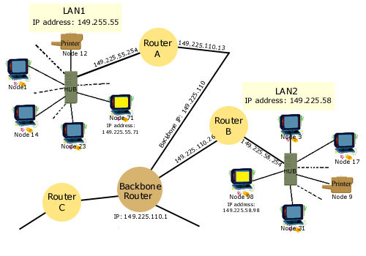
1.10 ARP and RARP:
The Address Resolution Protocol (ARP) is a protocol that maps an IP address to hardware (machine) address. In an Ethernet LAN, the hardware address is 48 bits long such as 00:00:e0:29:d8:9d. A table, called the ARP cache, on the router contains IP addresses and their corresponding hardware addresses. ARP protocol directs activities for address conversion on the LAN. When the packet arrives at the destination's gateway (LAN router), the gateway requests the matching hardware address of the IP address from the ARP program.
The Reverse Address Resolution Protocol (RARP) is for finding an IP address of a node from its hardware address. The network manager creates a table of addresses (IPs and machines) on the LAN gateway (router). When a new node is added to the network, the RARP client program requests that the RARP server find its IP address from the ARP table.

Q9 1) Define Switching in Networking and Communication. What are the main types of Switching. Define each.

Q9 2) Discuss the main characteristics and behavior of Circuit Switching..

Q9 3) Discuss the main characteristics and behavior of Packet Switching.

Q9 4) Compare between Circuit Switching and Packet Switching.

Q9 5) Compare between Datagram Switching and Virtual Circuit Switching

