8- chapter Seven
Local Area Networks (LAN)

Contents:
8.1 Introduction
8-2 ALOHA protocol
8-3 Ethernet and IEEE 802.3
8-4 Token Ring Networks
8-5 Token Bus Network

8.1 Introduction:
The LANs are a popular group of networks because they provide inexpensive and fast interconnections of minicomputers , personal computers, and workstations that proliferate among business users and educational and research institutions. Attaching a microcomputers to a LAN require some hardware and software.

The most widely used LANs are Aloha, Ethernet, Token ring, Token bus, and AppleTalk. The Fiber Distributed Data Interface (FDDI) and Distributed queue Dual Bus (DQDB) networks are examples of high-speed LANs.

In LANs , computer devices share a common transmission medium instead of being connected by point-to-point links. In LANs , there is no point-to-point link dedicated to the transfer of packets between two computers devices, i.e., between two network nodes. Instead, a common link is shared by many nodes. Regulating the access to the shared link is an important task in the transmission of packets on a LAN that is absent in other networks. As a result the organization of protocols for LANs is different from those in other networks.
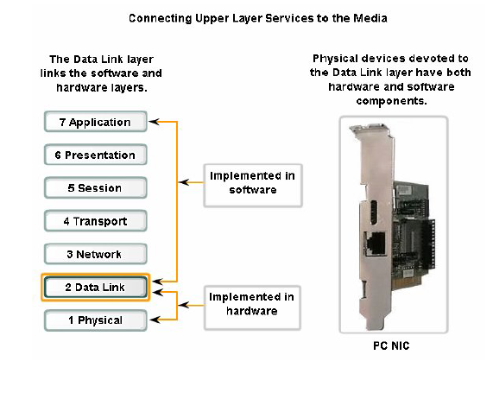

Data Link Sublayers
To support a wide variety of network functions, the Data Link layer is often divided into two Sublayers: an upper sublayer and an lower sublayer. The upper sublayer defines the software processes that provide services to the Network layer protocols.
The lower sublayer defines the media access processes performed by the hardware. Separating the Data Link layer into sublayer allows for one type of frame defined by the upper layer to access different types of media defined by the lower layer. Such is the case in many LAN technologies, including Ethernet.
The two common LAN sublayer are:
Logical Link Control
Logical Link Control (LLC) places information in the frame that identifies which Network layer protocol is being used for the frame. This information allows multiple Layer 3 protocols, such as IP and IPX, to utilize the same network interface and media.
Media Access Control
Media Access Control (MAC) provides Data Link layer addressing and delimiting of data according to the physical signaling requirements of the medium and the type of Data Link layer protocol in use.
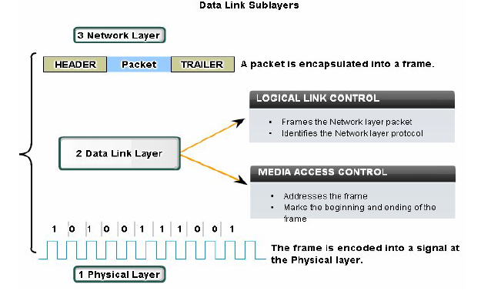
Regulating the placement of data frames onto the media is known as media access control. Among the different implementations of the Data Link layer protocols, there are different methods of controlling access to the media. These media access control techniques define if and how the nodes share the media.
Media access control is the equivalent of traffic rules that regulate the entrance of motor vehicles onto a roadway. The absence of any media access control would be the equivalent of vehicles ignoring all other traffic and entering the road without regard to the other vehicles.
However, not all roads and entrances are the same. Traffic can enter the road by merging, by waiting for its turn at a stop sign, or by obeying signal lights. A driver follows a different set of rules for each type of entrance.
In the same way, there are different ways to regulate the placing of frames onto the media. The protocols at the Data Link layer define the rules for access to different media. Some media access control methods use highly-controlled processes to ensure that frames are safely placed on the media. These methods are defined by sophisticated protocols, which require mechanisms that introduce overhead onto the network.
The method of media access control used depends on:
Media sharing - If and how the nodes share the media
Topology - How the connection between the nodes appears to the Data Link layer

The MAC protocol regulates the access to the channel by giving each node a chance to transmit its packets.
The LLC implements packet transmission services between the nodes.
The main performance measures of a LAN are the Throughput and the Delay.
The THROUGHPUT is the maximum bit transmission rate when the LAN is heavily loaded by many nodes. The throughput is a fraction of the rate of the transmitters. This fraction is called the EFFICIENCY of the MAC protocol.
The delay is usually measured as a typical time taken to transmit a packet between two nodes on the network. The delay has three components the queueing time, the transmission time, and propagation time
The Queueing time is the time that a packet waits before the start of its transmission. It comprises the time to transmit other packets and the time needed to access the transmission medium.
The transmission time is equal to the number of bits in the packet divided by the transmission rate in bits per second
The propagation time is the length of the signal path divided by the signal propagation speed. The propagation speed is about 2.3x10^8 m/s in a coaxial cable and 2x10^8 m/s in an optical fiber with a refractive index of 1.46, a typical value.

8-2 ALOHA protocol
ALOHA is a packet-switched radio communication network that was built at the University of Hawaii in the early 1970s. The main components of the network are; A central node listens to packets transmitted by other nodes at a radio frequency fo =407 MHz and transmits these packets at the radio frequency f1= 413 MHZ. The nodes in the ALOHA network transmitted the packets at the rate of 9600 bps.

The protocol used by ALOHA network, called the ALOHA protocol, is a media-access control protocol. It is a multiple-access protocol.

A multiple-access protocol is a method for sharing a transmission channel by enabling the transmitters to access the channel at random times. This method contrasts with the time-division multiplexing method, which allocates specific time periods to the different transmitters.
The ALOHA protocol can be used with radio transmitters, as in the original ALOHA network, or with a coaxial cable, a twisted wire pair, or optical fibers. The ALOHA protocol and some variant are used in satellite networks. ALOHA inspired Ethernet which is the most widely used LAN.
The ALOHA protocol is used by nodes that transmit on a common channel and that listen to the same channel. The nodes transmit packets of a fixed length. When two transmissions occur simultaneously , they garble each other. In such an instance, packets are described as colliding.
In the original ALOHA network, the central node acknowledges the correct packets it receives. When a node does not get an acknowledgment with in a specific timeout, it assumes that its packet collided. When a packet collides, the transmitting node schedules a retransmission after a random delay
There are two versions of ALOHA protocols: slotted and pure.
In slotted ALOHA protocol , the time axis is divided into timer slots with duration equal to the time required to transmit a packet on the channel. Nodes must start their transmissions at the beginning of a time slot. In the pure ALOHA protocol, the nodes can start transmitting at any time.
The Efficiency of PURE ALOHA protocol = 18%
The Efficiency of SLOTTED ALOHA protocol = 36%
The slotted ALOHA protocol is more difficult to implement than the pure ALOHA protocol because it requires that the nodes have access to common time reference (a common clock) to identify the beginning of the time slots.
The efficiency of the two ALOHA protocols is rather poor. A simple method for improving the efficiency of the ALOHA protocols is to use RESERVATIONS. Two protocols based on ALOHA that use reservations are SPADE and the R.ALOHA protocols. The efficiency of SPADE protocol is 397/398. The efficiency of the R.ALOHA protocol is about (85-90)%.

8-3 Ethernet and IEEE 802.3

Networks based on the IEEE 802.3 standards compose the most widely used LANs. These are bus networks that use a media-access control protocol called carrier sense multiple access with collision detection (CSMA-CD). The CSMA-CD protocol is very similar to the ALOHA protocol. The IEEE 802.3 standards specify the physical layer and the media access control of the LANs.
There are five versions of IEEE 802.3 : 10BASE5, 10BASE2, 1BASE5, 10BASE-T, and 10BOARD36 these networks are built from segments of coaxial cable, twisted wire pairs, or optical fibers that are attached together by repeaters. The first number indicates the transmission rate in mega bits per second. BASE indicates that the node transmit the information in baseband by using the Manchester encoding. BROAD identifies a broadband network that encodes the bits using DPSK(differential phase shift keying). The number at the end of the designation is the maximum length of the segment of the network as a multiple of 100 m. In 10 BASE-T, each computer is attached to a medium access unit (MAU) by two simplex twisted pairs. Each MAU is connected to a central repeater unit by two unidirectional point-to-point links.

The CSMA-CD protocol specifies that a station must wait for the channel to be idle before it can transmit (carrier sense) and that it must stop transmitting as soon as it detects a collision (collision detection).
In Ethernet, each node contains a special network interface board attached to the bus inside the node. The interface board is connected by a transceiver cable to a transceiver which attached to a network segment. The transceiver cable is a bundle of twisted wire pairs up to 50 m long.

The Ethernet MAC protocol (CSMA-CD) specifies that a node with a packet to transmit must proceed as follow:
- Wait until the channel is idle.
- When the channel is idle, transmit and listen while transmitting.
- In case of collision, stop the packet transmission, transmit a jam signal, and then wait for a random delay and GO TO (1).

Note the similarity between the CSMA-CD protocol and ALOHA protocol, nodes transmit after a random delay when the packets collides.
The two protocols differ in how they avoid collision. Nodes that use the ALOHA protocol start transmitting as soon as they get a packet to transmit. Moreover, they transmit the complete packet even if they collide. The CSMA-CD protocol is a polite version of the ALOHA protocol. It is more efficient it could reached (50-60)%.

8-4 Token Ring Networks
Token Ring Networks were developed by IBM in the early 1980s. the transmission medium is typically a twisted pair or a coaxial cable, although some versions use optical fibers.
The MAC protocol of the Token Ring is as follow: a specific bit pattern, called the token, circulates in the ring. When a node wants to transmit, it waits until the token comes by. It then replaces the token with another pattern (SFD) which indicates the star of frame, and it appends its packet. Once the packet has been transmitted, the node transmits the token , which then becomes available to another node.
There are two versions of this protocol:
- Release after transmission (RAT).
- Release after reception (RAR).

These versions differ by when the node release the token. A node that is not transmitting repeats the packets that is receives. In RAT the transmitting node release the token as soon as it has completely transmitted the packet. In RAR the transmitting node release the token only after the complete frame has come back. RAT is significantly more efficient than RAR when the transmission time around the ring is not much smaller than the packet transmission time. RAR has the advantage of simplifying acknowledgement by appending an acknowledgement at the end of the frame. The protocols RAT and RAR are substantially more efficient than the CSMA-CD protocol.
In some version of token ring protocol, the token is released by the receiving node. That is, once the node has received the packet, it transmits a token. This protocol is more efficient than RAR.

8-5 Token Bus Network
The Token Bus Network is a bus network that uses a token-passing MAC protocol. Suppose we have four nodes (A, B, C, and D) attached to the bus. Initially, node A holds the token and transmit a frame of data. The destination of that frame is any other node on the network. After having transmitted its data frame, node A transmits a token with destination address B. All the nodes on the network see the token and recognize that it is for node B. Node B transmits its data frame and then the token with destination address C. then to D and D to A and so on.

