Chapter Six
Network Software
Contains
6.1 Protocol Hierarchies
6-2 Design Issues for the Layers
6-3 Connection-Oriented and Connectionless Services
6.4 Service Primitives

6.5 The Relationship of Services to Protocols
The first computer networks were designed with the hardware as the main concern and the software as an afterthought. This strategy no longer works. Network software is now highly structured.
6.1 Protocol Hierarchies
To reduce their design complexity, most networks are organized as a stack of layers or levels, each one built upon the one below it. The number of layers, the name of each layer, the contents of each layer, and the function of each layer differ from network to network.
The purpose of each layer is to offer certain services to the higher layers, shielding those layers from the details of how the offered services are actually implemented. In a sense, each layer is a kind of virtual machine, offering certain services to the layer above it.
Layer n on one machine carries on a conversation with layer n on another machine. The rules and conventions used in this conversation are collectively known as the layer n protocol. Basically, a protocol is an agreement between the communicating parties on how communication is to proceed.
In reality, no data are directly transferred from layer n on one machine to layer n on another machine. Instead, each layer passes data and control information to the layer immediately below it, until the lowest layer is reached. Below layer 1 is the physical medium through which actual communication occurs. In Fig. 1-13, virtual communication is shown by dotted lines and physical communication by solid lines.
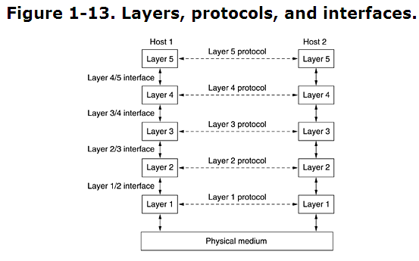
Between each pair of adjacent layers is an interface. The interface defines which primitive operations and services the lower layer makes available to the upper one.
1-Interfaces minimizing the amount of information that must be passed between layers,
2- Interfaces also make it simpler to replace the implementation of one layer with a completely different implementation (e.g., all the telephone lines are replaced by satellite channels).
A set of layers and protocols is called a network architecture.
A list of protocols used by a certain system, one protocol per layer, is called a protocol stack.

Service: is a set of primitive operations that low layer provide to high

layer.

Now consider a more technical example: how to provide communication to the top layer of the five-layer network in Fig. 1-15. A message, M, is produced by an application process running in layer 5 and given to layer 4 for transmission. Layer 4 puts a header in front of the message to identify the message and passes the result to layer 3. The header includes control information, such as sequence numbers, to allow layer 4 on the destination machine to deliver messages in the right order if the lower layers do not maintain sequence. In some layers, headers can also contain sizes, times, and other control fields.
In many networks, there is no limit to the size of messages transmitted in the layer 4 protocol, but there is nearly always a limit imposed by the layer 3 protocol. Consequently, layer 3 must break up the incoming messages into smaller units, packets, prepending a layer 3 header to each packet. In this example, M is split into two parts, M₁ and M₂.
Layer 3 decides which of the outgoing lines to use and passes the packets to layer 2. Layer 2 adds not only a header to each piece, but also a trailer, and gives the resulting unit to layer 1 for physical transmission. At the receiving machine the message moves upward, from layer to layer, with headers being stripped off as it progresses. None of the headers for layers below n are passed up to layer n.

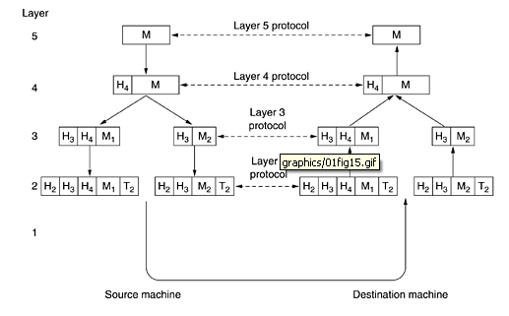

6-2 Design Issues for the Layers

The more important Design Issues for the Layers are:

1- Every layer needs a mechanism for identifying senders and receivers. As a consequence of having multiple destinations, some form of addressing is needed in order to specify a specific destination.

2- the rules for data transfer. In some systems, data only travel in one direction; in others, data can go both ways.( Simplex, Half-Duplex, and Full-Duplex)

3- How many logical channels the connection corresponds to and what their

priorities are. Many networks provide at least two logical channels per connection, one for normal data and one for urgent data.

4- Error control: Many error-detecting and error-correcting codes are known, but both ends of the connection must agree on which one is being used. In addition, the receiver must have some way of telling the sender which messages have been correctly received and which have not.
5- Sequencing: Not all communication channels preserve the order of messages sent on them. To deal with a possible loss of sequencing, the protocol must make explicit provision for the receiver to allow the pieces to be reassembled properly. An obvious solution is to number the pieces, but this solution still leaves open the question of what should be done with pieces that arrive out of order.
6- Flow Control: An issue that occurs at every level is how to keep a fast sender from swamping a slow receiver with data. Various solutions have been proposed and will be discussed later. Some of them involve some kind of feedback from the receiver to the sender, either directly or indirectly, about the receiver's current situation. Others limit the sender to an agreed-on transmission rate.
7- Massage Fragmentation: inability of all processes to accept arbitrarily long messages. This property leads to mechanisms for disassembling, transmitting, and then reassembling messages.
8- multiplexing and demultiplexing: When it is inconvenient or expensive to set up a separate connection for each pair of communicating processes, the underlying layer may decide to use the same connection for multiple, unrelated conversations.
9- Routing: When there are multiple paths between source and destination, a route must be chosen.
10- Coding
11- Encryption
6-3 Connection-Oriented and Connectionless Services
Layers can offer two different types of service to the layers above them: connection-oriented and connectionless. In this section we will look at these two types and examine the differences between them.
Connection-oriented service the service user first establishes a connection, uses the connection, and then releases the connection. The essential aspect of a connection is that it acts like a tube: the sender pushes objects (bits) in at one end, and the receiver takes them out at the other end. In most cases the order is preserved so that the bits arrive in the order they were sent.
In some cases when a connection is established, the sender, receiver, and subnet conduct a negotiation about parameters to be used, such as maximum message size, quality of service required, and other issues. Typically, one side makes a proposal and the other side can accept it, reject it, or make a counterproposal.
In contrast, connectionless service is modeled after the postal system. Each message (letter) carries the full destination address, and each one is routed through the system independent of all the others. Normally, when two messages are sent to the same destination, the first one sent will be the first one to arrive. However, it is possible that the first one sent can be delayed so that the second one arrives first.
Each service can be characterized by a quality of service. Some services are reliable in the sense that they never lose data. Usually, a reliable service is implemented by having the receiver acknowledge the receipt of each message so the sender is sure that it arrived. The acknowledgement process introduces overhead and delays, which are often worth it but are sometimes undesirable.
Unreliable (meaning not acknowledged) connectionless service is often called datagram service, in analogy with telegram service, which also does not return an acknowledgement to the sender.
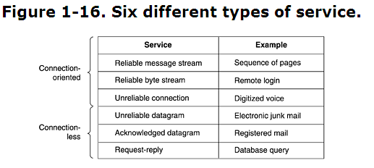
5.4 Service Primitives

A service is formally specified by a set of primitives (operations) available to a user process to access the service.

The set of primitives available depends on the nature of the service being provided. The primitives for connection-oriented service are different from those of connectionless service.

Figure 1-17. Five service primitives for implementing a simple connection-oriented service.

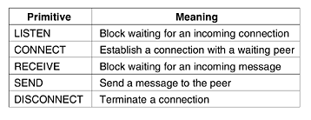

Figure 1-18. Packets sent in a simple client-server interaction on a connection-oriented network. 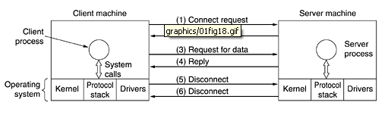

6.5 The Relationship of Services to Protocols

A service is a set of primitives (operations) that a layer provides to the layer above it. The service defines what operations the layer is prepared to perform on behalf of its users, but it says nothing at all about how these operations are implemented. A service relates to an interface between two layers, with the lower layer being the service provider and the upper layer being the service user.
A protocol, in contrast, is a set of rules governing the format and meaning of the packets, or messages that are exchanged by the peer entities within a layer. Entities use protocols to implement their service definitions. They are free to change their protocols at will, provided they do not change the service visible to their users. In this way, the service and the protocol are completely decoupled.
In other words, services relate to the interfaces between layers, as illustrated in Fig. 1-19. In contrast, protocols relate to the packets sent between peer entities on different machines. It is important not to confuse the two concepts.

Figure 1-19. The relationship between a service and a protocol.

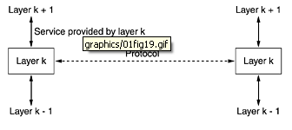

Three concepts are central to the OSI model:
- Services.
- Interfaces.
- Protocols.
Probably the biggest contribution of the OSI model is to make the distinction between these three concepts explicit. Each layer performs some services for the layer above it.
The service definition tells what the layer does, not how entities above it access it or how the layer works. It defines the layer's semantics.
A layer's interface tells the processes above it how to access it. It specifies what the parameters are and what results to expect. It, too, says nothing about how the layer works inside.
Finally, the peer protocols used in a layer are the layer's own business. It can use any protocols it wants to, as long as it gets the job done (i.e., provides the offered services). It can also change them at will without affecting software in higher layers.
5-6 Error Detection And Error Correction: error detection and correction or error control are techniques that enable reliable delivery of digital data over unreliable communication channels. Many communication channels are subject to channel noise, and thus errors may be introduced during transmission from the source to a receiver. Error detection techniques allow detecting such errors, while error correction enables reconstruction of the original data.
The general definitions of the terms are as follows:
- Error detection is the detection of errors caused by noise or other impairments during transmission from the transmitter to the receiver. Summer is another name for error detection^{[1]}
- Error correction is the detection of errors and reconstruction of the original, error-free data.
The general idea for achieving error detection and correction is to add some redundancy (i.e., some extra data) to a message, which receivers can use to check consistency of the delivered message, and to recover data determined to be corrupted. Error-detection and correction schemes can be either systematic or non-systematic: In a systematic scheme, the transmitter sends the original data, and attaches a fixed number of check bits (or parity data), which are derived from the data bits by some deterministic algorithm. If only error detection is required, a receiver can simply apply the same algorithm to the received data bits and compare its output with the received check bits; if the values do not match, an error has occurred at some point during the transmission. In a system that uses a non-systematic code, the original message is transformed into an encoded message that has at least as many bits as the original message.
Good error control performance requires the scheme to be selected based on the characteristics of the communication channel. Common channel models include memory-less models where errors occur randomly and with a certain probability, and dynamic models where errors occur primarily in bursts. Consequently, error-detecting and correcting codes can be generally distinguished between random-error-detecting/correcting and burst-error-detecting/correcting. Some codes can also be suitable for a mixture of random errors and burst errors.
5-7 Compression: In computer science and information theory, data compression, source coding, or bit-rate reduction involves encoding information using fewer bits than the original representation. Compression can be either lossy or lossless. Lossless compression reduces bits by identifying and eliminating statistical redundancy. No information is lost in lossless compression. Lossy compression reduces bits by identifying unnecessary information and removing it. The process of reducing the size of a data file is popularly referred to as data compression, although its formal name is source coding (coding done at the source of the data before it is stored or transmitted).
Compression is useful because it helps reduce resources usage, such as data storage space or transmission capacity. Because compressed data must be decompressed to use, this extra processing imposes computational or other costs through decompression; this situation is far from being a free lunch. Data compression is subject to a space-time complexity trade-off. For instance, a compression scheme for video may require expensive hardware for the video to be decompressed fast enough to be viewed as it is being decompressed, and the option to decompress the video in full before watching it may be inconvenient or require additional storage. The design of data compression schemes involves trade-offs among various factors, including the degree of compression, the amount of distortion introduced (e.g., when using lossy data compression), and the computational resources required to compress and uncompress the data.
New alternatives to traditional systems (which sample at full resolution, then compress) provide efficient resource usage based on principles of compressed sensing. Compressed sensing techniques circumvent the need for data compression by sampling off on a cleverly selected basis.

QUESTIONS:
Q6 1) Define : protocols, Layers, and Interfaces in Computer Network. Draw a block diagram show the relationships between them.
Q6 2) What are the main design issues ( functions and jobs) of the layers. Discuss three of them briefly.
Q6 3) Define Connection-Oriented and Connectionless services. Compare between them.
Q6 4) Define protocols, layers, and services. Draw a siagram show the relations between them.

