Chapter Four
Multiplexing

Contents: Reference: Data Communication And Networking
4-1- FDM By: Behrouz A. Forouzan , Mc Graw Hill, 2007
4.2- TDM
4.3- SDTM
4.4- WDM

To make efficient use of high speed telecommunications lines ,some form of multiplexing is used.
MUX :allows sseveral transmission sources to share a larger transmission capacity.

Is a set of techniques that allows the simultaneous transmission of multiple signals across a single data link. Whenever the transmission capacity of a medium linking two devices is greater than the transmission needs of the devices,the link can be shared in order to maximize the utilization of the link ,much as one cable can carry a hundred of TV.
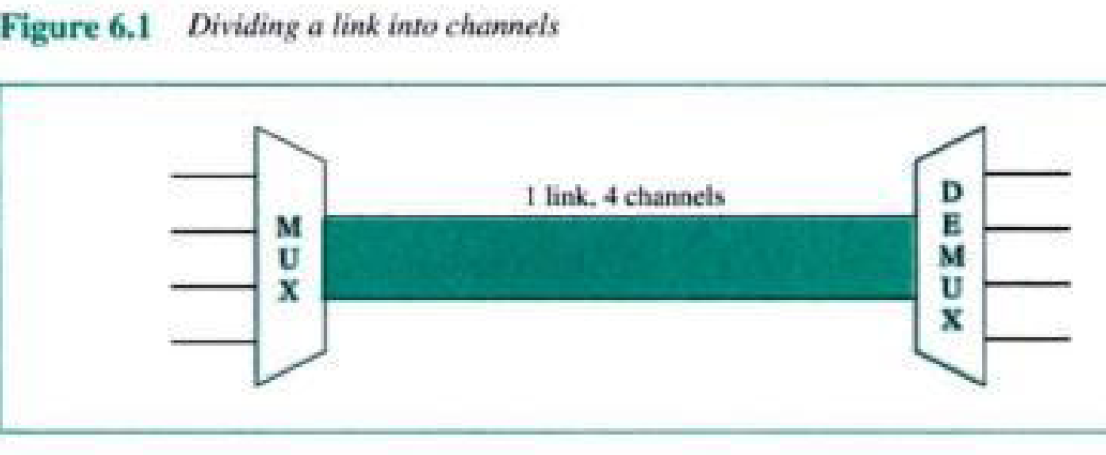

Types of multiplexing :

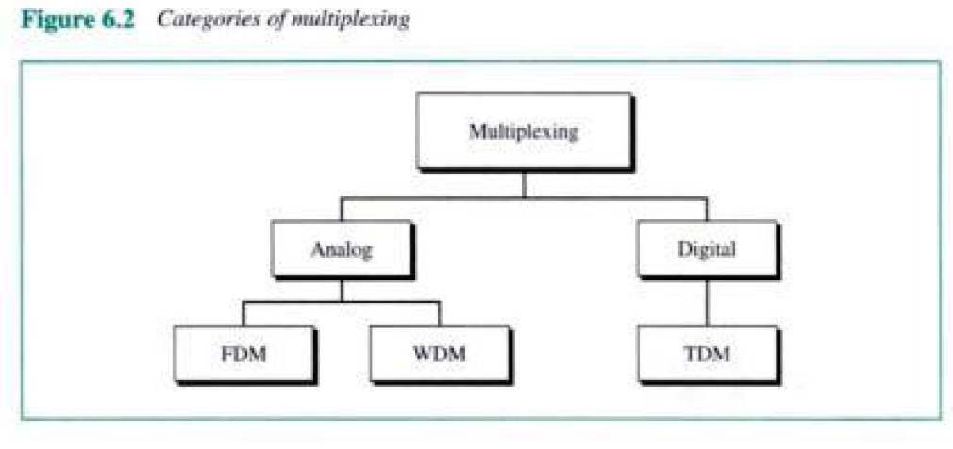

- Frequency Division Multiplexing
- Time Division Multiplexing
- Wavelength Division Multiplexing
A common application of MUX is in long-houl communications.trunks on long-haul networks are high capacity fiber ,coaxial or microwave links. These links can carry large numbers of voices and data transmissions simulatanously using multiplexing.

Multiplexer: combines (multiplexes ) data from n input lines and transmits over a higher capacity data link .
Demultiplexer : accepts the multiplexed data strem ,separates (demux) the data according to channel ,and delivers them to the appropriate output lines.
*the higher data rate ,the more cost-effective the transmission facility.

  - FDM
Is an analog technique that can be applied when the B.W of a link is greater than the combined B.W of the signals to be transmitted.

Signals generated by each sending device modulate different frequencies (f1 and f2..etc).these modulated signals are then combined into a single composite signal that can be transported by the link .the carrier frequencies have to be different enough to accommodate the modulation and demodulation signals .
Each modulated signals requires a certain B.W centerd on its carrier frequency ,referred to as channel.. Channels must be sprated by unused B.W (guared bands) ratiou of spectrum.
To prevent signals from overlapping.

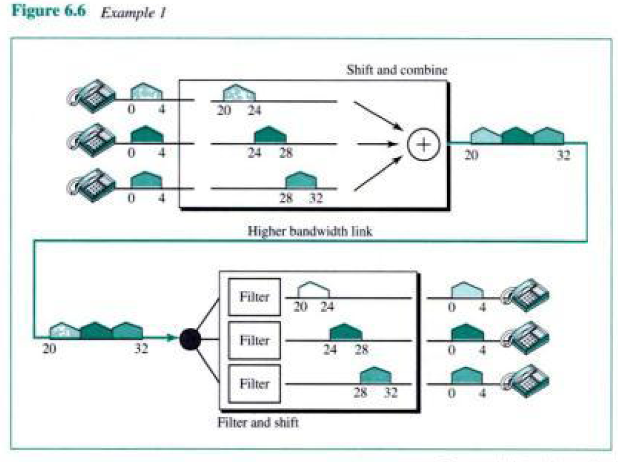
Demultiplexing :

The demultiplexer uses filters to decompose the multiplexed signal into its constituent component signals then each signal is passed to an amplitude demodulation process to separate the carrier signal from the message signal .then ,the message signal is sent to the waiting receiver.

Ex: cable TV
The coaxial cable(CC) used in a cable TV system has a B.W of approximately 500 MHz .an individual channel requires about 6 MHz of B.W for transmission.
The CC therefore can cary many multiplexed channels .a demltiplexer at your TV. Allows you to select which of those channels you wish to receive .
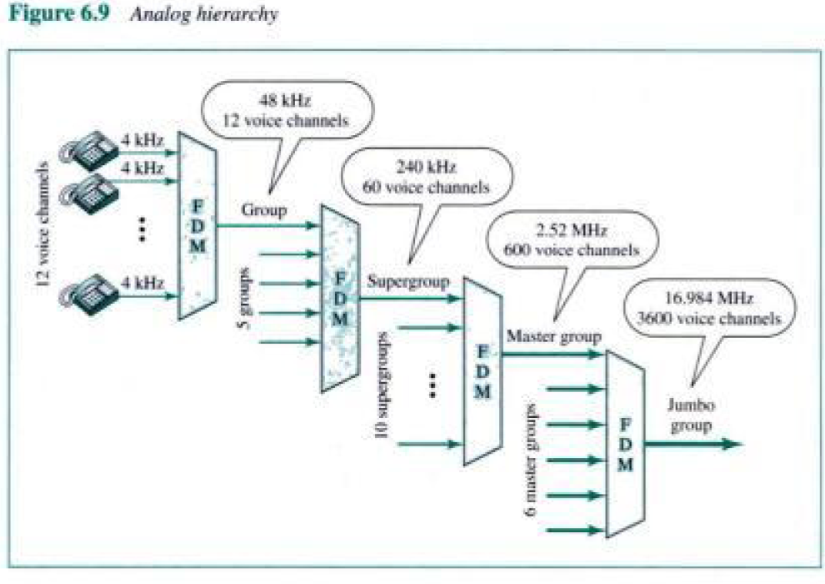

  - TDM

TDM is a digital process that can be applied when the data rate capacity of the transmission meduim is greater than the data rate required by the sending and receiving devices .in such case ,multiple transmissions can occupy a single link by subdividing them and interleaving the portions.

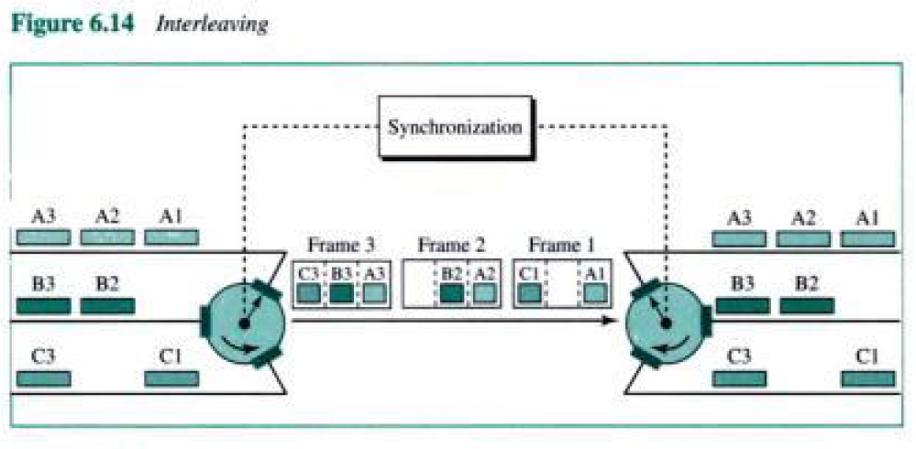

Multiple transmission occupy a single link by subdividing them and interleaving the portions .the TDM is a round robin use of a frequency .TDM can be implemented in two ways : synchronous and asynchronous TDM.
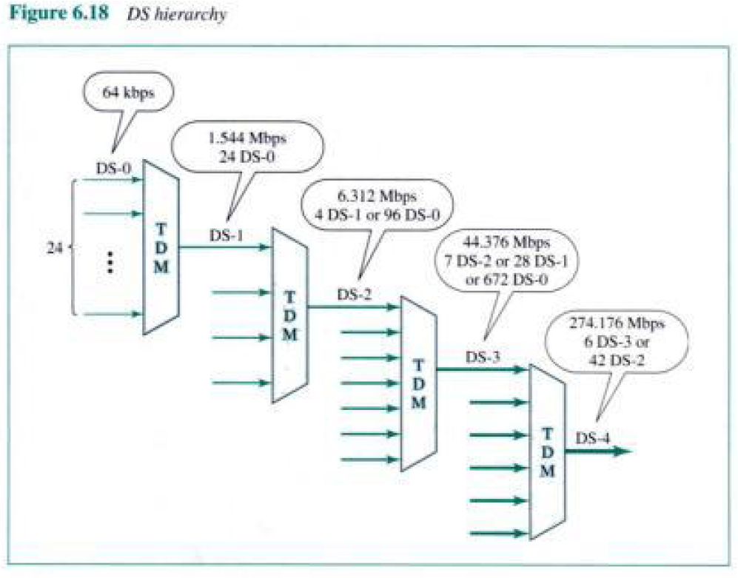

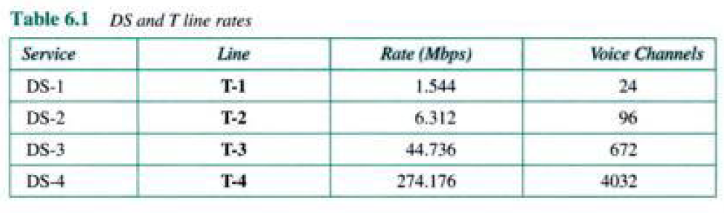

  - (STDM) Statistical TIME Division Multiplexing :
Statistical Time Division Multiplexing uses intelligent devices that are capable of identifying when a terminal is idle. They allocate time only to lines when required. This means that more lines can be connected to a transmission medium because this device statistically compensates for normal idle time (in data communication lines). Newer STDM units provide additional capabilities: data compression, line priority, mixed speed lines, host port sharing, network port control, automatic speed detection and much more.

  - WDM
A new more efficient developed to implement FDM over fiber optic cable .it uses the same concepts as FDM but incorporates the range of frequencies in the visible light spectrum.
Here two fibers come together at a Prism (or diffraction grating), each with its energy in a different band .the two beams are passed through the prism or grating.
And combined onto a single shared fiber for transmission to a distant destination, where they are split again.
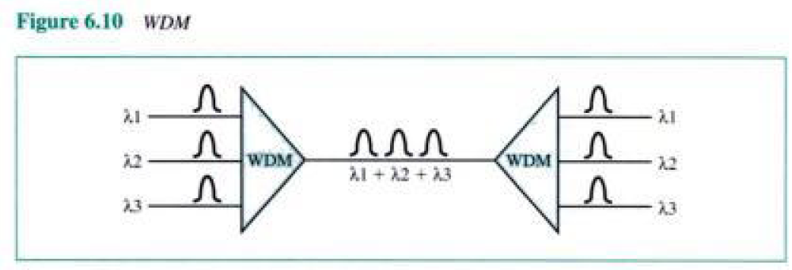Ex in fig above we have a fixed wavelength system .bits from fiber 1 goto fiber 3 ,and bits from fiber 2 go to fiber 4.it is not possible to have bits go from fiber 1 to fiber 4.
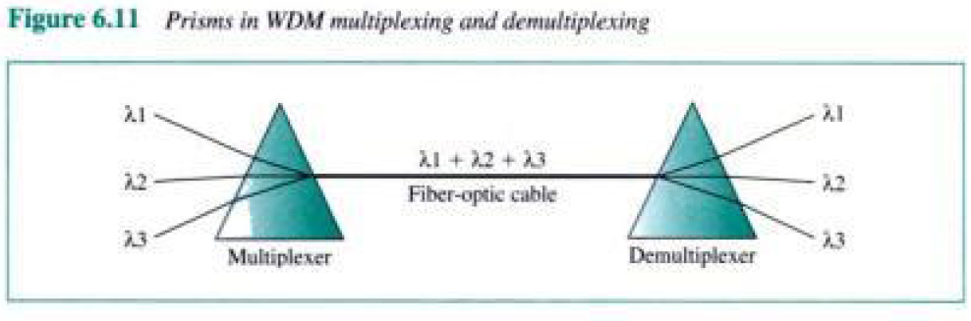
Each channel has its own frequency range and all the range disjoint they can be multiplexed together on the long-haul fiber.
The reason WDM popular is that the energy on a single fiber is only a few gigahertz wide because it is currently impossible to convert between electrical and optical media any faster .since the B.W of a single fiber band is about 25,000 Ghz .a necessary condition ,is that the incoming channels use different frequencies.

Q4 1) Define the Multiplexing.. What are the main types of Multiplexing used in Networking and communication. Define each.

Q4 2) Discuss the main characteristics and behavior of Frequency Division Multiplexing (FDM).

Q4 3) Discuss the main characteristics and behavior of Time Division Multiplexing (TDM).

Q4 4) Discuss the main characteristics and behavior of Statistical Time Division Multiplexing (STDM).

Q4 5) Discuss the main characteristics and behavior of Wavelength Division Multiplexing (WDM).

