Chapter one : COMMUNICATION

Contains 2011-2012
1.1 A Communication Model Data and Computer Communications
1-2 DATA COMMUNICATION By: William STALING 5th Edition
1-3 Data Communication Networking Prentice Hall 1997

1.1 A Communication Model

The fundamental purpose of a communications system is the exchange of data between two parties.

Figure l.lb presents one particular example, which is the communication between a workstation and a server over a public telephone network
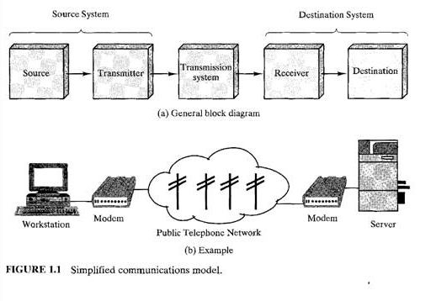
The key elements of the model are:

Source. This device generates the data to be transmitted; examples are telephones
and personal computers.

Transmitter. a transmitter transforms and encodes the information in such a way as to produce electromagnetic signals that can be transmitted across some sort of transmission system. For example, a modem takes a digital bit stream from an attached device such as a personal computer and transforms that bit stream into an analog signal that can be handled by the telephone network.

Transmission System. This can be a single transmission line or a complex network connecting source and destination.

* Receiver. The receiver accepts the signal from the transmission system and converts it into a form that can be handled by the destination device. For example, a modem will accept an analog signal coming from a network or transmission line and convert it into a digital bit stream.

Destination. Takes the incoming data from the receiver.

key tasks performed in a data communications system.

TABLE 1.1 Communications tasks.
Transmission system utilization Addressing
Interfacing Routing
Signal generation Recovery
Synchronization Message formatting
Exchange management Security
Error detection and correction Network management
Flow control

transmission system utilization, refers to the need to make efficient use of transmission facilities that are typically shared among a number of communicating devices. Various techniques (referred to as multiplexing) are used to allocate the total capacity of a transmission medium among a number of users. Congestion control techniques may be required to assure that the system is not
overwhelmed by excessive demand for transmission services.

interface : In order to communicate, a device must interface with the transmission system. All the forms of communication discussed in this book depend, at bottom, on the use of electromagnetic signals propagated over a transmission medium.

signal generation is required for communication. The properties of the signal, such as form and intensity, must be such that they are (1) capable of being propagated through the transmission system, and (2) interpretable as data at the receiver.

synchronization : must be some form of synchronization between transmitter and receiver. The receiver must be able to determine when a signal begins to arrive and when it ends. It must also know the duration of each signal element.

exchange management: If data are to be exchanged in both directions over a period of time, the two parties must cooperate. For example, for two parties to engage in a telephone conversation, one party must dial the number of the other, causing signals to be generated that result in the ringing of the called phone.

Error detection and correction are required in circumstances where errors cannot be tolerated; this is usually the case with data processing systems.

Flow control is required to assure that the source does not overwhelm the destination by sending data faster than they can be processed and absorbed.

addressing and routing.
When a transmission facility is shared by more than two devices, a source system must somehow indicate the identity of the intended destination. The transmission system must assure that the destination system, and only that system, receives the data.

Recovery is a concept distinct from that of error correction. Recovery techniques are needed in situations in which an information exchange, such as a data base transaction or file transfer, is interrupted due to a fault somewhere in the system.

Message formatting has to do with an agreement between two parties as to the form of the data to be exchanged or transmitted. For example, both sides must use the same binary code for characters.

Network management capabilities are needed to configure the system, monitor its status, react to failures and overloads, and plan intelligently for future growth.

1-3 Transmission Modes
A transmission may be simplex, half-duplex, or full-duplex.
In simplex transmission, signals are transmitted in only one direction; one station is the transmitter and the other is the receiver.
In half-duplex operation, both stations may transmit, but only one at a time.

In full-duplex operation, both stations may transmit simultaneously. In the latter case, the medium is carrying signals in both directions at the same time. How this can be is explained in due course.

1-3 Data Communication Networking

In its simplest form, data communication takes place between two devices that are directly connected by some form of point-to-point transmission medium. Often, however, it is impractical for two devices to be directly, point-to-point connected.

This is so for one (or both) of the following contingencies:
The devices are very far apart. It would be inordinately expensive, for example, to string a dedicated link between two devices thousands of miles apart. There is a set of devices, each of which may require a link to many of the others at various times. Examples are all of the telephones in the world and all of the terminals and computers owned by a single organization. Except for the case of a very few devices, it is impractical to provide a dedicated wire between each pair of devices.

The solution to this problem is to attach each device to a communications network. Figure 1.3 relates this area to the communications model of Figure l.la and also suggests the two major categories into which communications networks are traditionally classified: wide-area networks (WANs) and local-area networks (LANs).
The distinction between the two, both in terms of technology and application, has become somewhat blurred in recent years, but it remains a useful way of organizing the discussion

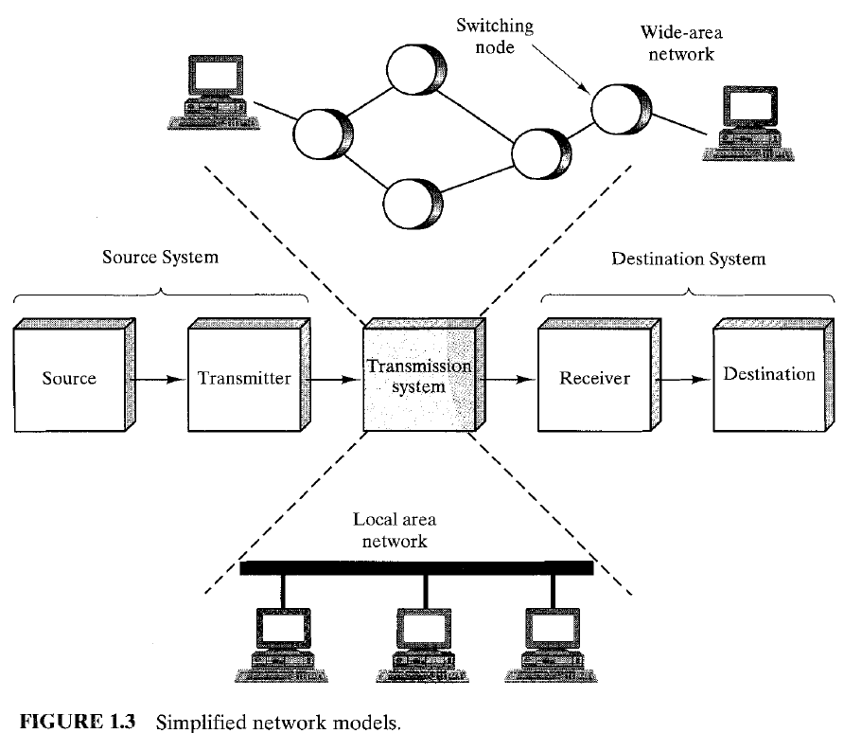

Questions
Q1 1 ) Draw a general block diagram shows the key elements in a simplified communication model. Explain the function of one block briefly.
Q1 2) Draw a block diagram presents one particular example, of the communication between a workstation and a server over a public telephone network. Explain the function of each briefly.

Q1 3) List some of the key tasks that must be performed in a data communications system.
Discuss three of them briefly
Q1 4)Discuss briefly the following tasks in the communication systems,
1- Synchronization 2- Message formatting
3- Error detection and correction 4- Network management
5- Addressing 6- Signal generation

َQ1 5) Draw a general block diagram shows the key elements in a simplified Data
communication model. Explain the function of one block briefly.
Q1 6) What is the meaning of " Data Communication Networking". Explain briefly.

