English Grammar Exercise
Name:__________________________ Class:__________ Date:___________________________
Simple present tense(1)
We use the simple present tense to talk about:
(1) things that are true now, e.g. My name is Susie. I am twelve years old.
(2) how often we do things, e.g. Susie and Betty go shopping every Saturday morning. They usually buy a lot of things.
(3) Things that are always true, e.g. Birds have two wings. They fly very high.

We form positive and negative statements in the simple present tense with the verb ‘to be’ (is/am/are)like this.
Subject | verb ‘to be’
Subject | Positive (+) | Negative (-)
I | am (‘m) | am not (‘m not)
 | e.g. I am twelve years old. | e.g. I am not twelve years old.
We  You (singular)  You(plural)  They | are (‘re) | are not (aren’t)
 | e.g. We are very good students.  You are a handsome boy.  You are my friends. | e.g We are not very good students.  You are not a handsome boy.  You are not my friends.
He  She  It | is (‘s) | is not (isn’t)
 | e.g. He is the class monitor.  She is my sister.  It is a lovely dog. | e.g. He is not the class monitor  She is not my sister.  It is not a lovely dog.

Exercise 1
Fill in these sentences using the correct form of the verb ‘to be’ and the words in the brackets. Then write the words in the blanks.
1. I_____________ happy.(not)  3. You _____________ Japanese.(not)  5. They ____________ busy.(not)  7. Cheung Chau __________ in Kowloon.(not)  9. We _______ good friends.  11. You ______ the monitor.  13. He ______ 2 years old.(not) | 2. He _________ sad.  4. We __________ Chinese.  6. Tigers _________big cats.  8. His name ______ Billy..  10. She ______ my mother.  12. I ______ thirteen years old.  14. They ______ good football players.(not)
English Grammar Exercise
Name:__________________________ Group:__________ Date:___________________________
Simple present tense(2)

With other verbs, we usually form positive and negative statements in the simple present tense like this

 | Subject  I/We/You/You/They | Subject  He/She/It
Positive (+) | I eat ice-cream.  You eat ice-cream.  We eat ice-cream.  They eat ice-cream. | He eats ice-cream.  She eats ice-cream.  It eats ice-cream.
Negative(-) | I don’t eat ice-cream.  You don’t eat ice-cream.  We don’t eat ice-cream.  They don’t eat ice-cream. | He does not eat ice-cream.  She does not eat ice-cream.  It does not eat ice-cream.

Exercise 2
Say these sentences using the correct form of the verbs in brackets. Then write the words in the blanks.
(1) Susie ______________ shopping in Causeway Bay.(love)
(2) Causeway Bay ____________ very busy.(be)
(3) Betty _______________________ early.(not get up)
(4) I ______________________ fruit.(not like)
(5) School always _____________ at eight o’clock in the morning.(start)
(6) We usually _________________ at school at half past seven.(arrive)
(7) The dog ________________ me. (like)
(8) Henry ___________ a nice school bag.(have)
(9) She ________________ television every night. (not watch)
(10) I ____________________ that dress.(not like)

English Grammar Exercise
Name:__________________________ Group:__________ Date:___________________________
Simple present tense(3)
With most verbs, we add –s to the verb when it is used with the third person singular. With other verbs, we change the verb in different ways:
Verbs | you should…
With most verbs  e.g. run  sleep | + s  →runs  →sleeps
Ending in a consonant + y  e.g. Fly  carry | - y + ies  →flies  →carries
Go/ Do | +es
Ending in ss, x, sh, ch  e.g. Kiss  Fax  Wash  switch | + es  →kisses  →faxes  →washes  →switches

Exercise 3
Say these sentences using the correct form of the verbs in brackets. Then write the words in the blanks.
1. Sam __________(wash)his face every day.
2. Susie ___________(kiss)Mum every night.
3. Dad often _____________(carry)Susie’s books.
4. Nick ___________(cook) dinner for his family every evening.
5. He ____________ (brush)his hair every morning.
6. May often ____________ (read)books.
7. Kitty ____________ (wash) the dishes every night.
8. My bird __________(fly) beautifully.
9. The dog __________(like) eating bones.
10.My baby sister ___________(cry) every night.
11.Jenny always ___________(do) her homework on time.
12.Vincent _____________(love) Flora.
13.Ron_________(take) his dog for a walk every afternoon.
14.Mable usually___________(buy) vegetables at the market.
15.The lion __________(run) very fast.

English Grammar Exercise
Name:__________________________ Group:__________ Date:___________________________
Simple present tense(4)
We form positive and negative statements in the simple present tense with the verb ‘to have’ like this:
Positive (+) |  |  |  |  | Negative(-)
I  You  You  We  They |  | have |  | a good book. | I  You  You  We  They |  | do not (don’t) have |  | a good book.
He  She  It | has |  | a good book. |  | He  She  It | does not(doesn’t) have |  | a good book.

Exercise 4
Say these sentences using the correct form of the verb ‘to be’ or ‘to have’ and the word in brackets. Then write the words in the blanks.
1. He ___________(have/not) any brothers.
2. Betty _____________(have) one sister.
3. Yuki ______________(have/not) a very nice dress.
4. The cat _____________(have) a very good place to live at.
5. They ___________(have/not) a very big house.
6. We _______________(have) a very kind class teacher.
7. Peter and Jason _____________(have) a powerful computer.
8. I __________(have) 5 members in my family.
9. She __________(have/not) long hair.
10.He ___________(have) white teeth.
11.Sally ___________(have) 6 members in her family. She _____________(have) 3 sisters but she __________(have/not) any brothers. Sally __________(have) short hair bur all her sisters ___________(have) long and straight hair. Sally and her sisters ___________(have) a pet cat called Dolly.

English Grammar Exercise
Name:__________________________ Group:__________ Date:___________________________
Simple present tense (Questions 1)
With the verb ‘to be’, we use ‘Am’/‘Are’/‘Is’ to ask a question in the simple present tense. The answer is always ‘Yes’ or ‘No’.
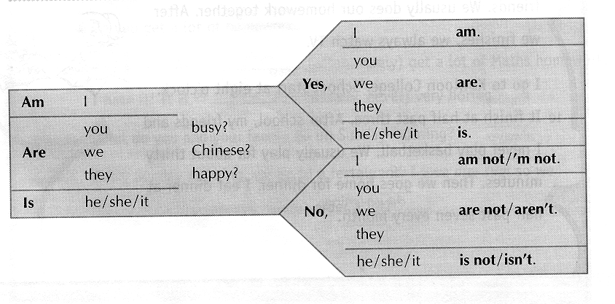
Exercise 1
Say these questions and answers using the correct form of the verb ‘to be’. Then write the words in the blanks.
1. ___________ he early? Yes, he is.
2. ___________ I late? No, you aren’t.
3. ___________ you sick? No, I’m not.
4. ___________ they friends? Yes, they are.
5. ___________ she at school? No, she isn’t.
6. ___________ we in the hall? No, you aren’t/we aren’t.
7. ___________ I in Class 1S? Yes, you are.
8. ___________she your friend? Yes, she is.
9. ___________they police? No, they aren’t.
10.__________we good friends? Yes, we are.

Simple present tense (Questions 2)
We can also use ‘Do’/‘Does’ to ask a question in the simple present tense with other verbs. The answers is always ‘Yes’ or ‘No’.
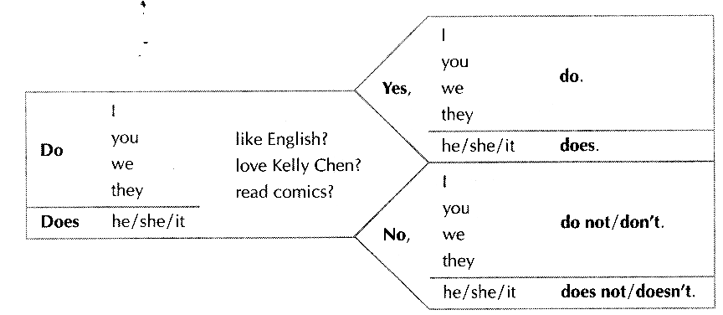

Exercise 2
Say these questions and answers using the correct form of the verb ‘to do’. Then write the words in the blanks.
1. ________ you like English? Yes, I do/we do.
2. _________Bobby like noodles? No, he doesn’t.
3. _________ we have a test now? Yes, you do/we do.
4. __________ they have a test this morning? No, they don’t.
5. __________ Susie like ice cream? Yes, she does.
6.___________Tommy walk to school? Yes, he does.
7.___________you understand? Yes, I do.
8. ___________I read English books? No, you don’t.
9. ___________you remember me? Yes, I do.
10. ___________we have to stay after school? No, you don’t.

