Chapter One (The Nature and Propagation of Light), wave fornt and rays,
Figure 1.: Reflection by the Mirror
The four Important Theories, Newton's theory , Huygens principle.
Index of refraction, The electromagnetic Spectrum, problems.

(1-1) Wave front and Rays
For an electromagnetic wave, the wavefront is represented as a surface of identical phase, and can be modified with conventional optics. For instance, a lens can change the shape of optical wavefronts from planar to spherical
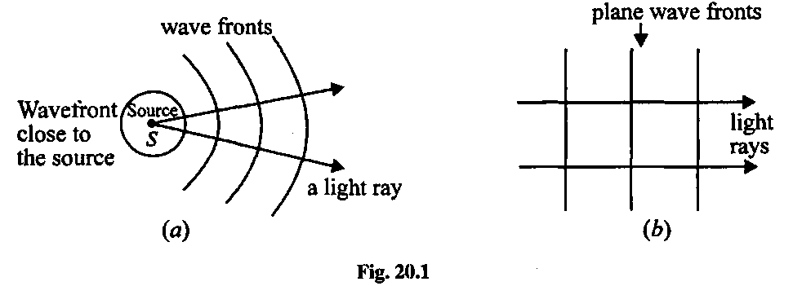
Figure 1: wove front shape (a) spherical and (b) planar, (c) difference between them after very large distance

(c)
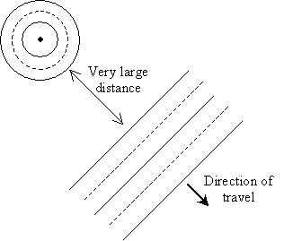
This direction of travel, because it is uniform all across the plane wave , is called a ray
A wave front is a surface passing through the points of a wave that have the same phase and amplitude.
A ray is a thin beam of light that travels in a straight line. A wave front is the line (not necessarily straight) or surface connecting all the light that left a source at the same time. light travels in a straight-line path in a homogeneous medium, until it encounters a boundary between two different materials.
geometrical optics, which is the study of electromagnetic waves that can be approximated using rays . The rays, corresponding to the direction of wave motion, are straight lines perpendicular to the wave

(1-2) The four Important theories of light
Different theories on the nature of light have been proposed. The important theories are as follows:
- Newton's Corpuscular Theory
- Huygens' Wave Theory
- Maxwell's Electromagnetic Theory
- Planck's Quantum Theory

1-Newton's Corpuscular Theory
According to Sir Issac Newton's Corpuscular Theory, a luminous body continuously emits tiny, light and elastic particles called corpuscles in all directions. When these particles fall on the retina of the eye, they produce the sensation of vision.
This theory could explain a number of phenomena concerning light like rectilinear propagation, reflection and refraction.

2-Huygens' Wave Theory
In 1967 Christian Huygens proposed the wave theory of light. According to this, a luminous body is a source of disturbance in hypothetical medium called ether. The disturbance from the source is propagated in the form of waves through space and the energy is distributed equally in all directions. Even though this theory could satisfactorily explain several optical phenomena, the presence of ether could not be detected.

3-Maxwell's Electromagnetic Theory
Electromagnetic theory of light was put forward by James Clerk Maxwell in 1873. According to this theory, light consists of fluctuating electric and magnetic fields propagating in the form of electromagnetic waves. But this theory failed to explain the photoelectric effect.
Maxwell’s wave equation showed that the speed of the waves, labeled c, is determined by a combination of constants in the laws of electrostatics and magnetostatics—in modern notation: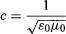where ε0, the permittivity of free space, has an experimentally determined value of 8.85 × 10⁻¹² square coulomb per newton square metre, and μ0, the magnetic permeability of free space, has a value of 1.26 × 10⁻⁶ newton square seconds per square coulomb. The calculated speed, about 3 × 10⁸ metres per second, agreed with the known speed of light.

4-Planck's Quantum Theory
According to Max Planck's Quantum theory, radiation is not continuous but is made up of tiny packets of energy called photons. However, this theory could not explain other optical phenomena.
From all the above theories it is clear that certain optical phenomena can be explained clearly only if light is considered to be made up of particles, while certain other phenomena can be explained only if we consider light as a wave. Thus light appears to have a dual nature.It is interesting to compare the two classical theories of light and see which phenomena can be explained by each theory. The following table does this.
After the failure of classical electromagnetic theory of radiation to explain photoelectric effect affect led Max Planck to propose a new theory on EM radiation which later known as Quantum theory of radiation.
Two major postulates of this theory are:-
Radiant energy is emitted or absorbed not continuously but discontinuously in the form of small packets of energy called quanta.
The amount of energy of energy associated with a quantum( or photon) of radiation is proportional to the frequency of radiation.
A body can emit or absorb energy only in terms of integral multiples of quantum.
E ∝ v
=> E = hv , where v is frequency of radiation and h is called Planck's constant (= 6.625 × 10^ -34 Js).
This theory is put forward to explain phenomenons like Black Body radiation, Photoelectric effect, etc.
(1-2-1) Reflection and Refraction by Newton's theory

(a) Reflection on light by Corpuscular of Newton's theory
Consider a particle of light in collision with a mirror. The collision is supposed to be perfectly elastic, and so tile component of velocity perpendicular to the mirror is reversed while that parallel to the mirror remains unaltered (see fig 1. )
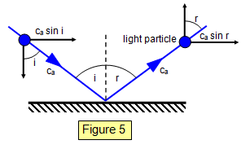

Figure 2.: Reflection by the Mirror

Component of velocity before collision parallel to the mirror :
c_{a} sin i and component of velocity after collision parallel to the mirror is c_{a} sin r, Therefore:
c_{a} sin i = c_{a} sin r
i= r (1)
the incident and reflected paths of the corpuscles and the normal line in the same plane this is law of reflection is proved.

(b) Refraction on light on corpuscular theory
Newton assumed that there is an attraction between the molecules of a solid and the particles of light, and that this attraction acts only perpendicularly to the surface and only at very short distances from the surface. Let the velocity of light in air ( n₁ ) and the velocity of light in the material (n₂ ₎ in Fig, 2.
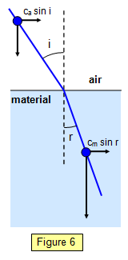

Өi

Өr

Figure 3. : Explain refraction by two media according Newton's theory

The parallel to the material is unaltered and therefore:
n₁sin Өi = n₂sinӨ r
Therefore:
n₂/n₁ = sin Өi/ sin Өr (2)
This ratio is the refractive index, but because n > 1 the velocity of light in the material must be greater than that in air. Newton accepted this result and other scientists preferred it to that of Huygens, mainly because of Newton's eminence.
A problem of the corpuscular theory was that temperature has no effect on the velocity of light, although on the basis of this theory we would expect the particles to be shot out at greater velocities as the temperature rises.
Newton’s corpuscular theory of light is based on the following points
1. Light consists of very tiny particles known as “corpuscular”.
2. These corpuscles on emission from the source of light travel in straight line with high velocity
3. When these particles enter the eyes, they produce image of the object or sensation of vision.
4. Corpuscles of different colours have different sizes.

(1-2-2) Huygens' principle (Wave Theory)
- The wave theory says that every point on the wavefront is taken as a source of secondary spherical wavelets.
- Each point on the wavefront radiates spherical waves which interfere to preserve it during propagation( see fig 4).

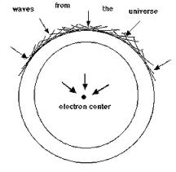
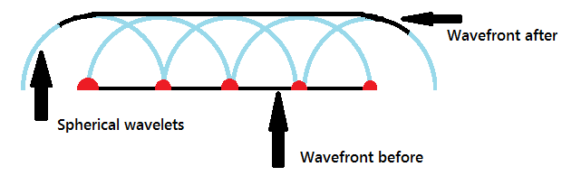
Figure 4: Source of Spherical In-Waves, Huygens Principle
To brief of Huygens' wave theory of light
- Each point in a source of light sends out waves in all directions in hypothetical medium called "ETHER".
2. Light is a form of energy
3. Light travels in the form of waves.
4. A medium is necessary for the propagation of waves & the whole space is filled with an imaginary medium called Ether
5. Light waves have very short wave length .
The lines below the mirror show the position that the wavefront would have reached at the Mirror Plane. We will now show how Huygens' wave theory can be used to explain reflection and refraction.

(a) Reflection according Huygens' theory
The reflection of a plane wavefront by a plane mirror is shown in Figure 5. Notice the initial position of the wavefront (AC), the secondary wavelets and the final position of the wavefront (DB). Notice that he shape of the wavefront is not affected by reflection at a plane surface.
Consider a point where the wavefront AC has just touched the mirror at edge A. While the light travels from A to D, that from C travels to B. The new envelope for the wavefront AC will be BD after reflection.
Therefore: AD = CB, Angle ACB = angle ADB = 90º, AB is common
Therefore ΔACB and ΔBDA are similar and so angle CAB = angle BAD. Therefore i = r and the law of reflection is proved.
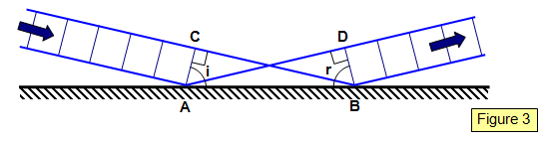
Figure 5 : The wave fronts will be Mirror plane both before and after reflection

(b) Refraction according Huygens' theory
Consider a plane monochromatic wave hitting the surface of a transparent material of refractive index n. The velocity of light in the material is c_{m} and that in air( c_{a}_) as shown in fig 6,
AC = AB sin i
BD = AB sin r
time to travel CB = CB/c_{a} = AB sin i/v
time to travel AD = AD/c_{m} = AB sin r/v'
therefore:
v/v' = sin i/sin r ==== =$\frac{c/n_{1}}{c/n_{2}}$
$\frac{n_{2}}{n_{1}} = \frac{\sin{i}}{\sin{r}}$ (3)
This is Snell's law, , Huygens' theory requires that the velocity of light
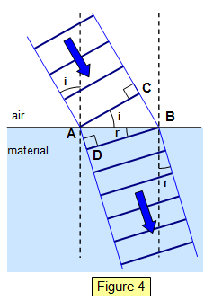
in air should be greater than that in the material.

Figure 6: Explain refraction by two media according wave's theory
Q1: Compare the two classical theories of light.
It is interesting to compare the two classical theories of light and see which phenomena can be explained by each theory. The following table does this.
Wave theory | Corpuscular theory
Reflection | Reflection
Refraction | Photoelectric effect
Diffraction
Interference

  - Electromagnetic spectrum
Waves have two important characteristics - wavelength and frequency. The sine wave is the fundamental waveform in nature. When dealing with light waves, we refer to the sine wave. The period (T) of the waveform is one full 0 to 360 degree sweep. The relationship of frequency and the period is given by the equation (see fig 9.):
f = 1 / T (4)
The waveforms are always in the time domain and go on for infinity.
Wavelength: | This is the distance between peaks of a wave. Wavelengths are measured in units of length - meters, When dealing with light, wavelengths are in the order of nanometres (1 x 10⁻⁹)
Frequency: | This is the number of peaks that will travel past a point in one second. Frequency is measured in cycles per second. The term given to this is Hertz (Hz) named after the 19th century discoverer of radio waves - Heinrich Hertz. 1 Hz = 1 cycle per second

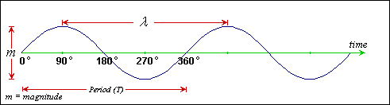
Figure 9: the sine wave is the fundamental waveform in nature

EM radiation is classified into types according to the frequency of the wavelength.
The diagram below depicts the electromagnetic spectrum and its various regions.
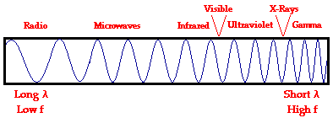

E=hf=h c/λ
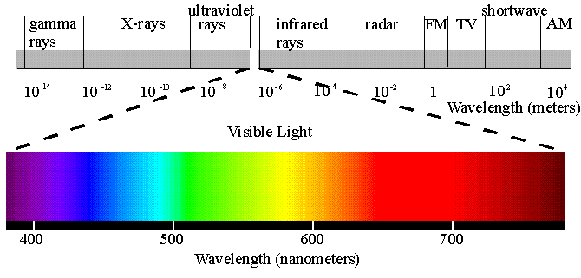
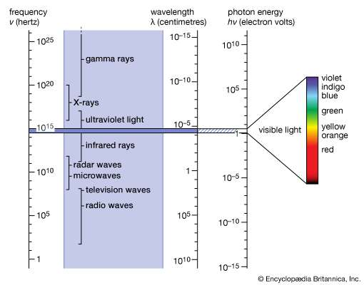

Table (1-1) : represented the wavelength and frequency ranges of the divisions of the electromagnetic spectrum.
Category | Range of Wavelengths (nm) | Range of Frequencies (Hz)
gamma rays | <1 | >3×10 ¹⁷ >3×10¹⁷
X-rays | 1–10 | 3×10 ¹⁶ –3×10 ¹⁷
ultraviolet light | 10–400 | 7,5×10 ¹⁴ –3×10
visible light | 400–700 | 4,3×10 ¹⁴ –7,5×10 ¹⁴
Infrared | 700–10 ⁵ | 3×10 ¹² –4,3×10 ¹⁴
microwave | 10 ⁵ –10 ⁸ | 3×10 ⁹ –3×10 ¹²
radio waves | >10 ⁸ | <3×10 ⁹

Index of refraction
The index of refraction is defined as the speed of light in vacuum
divided by the speed of light in the medium.
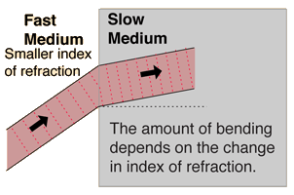 | 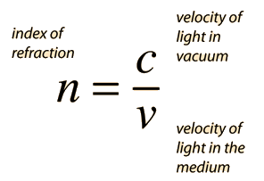
The indices of refraction of some common substances are given below with a more complete description of the indices for optical glasses given elsewhere. The values given are approximate and do not account for the small variation of index with light wavelength which is called dispersion.
Table (1-2) :shows different refractive index with various materials.
Material | n | Material | n
Vacuum | 1.000 | Ethyl alcohol | 1.362
Air | 1.000277 | Glycerine | 1.473
Water | 4/3 | Ice | 1.31
Carbon disulfide | 1.63 | Polystyrene | 1.59
Methylene iodide | 1.74 | Crown glass | 1.50-1.62
Diamond | 2.417 | Flint glass | 1.57-1.75

The phase velocity is the speed at which the crests or the phase of the wave moves, which may be different from the group velocity, the speed at which the pulse of light or the envelope of the wave moves. in vacuum.
As the refractive index of a material increases, the greater the extent to which a light beam is deflected (or refracted) upon entering or leaving the material. The refractive index of a medium is dependent (to some extent) upon the frequency of light passing through, with the highest frequencies having the highest values of n. For example, in ordinary glass the refractive index for violet light is about one percent greater than that for red light. A consequence of this phenomenon is that each wavelength experiences a slightly different degree of refraction when a heterogeneous light beam containing more than one frequency enters or leaves the medium. This effect is termed dispersion and is responsible for chromatic aberration in microscope objectives.
Example (1):The speed of light in an unknown medium is measured to be 2.76 x 10⁸ m/s. What is the index of refraction of the medium?

Solution:
The index is found to be
n = c/v = (3.00 x 108 m/s)/(2.76 x 108 m/s) = 1.09.

1-5) Optical path
In a medium of constant refractive index, n, the optical path length OPL for a path of physical length d ,to define a quantity called the optical path. The path d of a ray of light in any medium is given by the product velocity times time:
d = vt
Since by definition n = clv, which gives v = c/n, we can write the product nd is called the optical path $∆$:
nd = ct
$∆∆=n d$
If the refractive index varies along the path, the OPL is given by
Opt= n₁d₁+n₂d₂
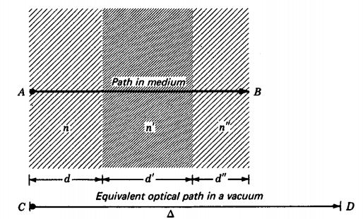

Color dispersion
The refractive index of materials varies with the wavelength (and frequency) of light This is called dispersion and causes prisms and rainbows to divide white light into its constituent spectral colors.^{[26]} As the refractive index varies with wavelength, so will the The refractive index of materials varies with the wavelength (and frequency) of light This is called dispersion and causes prisms and rainbows to divide white light into its constituent spectral colors. As the refractive index varies with wavelength,

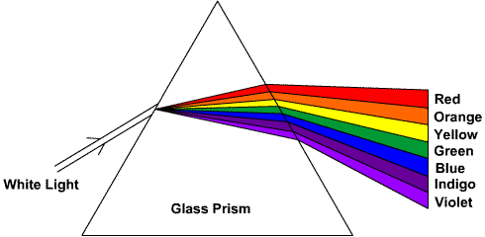
A prism of glass separates white light into its spectral components in such a manner that colors associated with shorter wavelengths are more refracted than the colors associated with longer wavelengths. so that “violet light” is less refracted than “red light.” This phenomenon is fundamentally different from conventional anomalous dispersion effects, which are invariably accompanied by significant loss and are typically very narrow band.

Prism
A prism is an optical element. It has polished flat surfaces that refract light. The traditional geometric shape of a prism has a triangular base and two rectangular sides. It is called triangular prism.
A prism can be made from materials like glass, plastic and fluorite. It can be used to split light into its components.

How a Prism Works
When light travels from one medium to another medium, it is refracted and enters the new medium at a different angle. The degree of bending of the light's path depends on the angle that the incident beam of light makes with the surface of the prism, and on the ratio between the refractive indices of the two media. This is called Snell's law.
n₁ sin i= n₂ sin r.
where, n is the refractive index of the material of the prism.
i is the angle of incidence.
r is the angle of refraction.
The refractive index of many materials varies with the wavelength of the light used. This phenomenon is called dispersion. This causes light of different colors to be refracted differently and to leave the prism at different angles, creating an effect similar to a rainbow. This can be used to separate a beam of white light into its constituent spectrum of colors.
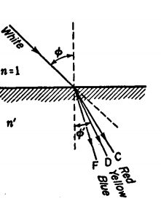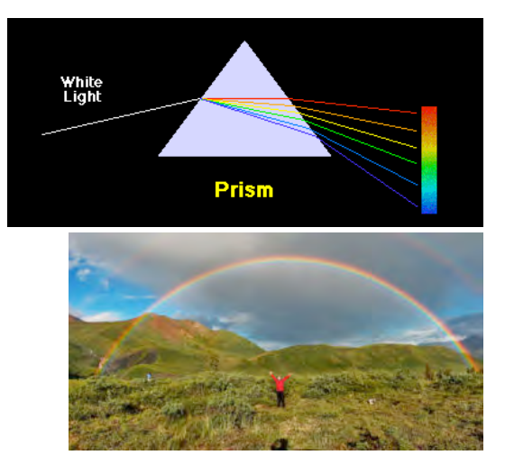
which is measured by the angle through which ray D is bent. To take a
typical case of crown glass, the refractive indices as given in Table IA are
nF = 1.52933 nD = 1.52300 nc = 1.5204
It is called the dispersive power and is defined by the equation

Problems ( ref. Fundemantal of Optics 1.4-1.13)
1.4 If the refractive index for a piece of optical glass is 1.5250, calculate the speed of light in the glass. Ans. 1.9659 x 108 m/s 1.5 Calculate the difference between the speed of light in kilometers per second in a vacuum and the speed of light in air if the refractive index of air is 1.0002340. Use velocity values to seven significant figures.
1.6 If the moon's distance from the earth is 3.840 x 105 km, how long will it take microwaves to travel from the earth to the moon and back again?
1.7 How long does it take light from the sun to reach the earth? Assume the earth's distance from the sun to be 1.50 X 108 km. Ans. 500 s, or 8 min 20 s
1.8 A beam of light passes through a block of glass 10.0 cm thick, then through water for a distance of 30.5 cm, and finally through another block of glass 5.0 cm thick. If the refractive index of both pieces of glass is 1.5250 and of water is 1.3330, find the total optical path.
1.9 A water tank is 62.0 cm long inside and has glass ends which are each 2.50 cm thick. If the refractive index of water is 1.3330 and of glass is 1.6240, find the overall optical path.
1.10 A beam of light passes through 285.60 cm of water of index 1.3330, then through 15.40 cm of glass of index 1.6360, and finally through 174.20 cm of oil of index 1.3870. Find to three significant figures (a) each of the separate optical paths and (b) the total optical path. Ans. (a) 380.7, 25.19, and 241.6 cm, (b) 647 cm
1.11 A ray of light in air is incident on the polished surface of a block of glass at an angle of 10°. (a) Ifthe refractive index of the glass is 1.5258, find the angle of refraction to four significant figures. (b) Assuming the sines of the angles in Snell's law can be repllJced by the angles themselves, what would be the angle of refraction? (c) Find the percentage error.
1.12 Find the answers to Prob. 1.11, if the angle of incidence is 45.0° and the refractive index is 1.4265. 1.13 A ray of light in air is incident at an angle of 54.0° on the smooth surface of a piece of glass. (a) If the refractive index is 1.5152, find the angle of refraction to four significant figures. (b) Find the angle of refraction graphically. (See Fig. P1.13). Ans. (a) 32.272°, (b) 32.3°

$$54°$$
air
32$°$

glass

