Special case:
If the light, instead of being incident on the slit perpendicular to its plane, makes an angle i, a little consideration will show that it is merely necessary to replace the above expression for by the more general expression:
$$β=\frac{πa(\sin{i+\sin{θ)}}}{λ}$$
RECTANGULAR APERTURE
For a slit of width b and length I, the following expression for the intensity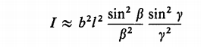………(2)
parallel to the sides b and l, respectively.
Now for a slit having l very large, the factor (sin² $γ$)/$γ$2 in Eq.(2) is zero
4- RESOLVING POWER WITH A RECTANGULAR APERTURE
By the resolving power of an optical instrument we mean its ability to produce separate images of objects very close together. Using the laws of geometrical optics, one designs a telescope or a microscope to give an image of a point source which is as small as possible.
If the two sources are far enough apart to keep their central maxima from
overlapping, as shown in Figure 38.12a, their images can be distinguished and are said to be resolved. If the sources are close together, however, as shown in Figure 38.12b, the two central maxima overlap, and the images are not resolved. In determining whether two images are resolved, the following condition is often used:
When the central maximum of one image falls on the first minimum of the other image, the images are said to be just resolved. This limiting condition of resolution is known as Rayleigh’s criterion.
by Rayleigh
to arbitrarily fix the separation as the criterion for resolution of two
diffraction patterns. This quite arbitrary choice is known as Rayleigh's criterion.
The angle is sometimes called the resolving power of the aperture b, although the ability to resolve increases as becomes smaller. A more appropriate designation
for $β=\frac{1}{2}k b\sin{Ө} β=π and the wave no. k=\frac{2π}{λ}$
$$π=\frac{1}{2}\frac{2π}{λ}*b\sin{Ө}$$
$$b\sin{Ө=λ path diff.}$$
At small angle sinӨ=dӨ , since dӨ is limit of resolution
$$bdӨ=λ$$
R.P= $\frac{λ}{b}=d Ө$
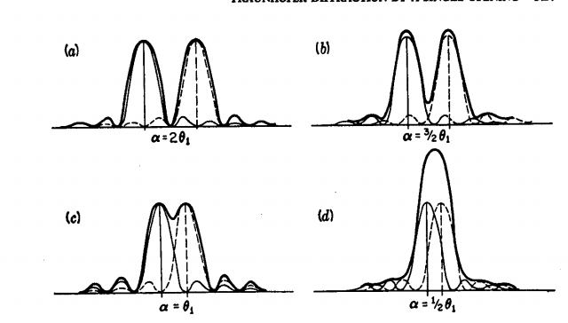

When more than one slit is present, we must consider not only diffraction due to the individual slits but also the interference of the waves coming from different slits. You may have noticed the curved dashed line in Figure 5, which indicates a decrease in intensity of the interference maxima as increases. This decrease is due to diffraction. To determine the effects of both interference and diffraction,
we simply combine Equation:

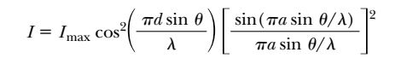
The conditions for interference maxima as …….3, where d is the distance between the two slits.
the first diffraction minimum occurs when …………………….4
where a is the slit width. Dividing equation 3,4
(with allows us to determine which interference maximum coincides with the first diffraction minimum. is given by
