Fresnel and fraunhofer diffraction, Diffraction by a single silt

Diffraction:
When a beam of light passes through a narrow slit, it spreads out to a certain extent into the region of the geometrical shadow. When waves pass through an aperture or past the edge of an obstacle, they always spread to some extent into the region which is not directly exposed to the oncoming waves. i.e., of the failure of light to travel in straight lines.
This phenomenon is called diffraction
1- FRESNEL AND FRAUNHOFER DIFFRACTION
Diffraction phenomena are conveniently divided into two general classes, (1) those in which the source of light and the screen on which the pattern is observed are effectively at infinite distances from the aperture causing the diffraction and (2) those in which either the source or the screen, or both, are at finite distances from the aperture.
The phenomena coming under class (1) are called, for historical reasons, Fraunhofer diffraction, and those coming under class (2) Fresnel diffraction.
It is easily observed in practice by rendering the light from a source parallel with a lens and focusing it on a screen with another
lens placed behind the aperture, an arrangement which effectively removes the source and screen to infinity. In the observation of Fresnel diffraction, on the other hand, no lenses are necessary, but here the wave fronts are divergent instead of plane, and the theoretical treatment is consequently more complex.
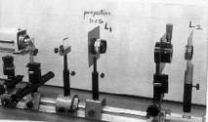
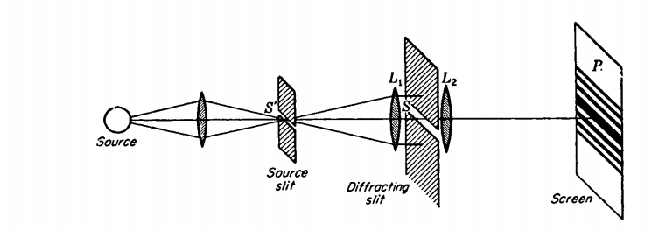
Figure 1 Experimental arrangement for obtaining the diffraction pattern of a single slit; Fraunhofer diffraction.
2 DIFFRACTION BY A SINGLE SLIT
A slit is a rectangular aperture of length large compared to its breadth. Consider a
slit S to be set up as in Fig1 with its long dimension perpendicular to the plane
of the page, and to be illuminated by parallel monochromatic light from the narrow
slit S', at the principal focus of the lens Ll• The light focused by another lens L2
on a screen or photographic plate P at its principal focus will form a diffraction pattern, as indicated schematically. 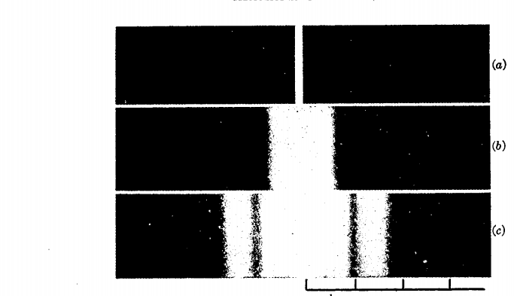.
Fraunhofer Single Slit  This is an attempt to more clearly visualize the nature of single slit diffraction. The phenomenon of diffraction involves the spreading out of waves past openings which are on the order of the wavelength of the wave. The spreading of the waves into the area of the geometrical shadow can be modeled by considering small elements of the wavefront in the slit and treating them like point sources.  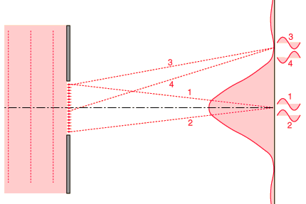  If light from symmetric elements near each edge of the slit travels to the centerline of the slit, as indicated by rays 1 and 2 above, their light arrives in phase and experiences constructive interference. Light from other element pairs symmetric to the centerline also arrive in phase. Although there is a progressive change in phase as you choose element pairs closer to the centerline, this center position is nevertheless the most favorable location for constructive interference of light from the entire slit and has the highest light intensity.  The first minimum in intensity for the light through a single slit can be visualized in terms of rays 3 and 4. An element at one edge of the slit and one just past the centerline are chosen, and the condition for minimum light intensity is that light from these two elements arrive 180° out of phase, or a half wavelength different in pathlength. If those two elements suffer destructive interference, then choosing additional pairs of identical spacing which progress downward across the slit will give destructive interference for all those pairs and therefore an overall minimum in light intensity.  One of the characteristics of single slit diffraction is that a narrower slit will give a wider diffraction pattern as illustrated below, which seems somewhat counter-intuitive. One way to visualize it is to consider that rays 3 and 4 must reach one half wavelength difference in light pathlength, and if the slit is narrower, it will take a greater angle of the rays to achieve that difference.  More examples of variation with slit width  The diffraction patterns were taken with a helium-neon laser and a narrow single slit. The slit widths used were on the order of 100 micrometers, so their widths were 100 times the laser wavelength or more. A slit width equal to the wavelength of the laser light would spread the first minimum out to 90° so that no minima would be observed. The relationships between slit width and the minima and maxima of diffraction can be explored in the single slit calculation. | Index  Diffraction concepts  Fraunhofer diffraction

Single Slit Amplitude Construction
Under the Fraunhofer conditions, the wave arrives at the single slit as a plane wave. Divided into segments, each of which can be regarded as a point source, the amplitudes of the segments will have a constant phase displacement from each other, and will form segments of a circular arc when added as vectors. In this way, the single slit intensity can be constructed.
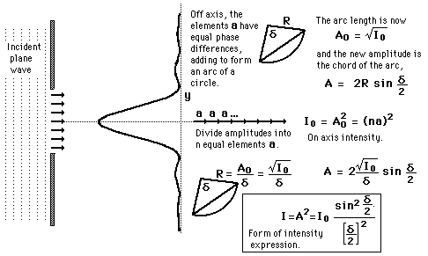

Single Slit Peak Intensities
Under the Fraunhofer conditions, the wave arrives at the single slit as a plane wave. Divided into segments, each of which can be regarded as a point source, the amplitudes of the segments will have a constant phase displacement from each other, and will form segments of a circular arc when added as vectors. In this way, the single slit intensity can be constructed.
