**C II. INTERFERENCE BY DVSION OF AMPLITUDE**

1-MICHELSONt INTERFEROMETER

The main optical parts consist of two highly polished plane mirrors *M1* and *M2*and two plane-parallel plates of glass Gland *G2•* Sometimes the rear side of the plate  
G1 is lightly silvered (shown by the heavy line'in the figure) so that the light coming  
from the source S is divided into (1) a reflected and (2) a transmitted beam of equal  
intensity. The light reflected normally from mirror *M1* passes through G1 a third  
time and reaches the eye as shown. The light reflected from the mirror *M* 2 passes  
back through G2 for the second time, is reflected from the surface of G1 and into the

Even when the above adjustments have been made, fringes will not be seen  
unless two important requirements are fulfilled. First, the light must originate from  
an *extended* source. A point source or a slit source, as used in the methods previously  
described, will not produce the desired system of fringes in this case. The reason  
for this will appear when we consider the origin of the fringes. Second, the light must  
in general be *monochromatic,* or nearly so. Especially is this true if the distances of  
*M1* and *M2* from G1 are appreciably different

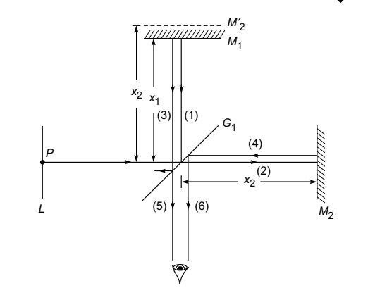 Schematic of the Michelson interferometer.

**Circular fringes**

Circular fringes are produced with monochromatic light when the mirrors M1 and M2 are exactly perpendicular to each other.

**Visibility of the Fringes**

In case of Michelson interferometer, the intensity is given by:



Here The intensity distribution across the rings follows Eq. (13b), in which the phase difference  
is given by:

The intensity distribution across the rings follows Eq. (13b), in which the phase difference  
is given by

Michelson tested the lines from various sources and concluded that a certain red line in the spectrum of  
cadmium was the most satisfactory. He measured the *visibility,* defined as

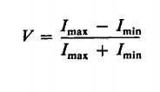

where *Imax* and Imin are the intensities at the maxima and minima of the fringe pattern. The more slowly *V* decreases with increasing path difference, the sharper the line.

**Uses of Michelson's Interferometer**

**1.determnation of wavelength of monochromatic light**

$∆x=x_{2- }x_{1}=N.\frac{λ}{2}$

$$λ=\frac{2\left(x_{2}-x_{1}\right)}{N}=\frac{2x}{N}$$

**X2-x1:** no. of fringes counting the center of the field of view.

(Conversely, if *x* is increased, the fringe pattern will expand.)

*N: no. of* fringes

**2- determination of different in wavelength between two neighbor lines or two waves**

Let the source of light emit close wavelength $λ_{1}$ and $λ_{2}$,condition λ1>λ2 . the apparatus is adjusted to form circular rings. the arrangement of the position of mirror M1 is moved and reached when a bright fringes of one set falls on the bright fringe of the other an fringes are again distinct. So the small difference $∆$ λ is given by:

$$∆λ=\frac{λ^{2}}{2x}$$

**3-thickness of a thin transparent sheet**

**4-determination of the refractive index of gases**

the path difference introduce between the two interfering beam is 2(n-1)L

where n:Refractive index of gas

L: length of the tube. If m fringes cross the center of the field of view thus:

2(n-1)L=mλ

$$n=\frac{mλ}{2L}+1$$

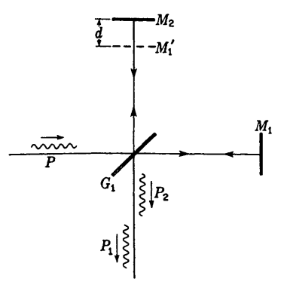

Limiting path difference as determined by the length of wave packets.

**Interferometry**

Instrument used by the principle of interference of light is called **interferometer** this instrument designed by Jamis and Rayleigh are used to determine the refractive index of gases and are known as **refract meter**

**INTERFEROMETRIC MEASUREMENTS OF LENGTH**The principal advantage of Michelson's form of interferometer over the earlier  
methods of producing interference lies in the fact that the two beams are here widely  
separated and the path difference can be varied at will by moving the mirror or by  
introducing a refracting material in one of the beam

**TWYMAN AND GREEN INTERFEROMETER**If a Michelson interferometer is illuminated with strictly parallel monochromatic light, produced by a point source at the principal focus of a well-corrected lens, it becomes a very powerful instrument for testing the perfection of optical parts such  
as prisms and lenses. The piece to be tested is placed in one of the light beams, and the mirror behind it is so chosen that the reflected waves, after traversing the test piece a second time, again become plane. These waves are then brought to interference with the plane waves from the other arm of the interferometer by another lens, at the focus of which the eye is placed. If the prism or lens is optically perfect, so that the

returning waves are strictly plane, the field will appear uniformly illuminated. Any local variation of the optical path will, however, produce fringes in the corresponding part of the field, which are essentially the contour lines of the distorted wave front.  
Even though the surfaces of the test piece may be accurately made, the glass may contain regions that are slightly more or less dense. With the Twyman and Green interferometer these can be detected and corrected for by local polishing of the surface.

INDEX OF REFRACTION BY INTERFERENCE  
METHODS



In principle a measurement of*, t,* and), thus gives a determination of *n*

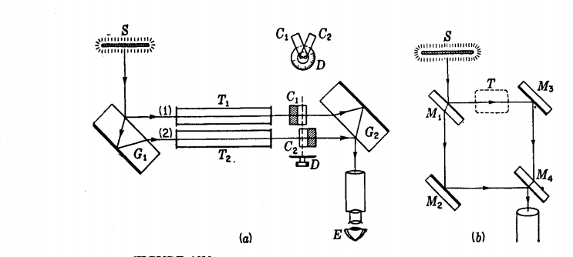figure ( 1 ) *(a)* The Jamin and *(b)* the Mach-Zehnder interferometer.

**Coherence source**

Light which is capable of interference is called ‘coherent,’ and it is evident that in order to  
yield many interference fringes, it must be very monochromatic. Coherence is conveniently  
measured by the path difference between two rays of the same source, by which they can  
differ while still giving observable interference contrast. This is called the coherence length. . Lord Rayleigh and Albert Michelson were the first to understand that it is a reciprocal measure of the spectroscopic line width.

The coherence time t *c* represents the average duration of the wave trains; i.e., the electric field remains sinusoidal for times of the order of t *c*.

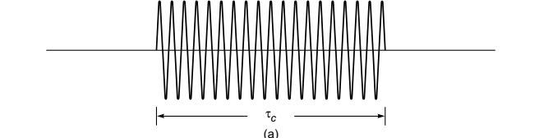  
The length of the wave train, given by *L  
c* = *c*t*c*(where *c* is the speed of the light in free space) is referred to as the coherence length

Producing Coherent Sources

Light from a monochromatic source is used to illuminate a barrier. The barrier contains two small openings.

* + The openings are usually in the shape of slits.

The light emerging from the two slits is coherent since a single source produces the original light beam.

This is a commonly used method.

**INTERFERENCE IN THIN FILMS**

Interference effects are commonly observed in thin films, such as thin layers of oil on water or the thin surface of a soap bubble. The varied colors observed when white light is incident on such films result from the interference of waves reflected from the two surfaces of the film.  
Consider a film of uniform thickness *t* and index of refraction *n*, as shown in Figure 2. Let us assume that the light rays traveling in air are nearly normal to the two surfaces of the film. To determine whether the reflected rays interfere constructively or destructively, we first note the following facts:  
• A wave traveling from a medium of index of refraction *n* 1 toward a medium of index of refraction *n* 2 undergoes a 180° phase change upon reflection when and undergoes no phase change if  
• The wavelength of light *n* in a medium whose refraction index is *n*   
where is the wavelength of the light in free space.  
Let us apply these rules to the film of Figure 3, where Reflected ray 1, which is reflected from the upper surface (*A*), undergoes a phase  
change of 180° with respect to the incident wave. Reflected ray 2, which is reflected from the lower film surface (*B*), undergoes no phase change because it is reflected from a medium (air) that has a lower index of refraction. Therefore, ray 1 is 180° out of phase with ray 2, which is equivalent to a path difference of *n*/2.  
  
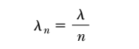

However, we must also consider that ray 2 travels an extra distance 2*t* before the waves recombine in the air above surface *A*. If then rays 1 and 2 recombine in phase, and the result is constructive interference. In general, the condition for constructive interference in such situations is



This condition takes into account two factors: (1) the difference in path length for the two rays (the term *mn*) and (2) the 180° phase change upon reflection (the term *n*/2). we can write



If the extra distance 2*t* traveled by ray 2 corresponds to a multiple of *n*, then the two waves combine out of phase, and the result is destructive interference. The general equation for destructive interference is

INDEX OF REFRACTION BY INTERFERENCE METHODS

If a thickness *t* of a substance having an index of refraction *n* is introduced into the path of one of the interfering beams in the interferometer, the optical path in this beam is increased because of the fact that light travels more slowly in the substance and consequently has a shorter wavelength. The optical path [Eq. (It)] is now *nt* through the medium, whereas it was practically *t* through the corresponding thickness of air *(n* = 1). Thus the increase in optical path due to insertion of the substance is

*(n - l)t.t* This will introduce *(n - l)tl).* extra waves in the path of one beam; so if we call *lim* the number of fringes by which the fringe system is displaced when the substance is placed in the beam, we have:



In principle a measurement of *m, t,* and), thus gives a determination of *n.*

In practice, the insertion of a plate of glass in one of the beams produces a is continuous shift of the fringes so that the number lim cannot be counted. With monochromatic fringes it is impossible to tell which fringe in the displaced set corresponds to one in the original set. With white light, the displacement in the fringes of different colors is very different because of the variation of *n* with wavelength, and the fringes disappear entirely. This illustrates the necessity of the compensating plate

G2 in Michelson's interferometer if white-light fringes are to be observed. If the plate of glass is very thin, these fringes may still be visible, and this affords a method of measuring *n* for very thin films. For thicker pieces, a practicable method is to use two plates of identical thickness, one in each beam, and to turn one gradually about a vertical axis, counting the number of monochromatic fringes for a given angle of rotation. This angle then corresponds to a certain known increase in effective thickness.

For the measurement of the index of refraction of gases, which can be introduced gradually into the light path by allowing the gas to flow into an evacuated tube, the interference method is the most practicable one. Several forms of refractometers have been devised especially for this purpose, of which we shall describe three, the Jamin, the Mach-Zehnder, and the Rayleigh refractometers.

Jamin's refractometer is shown schematically in Fig. 13V(a). Monochromatic



light from a broad source S is broken into two parallel beams 1 and 2 by reflection at the two parallel faces of a thick plate of glass Gl' These two rays pass through to another identical plate of glass *Gz* to recombine after reflection, forming interference fringes known as Brewster's fringes If now the plates are parallel, the light paths will be identical. Suppose as an experiment we wish to measure the index of refraction of a certain gas at different temperatures and pressures. Two similar evacuated tubes *T1* and *T2* of equal length are placed in the two parallel beams.

Gas is slowly admitted to tube *T2.* If the number of fringes *Am* crossing the field is counted while the gas reaches the desired pressure and temperature, the value of *n* can be found by applying Eq. (13k). It is found experimentally that at a given temperature the value *n -* 1 is directly proportional to the pressure. This is a special case of the *Lorenz-Lorentz* law,* according to which:



Here *ρ* is the density of the gas. When *n* is very nearly unity, the factor *(n* + *1)/(n2* + 2) is nearly constant, as required by the above experimental observation.

The interferometer devised by Mach and Zehnder, and shown in Fig. *13V(b),* has a similar arrangement of light paths, but they may be much farther apart. Therole of the two glass blocks in the Jamin instrument is here taken by two pairs ofmirrors, the pair *M1* and *M2* functioning like *G1,* and the pair *M3* and *M4* like *G2•*

The first surface of *M1* and the second surface of *M4* are half-silvered. Although it is 

more difficult to adjust, the Mach-Zehnder interferometer is suitable only for studying slight changes of refractive index over a considerable area and is used, Contrary to the situation in the Michelson interferometer, the light traverses a region such as *T* in the figure in only one direction, a fact which simplifies the study of local changes of optical path in that region.

The purpose of the compensating plates C1 and *C2* in Figs. 13V(a) and 13W is to speed up the measurement of refractive index. As the two plates, of equal thickness, are rotated together by the single knob attached to the dial *D,* one light path is shortened and the other lengthened. The device can therefore compensate for the path difference in the two tubes. The dial, if previously calibrated by counting fringes, can be made to read the index of refraction directly. The sensitivity of this device can be varied at will, a high sensitivity being obtained when the angle between the two plates is small and a low sensitivity when the angle is large.

In Rayleigh's* refractometer (Fig. 13W) monochromatic light from a linear source S is made parallel by a lens *L1* and split into two beams by a fairly wide double slit. After passing through two exactly similar tubes and the compensating plates, these are brought to interfere by the lens *L2.* This form of refractometer is often used to measure slight differences in refractive index of liquids and solutions.