7-1) INTRODUCATION)
In this chapter we will discuss the phenomenon of waves. A wave is propagation of a disturbance. For example, when we drop a small stone in a calm pool of water, a circular pattern spreads out from the point of impact
Fig. 1(a) and (b), we note that the shape of the string at the instant $Δ$t is similar to its shape at t = 0, except for the fact that the whole disturbance has traveled through a certain distance. If v represents the speed of the wave, then this distance is simply v$Δ$t. Consequently, if the equation describing the rope at t = 0 is y(x), then at a later instant t, the equation of the curve is y(x – vt), which simply implies a shift of the origin by a distance vt . Similarly, for a disturbance propagating in the –x direction, if the equation describing the rope at t = 0 is y(x), then at a later instant t the equation of the curve is y(x + vt).
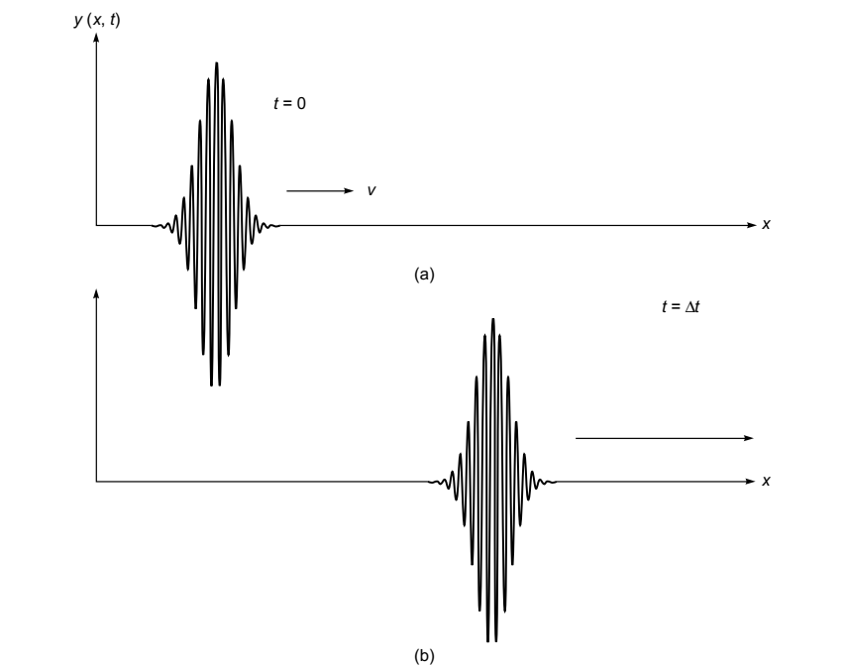Figure (1) A transverse wave is propagating along the +x axis on a string. (a) and (b) Displacements at t = 0 and t =Δt, respectively

A useful and concise way of expressing the equation for simple harmonic waves is in terms of the angular frequency w = 2$π$f and the propagation wave number k = 2$π$/λ , this relation can be express by:
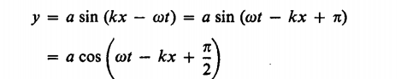
(7-1)
The addition of a constant to the quantity in parentheses is of little physical significance, since such a constant can be eliminated by suitably adjusting the zero of the time scale.
Thus the equations when written
(7-2)

consider the propagation of a pulse which lasts for a finite amount of time. We now consider a periodic wave in which the displacement y(x, t) has the form
y(x, t) = a cos [k(x ∓ vt) + Φ] (7-3)
where the upper and lower signs correspond to waves propagating in the +x and –x directions, respectively. Such a displacement is indeed produced in a long stretched string at the end of which a continuously vibrating tuning fork is placed. The quantity f is known as the phase of the wave Φ
figure (7-2) This distance is known as the wavelength. Further, the displaced curve (which corresponds to the instant t = Δt) can be obtained by displacing the curve corresponding to t = 0 by a distance vΔt; this shows that the wave is propagating in the +x direction with speed v. It can also be seen that the maximum displacement of the particle (from its equilibrium position) is a, which is known as the amplitude of the wave.
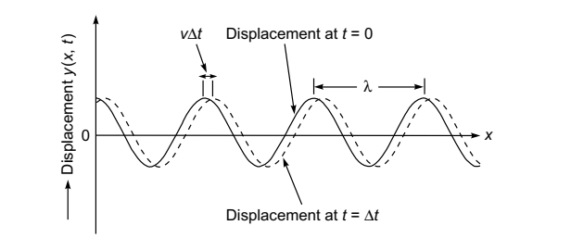
a
Figure (7-2) The curves represent the displacement of a string at t = 0 and t = Δt, respectively, when a sinusoidal wave is propagating in the +x direction.
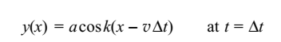 (7-4)
The two curves are the snapshots of the string at the two instants. It can be seen from the figure that, at a particular instant, any two points separated by a distance
$λ=\frac{2π}{k}$ (7-5)
Two such waves can be represented by the equations which is known as the time period of the wave. The quantity
$f=\frac{1}{\begin{aligned}T \\ \end{aligned}}$ (7-6)
$f$ is known as the frequency of the wave and represents the number of oscillations that a particle carries out in 1 s.

(7-2) PHASE VELOCITY AND WAVE VELOCITY

When we switch a light source on and off, we produce a pulse. This pulse propagates through a medium with what is known as the group velocity, which is given by:
v g =1 /dk dw
and the wave velocity 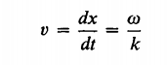 (7-7)

Since
ω=2πf: angular frequency [rad/sec]
f=1/T: frequency [Hz]
T: optical period [sec]
k=2π/λ: wavenumber [m-1]
λ: wavelength [m]
From the wave equation: ω=ck ⇔ ν=c/λ
c: speed of light (3×10⁸ m/sec in free space)
The ratio w/k for a given kind of wave depends on the physical properties of the medium in which the waves travel and also, in general, on the frequency w itself.
(7-3) TYPES OF WAVES
As mentioned earlier, when a wave is propagating through a string, the displacement is at right angles to the direction of propagation. Such a wave is known as a transverse wave.Similarly, when a sound wave propagates through air, the displacement of the air molecules is along the direction of propagation of the wave; such waves are known as longitudinal waves. However, there are waves which are neither
longitudinal nor transverse in character; for example, when a
wave propagates through the surface of water, the water molecules move approximately in circular orbits
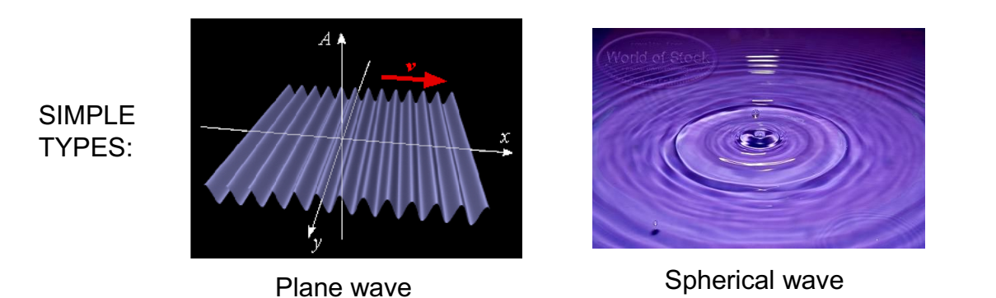 (a)

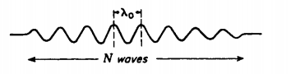
(b)
Figure (7-3) explain type waves (b) describe of N waves

(7-4) HUYGENS' PRINCIPLE

Huygens nearly three centuries ago proposed the rule that each point on a wave front may be regarded as a new source of waves(see chapter one)
Huygens’ theory is essentially based on a geometrical construction which allows us to determine the shape of the wave front at any time, if the shape of the wave front at an earlier time is known. A wave front is the locus of the points which are in the same phase; for example, if we drop a small stone in a calm pool of water, circular ripples spread out from the point of impact, each point on the circumference of the circle (whose
center is at the point of impact) oscillates with the same amplitude and same phase, and thus we have a circular wave front.
On the other hand, if we have a point source emanating waves
in a uniform isotropic medium, the locus of points which have
the same amplitude and are in the same phase is spheres. In this
case we have spherical wave fronts, as shown in Fig. (7-4)(a).
At large distances from the source, a small portion of the sphere can be considered as a plane, and we have what is known as a plane wave [see Fig.(7-4) 1(b)].
Now, according to Huygens’ principle, each point of a wave front is a source of secondary disturbance, and the wavelets emanating from these points spread out in all directions with the speed of the wave. The envelope of these wavelets gives the shape of the new wave front.
The medium is assumed to be homogeneous and isotropic; i.e., the medium is characterized by the same property at all points, and the speed of propagation of the wave is the same in all directions we will derive the laws of refraction and reflection by using Huygens’ principle.
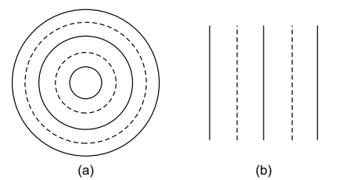
Figure (7-4): (a) A point source emitting spherical waves. (b) At large distances, a small portion of the
spherical wave front can be approximated to a plane wave front, thus resulting in plane waves.
The speed of propagation of the wave is the same in all directions.
Huygens’ theory, the presence of the back wave is avoided by one does obtain a finite intensity in the region of the geometrical shadow. However, at the time of Huygens, light was known to travel in straight lines, and Huygens explained this by assuming that the secondary wavelets do not have any amplitude at any point not enveloped by the wave front.
Laws of reflection and Snell’s law of refraction can be derived using Huygens’ principle.
when Maxwell propounded his famous electromagnetic
theory, that the nature of light waves could be understood
(7-5)AMPLITUDE AND INTENSITY
The displacements produced by each of the disturbances: we are assuming that the displacements are in the same direction. However, they may have different amplitudes and different initial phases.
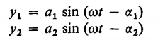(7-8)
According to the principle of superposition, the resultant displacement Y is merely the sum of Yl and Y2, and we have:
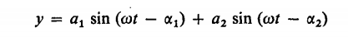 (7-9)
When the expression for the sine of the difference of two angles is used, this can be written :
(7-10)
, we are justified in setting:
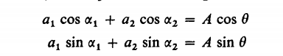(7-11)
The Amplitude of the wave is conserved by each wave period A the law of cosines gives
(7-12)

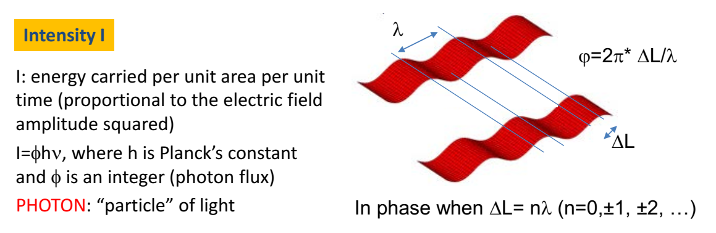
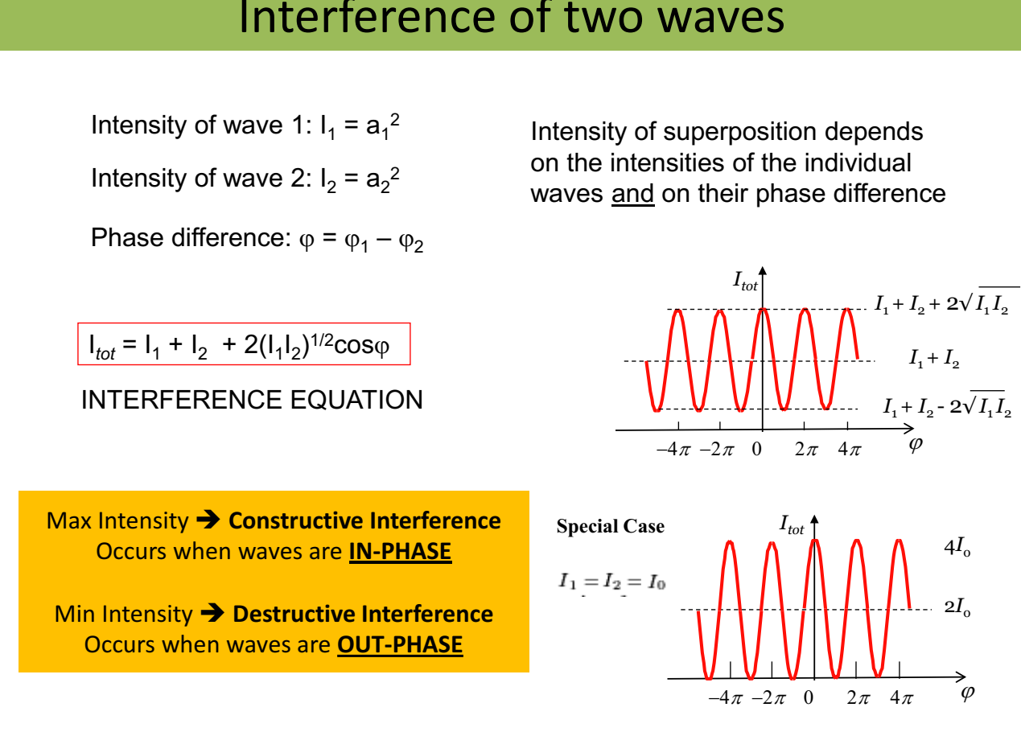 Waves transport energy, and the amount of it that flows per second across unit area perpendicular to the direction of travel is called the intensity(I) of the wave.
$$I=\frac{P}{A}$$
If the wave flows continuously with the velocity v, there is a definite.
In spherical waves, the intensity decreases as the inverse square of the distance from the source.

(7-6) INTERFERENCE FRINGES FROM THE DOUBLE SLITE
Interference in light waves occurs whenever two or more waves overlap at a given point. A sustained interference pattern is observed if (1) the sources are coherent and (2) the sources have identical wavelengths.

