H.W (1) Suppose you have BP- ANN with 2-input, 2-hiddden, 1-output nodes with sigmoid function and the following matrices initial weights, trace with 2-iteration.

0.1 0.4 0.2
V= - 0.2 0.2 W = - 0.5 , Where ∝ = 0.1, η = 0.6

Epoch | i | Input |  | Output | Initial Weights |  |  |  |  |  | Y₁  (O_{actual)} | △₁ | δ₁ | δ₂ | Final Weights
 |  | X₁ | X₂ | d₁  ( O_{desired}) | V₁₁ | V₁₂ | V₂₁ | V₂₂ | W₁₁ | W₂₁ |  |  |  |  | V₁₁ | V₁₂ | V₂₁ | V₂₂ | W₁₁ | W₂₁
1 | 1 | 0.4 | - 0.7 | 0.1 | 0.1 | 0.4 | - 0.2 | 0.2 | 0.2 | - 0.5
 | 2 | 0.3 | - 0.5 | 0.05
 | 3 | 0.6 | 0.1 | 0.3
 | 4 | 0.2 | 0.4 | 0.25
 | 5 | 0.1 | - 0.2 | 0.12
2 | 1 | 0.4 | - 0.7 | 0.1
 | 2 | 0.3 | - 0.5 | 0.05
 | 3 | 0.6 | 0.1 | 0.3
 | 4 | 0.2 | 0.4 | 0.25
 | 5 | 0.1 | - 0.2 | 0.12

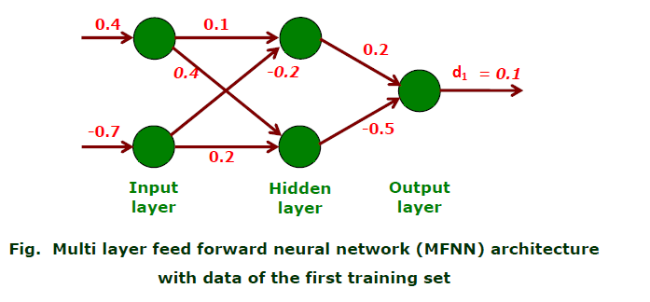
توضيح الحل :

