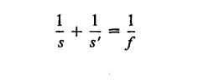
This is the lens formula in the Gaussian form
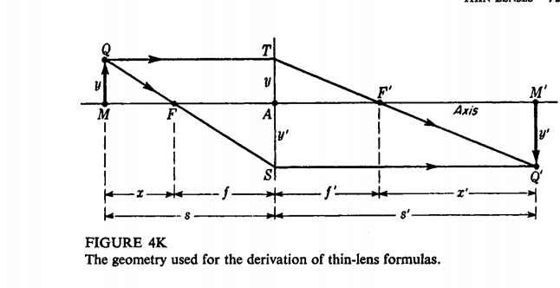
Another form of the lens formula, the newtonian form, is obtained in an analogous way from two other sets of similar triangles, QMF and FAS on the one hand and TAF' anq F'M'Q' on the other. We find
Multiplication of one equation by the other gives.
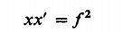$M_{T}=\frac{y^{'} }{y}=- \frac{f}{x^{'}}= - \frac{x'}{f}$

The result is that the object and image must be on the opposite sides of their respective focal points
DERIVATION OF THE LENS MAKERS' FORMULA:
Let n, n', and n"represent the refractive indices of the three media as shown, f_{l} and f₁' the focal lengths for the first surface alone, and f₂ and f₂'' the focal lengths for the second surface alone.
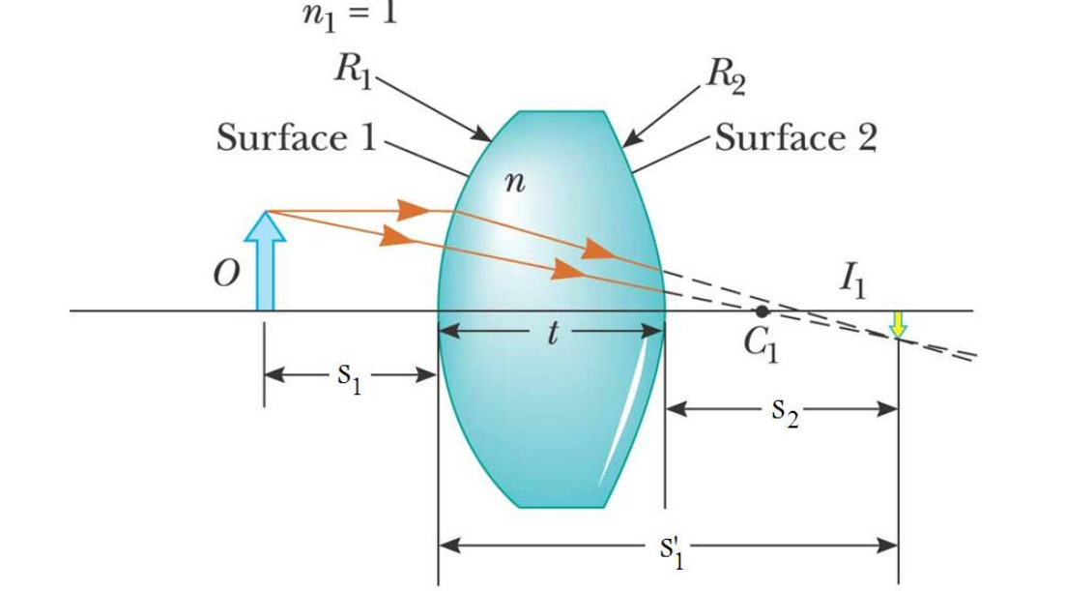

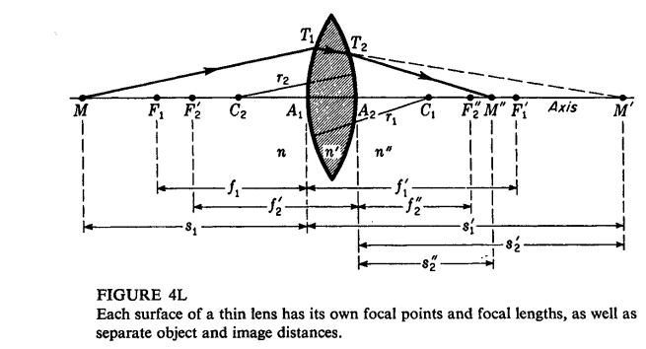

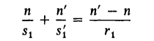 (1)
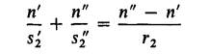 (2)
we note the image distance s₁ ' for the first surface becomes equal in magnitude to the object distance s₂' for the second surface. Since M' is a virtual object for the second surface, the sign of the object distance for this surface is negative. As a consequence we can set s₁' = -S₂' and write:
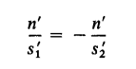
f we now add Eqs. (1)and (2) and substitute this equality, we obtain
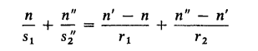(3)
If we now call SI the object distance and designate it' s as in Fig. 4M
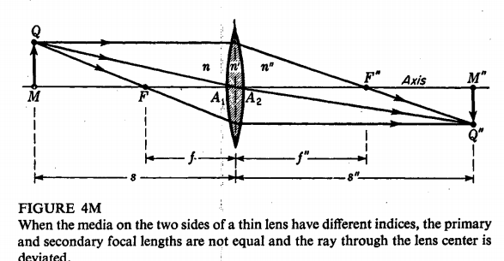
and call s₂''. the image distance and designate it S", we can write Eq. (3) as:
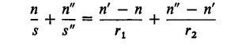(4)
This is the general formula for a thin lens having different media on the two sides. For such cases we and use primary and secondary focal points F and F", and the corresponding focal lengths f and f", by setting s or s" equal to infinity. When this is done, we obtain:
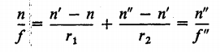(5)
In words, the focal lengths have the ratio of the refractive indices of the two media nand n" (see Fig. 4M)
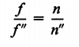 (6)
If the medium on both sides of the lens is the same, n = n", Eq. (6) reduces to:
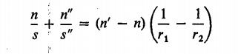 (7)
Finally, if the surrounding medium is air (n = 1), we obtain the lens makers' formula:
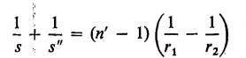 (8)
Return to define vengeances and power of lens we can written:
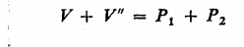 (9)
Where:
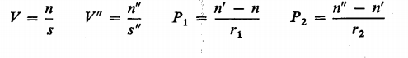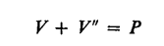
And power of lenses:
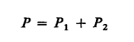
THIN LENSES IN CONTACT
For this two lens system, let’s determine the front focal length (ffl) f₁ and the back focal length (bfl) f₂.
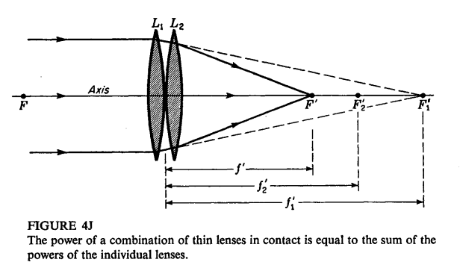
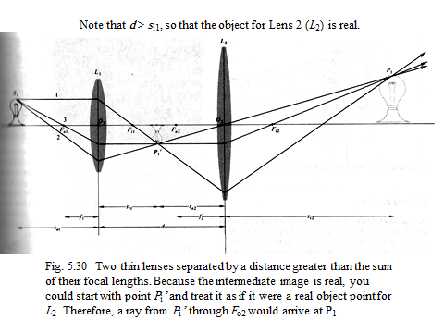

If we now apply the simple lens formula (41) to the rays as they enter and
leave the second lens L2, we note that for the second lens alone f ₁' is the object distance (taken with a negative sign), f' is the image distance, and f2 '' is the focal length. When Eq. (8) is applied, these substitutions for s, s', and s"" respectively, give Since we have assumed that the lenses are in air, the primary focal lengths are all equal to their respective secondary focal lengths and we can drop all primes and write:
(10)
