It’s Not Always Black and White.
You can find the names of colors in a lot of English expressions. Many of these expressions, however, talk about colors in very different ways. For example, the expression black and white can have different meanings. If something is black and white, it means it is clear, easy to understand. However, some people see everything in black and white, which means that they judge everything they see as either good or bad. Some people have to see something in black and white to know that it is true; this black and white talks about seeing something printed, as in a newspaper, it must be true, right?
The color red is often used to talk about things that are hot or exciting. You can listen to red-hot Jazz music or eat red-hot chili peppers. If you roll out the red carpet for someone, you are giving them a big welcome. On TV, you may see stars walking on the red carpet at the opening night of a Hollywood movie or at the Academy Awards. After a big night like this, the stars often paint the town red, which means that they celebrate and have fun, going to parties or nightclubs all over the town. However, red isn’t always fun.

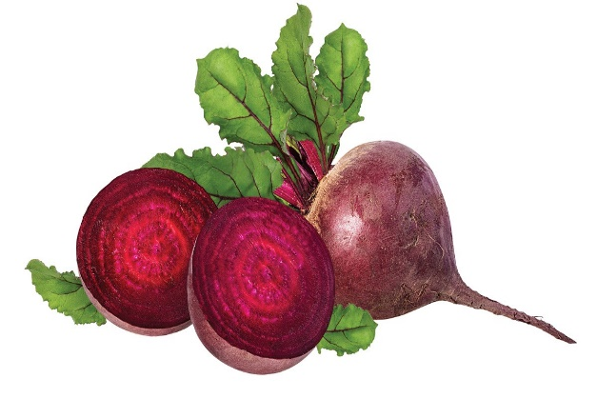
If you do something embarrassing, like spill coffee on your teacher’s desk, perhaps your face is beet-red. Your teacher’s face might be red with anger, too! Or if you see a person doing something bad on purpose, like taking someone’s wallet, you can say that you caught the person red-handed. Whether it’s good or bad, red usually means something interesting is happening.
Blue is different. When people are blue, or have got the blues, it means they feel sad. They might listen to blues music, which usually tells sad stories. Blue isn’t always a sad color, though. If something good happens to you when you’re not expecting it, like when you get a good idea, or if you run into an old friend, you can say it happened out of the blue.
Green is another color that can have very different meanings. In the past, being green was almost always something negative. For example, if you ride on a boat and feel seasick (when someone suffers from nausea. Car-sickness, plane-sickness. Motion-sickness), your face may look (become; turn) green. If someone has something nice that you really want, like a new car or an expensive watch, you may also be green with envy (n. envious adj.). Or if you are starting a new job, your boss may say you are green, which means that you don’t have experience. (inexperienced adj.) lacking experience
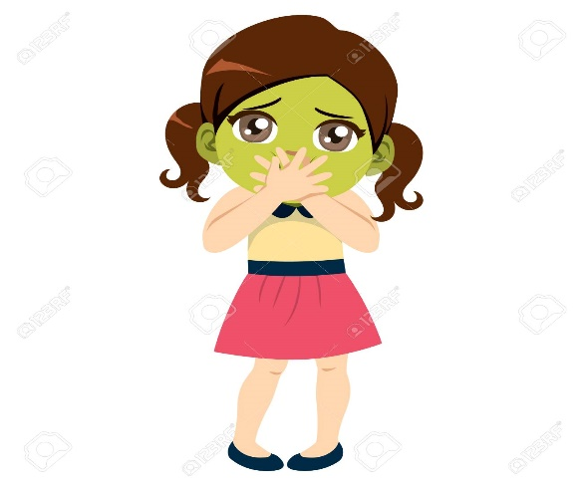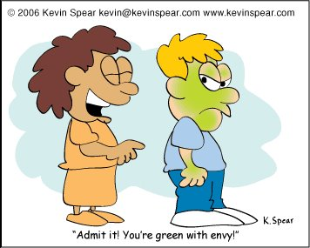
Now, however, green is usually good, being green more often means doing good things for the environment. People who are good at growing plants have green thumbs. Many companies are going green, which means they are recycling (recyclable adj. recycled; fertilizers) more or are trying to use less energy. In fact, some companies are moving to new, green buildings, which may use solar power or grow plants on their roofs. So if someone asks you how green you are, it probably means they want to know if you do good things for the environment. Solar panels
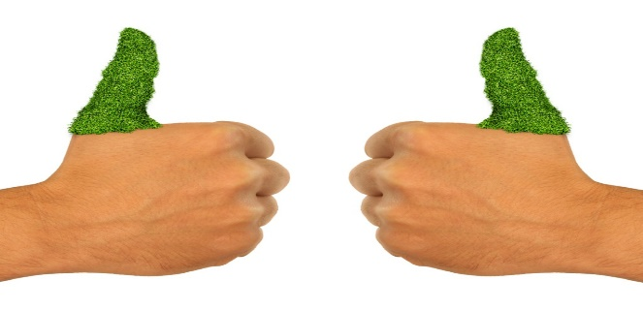
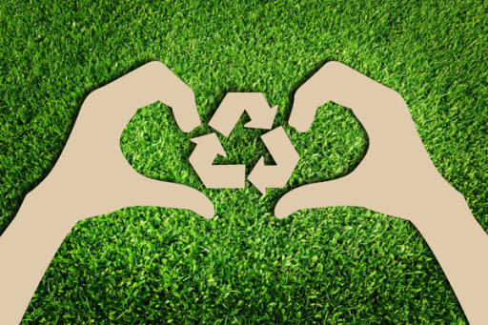

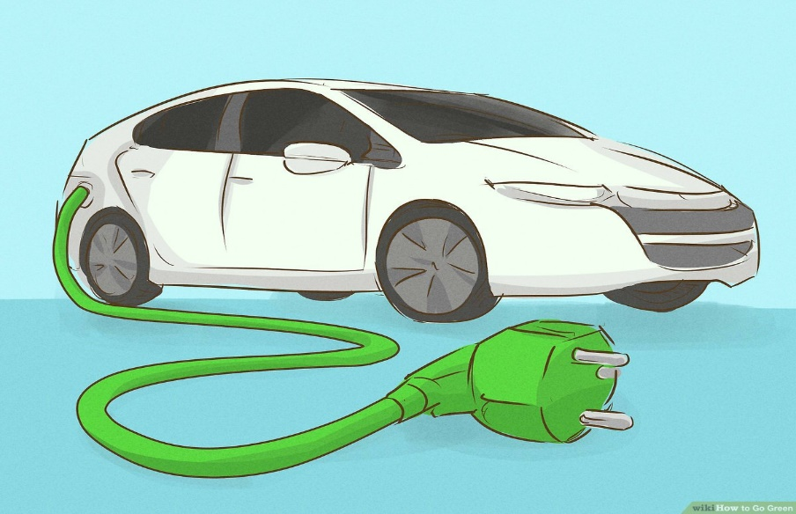
Learning new expressions with colors can be fun, but it’s not always easy. As you can see, their meanings can sometimes be very different. Try looking for these expressions in the things you read. If you learn more about how these expressions are used, you may add a little color to your writing, or even pass your next English test with flying colors.

After you read
Understanding the Text
- Comprehension
For each item below, fill in the correct circle.
- Finding the main idea. This reading is primarily about _______________.

- Learning the names of colors
- How people feel when they see colors
- English expressions with colors in them

- Scanning for details. According to the reading, if your face is red, it can mean you are __________

- Angry or embarrassed
- Angry or happy
- Happy or embarrassed

- Scanning for details. The following colors are mentioned in the reading _____________

- Black, white, red, purple, blue
- Black, red, blue, green, yellow
- Black, white, red, blue, green

- Scanning for details Being green ___________

- Is always good
- Is always bad
- Can be good or bad

- Scanning for details. In this article, the author shows that _____________

- The expression “black and white” always has a bad meaning
- Being blue means feeling sad
- Learning color expressions is necessary for taking tests

- Vocabulary
Underline these words in the reading passage on pages 23-24. Then complete the sentences.
Embarrassing energy expecting experience judge

- It was so embarrassing when Haluk walked into (hit; bump into) the glass door.
- Sheila is expecting an important phone call this afternoon from her boss
- That man in the jeans and t-shirt (casual vs formal) is the president of the company. You really can’t judge (be critical about, to be judgmental) a person by what he’s wearing.
- Dennis (Denise) has six years of experience working as a nurse (male or female nurse) in this hospital.
- We have to try to get the energy we need from things other than oil (petroleum). (ex. Solar energy/power. Wind energy. Waves energy)

