Lab:5

Non-living cellular components (cytoplasmic inclusions)

Cytoskeleton
The cytoskeleton is a complex network of microfilaments and microtubules found in the cytoplasm. The microfilaments, made of actin, provide mechanical support, whereas the microtubules, made of tubulin, help in cell movement, division, and maintaining cell shape.
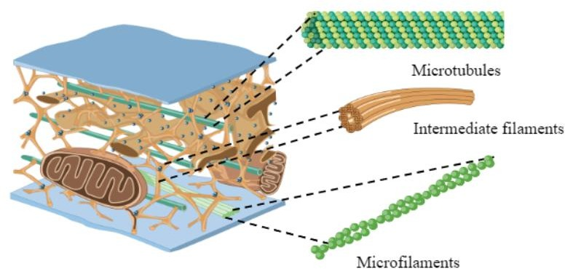

2. Ergastic substances
These are non-protoplasmic substances found in cells, often either organic or inorganic, and they include storage products (like starch and oils), pigments, crystals, and waste products (such as alkaloids and resins). Ergastic substances serve roles in storage, protection, and maintaining cellular structure.

2.1 Starch grains
Starch grains are tiny particles found in plant organs like leaves, roots, stems, fruits, and seeds, serving as energy reserves. Starch is a carbohydrate consumed by humans for energy. Examples include wheat, rice, oats, millet, potatoes, etc.

1-Cut a potato and wipe the middle area of the slice
2-Add a small drop of water, then place the cover.
3-Examine under 10x and 40x magnification and observe the starch grains.
4-Draw the thick lines of the starch grains, as they appear under high magnification. Make the concentric rings centered (concentric lamellae) and the central point or the hilum visible. as shown in the figure.

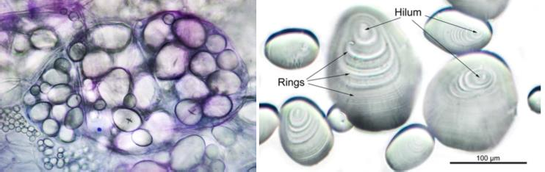

2.2 Pigment granules
Pigment granules, such as melanin granules, are dark particles that contribute to skin color. They are found in the basal layer of the skin and in other tissues like the iris and retina, offering protection against ultraviolet rays.

2.3 Crystals
Calcium oxalate crystals are common in plants, found in various shapes. These crystals, formed in specialized cells called crystalline endodermal cells., play a role in regulating calcium levels and protects the plant body against grazing animals and depends on the size, shape and position of the crystals in the tissue.
يمكن العثور على أنواع مختلفة من البلورات ن يف الخلايا النباتية
You can find different types of crystals in plant cells:
• Prismatic crystals (in the form of a rod or cubic crystals), found in onion peels.
• Raphides crystals (needle-like), found in the stem of the Mirabilis plant.
• Druses crystals (like shining diamonds), found in the stem of the Tilia plant.
• Cystolith crystals (found in the stem and body), in the leaves of the rubber plant (Ficus).

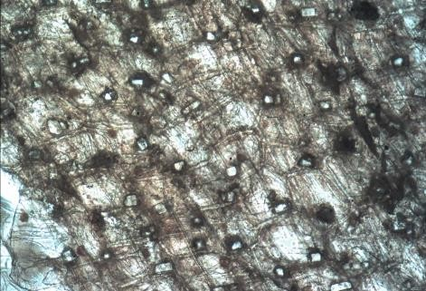
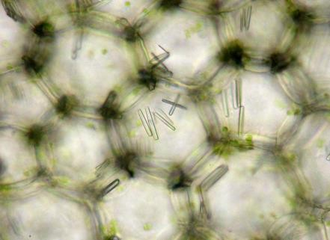
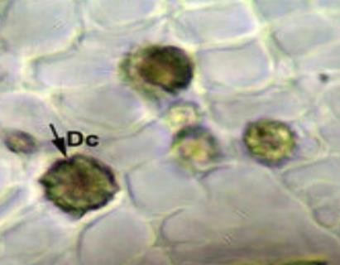
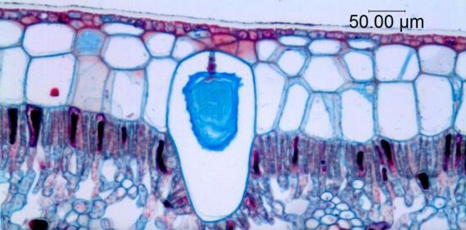

2.4 Vacuoles
Vacuoles are fluid-filled organelles found in plant and fungal cells, making up 30%-90% of the cell's volume.
Vacuoles have three main functions:
1-They help maintain cell rigidity.
2- Store nutrients.
3- Assist in breaking down complex molecules.

Examine the Vacuoles in :

Onion Leaf:
1. Cut a red onion and remove the inner fleshy leaf from it.
2. Cut the leaf from the back and remove the thin transparent piece from the inner skin at the broken point.
3. Once you have the onion piece, prepare a slice by adding a drop of water in the middle of a clean slice. Then place a cover slip on top of the specimen (the sample will be one cell thick).
4. Stain the onion tissue by placing one drop of neutral red stain on the edge of the cover slip and let it sit for 5-15 minutes.
5. Focus carefully to distinguish the surrounding structures with the help of a microscope.

