What is renewable energy?
Renewable energy is energy derived from natural sources that are replenished at a higher rate than they are consumed. Sunlight and wind, for example, are such sources that are constantly being replenished. Renewable energy sources are plentiful and all around us. Fossil fuels, coal, oil, and gas, on the other hand, are non-renewable resources that take hundreds of millions of years to form. Fossil fuels, when burned to produce energy, cause harmful greenhouse gas emissions, such as carbon dioxide. Generating renewable energy creates far lower emissions than burning fossil fuels. Transitioning from fossil fuels, which currently account for the lion’s share of emissions, to renewable energy is key to addressing the climate crisis. Renewables are now cheaper in most countries and generate three times more jobs than fossil fuels.
Benefits of using renewable energy sources
1- Its use is vital given the environmental damage caused by greenhouse gas emissions from fossil fuel use.
2- Using renewable energy sources has positive repercussions across various aspects of economic life, national security, and human health.
3- There is global competition and a significant decrease in the prices of renewable energy technologies worldwide, particularly between 2010 and 2022, with the global average cost of electricity production from solar power decreasing by 88%, wind power by 60%, and marine power by 69%.

Challenge of Using Renewable Energy
1. Renewable energy is not entirely reliable.
2. It cannot meet the full electricity needs of all economic sectors.
3. It is not entirely pollution-free.
4. It requires significant financial resources.
5. The technical and engineering expertise needed to establish and maintain renewable energy plants is limited, particularly in developing countries.
SOLAR ENERGY
Solar energy is the most abundant of all energy resources and can even be harnessed in cloudy weather. The rate at which solar energy is intercepted by the Earth is about 10,000 times greater than the rate at which humankind consumes energy. Solar technologies can deliver heat, cooling, natural lighting, electricity, and fuels for a host of applications. Solar technologies convert sunlight into electrical energy either through photovoltaic panels or through mirrors that concentrate solar radiation. The cost of manufacturing solar panels has plummeted dramatically in the last decade, making them not only affordable but often the cheapest form of electricity. Solar panels have a lifespan of roughly 30 years and come in a variety of shades depending on the type of material used in manufacturing.
Advantages of Solar Energy
1. Renewable Energy Source: Solar energy is obtained from the sun, which is an unlimited and naturally replenished source.
2. Environmentally Friendly: It generates electricity without producing harmful emissions during operation.
3. Reduces Dependence on Fossil Fuels
Solar power decreases the use of coal, oil, and natural gas.
4. Low Operating Cost: After installation, maintenance and running costs are relatively low.
5. Useful in Remote Areas: It can provide electricity in rural or isolated places where grid connection is difficult.
6. Improves Energy Security: Using local solar resources helps reduce electricity shortages.
7. Wide Range of Applications: It is used in homes, industries, water heating, street lighting, etc.
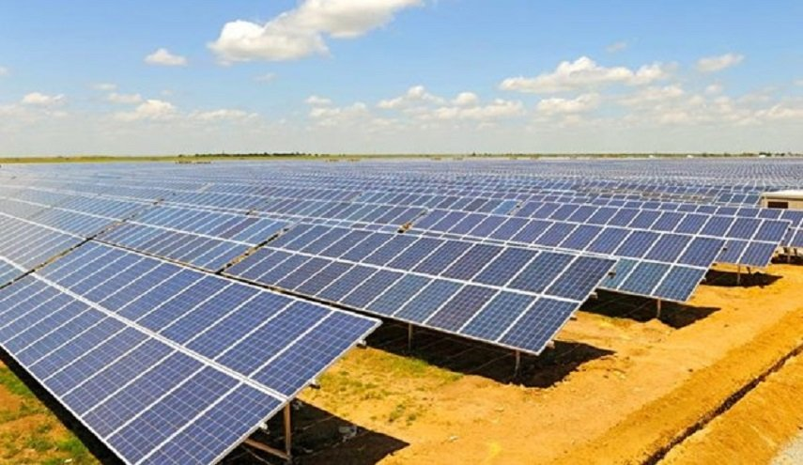

Disadvantages of Solar Energy
1- High Initial Cost: The installation of solar panels, batteries, and inverters can be expensive.
2-Weather Dependent: Electricity generation decreases on cloudy days, during rain, or in dusty conditions.
3- Intermittent Energy Source: Solar power is only available during daylight hours, so storage systems are needed at night.
4- Requires Large Area: Large-scale solar plants need a significant land area for installation.
5- Energy Storage Cost: Batteries used for storing solar energy are costly and have a limited lifespan.
6- Efficiency Limitations: Solar panels cannot convert all sunlight into electricity; efficiency is still limited.
7- Maintenance Needed: Panels must be cleaned regularly, especially in dusty regions, to maintain performance.

Wind energy
Wind energy is one of the most important renewable energy sources used in the modern world. It is generated from the natural movement of air caused by differences in temperature and pressure in the atmosphere. Wind turbines convert the kinetic energy of moving air into electrical energy. Wind energy is clean, sustainable, and helps reduce dependence on fossil fuels. It is widely used in many countries to produce electricity and support environmental protection. Wind energy production is related to several factors:
1-Wind speed., 2-Air density., 3-Turbine blade size.
Challenge of using Wind Energy
1- Intermittent Nature: Wind energy is not constant; it depends on wind speed and availability.
2- High Initial Cost: Wind turbines and installation require significant investment.
3- Noise Generation: Some wind turbines produce noise during operation.
4- Visual Impact: Wind farms can affect the natural landscape.
5- Location Dependent: They must be installed in areas with strong and steady winds.
6- Impact on Wildlife: Birds and bats may be affected by turbine blades.
7- Maintenance Requirements: Regular maintenance is needed, especially for offshore wind turbines.
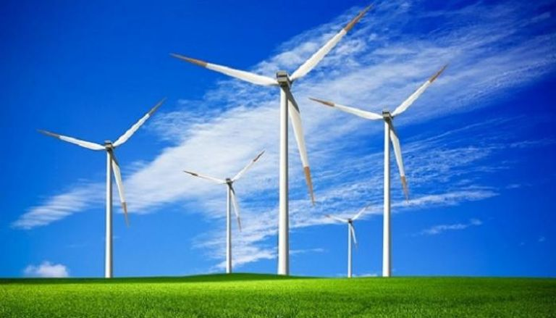

HYDROPOWER ENERGY
It is the energy generated from the movement of water from top to bottom through waterways. Hydroelectric power is one of the most widely used renewable energy sources for electricity generation. Dams are a practical way to generate electricity using flowing water. This energy source depends on consistent rainfall. It is characterized by high efficiency in electricity production. Low energy production costs characterize it because it relies heavily on dams. Its operating costs are low because it depends on dams, which have a lifespan of up to one hundred years. It negatively impacts ecosystems, especially large-scale ones. Hydropower currently is the largest source of renewable energy in the electricity sector. It relies on generally stable rainfall patterns and can be negatively impacted by climate-induced droughts or changes to ecosystems that impact rainfall patterns. The infrastructure needed to create hydropower can also impact ecosystems in adverse ways. For this reason, many consider hydro a more environmentally-friendly option, and especially suitable for communities in remote locations.

