 | 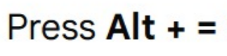
$$∀x$$
$$∧$$ | 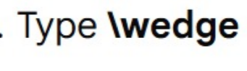
$$→$$

¬ | 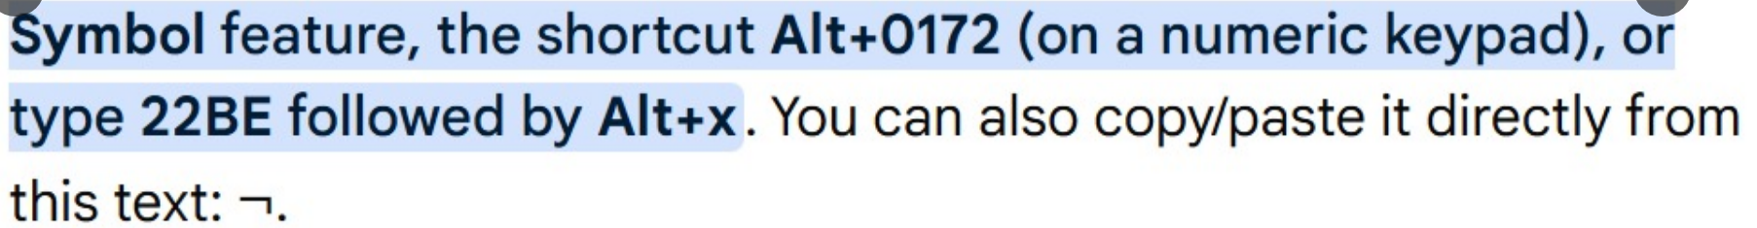
∨

"""
PRACTICAL LAB: Sentence → Predicate → Clause Form Converter
=============================================================
"""
# ─────────────────────────────────────────────
# STEP 1: Input sentence
# ─────────────────────────────────────────────
print("\nSTEP 1: Enter Your Sentence")
sentence = input("Enter sentence: ")
# ─────────────────────────────────────────────
# STEP 2: Define predicates
# ─────────────────────────────────────────────
print("\n\nSTEP 2: Define Predicates")
print("Enter predicates (press Enter when done)\n")
predicates = []
i = 1
while True:
phrase = input(f"Predicate {i} phrase (or Enter to finish): ")
# If the student pressed Enter without typing, stop the loop
if phrase == "":
break
name = input(f"Predicate {i} name: ")
# Store phrase and name together as a tuple, then add to list
single_predicate = (phrase, name)
predicates.append(single_predicate)
i = i + 1
# ─────────────────────────────────────────────
# STEP 3: Build Predicate Form
# ─────────────────────────────────────────────
print("\n\nSTEP 3: Predicate Form")
# Decide how many predicates are CONDITIONS vs RESULTS
if len(predicates) >= 2:
num_conditions = int(input(f"How many are conditions (1-{len(predicates) - 1})? "))
else:
num_conditions = len(predicates)
# Build the CONDITIONS list (left side of the arrow)
conditions = []
for index in range(num_conditions):
predicate_name = predicates[index][1] # [1] gets the name part of the tuple
conditions.append(predicate_name)
# Build the RESULTS list (right side of the arrow)
results = []
for index in range(num_conditions, len(predicates)):
predicate_name = predicates[index][1]
results.append(predicate_name)
# ── Build the condition string ──
if len(conditions) > 1:
# Join multiple conditions with AND symbol
condition_parts = []
for c in conditions:
condition_parts.append(f"{c}(x)")
cond_str = " ∧ ".join(condition_parts)
else:
cond_str = f"{conditions[0]}(x)"
# ── Build the result string ──
result_parts = []
for r in results:
result_parts.append(f"{r}(x)")
res_str = " ∧ ".join(result_parts)
# ── Assemble the full predicate formula ──
if results:
# There IS an implication (conditions → results)
predicate_form = f"∀x ({cond_str} → {res_str})"
else:
# No implication, just the conditions alone
predicate_form = f"∀x ({cond_str})"
print(f"\n Predicate Form:")
print(f" {predicate_form}")
# ─────────────────────────────────────────────
# STEP 4: Convert to Clause Form
# ─────────────────────────────────────────────
print("\n\nSTEP 4: Convert to Clause Form")
if "→" in predicate_form:
print("\nConversion steps:")
# ── Step 4.1: Eliminate implication ──
print("\n1. Eliminate → (A → B becomes ¬A ∨ B)")
if len(conditions) > 1:
# Wrap the whole condition group in ¬(...)
inner_parts = []
for c in conditions:
inner_parts.append(f"{c}(x)")
inner_str = " ∧ ".join(inner_parts)
neg_cond = "¬(" + inner_str + ")"
else:
neg_cond = f"¬{conditions[0]}(x)"
step1 = f"∀x ({neg_cond} ∨ {res_str})"
print(f" {step1}")
# ── Step 4.2: Apply De Morgan's Law ──
if len(conditions) > 1:
print("\n2. Apply De Morgan's Law: ¬(A ∧ B) becomes (¬A ∨ ¬B)")
neg_parts = []
for c in conditions:
neg_parts.append(f"¬{c}(x)")
neg_str = " ∨ ".join(neg_parts)
step2 = f"∀x ({neg_str} ∨ {res_str})"
print(f" {step2}")
else:
step2 = step1
# ── Step 4.3: Drop universal quantifier ──
print("\n3. Drop ∀x (implicit in clauses)")
clause_parts = []
# Add negated conditions
for c in conditions:
clause_parts.append(f"¬{c}(x)")
# Add results (no negation)
for r in results:
clause_parts.append(f"{r}(x)")
clause_form = " ∨ ".join(clause_parts)
print(f" {clause_form}")
else:
# No implication — already in clause form
clause_parts = []
for c in conditions:
clause_parts.append(f"{c}(x)")
clause_form = " ∧ ".join(clause_parts)
print(f"\n Already in clause form: {clause_form}")
# ─────────────────────────────────────────────
# FINAL RESULTS
# ─────────────────────────────────────────────
print("\nFINAL RESULTS")
print(f"\n1. English Sentence:")
print(f" {sentence}")
print(f"\n2. Predicate Form:")
print(f" {predicate_form}")
print(f"\n3. Clause Form:")
print(f" {clause_form}")
print("\nConversion is complete!")

