Lec. 9 Dr Yasir Al-Juraisy
Plastids
The plastids are major double-membrane organelles found in plant cells and algae. Plastids are the site of manufacture and storage of important chemical compounds used by the cell. They contain pigments used in photosynthesis; the types of pigments present can change or determine the cell's colour. They have a double-stranded DNA molecule, which is circular, like that of prokaryotes.
In plants, plastids may differentiate into several forms, depending upon which function they play in the cell. Undifferentiated plastids (proplastids) may develop into any of the following variants:
Chromoplasts
Chromoplasts are red, yellow, or orange in colour and are found in the petals of flowers and in fruit. Their colour is due to two pigments, carotene and xanthophyll.
Functions: in flowers is to attract agents of pollination, and in fruit to attract agents of dispersal.
Leucoplasts
Leucoplasts are colourless plastids and occur in plant cells not exposed to light, such as roots and seeds. They are colourless due to the absence of pigments. Leucoplasts sometimes differentiate into more specialized plastids:
  - Amyloplasts: for starch storage.
  - Elaioplasts: for storing fat .
  - Proteinoplasts: for storing and modifying protein.
  - Tannosomes: for synthesizing and producing tannins and polyphenols.
Functions: centers of starch grain formation; and synthesis of oils and proteins.

Chloroplasts
Chloroplasts are probably the most important among the plastids since they are directly involved in photosynthesis. They are usually situated near the surface of the cell. The green colour of chloroplasts is caused by the green pigment chlorophyll.
Functions: chloroplasts are the sites for photosynthesis; they contain enzymes and co-enzymes necessary for the process of photosynthesis.
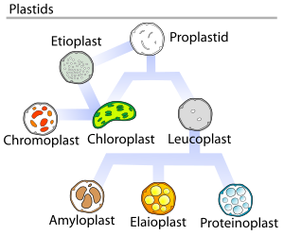

Etioplasts: are an intermediate type of plastid that develop from proplastids that have not been exposed to light, and convert into chloroplasts upon exposure to light. They are usually found in stem and leaf tissue of flowering plants (Angiosperms) grown either in complete darkness, or in extremely low-light conditions.

Chloroplast structures include:
- Membrane Envelope: contains inner and outer membranes that act as protective coverings and keep chloroplast structures enclosed.
- Outer membrane: It is a semi-porous membrane and is permeable to small molecules and ions, which diffuses easily. The outer membrane is not permeable to larger proteins.
- Intermembrane Space: It is usually a thin intermembrane space about 10-20 nanometers, and it is present between the outer and the inner membrane of the chloroplast.
- Inner membrane: The inner membrane of the chloroplast forms a border to the stroma. It regulates the passage of materials in and out of the chloroplast and forms fatty acids, lipids, and carotenoids.
- Thylakoid Membrane: internal membrane system consisting of flattened sac-like membrane structures called thylakoids that serve as conversion sites of light energy to chemical energy.
- Grana (singular granum): densely layered stacks of thylakoid sacs that serve as the sites of conversion of light energy to chemical energy.
Chlorophyll - a green photosynthetic pigment within the chloroplast grana that absorbs light energy.
- Stroma: dense fluid within the chloroplast that lies inside the envelope but outside the thylakoid membrane. This is the site of the conversion of carbon dioxide to carbohydrates (sugar). The chloroplast DNA, chloroplast ribosomes, thylakoid system, starch granules, and many proteins are found floating around the stroma.
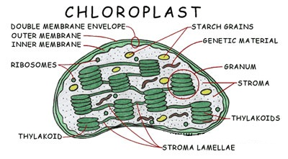

Origin of plastids
Symbiosis may explain the origin of chloroplasts. Chloroplasts have many similarities with photosynthetic bacteria, including circular DNA, prokaryotic-type ribosomes, and similar proteins in the photosynthetic reaction center. The endosymbiotic theory suggests that photosynthetic bacteria were acquired (by endocytosis) by early eukaryotic cells to form the first plant cells. Therefore, chloroplasts may be photosynthetic bacteria that adapted to life inside plant cells.
Chloroplast: Photosynthesis
- Photosynthesis is the process of converting light energy to chemical energy and storing it in the bonds of sugar. This process occurs in plants and some algae. Plants need only light energy, CO₂, and H₂O to make sugar. The process of photosynthesis takes place in the chloroplasts, specifically using chlorophyll.
The overall chemical reaction involved in photosynthesis is:
6 CO₂ + 6 H₂O (+ light energy) → C₆H₁₂O₆ + 6 O₂
Photosynthesis occurs in two stages:
  - The light reaction stage takes place in the presence of light and occurs within the chloroplast grana. The primary pigment used to convert light energy into chemical energy is “chlorophyll a”. Other pigments involved in light absorption include chlorophyll b, xanthophyll, and carotene. In the light reaction stage, sunlight is converted to chemical energy in the form of ATP (a free energy-containing molecule) and NADPH (a high energy electron-carrying molecule). Both ATP and NADPH are used in the dark reaction stage to produce sugar.
- The dark reaction stage is also known as “the carbon fixation stage” or the “Calvin cycle”. Dark reactions occur in the stroma. The stroma contains enzymes that facilitate a series of reactions that use ATP, NADPH, and carbon dioxide to produce sugar. The sugar can be stored in the form of starch, used during respiration, or used in the production of cellulose.
Green plants are green because they contain a pigment called chlorophyll. Chlorophyll absorbs certain wavelengths of light within the visible light spectrum. Chlorophyll absorbs light in the red (long wavelength) and the blue (short wavelength) regions of the visible light spectrum. Green light is not absorbed but reflected, making the plant appear green.

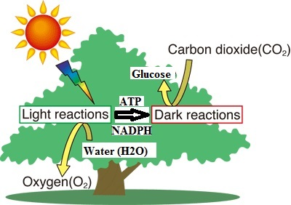

Difference between light and dark reactions in photosynthesis
Light Reaction | Dark Reaction
Occurs: Grana of the chloroplasts. | Occurs: Stroma of the chloroplast
It is a light-dependent process. | This process does not require light.
Involves two photosystems: PS I and PS II | No photosystem is required.
Photolysis of water takes place and oxygen is liberated. | Photolysis of water does not take place. Carbon dioxide is absorbed.
ATP and NADPH are produced, and they are used to drive the dark reaction. | Glucose is produced, and NADPH is oxidized to NADP+.

Differences between Photosynthesis and Respiration
