Lec. 8 Dr Yasir Al-Juraisy
Mitochondria
The term 'mitochondrion' is derived from the Greek word 'mitos' which means 'thread' and 'chondrion' which means 'granule'. The mitochondrion (plural mitochondria) is a membrane-enclosed structure found in most eukaryotic cells. Mitochondria range from 0.5 to 1.0 μm in diameter. These organelles are sometimes described as "powerhouses" because they generate most of the cell's supply of adenosine triphosphate (ATP), used as a source of chemical energy. In addition, mitochondria are involved in other tasks such as cellular differentiation, cell death, as well as the control of the cell cycle and cell growth.
Mitochondria are small organelles floating free throughout the cell. The number of mitochondria in the cell varies widely by organism and tissue type. Some cells have several thousand mitochondria, while others have one. Muscle cells need a lot of energy, so they have loads of mitochondria. Neurons (cells that transmit nerve impulses) don’t need as many. If a cell feels it is not getting enough energy to survive, more mitochondria can be created. It all depends on the needs of the cell.
Mitochondria are independent organelles; they have their own DNA and ribosomes. They can replicate and multiply on their own and make their own proteins. They have circular DNA similar to bacteria and replicate by fission.
Origin of Mitochondria:
There are two hypotheses about the origin of mitochondria: endosymbiotic and autogenous, but the most accredited theory at present is endosymbiosis. The endosymbiosis suggests mitochondrion was originally aerobic prokaryotic cell engulfed by anaerobic eukaryotic cell. The engulfed cell came to rely on the protective environment of the host cell, and conversely, the host cell came to rely on the engulfed prokaryote for energy production. Over time, the engulfed prokaryote developed into mitochondria, and the work of these organelles using oxygen to create energy.
In the autogenous hypothesis, mitochondria were born by splitting off a portion of DNA from the nucleus of the eukaryotic cell; this DNA portion would have been enclosed by membranes, which could be arise from the plasma membrane, ER network, or nuclear envelope.

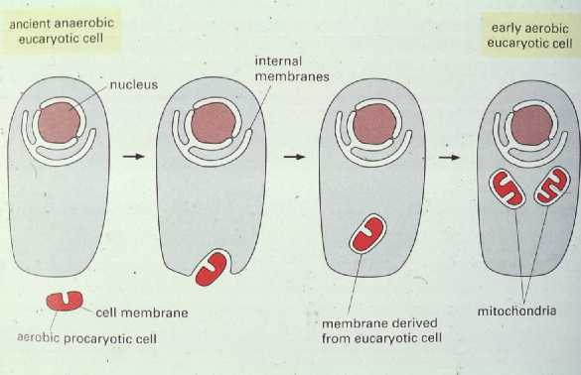
Endosymbiotic Theory

The evidence that is typically offered for endosymbiotic theory includes the following:
- Membranes: Mitochondria have cell membranes, similar to the prokaryotic cell.
- DNA: Each mitochondrion has its own circular DNA genome, like a bacteria's genome, but much smaller.
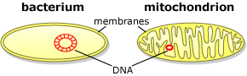

- Reproduction: Mitochondria multiply the same process used by bacteria.
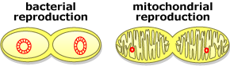

- They are enclosed by a double membrane.
- Mitochondria and bacteria are of similar size and shape.
Mitochondria Structure:
The components of mitochondria are as follows:
Outer membrane
- The outer membrane is freely permeable to nutrient molecules, ions, and energy molecules like the ATP and ADP molecules.
- Is composed of equal amounts of phospholipids and proteins.
- A large number of special proteins are known as porins.
- The porins are integral membrane proteins, and they allow the movement of molecules that are of 5000 Dalton or less in weight to pass through it.
- Larger proteins can enter the mitochondrion if a signaling sequence at their N-terminus binds to a large multisubunit protein called translocase of the outer membrane, which then actively moves them across the membrane.
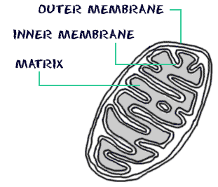

Inner membrane
- The inner membrane is selectively permeable; it is permeable only to oxygen and ATP, and it also helps in regulating the transfer of metabolites across the membrane.
- The inner membrane of mitochondria is more complex in structure.
- Folded into a number of folds many times and is known as the cristae.
- This folding helps to increase the surface area inside the organelle.
- The cristae and the proteins of the inner membrane aid in the production of ATP molecules.
- has a very high protein-to-phospholipid ratio. The inner membrane is home to around 1/5 of the total protein in a mitochondrion.
- Specific transport proteins that regulate metabolite passage into and out of the matrix.
- The area of the inner membrane is about five times as large as the outer membrane. This ratio is variable, and mitochondria from cells that have a greater demand for ATP, such as muscle cells, contain even more cristae.
- Inner membrane is studded with pinhead particles called oxysomes or elementary particles or F particles or subunits of Fernandez Moran (104 to 106 in number). Each F particle consists of three parts: basal plate, stalk, and head. ATP synthesis occurs in the head region of oxysome because here ATPase enzyme is present.
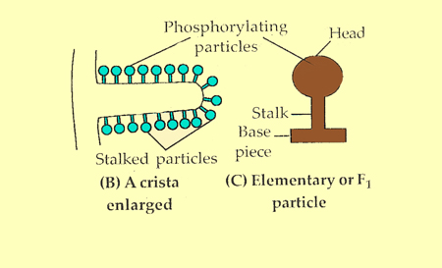

Intermembrane space
- The intermembrane space is the space between the outer membrane and the inner membrane. It is also known as “perimitochondrial space”.
- The protein composition of this space is different from the protein composition of the cytosol. This space is rich in coenzymes and enzymes required for the oxidation of fats.
Matrix
The matrix is the space enclosed by the inner membrane and has 70% of total cell enzymes. The major functions include oxidation of pyruvate and fatty acids and the citric acid cycle (Krebs cycles or TCA). Besides these enzymes, the matrix has a complete protein synthesis apparatus. The matrix contains DNA, RNA, and ribosomes.

Cellular respiration: is the process that releases energy by breaking down glucose and other food molecules in the presence of oxygen. It is the process of converting food energy into ATP energy. This ATP provides cells with the energy they need to carry out the activities of life.
C₆H₁₂O₆ + 6 O₂ → 6 CO₂ + 6 H₂O + ATP
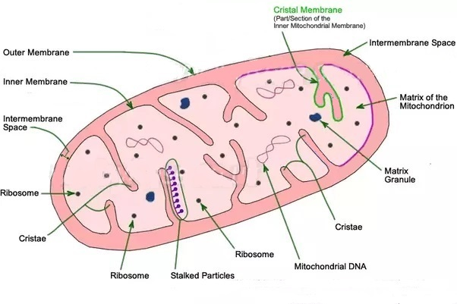

Mitochondrion Structure

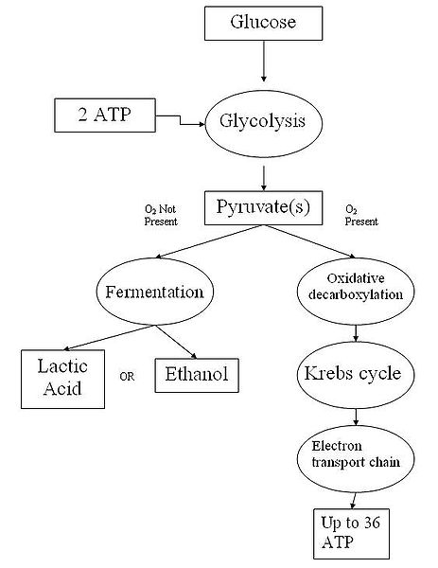

Cellular respiration flow chart

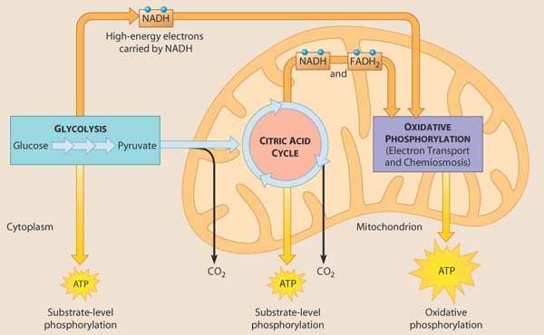

Mechanism of Cellular Respiration
The process occurs in three phases:
- Glycolysis
- The Kreb’s Cycle
- The Electron Transport Chain or Respiratory Chain
Glycolysis: is the first stage of cellular respiration; glucose is broken down into two molecules of pyruvate. During the process, a small amount of energy in the form of ATP is released; most energy is still stored in pyruvate molecules. It takes place in the cytosol.

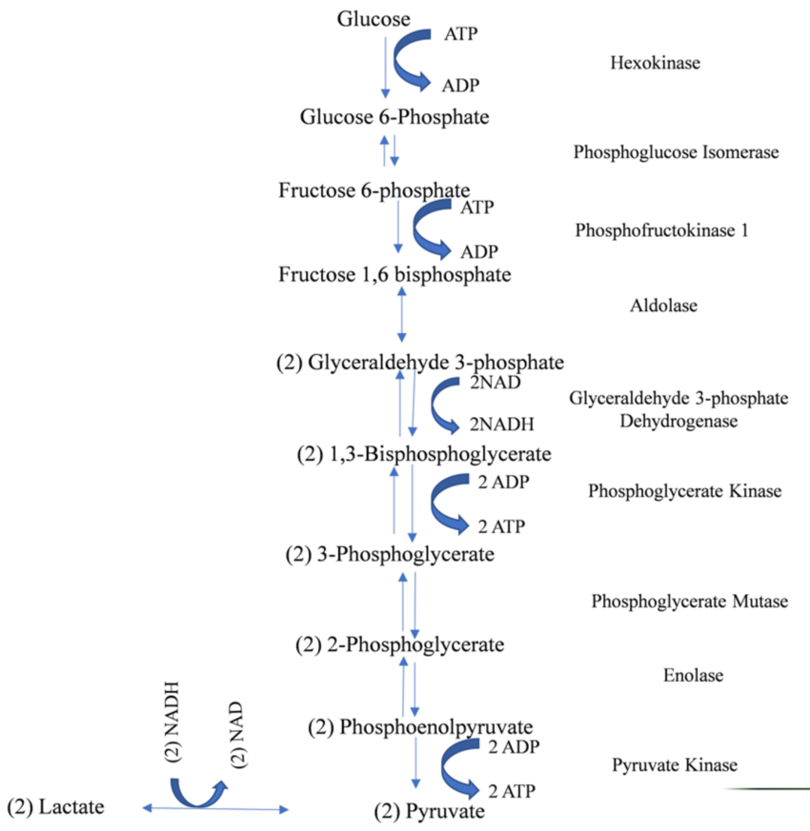

When oxygen is not present, pyruvate will undergo a process called fermentation, only two ATP are produced. Fermentation takes place in the cytosol. It is then converted into waste products, lactic acid and ethanol (alcoholic). It occurs in yeast and bacteria, and also during strenuous exercise, fermentation occurs in the muscles because of limited oxygen supply, creating lactic acid, which also causes muscle cramps.

Fermentation is a process that takes place in the cytosol in anaerobic condition (no oxygen), where the pyruvate is not oxidized; it undergoes the process of fermentation only two ATP are produced. It occurs in yeast and bacteria and also in oxygen-starved muscle cells, as in the case of lactic acid fermentation.
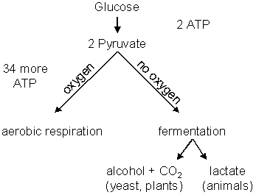

Transition reaction:
If oxygen is present, the two pyruvate molecules enter the transition reaction. The pyruvates move from the cytosol to the matrix of the mitochondria. In the matrix, a carbon dioxide molecule is broken off from each pyruvate. The end product of the transition reaction is a two-carbon molecule called acetyl-CoA.
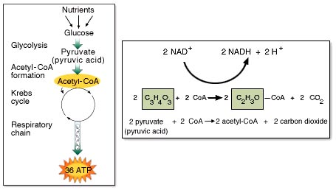

The Krebs Cycle:
This cycle is an oxidative pathway for carbohydrates, proteins, and fats.
- Sometimes it is also called the citric acid cycle because citric acid is first formed, or the tricarboxylic acid cycle (TCA cycle).
- Intermediates of the TCA cycle are used in synthesizing important biomolecules such as glutamate, succinic acid, fumaric acid and oxaloacetic acid.
- During Krebs cycle, pyruvic acid is used to produce carbon dioxide, NADH, ATP, and FADH₂.
- It takes place in the matrix of mitochondria. The Krebs cycle produces some chemical energy in the form of ATP, but most of the chemical energy is in the form of NADH and FADH₂ which then go on to the Electron Transport Chain.
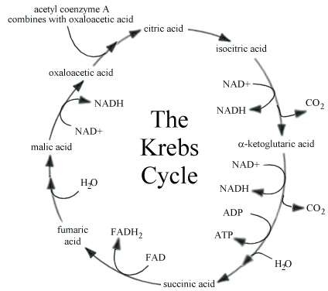

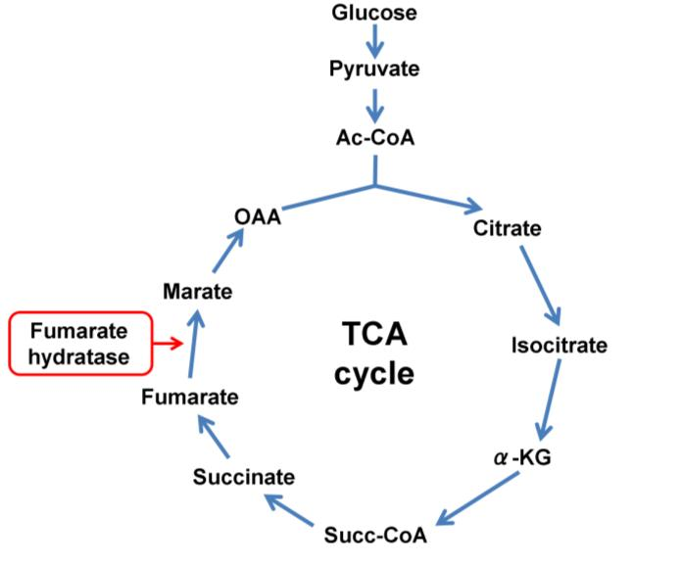

The electron transport chain
An electron transport chain (ETC) is a cellular mechanism using for getting energy. It consists of a series of redox reactions in which electrons are transferred from a donor molecule to an acceptor molecule and couples this electron transfer with the transfer of protons (H⁺ ions) across a membrane.
Inside the inner membrane of the mitochondria, there is a chain of electron carriers. This chain is a series of electron donors and acceptors that use the NADH and FADH₂ that are produced during glycolysis and Krebs cycles. Each electron donor passes electrons to a more electronegative acceptor, which in turn donates these electrons to another acceptor, a process that continues down the series until electrons are passed to oxygen. Passage of electrons between donor and acceptor releases energy, which is used to generate a proton gradient across the mitochondrial membrane by actively “pumping” protons into the intermembrane space, producing a thermodynamic state that has the potential to do work. The entire process is called oxidative phosphorylation.
Oxidative phosphorylation
Is the synthesis of ATP by phosphorylation of ADP, for which energy is obtained by the transfer of electrons from NADH and FADH₂ through a series of electron carriers.
What couples the formation of ATP to the transfer of electrons? a proton gradient
Where in the cell does oxidative phosphorylation take place?
Innermitocondrial membrane
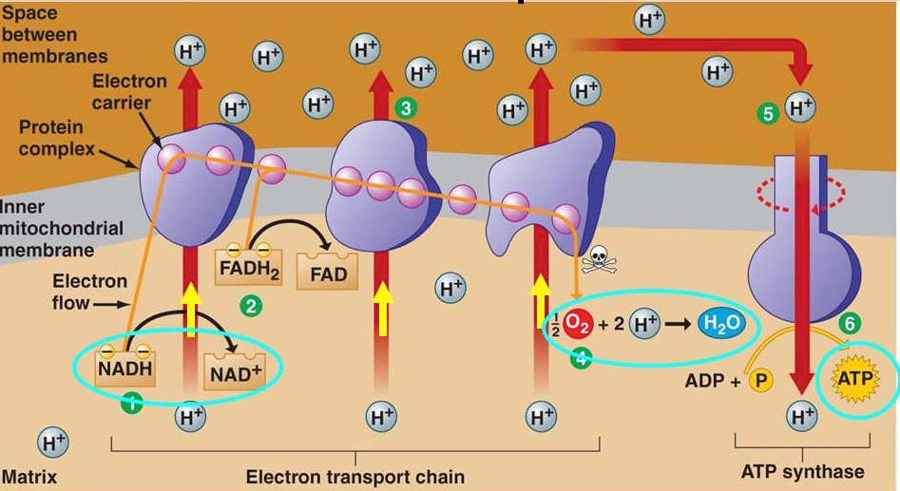

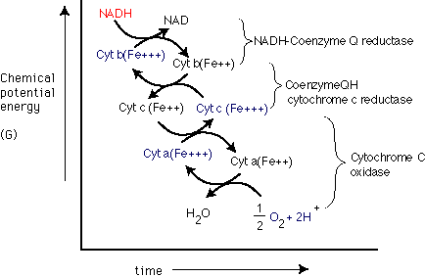

Total ATP Produced during Cellular Respiration
Both glycolysis and the TCA cycle produce 2 molecules of ATP per molecule of glucose (total 4 ATP). 10 NADH produces 30 ATP molecules (10x3), and 2 FADH₂ produces 4 ATP molecules.
Thus, a total of 38 ATP molecules are produced per glucose molecule oxidized.
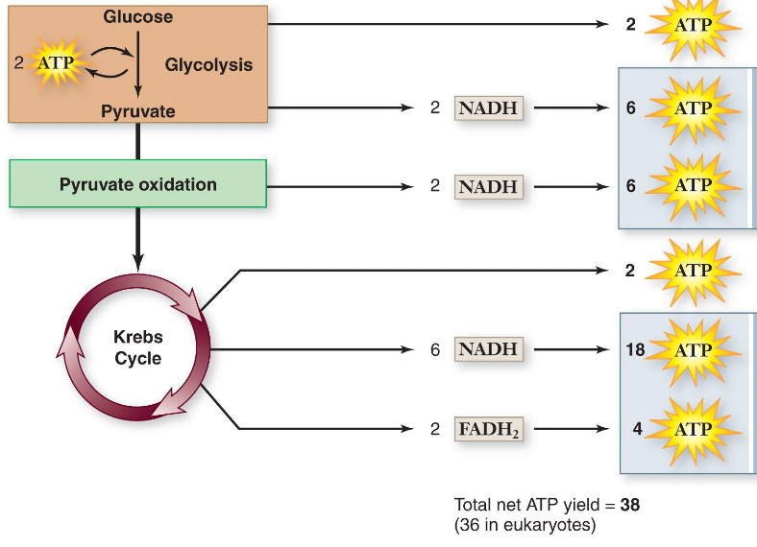

Additional functions for mitochondria
- Heat production
- Storage of calcium ions
- Apoptosis (programmed cell death)
- Calcium signaling (including calcium-evoked apoptosis)
- Regulation of cellular metabolism
- Cholesterol metabolism
- Detoxification of ammonia in the uric cycle.

