Ribosomes
Ribosomes are special because they are found in both prokaryotes and eukaryotes. Every cell needs ribosomes to manufacture proteins. Since there are no membrane-bound organelles in prokaryotes, the ribosomes float free in the cytosol.
Ribosomes are found in many places around the eukaryotic cell. You might find them floating in the cytosol. Those floating ribosomes make proteins that will be used inside of the cell. Other ribosomes are found on the endoplasmic reticulum; the attached ribosomes make proteins that will be used inside the cell and proteins made for export out of the cell. There are also ribosomes attached to the nuclear envelope. Those ribosomes synthesize proteins that are released into the perinuclear space.

Two Pieces Make the Whole
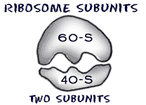
There are two pieces or subunits to every ribosome. For example, prokaryotes have ribosomes that are slightly smaller than eukaryotes. The 60-S/ 40-S model works fine for eukaryotic cells with ribosome of 80S, while prokaryotic cells have ribosomes made of 50-S and 30-S subunits which made a ribosome with 70S. Scientists have used this difference in ribosome structure to develop drugs that can kill prokaryotic microorganisms that cause diseases. There are even structural differences between ribosomes found in the mitochondria and free ribosomes.
S= Svedberg Unit
This unit is a measure of the sedimentation coefficient, which describes how fast a particle settles (sediments) in a solution under a strong gravitational field, typically during ultracentrifugation.
Note: Because the S value is based on shape and density (which change when subunits combine), the Svedberg units of the individual subunits do not simply add up to the total Svedberg value of the complete ribosome.

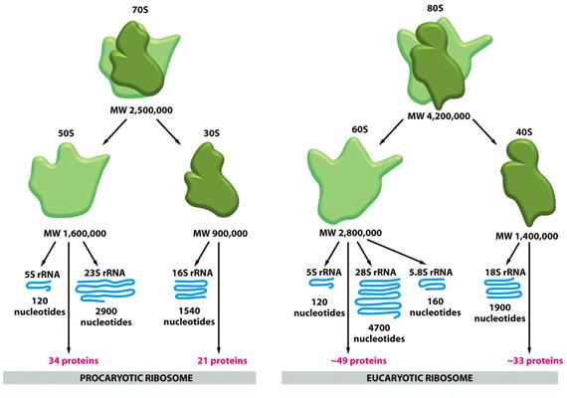

Mixing and Matching Amino Acids
When are ribosomes used in the process of protein synthesis?
When the cell needs to make a protein, mRNA is created in the nucleus. The new mRNA then moves out of the nucleus through the nuclear pores into the cytoplasm. When it is time to make the protein, the two subunits come together and combine with the mRNA. The subunits lock onto the mRNA and start the protein synthesis.
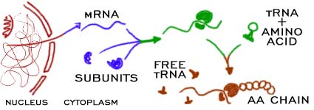

The process of making proteins is quite simple. First, you need an amino acid. Another nucleic acid that lives in the cell is transfer RNA (tRNA). tRNA is bonded to the amino acids floating around the cell. With the mRNA offering instructions, the ribosome connects to a tRNA and pulls off one amino acid. The tRNA is then released back into the cell and attaches to another amino acid. The ribosome builds a long amino acid (polypeptide) chain that will eventually be part of a larger protein.

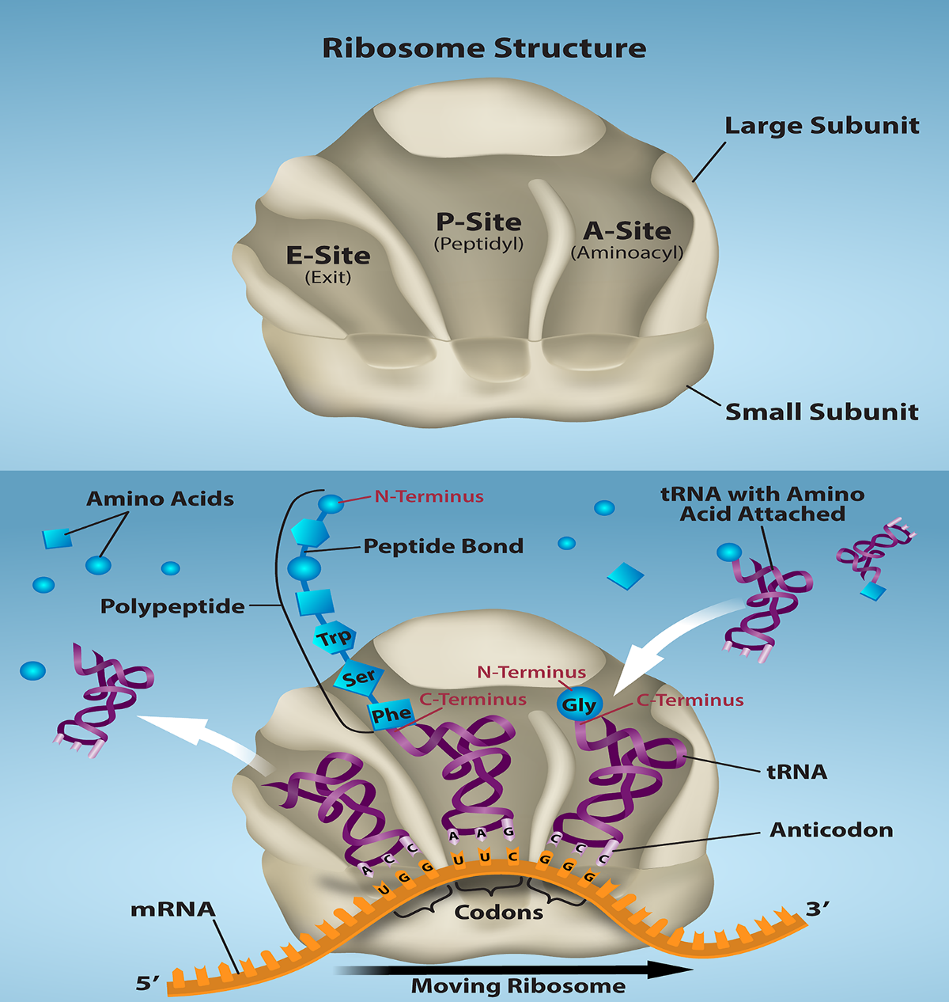

The ribosome's function is centered around three key binding sites for transfer RNA (tRNA) molecules, which are typically referred to as the A site, P site, and E site.
These sites work in sequence during protein synthesis (translation) as the ribosome moves along the messenger RNA (mRNA) strand:
- A site (Aminoacyl site): This is where the incoming tRNA molecule, carrying a new amino acid, first binds to the ribosome. It ensures the correct match between the mRNA codon and the tRNA anticodon before the amino acid is added to the growing chain.
- P site (Peptidyl site): After the new amino acid is accepted at the A site, the growing polypeptide chain is transferred from the P-site tRNA to the new amino acid at the A-site. The tRNA holding the elongated chain then moves to the P site. This site holds the tRNA with the nascent (growing) protein.
- E site (Exit site): This is the final site the now "empty" or deacylated tRNA occupies before it is released from the ribosome back into the cytoplasm to pick up another amino acid. The E site is sometimes described as being on the "L1 side" of the large ribosomal subunit, which might be what you're thinking of as the "east side".
The coordinated movement of tRNAs through these sites is crucial for the efficient and accurate synthesis of a protein.

