Properties of Buffer Solutions
1- The Effect of Dilution
The pH of a buffer solution remains essentially independent of dilution until the concentrations of the species it contains are decreased to the point where the approximations used was invalid.
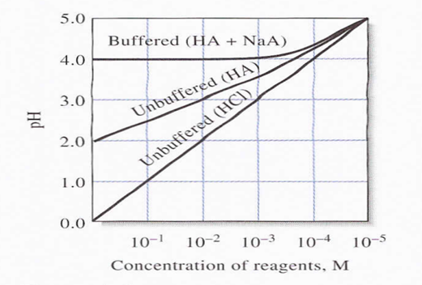
The effect of dilution of the pH of buffered and unbuffered solutions. The dissociation constant for HA is 10⁻⁴. Initial solute concentrations are 1.00 M.
Example: Calculate the pH of a solution that is 0.200 M in NH₃ and 0.300 M in NH₄Cl. dissociation constant K_{a} for NH₄⁺ is 5.70 ×10⁻¹⁰, then calculate the pH change that takes place when a 100mL portion of (a) 0.0500 M NaOH and (b) 0.0500 M HCI is added to 400 mL of the buffer solution.
2- The Effect of Added Acids and Bases
Example above illustrates a second property of buffer solutions, their resistance to pH change after addition of small amounts of strong acids or bases.
It is interesting to contrast the behavior of an unbuffered solution with a pH of 9.07 to that of the buffer in Example above. It can be readily shown that adding the same quantity of base to the unbuffered solution would increase the pH to 12.00 a pH change of 2.93 units. In unbuffered solution adding same amount of acid would decrease the pH by slightly more than 7 units.

Example: Calculate the pH change that takes place when a 100 mL portion of (a) 0.0500 M NaOH and (b) 0.0500 M HCI is added to 400 mL of the buffer solution that is 0.200 M in NH₃ and 0.300 M in NH₄Cl, we find that the acid dissociation constant Ka for NH₄⁺ is 5.7×10⁻¹⁰.
3- Buffer Capacity
The buffer capacity of a buffer is the number of moles of strong acid or strong base that 1 L of the buffer can absorb without changing pH by more than 1. Figure and Example above demonstrate that a solution containing a conjugate acid/base pair possesses remarkable resistance to changes in pH. The ability of a buffer to prevent a significant change in pH is directly related to the total concentration of the buffering species as well as to their concentration ratio. For example, the pH of a 400-mL portion of a buffer formed by diluting the solution described in Example by 10 would change by about 0.4 to 0.5 unit when treated with 100 mL of 0.0500 M sodium hydroxide or 0.0500 M hydrochloric acid. We showed in Example that the change is only about 0.04 to 0.05 unit for the more concentrated buffer.
The buffer capacity, β of a solution is defined as the number of moles of a strong acid or a strong base that causes 1.00 L of the buffer to undergo a 1.00 unit change in pH. Mathematically, buffer capacity is given by
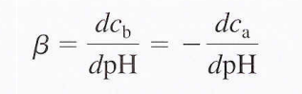
Where, dcb is the number of moles per liter of strong base and dca is the number of moles per liter of strong acid added to the buffer. Since adding strong acid to a buffer causes the pH to decrease, dc/dpH is negative, and buffer capacity is always positive. The capacity of a buffer depends not only on the total concentration of the two buffer components but also on their concentration ratio. Buffer capacity decreases, pKa of the acid chosen for a given application should lie within ±1 unit of the desired pH for the buffer to have a reasonable capacity.
Preparation of Buffers
In principle, a buffer solution of any desired pH can be prepared by combining calculated quantities of a suitable conjugate acid/base pair. In practice, however, the pH values of buffers prepared from theoretically generated recipes differ from the predicted values because of uncertainties in the numerical values of many dissociation constants and from the simplifications used in calculations. Because of these uncertainties, we prepare buffers by making up a solution of approximately the desired pH Example below and then adjusting it by adding strong acid or strong base until the required pH is indicated by a pH meter. Alternatively, empirically derived recipes for preparing buffer solutions of known pH are available in chemical handbooks and reference works.

Example:
Describe how you might prepare approximately 500.0 mL or a pH 4.5 buffer solution from 1.0 M acetic acid (HOAc) and sodium acetate (NaOAc). It is reasonable to assume there is little volume change if we add solid sodium acetate to the acetic acid solution. We then calculate the mass of NaOAc to add to 500.0 mL of 1.0 M HOAc. The H3O+ concentration should be
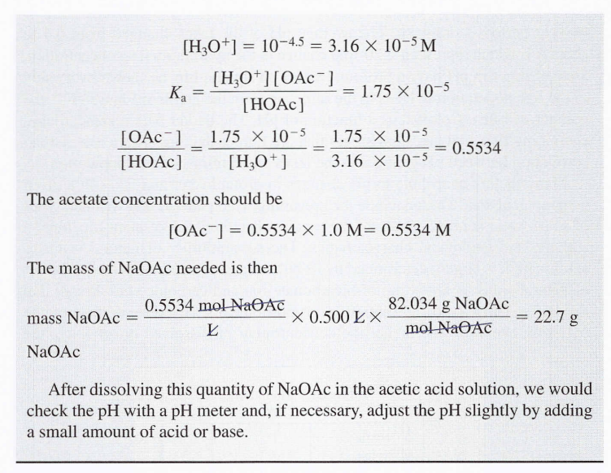
Selection of Suitable Buffer Mixtures: There are two useful rules of thumb for selecting buffer mixtures:
1- A good buffer mixture should have about equal concentrations of both of its components. A buffer solution has generally lost its usefulness when one component of the buffer pair is less than about 10% of the other. Figure below shows how Ph changes for an acetic acid-acetate ion buffer as base is added. The initial Ph is 4.74. A change of 1 Ph unit occurs when the acetic acid concentration is reduced to 11% of the acetate ion concentration.

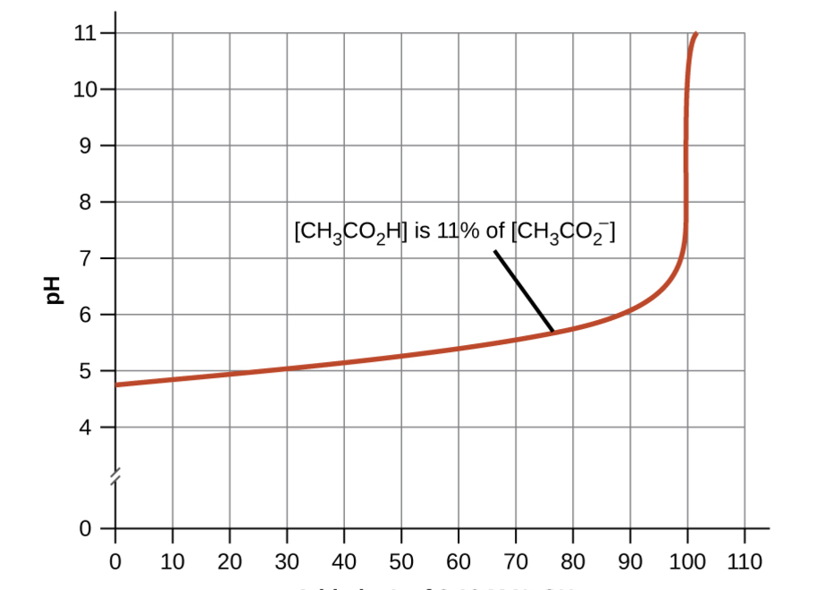
Added of Ml of o.1 M NaOH
Change in Ph as an increasing amount of a 0.10 M NaOH solution is added to 100 Ml of a buffer solution in which, initially, [CH₃CO₂H] = 0.10 M and Note the greatly diminished buffering action occurring after the buffer capacity has been reached, resulting in drastic rises in Ph on adding more strong base.
2- Weak acids and their salts are better as buffers for pH less than 7. weak bases and their salts are better as buffers for pH greater than 7. Blood is an important example of a buffered solution, with the principal acid and ion responsible for the buffering action being carbonic acid, H₂CO₃, and the bicarbonate ion, HCO⁻³. When a hydronium ion is introduced to the blood stream, it is removed primarily by the reaction:
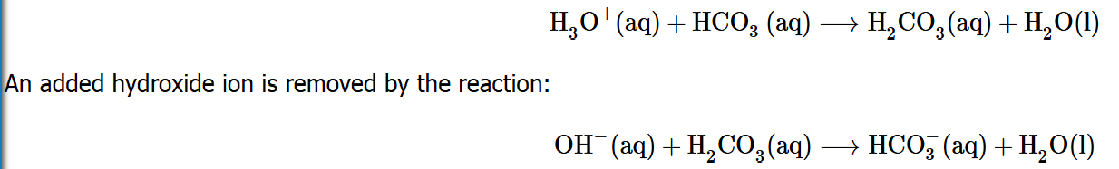
The added strong acid or base is thus effectively converted to the much weaker acid or base of the buffer pair (H₃O⁺ is converted to H₂CO₃ and OH⁻ is converted to HCO₃⁻). The pH of human blood thus remains very near the value determined by the buffer pairs pKa, in this case, 7.35. Normal variations in blood pH are usually less than 0.1, and pH changes of 0.4 or greater are likely to be fatal.

