Lec. 6 Dr Yasir Al-Juraisy
The Golgi apparatus
The Golgi apparatus (GA), also called Golgi body or Golgi complex, is found universally in both plant and animal cells. It is typically comprised of a series of four to eight cup-shaped, membrane-covered sacs called cisternae that look something like a stack of deflated balloons.
In some unicellular flagellates, however, as many as 60 cisternae may combine to make up the Golgi body. Similarly, the number of Golgi bodies per cell varies according to its function. Animal cells tend to have fewer and larger Golgi bodies, while plant cells can contain as many as several hundred smaller versions. The cisternae are held together into a single complex by cytoplasmic microtubule connections.
This complex is usually located close to the cell nucleus.

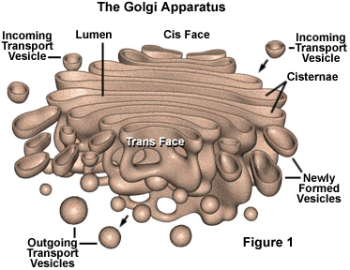

Golgi Apparatus Structure:
The Golgi is composed of membrane-bound stacks known as “Cisternae” (singular: cisterna). Each cisterna comprises a flattened membrane disk and carries Golgi enzymes to help or modify cargo proteins that travel through them. The cisternae stack has five functional regions: the cis-Golgi network, cis-Golgi, medial-Golgi, trans-Golgi, and trans-Golgi network.
Vesicles from the endoplasmic reticulum (via the vesicular-tubular cluster) fuse with the cis-Golgi network and subsequently progress through the stack to the trans-Golgi network, where they are packaged and sent to the required destination. Each region contains different enzymes which selectively modify the contents depending on where they reside.
The cisternae also carry structural proteins important for their maintenance as flattened membranes that stack upon each other. The trans-face of the trans-Golgi network is the face from which vesicles leave the Golgi.
These vesicles then proceed to later compartments such as the cell membrane, secretory vesicles, or late endosomes. The modifications to molecules that take place in the Golgi apparatus occur in an orderly fashion.
Each Golgi stack has two distinct ends, or faces. The cis-face of a Golgi stack is the end of the organelle where substances enter from the endoplasmic reticulum for processing, while the trans-face is where they exit in the form of smaller detached vesicles.
Consequently, the cis-face is found near the endoplasmic reticulum, from where most of the material it receives comes, and the trans-face is positioned near the plasma membrane of the cell, to where many of the substances it modifies are shipped. The chemical make-up of each face is different, and the enzymes contained in the lumens (inner open spaces) of the cisternae between the faces are distinctive.
Diagram of secretory process from endoplasmic
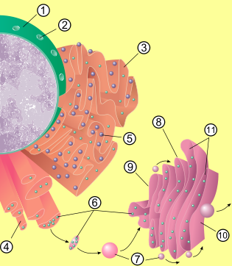
reticulum (orange) to Golgi apparatus (pink).
- Nuclear Membrane
- Nuclear Pore
- Rough Endoplasmic Reticulum (RER)
- Smooth Endoplasmic Reticulum (SER)
- Ribosome attached to RER
- Macromolecules
- Transport vesicles
- Golgi apparatus
- Cis-face of Golgi apparatus
- Trans-face of Golgi apparatus
- Cisternae of lipids
Smoothendoplasmic reticulum(sER)
 5. Ribosomeattachedto rER6.Macromolecules
 7. Transportvesicles
 8. Golgiapparatus
 9.Cisfaceof Golgi apparatus
 10.Transfaceof Golgi apparatus
-  11.Cisternaeof lipids

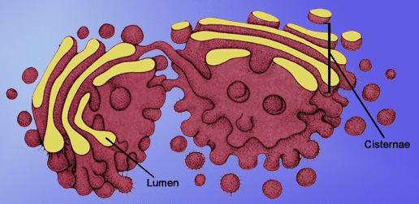

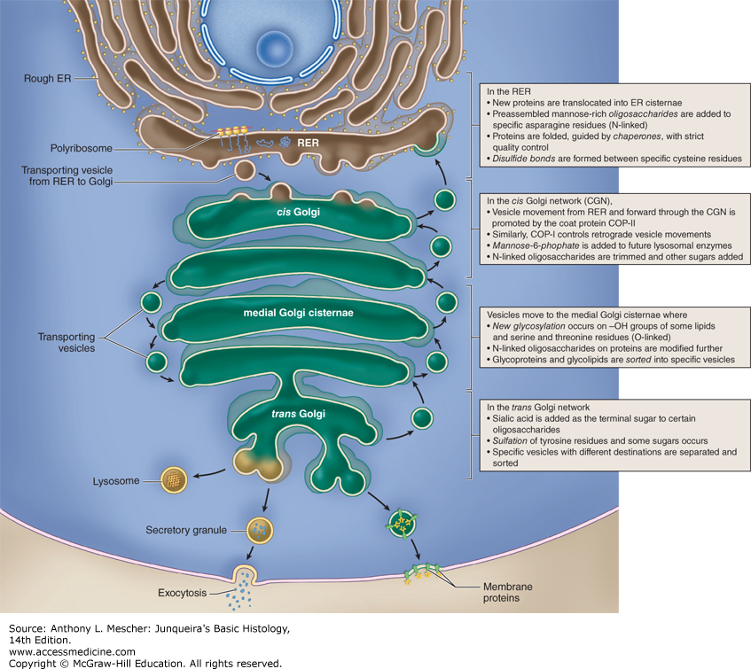

Endoplasmic reticulum
The endoplasmic reticulum (ER) is eukaryotic organelle that forms an interconnected network of tubules, vesicles, and cisternae within cells. The general structure of the endoplasmic reticulum is an extensive membrane network of cisternae held together by the cytoskeleton.
The phospholipid membrane encloses a space, the cisternal space (or lumen), from the cytosol, which is continuous with the perinuclear space. The functions of the endoplasmic reticulum vary greatly depending on the exact type of endoplasmic reticulum and the type of cell in which it resides.
The three varieties are called rough endoplasmic reticulum (RER), smooth endoplasmic reticulum (SER) and sarcoplasmic reticulum (SR). The quantity of RER and SER in a cell can quickly interchange from one type to the other, depending on changing metabolic needs.
Rough Endoplasmic Reticulum
The surface of the rough endoplasmic reticulum (RER) is studded with protein-manufacturing ribosomes giving it a "rough" appearance (hence its name). However, the ribosomes bound to the RER at any one time are not a stable part of this organelle's structure as ribosomes are constantly being bound and released from the membrane. A ribosome only binds to the ER once it begins to synthesize a protein destined for the secretory pathway.
Here, a ribosome in the cytosol begins synthesizing a protein until a signal recognition particle recognizes the pre-piece of 5-15 hydrophobic amino acids preceded by a positively charged amino acid. This signal sequence allows the recognition particle to bind to the ribosome, causing the ribosome to bind to the RER and pass the new protein through the ER membrane. The pre-piece is then cleaved off within the lumen of the ER and the ribosome released back into the cytosol.

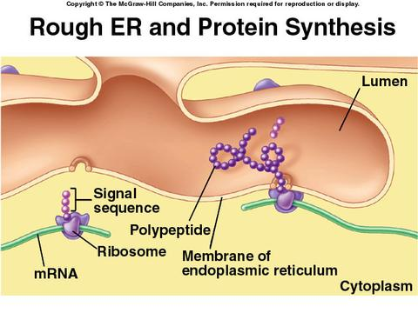

The membrane of the RER is continuous with the outer layer of the nuclear envelope. Although there is no continuous membrane between the RER and the Golgi apparatus, membrane-bound vesicles shuttle proteins between these two compartments. Vesicles are surrounded by coating proteins called COPI and COPII. COPII targets vesicles to the Golgi and COPI marks them to be brought back to the RER.

Smooth Endoplasmic Reticulum
The smooth endoplasmic reticulum (SER) has functions in several metabolic processes, including synthesis of lipids and steroids, metabolism of carbohydrates, regulation of calcium concentration, drug detoxification, attachment of receptors on cell membrane proteins, and steroid metabolism. It is connected to the nuclear envelope. Smooth endoplasmic reticulum is found in a variety of cell types (both animal and plant), and it serves different functions in each.
The SER also contains the enzyme glucose-6-phosphatase, which converts glucose-6-phosphate to glucose, a step in gluconeogenesis. The SER consists of tubules and vesicles that branch, forming a network. In some cells, there are dilated areas like the sacs of RER. The network of SER allows increased surface area for the action or storage of key enzymes and the products of these enzymes.

The Sarcoplasmic Reticulum
The sarcoplasmic reticulum (SR), from the Greek sarx,"flesh", is a special type of smooth ER found in smooth and striated muscle. The only structural difference between this organelle and the SER is the medley خليط)) of proteins they have, both bound to their membranes and drifting within the confines (حدود)of their lumens. This fundamental difference is indicative of their functions: the SER synthesizes molecules, while the SR stores and pumps calcium ions. The SR contains large stores of calcium, which it sequesters (يحجز)and then releases when the muscle cell is stimulated. The SR's release of calcium upon electrical stimulation of the cell plays a major role in excitation-contraction coupling.

