Lec. 5 Dr Yasir Al-Juraisy
Lysosomes and Microbodies
Lysosomes are spherical bodies enclosed by a single membrane. They are formed by the Golgi apparatus. It is found in both plant and animal cells, but is more common in animal cells. Lysosomes are not visible under a light microscope.
They contain different kinds of hydrolytic enzymes including: Lipase which digests lipids; Amylase which digests carbohydrates; Protease which digests proteins; and Nuclease which digests nucleic acids.
The size of the lysosome varies from 0.1–1.2 μm. At pH 4.8, the interior of the lysosomes is acidic compared to the slightly basic cytosol (pH 7.2). The lysosome maintains this pH differential by pumping protons (H+ ions) from the cytosol across the membrane via proton pumps and chloride ion channels. They are frequently nicknamed "suicide bags" or "suicide sacs" by cell biologists due to their role in autolysis.
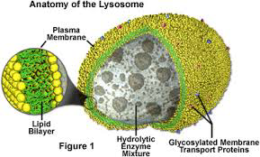

Why are the contents of the cell protected from the digestive enzymes of the lysosome? First, the enzymes are enclosed in the lysosomal membrane. Second, even if the enzymes were to leak out of the lysosome, they would not be active at the neutral pH of the cytosol.
Formation of lysosomes: Lysosomal protein genes are transcribed in the nucleus. mRNA transcripts exit the nucleus into the cytosol, where they are translated by ribosomes. The peptide chains are translocated into the rough endoplasmic reticulum where they are modified. Upon exiting the endoplasmic reticulum and entering the Golgi apparatus via vesicular transport, a specific lysosome tag, mannose 6-phosphate, is added to the peptides. The presence of these tags allows for binding to mannose 6-phosphate receptors in the Golgi apparatus, a phenomenon that is crucial for proper packaging into vesicles destined for the lysosomal system.

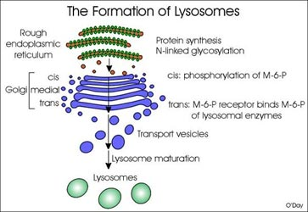

Extracellular materials to be degraded in the lysosome are brought into the cell by either pinocytosis or phagocytosis. These small vesicles carrying endocytosis molecules are initially delivered to membranous organelles called endosomes.
Endosome: is a membrane-bounded compartment inside eukaryotic cells. It is a compartment of the endocytic membrane transport pathway from the plasma membrane to the lysosome.
Lysosomes are divided into groups according to stages of development:
- Primary lysosome is formed and secreted by the Golgi body. It obtains over 60 hydrolases without activity. When the lysosome is broken or a substance enters the lysosome, the enzymes can be activated immediately.
- Secondary lysosomes: primary lysosomes fused with heterophagosomes or with autophagosomes. It is classified into two types:
- Autophagy: refers to a process whereby the cell digests its own contents. For example, when a mitochondrion comes to the end of its life, the newly enclosed mitochondrion then fuses with a lysosome.
- Heterophagy: refers to a process whereby lysosomes in the intracellular digestion of material gathered from outside of the cell by some kind of endocytosis mechanism. Heterophagy is of two types, namely phagocytosis and pinocytosis.
- Residual bodies: the residual body is the lysosome that has lost its enzyme activity and contains the undigested residues only. Residual bodies can be exported out of cells or remained in cells, such as lipofuscins in liver cells.
Lysosomal Storage Disease
Lysosomal storage diseases are caused by the accumulation of macromolecules (proteins, polysaccharides, and lipids) in the lysosomes because of a genetic failure to manufacture an enzyme needed for their breakdown. Neurons of the central nervous system are particularly susceptible to damage. The accumulated materials impair or kill the affected cells, resulting in skeletal or muscular defects, mental retardation, or even death.
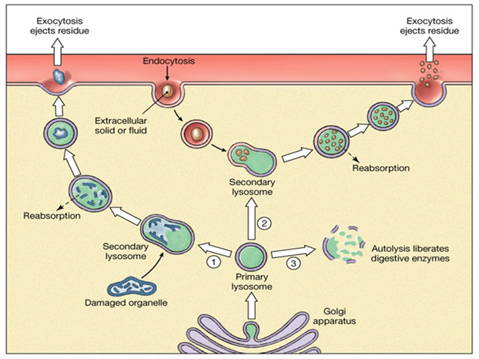
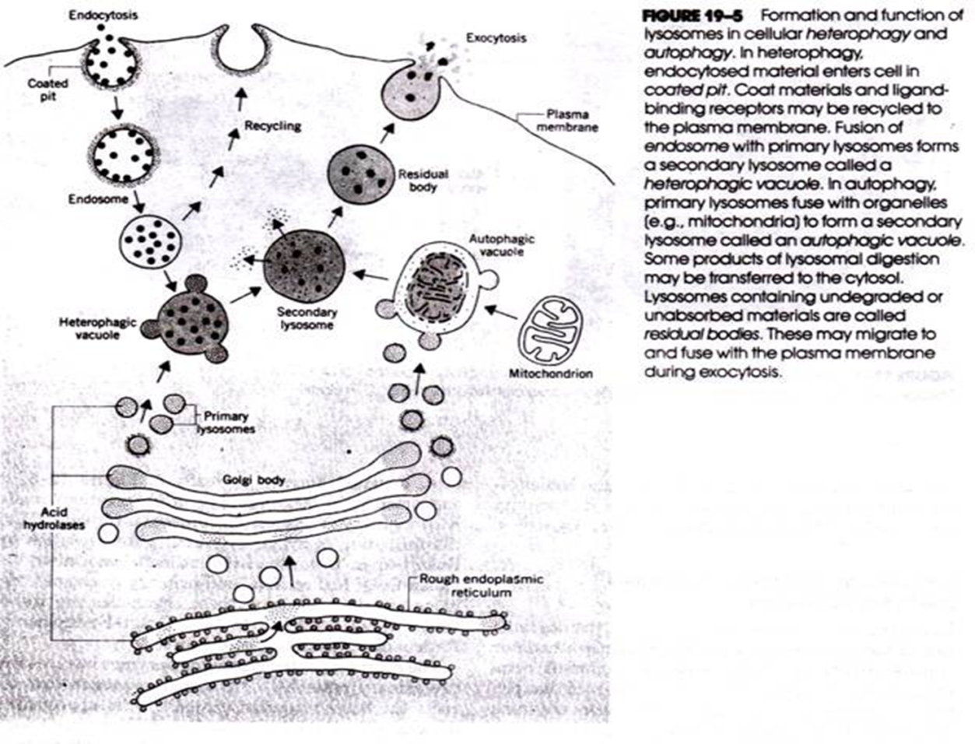
Function of lysosome:
- Digestion in cell: The macromolecules entered by phagocytosis can be digested by the lysosome to be utilized by the cell.
- Apoptosis: Lysosomes are also involved in programmed cell death.
- Autolysis: which is a catabolic process involving degradation of the cells own components. This is the reason why lysosomes are often known as "suicide bags" or "suicide sacs".
- Defense: Macrophage kills pathogens using its lysosome.
- Regulation to endocrine: Thyroglobulin can be digested in the lysosome as thyroxin.
- Formation of acrosome of sperm: the acrosome helps sperm to enter the ovum.
- Repair the damage to the plasma membrane. They serve as membrane patches and help in sealing the wound in the plasma membrane.

Microbodies
Microbodies are membrane-bound organelles found in both plants and animal cells. These bodies appear to be bound by a single unit membrane and are characterized by the presence of specific enzymes. Microbodies are originating from the ER. There are two main types of microbodies: peroxisomes and glyoxysomes.
Peroxisome: is a small organelle present in the cytoplasm of many cells; it contains catalase and oxidase enzymes. It’s a vesicle with a spherical shape, ranging from 0.2-1.5 micrometers in diameter. Peroxisomes originate from the endoplasmic reticulum, not from Golgi apparatus (that is the source of lysosomes). They are surrounded by a single membrane, and they contain a matrix of intracellular material, including enzymes and other proteins. Peroxisomes were defined as organelles that carry out oxidation reactions leading to the production of hydrogen peroxide. Because hydrogen peroxide is harmful to the cell, peroxisomes also contain the enzyme catalase, which decomposes hydrogen peroxide either by converting it to water or by using it to oxidize another organic compound.
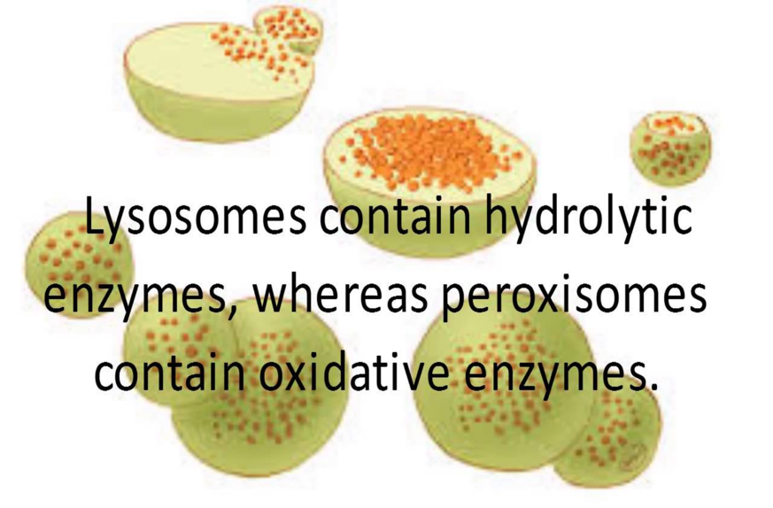
Note: In animal cells, fatty acids are oxidized in both peroxisomes and mitochondria, but in yeasts and plants, oxidation of fatty acids is restricted to peroxisomes.
Some of the functions of the peroxisomes:
1- Lipid metabolism and chemical detoxification.
2- Responsible for oxidation reactions that break down fatty acids and amino acids.
3- Neutralize free radicals, which cause cellular damage and cell death.
4- Peroxisomes chemically neutralize poisons through a process that produces large amounts of toxic H₂O₂, which is then converted into water and oxygen.
5- The liver is the organ primarily responsible for detoxifying the blood before it travels throughout the body; as a result, liver cells contain large amounts of peroxisomes.
6- They detoxify alcohol and other harmful compounds.
7- Initiate the production of phospholipids, which are typically used in the formation of membranes.
Peroxisomes play important roles in plants. Peroxisomes in seeds are responsible for the conversion of stored fatty acids to carbohydrates, which is critical to providing energy and raw materials for the growth of the germinating plant.
How are different between lysosomes and peroxisomes?
- Lysosomes contain hydrolase enzymes. These enzymes are responsible for digestion. Peroxisomes, on the other hand, contain three oxidative enzymes such as catalase, D-amino acid oxidase, and uric acid oxidase.
- Lysosomes are responsible for the digestion of cells, while peroxisomes are responsible for the protection of cells against hydrogen peroxide.
Glyoxysomes:
They are very small spherical bodies with a single unit membrane found only in plants (particularly in the fat storage tissues of germination seeds) and also in filamentous fungi. They contain enzymes for the glyoxylate pathway. They are found in abundance in the cells of germinating oil seeds and some fungi. β-oxidation of fatty acids produces acetyl CoA, which is metabolized in the glyoxylate cycle to produce carbohydrates. It also helps in the conversion of stored lipid in germination oil seeds into glucose, called gluconeogenesis. Glyoxysomes participate in photorespiration and nitrogen fixation.
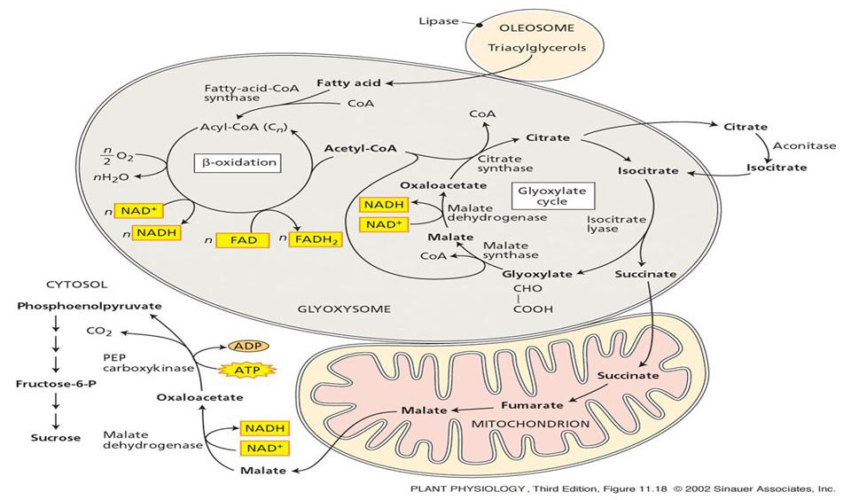
How are different between peroxisomes and glyoxysome?
Peroxisomes | Glyoxysome
1. Peroxisomes are single membrane microbodies found in photosynthetic cells of plants and liver and kidney cells of vertebrates. | 1. Glyoxysomes are also single membrane microbodies but found only in plant cells.
2. It contains enzymes like peroxidases, oxidases, and catalases. | 2. It contains many enzymes like isocitrate lyase, malate synthase, glycolate oxidases, etc. for glyoxylate cycle (i.e., metabolism of glycolic acid).
3. It is involved in formation and degradation of hydrogen peroxide and detoxification of poisons in the cell. | 3. It is involved in photorespiration and conversion of fats into carbohydrates.

Vacuoles
Vacuoles, like vesicles, are membranous sacs, but vacuoles are larger than vesicles.
Function of vacuoles
- Contractile vacuoles are typically in protists for ridding the cell of excess water.
- Digestive vacuoles for breaking down nutrients.
- Vacuoles usually store substances, such as nutrients or ions. Plant vacuoles contain not only water, sugars, and salts but also pigments and toxic molecules. In seeds, stored proteins needed for germination are kept in 'protein bodies', which are modified vacuoles.
- Exporting unwanted substances from the cell.
- Maintaining internal hydrostatic pressure.

