Lec.3 Dr Yasir Al-Juraisy
Plasma Membrane
Membranes cover the surface of every cell, and also surround most organelles within cells. They have a number of functions, such as:
- Keeping all cellular components inside the cell.
- Allowing selected molecules to move in and out of the cell.
- Isolating organelles from the rest of the cytoplasm, allowing cellular processes to occur separately.
- A site for biochemical reactions, allowing a cell to change shape.
1925 | Gorter and Grendel membrane model propose lipid bilayer structure for cell membranes; the surface area covered by lipids extracted from red blood cells on the water surface is twice as large as original surface of red blood cells.  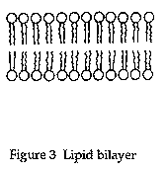  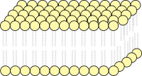
1935 | Danielli and Davson's membrane model of globular proteins on the surface of lipid bilayer; this model specifically excludes transmembrane proteins based on the previously shown hydrophilic surface of globular proteins.  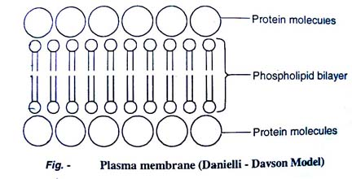
1950s Robertson suggests that all membranes in various cells have basically the same composition. This proposal was called the unit membrane model.
This model was proposed by Robertson in 1959. According to this model, the plasma membrane is formed of three layers. The three layers are an outer protein layer, a middle lipid bilayer and an inner protein layer. The middle layer is 35A^{O} thick and the inner and outer layers are 20A^{O} each. Robertson believed that all biological membranes are unit membranes. The plasma membranes of prokaryotes and eukaryotes are unit membranes. Again the membranes of endoplasmic reticulum, Golgi bodies, Mitochondria, lysosomes, plastids and nucleus are unit membranes.

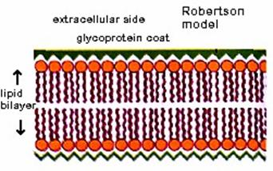
The unit membrane model

Fluid Mosaic Model:
In 1972 Singer and Nicolson proposed a model for explaining the membrane structure, taking into account all the known facts. According to this model, cell membrane consists of a highly viscous fluid matrix of a bilayer of phospholipids having globular proteins associated with them. This model came to be known as fluid mosaic model. The phospholipid molecules in the cell membrane have their polar, hydrophilic heads towards outer surface and the nonpolar, hydrophobic tails towards inner surface. This arrangement forms a water resistant barrier through which only lipid soluble substances can pass through. The proteins in cell membrane are of two kinds.
Peripheral protein: Some of the proteins are found at the periphery, partly projecting out of the lipid layer. These are the extrinsic proteins. These proteins can be easily extracted.
Integral proteins: some of the protein molecules are found totally embedded in the phospholipid matrix. Those are the intrinsic, which represent nearly 70% of the membrane proteins. These proteins cannot be extracted.
Some of the integral proteins have very large molecules that extend throughout the phospholipid matrix, projecting out on both surfaces. These proteins are called tunnel proteins or trans-membrane proteins. They are believed to have channels for the passage of water-soluble substances. The scattered arrangement of protein molecules in the phospholipid matrix gives the appearance of a mosaic pattern.
A few molecules of oligosaccharides are found attached to the free ends of protein molecules on the outer surface of the membrane is called glycoprotein. Sometimes they are also found attached to phospholipid layer is called glycolipid.

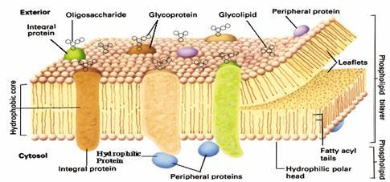
.
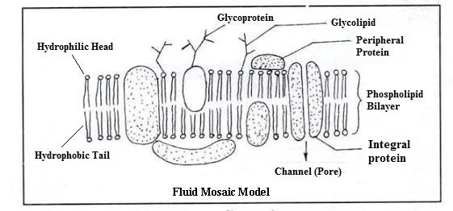
The fluid-mosaic model of plasma membrane

The phospholipid bi-layer and associated proteins is called the fluid mosaic model of the membrane's structure. 'Fluid' because the positions of the constituents are always changing and 'mosaic' because the membrane is made from different types of molecules.
Types of Cellular Transport
The membrane is selectively permeable and able to regulate what enters and exits the cell. The movement of substances across the membrane can be:
1-Passive Transport
a. Simple diffusion
b. Facilitated diffusion (diffusion with the help of transport proteins)
c. Osmosis (diffusion of water)
- Cell doesn't use energy; Molecules move randomly; Molecules spread out from an area of high concentration to an area of low concentration.
2-Active Transport (the cell uses energy)
- Protein Pumps b. Endocytosis c. Exocytosis

1-Passive Transport
a. Simple diffusion
Simple diffusion is the random movement of particles (molecules) from a region of high concentration to a region of low concentration, no energy required, this process will continue until a dynamic equilibrium reached.
Example – diffusion of oxygen from the alveoli into blood capillaries
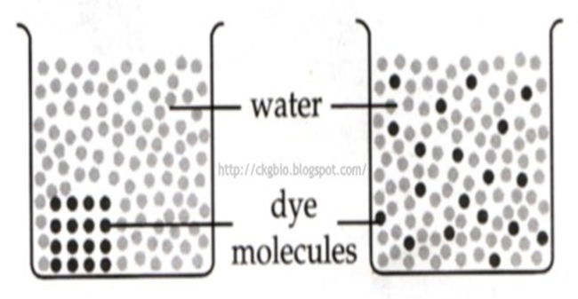

b. Facilitated diffusion
Facilitated diffusion is the passive movement of molecules or ions down a concentration gradient. The process involves special pore proteins (channel proteins) or specific carrier proteins in the plasma membrane. Transport proteins are specific – they “select” only certain molecules to cross the membrane transports larger or charged molecules.
Example: the absorption of glucose and amino acid from the villi into the blood capillaries.
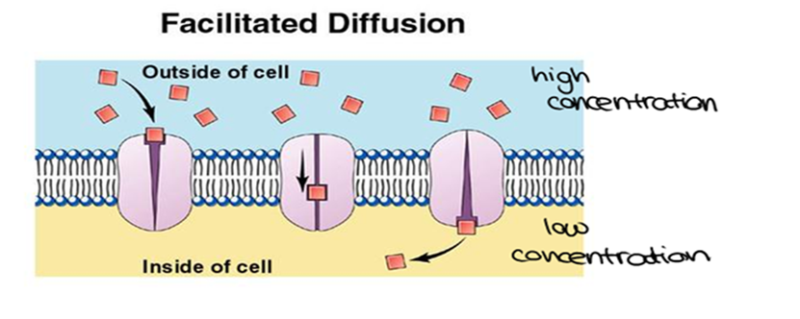
Facilitated diffusion through a carrier protein in the plasma membrane

c. Osmosis (diffusion of water)
Osmosis is the random movement of water molecules from a region of high concentration of water molecules to a region of low concentration of water molecules through a partially permeable membrane.
Example: the re-absorption of water molecules from the nephrons into the blood capillaries.
How Does Osmosis Affect Cells?
Osmosis allows cells to regulate the balance of water inside the cells. The concentration of solutes outside the cells determines whether a cell is isotonic, hypotonic, or hypertonic.
Isotonic: When cell is in isotonic solution, there is no difference in the concentration of solute present inside and outside of the cell (the two solutions having the same osmotic pressure across a cell membrane). Animal cells are in their normal state in isotonic solution, while plant cells are flaccid.
Hypertonic: cells that are in a hypertonic solution reside in a solution which has the higher concentration of the solute outside of the cell. This concentration gradient results in a net flow of water out the cell. Animal cells shrivel in a hypertonic solution, as water has left the cell, causing the cell to die, but plant cells are plasmolyzed, meaning that the cell has lost water inside its membrane, resulting in it pulling away from the side of its cell wall.
Hypotonic: cells that are in a hypotonic solution reside in a solution which has the lower concentration of the solute outside of the cell. This concentration gradient results in a net flow of water into the cell. Animal cells burst in hypotonic solutions as the cell cannot contain so much water. Plant cells are in their healthy state in hypotonic solution, as the cell pushes against the cell wall, giving the cell its structure as the cell wall doesn’t allow the plant cell to burst as the animal cell does.
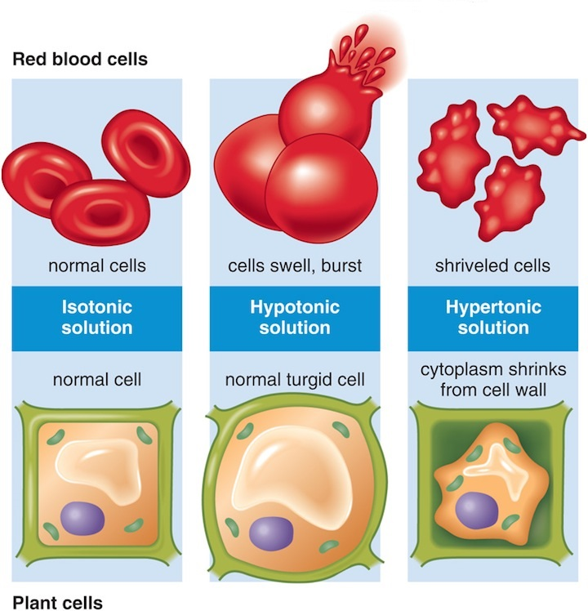
2-Active Transport
Process that moves materials across the plasma membrane requires energy from the cell in the form of ATP, Materials move against the concentration gradient:
Low concentration high concentration
Three types of active transport: a. Protein pumps b. Endocytosis c. Exocytosis

a. Protein Pumps
1-An ATP molecule breaks down into ADP, releasing a phosphate group and a whole lot of energy.
2-The phosphate group attaches to a protein pump, causing it to change its shape so that it can move a small molecule or ion across the plasma membrane.
3-The protein changes shape again so that the molecule can be released on the other side.
There are many types of carrier proteins and they only carry specific molecules across the plasma membrane.
Example of protein pumps: sodium-potassium pump in nerve cells
Sodium ions are kept at low concentrations inside the cell and potassium ions are at higher concentrations outside the cell,
- 3 Na⁺ and 1 ATP bind to the protein pump.
- ADP is released, causing a change in the pump’s shape.
- 3 Na⁺ are released as 2 K⁺ bind to the pump.
- Pi is released, causing the pump’s shape to change, and releasing 2 K⁺
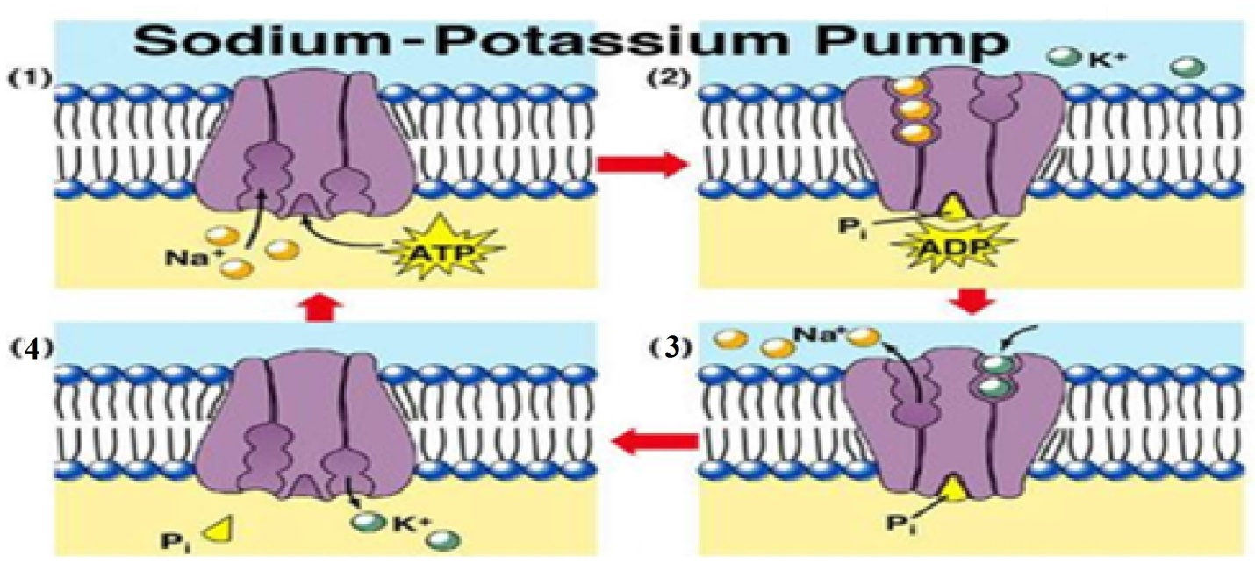
The Sodium-Potassium Pump

The movement of macromolecules such as proteins or polysaccharides into or out of the cell is called bulk transport. There are two types of bulk transport, exocytosis and endocytosis, and both require of energy (ATP).

b. Endocytosis
Endocytosis is the process of cellular ingestion by which the plasma membrane folds inward to bring substances into the cell. There are three types of endocytosis: phagocytosis, pinocytosis, and receptor-mediated endocytosis.
In phagocytosis or “cellular eating”, the cell’s plasma membrane surrounds a macromolecule or even an entire cell such as bacteria and buds off to form a food vacuole or phagosome. The newly-formed phagosome then fuses with a lysosome whose hydrolytic enzymes digest the “food” inside.

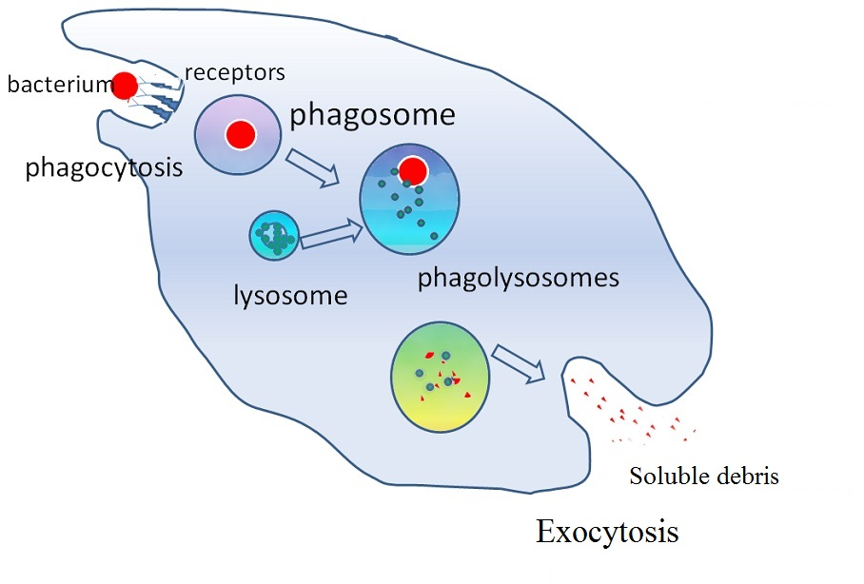
pinocytosis or “cellular drinking”, the cell engulfs drops of fluid by pinching in and forming vesicles.
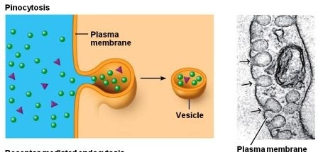
Receptor-mediated endocytosis is a process by which cells absorb metabolites, hormones, proteins, viruses (endocytosis) by the inward budding of plasma membrane vesicles containing proteins with receptor sites specific to the molecules being absorbed.

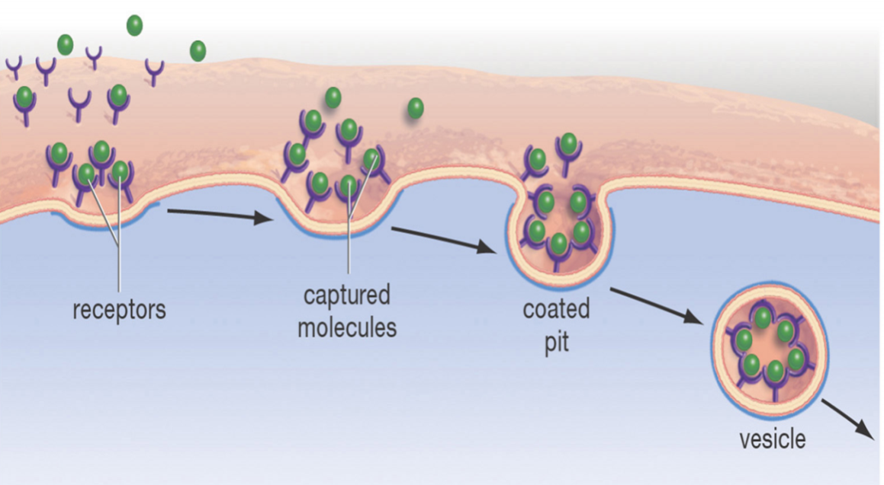
Receptor-mediated endocytosis

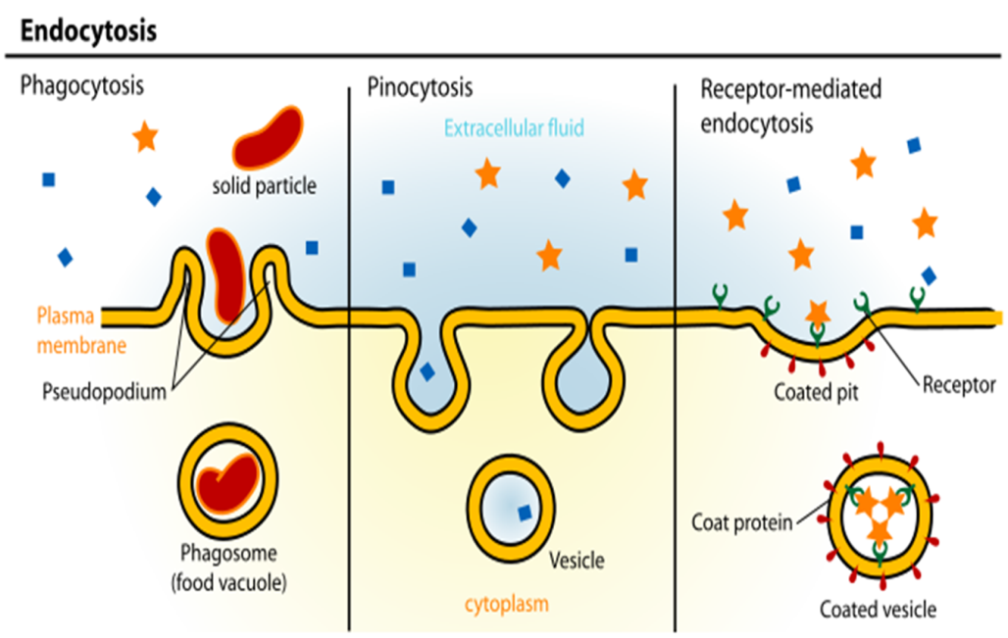
c. Exocytosis
In exocytosis, materials are exported out of the cell via secretory vesicles. In this process, the Golgi complex packages macromolecules into transport vesicles that travel to and fuse with the plasma membrane. This fusion causes the vesicle to spill its contents out of the cell. Exocytosis is important in expulsion of waste materials out of the cell and in the secretion of cellular products such as digestive enzymes or hormones.
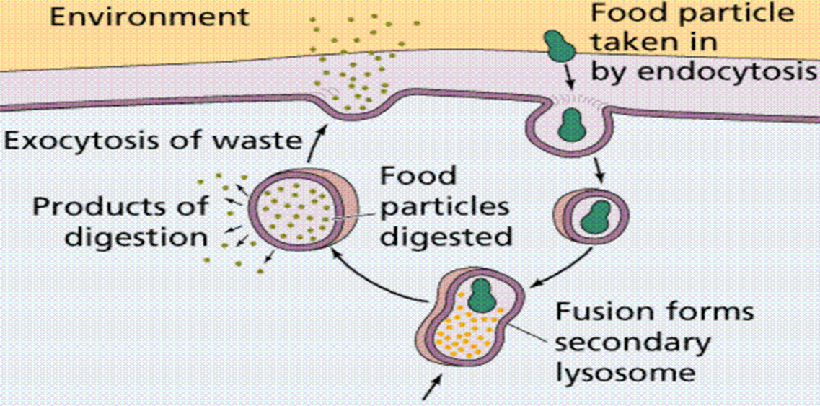.

Differences between active and passive transports
Active Transport | Passive Transport
Transport requires energy | Transport doesn't require energy
Molecules or ions move against concentration gradient (from an area of low concentration to an area of high concentration). | Molecules or ions move with concentration gradient (from an area of high concentration to an area of low concentration).
Include protein pumps, endocytosis and Exocytosis. | Include simple diffusion, Facilitated diffusion (diffusion with the help of transport proteins) and Osmosis (diffusion of water).

