Lec.2 Dr Yasir Al-Juraisy
Properties of Water

Importance of water
Water (H₂O) is one of the most abundant chemical compounds on earth, covering 70% of the earth's surface, and is essential to all life. After carbon, water is the most crucial substance to sustaining life. For example, humans are made up of over 70% water, with the brain being composed of over 80% water. There are a number of properties of water which are particularly important to biological life. The properties are largely the result of the extensive hydrogen bonds between molecules in water. These bonds are strong enough to produce the characteristic properties but are also easily broken to allow water molecules to move around or change between states.
Two hydrogen atoms bonded to an oxygen atom form a water molecule. Water has several properties that make it a very unique substance.
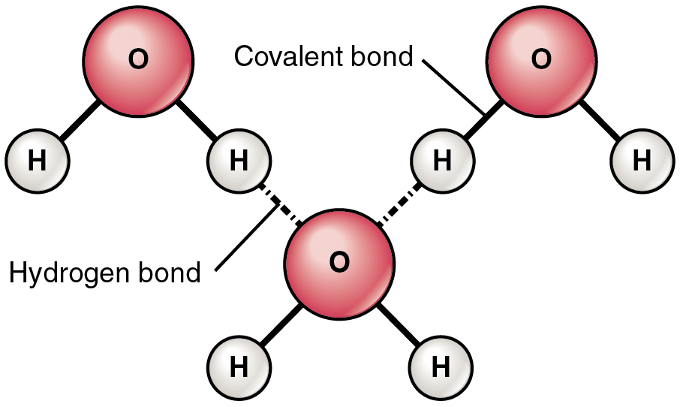
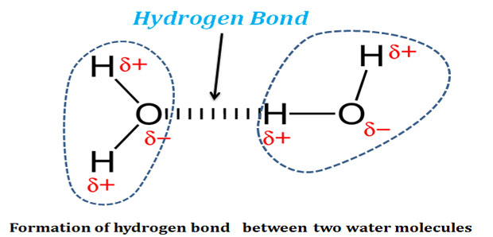

The biological properties of water are listed below:
1. Solvency: water is considered a universal solvent for its ability to dissolve a wide range of substance since it is a polar molecule (i.e. salt or sugar dissolving in water). The oxygen end has negative charge while the hydrogen end has positive charge.
The reason why water is such as good solvent is due to the dipole, polar nature of the water molecules, which allow water molecules to be attracted to each other, but also to other polar molecules.
- Hydrophilic molecules (or water-loving): substances having a strong affinity for water; tending to dissolve in, mix with, or be wetted by water.
- Hydrophobic molecules (water-hating): nonpolar substances don't combine with water molecules, do not dissolve in water.
2. Cohesion: is the attraction between water molecules due to hydrogen bonds. Cohesive attractive forces are responsible for the characteristic surface tension of water. This allows insects to run across the water surface without breaking the surface.
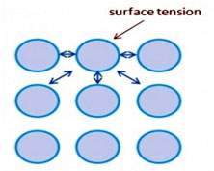
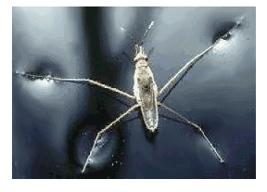

3. Adhesion: Adhesion is the attraction between molecules of water and molecules of another substance. water tends to stick unlike substances (i.e. water sticking to blood vessels).
Adhesive forces when combined with surface tension can result in a phenomenon known as capillary action. This action results in the movement of water up a narrow tube, against the force of gravity for example in the xylem vessels of plants.
4. Chemical reactivity: water can participate in chemical reactions (i.e. involvement of water molecules in dehydration and hydrolysis reactions).
5. Thermal stability: Water molecules are attracted to one another by hydrogen bonds and this restricts the movement of the molecules. This means that a relatively large amount of energy is required to increase the temperature of water (it has a high specific heat capacity) and that large bodies of water are slow to change temperature e.g. lakes and oceans. Due to their high-water content, the bodies of organisms are also slow to change temperature and this makes maintaining a stable body temperature easier.

Chemistry of the cell and the organism
- Small organic molecules
Carbon chain makes up the skeleton or backbone of organism molecules. The small organic molecules in living things include monosaccharides, fatty acids, amino acids, and nucleotides all have a carbon backboned.
- Large organic molecules (Macromolecules)
Each of the small organic molecules can be subunit of a large organic molecule, often called a macromolecule. A subunit is called a monomer, and the macromolecule is called a polymer.
Macromolecules (Polymers) | Monomers
Carbohydrate (polysaccharide) | monosaccharide
Lipid | glycerol and fatty acid
Protein (polypeptide) | amino acid
Nucleic acid | nucleotides

The basic chemistry of cells can thus be understood in terms of the structures and functions of four major classes of organic molecules:
- Carbohydrates:
Are large macromolecule, consisting of carbon (C), hydrogen (H), and oxygen (O) atoms, their formula is (CH₂O)_{n} .
The carbohydrates are divided into four chemical groups:
monosaccharides, disaccharides, oligosaccharides, and polysaccharides.
In general, the monosaccharides and disaccharides, which are smaller (lower molecular weight) carbohydrates, their names very often end in the suffix “ose”. For example, grape sugar is the monosaccharide glucose, cane sugar is the disaccharide sucrose, and milk sugar is the disaccharide lactose (see illustration).
Carbohydrates perform numerous roles in living organisms:
1- Polysaccharides serve for the storage of energy (e.g. starch and glycogen).
2- Structural components (e.g., cellulose in plants and chitin in arthropods).
3- The 5-carbon monosaccharide ribose is an important component of coenzymes (e.g. ATP, FAD, and NAD), and the backbone of the genetic molecules known as DNA and RNA.
4- Saccharides and their derivatives play key roles in the immune system, fertilization, preventing pathogenesis, blood clotting.
1- Monosaccharide
'Mono' refers to “single” and 'saccharide' means “sugar”. Glucose, fructose, galactose, arabinose, and xylose are common types of monosaccharides.
Properties: Crystalline; Soluble in water; Sweet-tasting.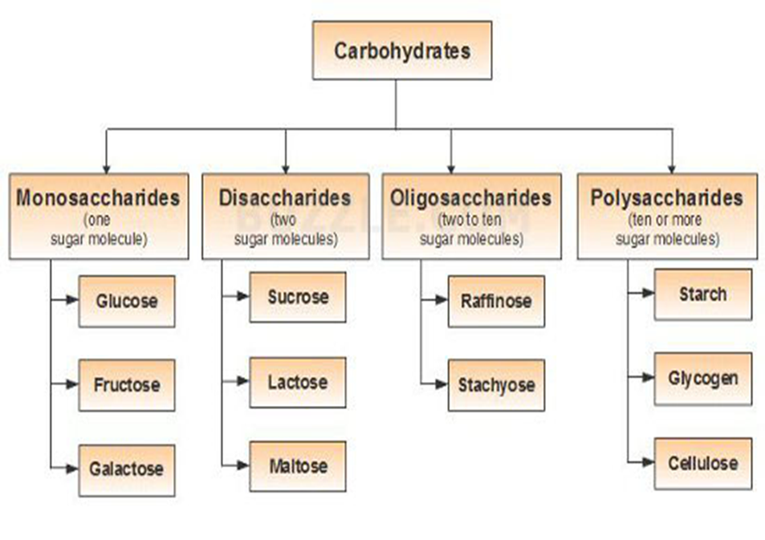

2-Disaccharides
Disaccharides contain two sugar molecules. Common disaccharides are sucrose, lactose, maltose, trehalose, and cellobiose.
Properties: Crystalline; Water-soluble; Sweet-tasting; Sticky.
3-Oligosaccharides
These are carbohydrates with more than two (usually 3-10) basic types of sugar molecules. Raffinose and stachyose are the main types of oligosaccharides which consist of repetitive chains of fructose, galactose, and glucose.
Properties: Crystalline; Water-soluble.

4-Polysaccharides
Polysaccharides have a high molecular weight. They are divided into:
- Homopolysaccharides contain the same monosaccharides. They include starch, cellulose, and glycogen.
- Heteropolysaccharides contain more than one type of monosaccharides. They include pectin, hemicellulose, and gums.
Physical Properties: Not water-soluble; Not crystalline; Not sweet; Form colloidal suspensions instead of solutions.
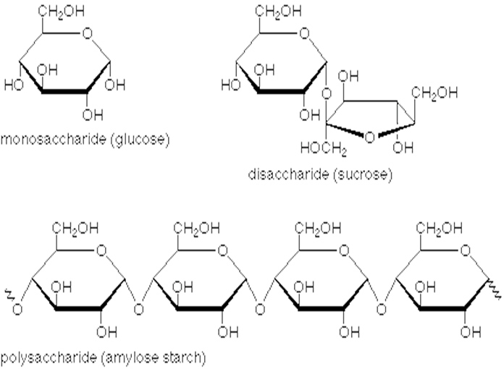

Proteins
Proteins are large, complex molecules that play many critical roles in the body. They do most of the work in cells and are required for the structure, function, and regulation of the body’s tissues and organs.
Proteins are made up of hundreds or thousands of smaller units called amino acids, which are attached to one another in long chains. There are 20 different types of amino acids. All amino acids contain 2 important functional groups; carboxyl- COOH group and amino- NH₂ group. The sequence of amino acids determines each protein’s unique 3-dimensional structure and its specific function.
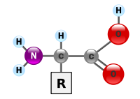
Structure of amino acid
Proteins can be described according to their large range of functions in the body, listed below:
Examples of protein functions
Function | Description | Example
Antibody | Antibodies bind to specific foreign particles, such as viruses and bacteria, to help protect the body. | Immunoglobulin G (IgG)
Enzyme | Enzymes carry out almost all of the thousands of chemical reactions that take place in cells. They also assist with the formation of new molecules by reading the genetic information stored in DNA. | Phenylalanine hydroxylase
Messenger | Messenger proteins, such as some types of hormones, transmit signals to coordinate biological processes between different cells, tissues, and organs. | Growth hormone
Structural component | These proteins provide structure and support for cells. On a larger scale, they also allow the body to move. | Actin
Transport/storage | These proteins bind and carry atoms and small molecules within cells and throughout the body. | Hemoglobin  Seeds, eggs, milk

Levels of Protein Structure
Primary structure
The primary structure of a protein is the sequence of the amino acids joined together by peptide bonds. In 1953, Frederick Sanger determined the amino acid sequence of the hormone insulin.
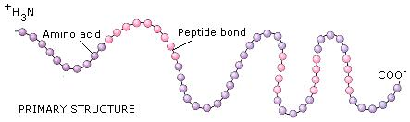
The importance of sequence of amino acids in the protein of the organism as an example: the structural difference between a normal hemoglobin molecule and a sickle cell molecule. Specifically, the amino acid glutamic acid is substituted by valine in the location 6 of the multi-chain peptide while arrangement stays of the 145 amino acid components of hemoglobin unaffected.
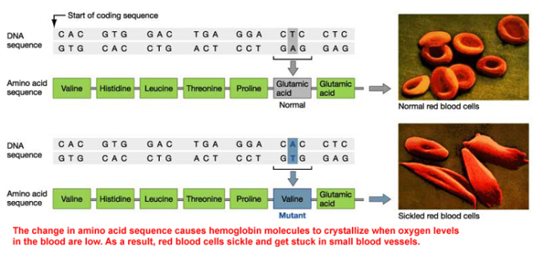

Secondary Structure: refers to the coiling or folding of a polypeptide chain that gives the protein its 3-D shape. There are two types of secondary structures:
- alpha (α) helix structure: resembles a coiled spring and is secured by hydrogen bonding in the polypeptide chain.
- beta (β) pleated sheet: this structure appears to be folded or pleated and is held together by hydrogen bonding between polypeptide units of the folded chain that lie adjacent to one another.
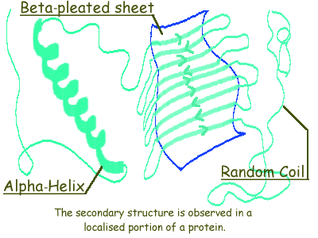

Tertiary Structure: is the 3D shape of a protein. The tertiary structure will have a single polypeptide chain "backbone" with one or more protein secondary structure. Amino acid side chains may interact and bond in a number of ways.
  - Disulphide Bonds - Ionic Bonds - Hydrogen Bonds - Hydrophobic and Hydrophilic Interactions.

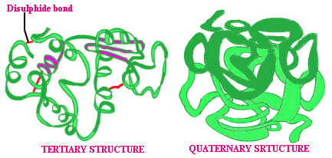
Quaternary Structure: The structure formed when two or more polypeptide chains join together, sometimes with an inorganic component, to form a protein.

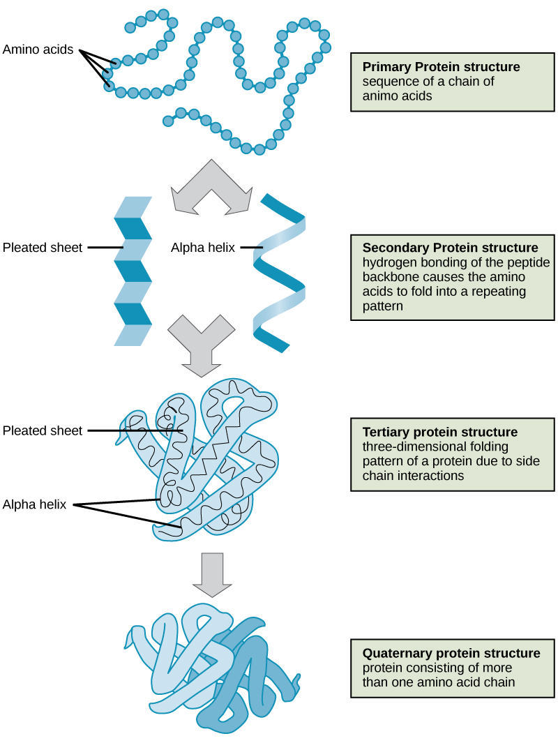

Denaturation of proteins
Denaturation is a process in which proteins lose its native state by application of some external stress or compound such as a strong acid or base, a concentrated salt, an organic solvent, radiation or heat.
The external stress or compound can bring a change in protein shape. For example, we are all aware that the addition of acid to milk causes curding; heating causes egg white, a protein called albumin to coagulate. Denaturation occurs because the normal bonding patterns between parts of a molecule have been disturbed.
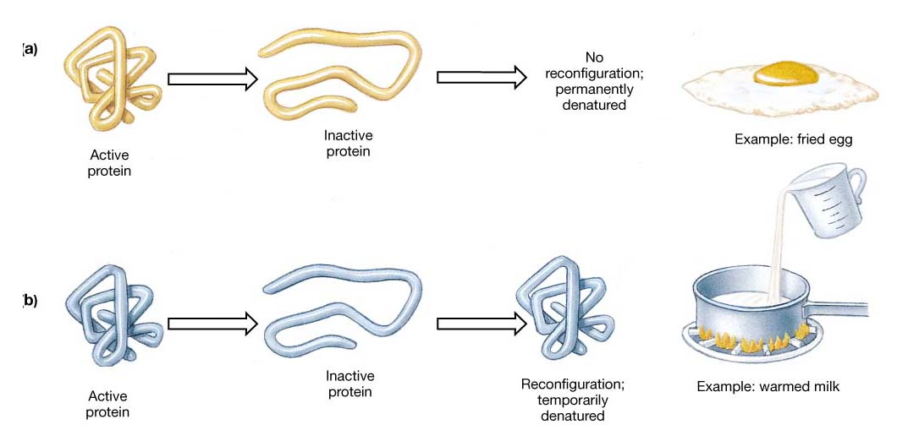
Lipids
Lipids are organic compounds; insoluble in water because they lack any polar groups. The lipid can be divided into the following:
1- Fats and Oils: fats tend to contain saturated fatty acids, and oils tend to contain unsaturated fatty acids. Both can be unhealthy but also serve two important functions for plants and animals:
a. Energy storage. Fats are a more compact fuel than starch.
b. Cushions and insulates the body and nerves. Each and every one of your nerves wrapped in a lipid-rich layer called the myelin sheath.
2- Phospholipids: lipid bilayers (the plasma membrane of every cell and the membranes within eukaryotic cells).
3- Waxes: are nonpolar lipids that plants and animals use for protection and have many functions in society.
4- Steroids: Steroids, like cholesterol. They play roles in reproduction, absorption, metabolism regulation, and brain activity.

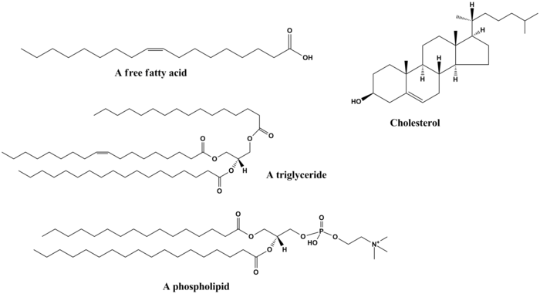

Nucleic acids
Nucleic acids are built from subunits called nucleotides. Each nucleotide has three components:
1. a ring-shaped molecule belonging to the class of purine or pyrimidine bases.
2. a 5-carbon, or pentose sugar.
3. one or more phosphate groups.
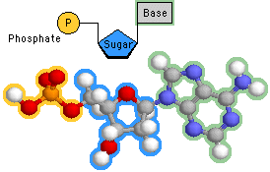
Structure of nucleotide
There are two types of nucleic acids:
Deoxyribonucleic acid (DNA), which contains the sugar deoxyribose, is the genetic material that stores information for its own replication and for the order in which amino acids are to be sequenced in protein.
Ribonucleic acid (RNA), which occurs in several different forms (messenger RNA, ribosomal RNA, transfer RNA) is needed to convert DNA information into polypeptide sequences. In some viruses, RNA serves as the primary database with no DNA involvement.
The nucleic acids (DNA and RNA) are the principal informational molecules of the cell. Deoxyribonucleic acid (DNA) has a unique role as the genetic material, which in eukaryotic cells is located in the nucleus. Different types of ribonucleic acid (RNA) participate in a number of cellular activities.
Messenger RNA (mRNA) carries information from DNA to the ribosomes, where it serves as a template for protein synthesis. Two other types of RNA (ribosomal RNA and transfer RNA) are involved in protein synthesis.
DNA and RNA are polymers of nucleotides, which consist of purine and pyrimidine bases linked to phosphorylated sugars. DNA contains two purines (adenine and guanine) and two pyrimidines (cytosine and thymine). Adenine, guanine, and cytosine are also present in RNA, but RNA contains uracil in place of thymine. The bases are linked to C1of sugars (2′-deoxyribose in DNA, or ribose in RNA) to form nucleosides. Nucleotides additionally contain one or more phosphate groups linked to the 5′ carbon of nucleoside sugars. The polymerization of nucleotides to form nucleic acids involves the formation of phosphodiester bonds between the 5′ phosphate of one nucleotide and the 3′ hydroxyl of another.

The table shows the differences between DNA and RNA
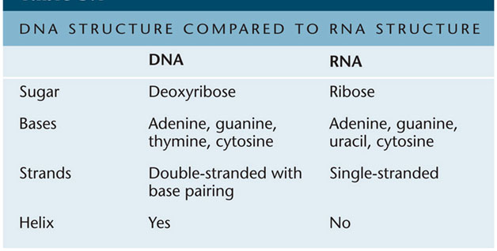

The table shows the types of RNA
