Lec. 1 Dr Yasir Al-Juraisy

Cell biology

Cell biology (also called cytology) is a branch of biology that studies the structure and function of the cell, which is the basic unit of life.

Early history in Cell Biology
- The cell was first discovered and named by Robert Hooke in 1665. He saw the dead cell walls of plant cells (cork) as it appeared as small rooms under the microscope.
- 1674 Anton van Leeuwenhoek, invented the first practical microscopes and used them to become the first person to see and describe single celled organisms, which he originally referred to as animalcules (which we now refer to as microorganisms).
- 1838 - German scientists Schleiden and Schawann summarize the findings of many scientists and conclude that all living organisms are made of cells. This forms the basis of the Cell Theory of Biology.
The Cell Theory of Biology
- All organisms are composed of cells.
- The cell is the structural unit of life - units smaller than cells are not alive.
- Cells arise by division of preexisting cells - spontaneous generation does not exist.
- Cells can be cultured to produce more cells.

Properties of Cells
1- Cells are complex and highly organized
- They contain numerous internal structures.
- Some of these structures are membrane bound (organelles) while others do not.
2- Cells contain a genetic blueprint and machinery to use it.
- Genes are instructions for cells to create specific proteins.
- All cells use the same types of information
  - The genetic code is universal
  - The machinery used for synthesis is interchangeable
- However, for this to function properly, information transfer must be error free
  - Errors are called mutations
3- Cells arise from the division of other cells
- Daughter cells inherit the genes from the mother cells
- Binary fission - cell division in bacteria.
- Mitosis - the genetic complement of each daughter cell is identical to the other and to the mother cell. This is asexual reproduction.
- Meiosis - the genetic complement of each daughter cell is reduced by half and each daughter cell is genetically unique. This is used in sexual reproduction.
- Daughter cells inherit cytoplasm and organelles from the mother cells.
4- Cells acquire and utilize energy
- Plant cells undergo photosynthesis
  - convert light energy and CO₂ to chemical energy (ATP and glucose)
- Most cells respire
  - release energy found in organic compounds
  - convert organic compounds to CO₂ and H₂O
  - make ATP
5- Cells can perform a variety of chemical reactions
- Transform simple organic molecules into complex molecules (anabolism).
- Breakdown complex molecules to release energy (catabolism).
- Metabolism = all reactions performed by cells.
6- Cells can engage in mechanical activities
- Cells can move , Organelles can move inside the cell
7- Cells can respond to stimuli
  - chemotaxis - movement towards chemicals
  - phototaxis - movement towards light
  - hormone responses
  - touch responses
8-Cells can regulate activities
- Cells control DNA synthesis and cell division
- Gene regulation - cells make specific proteins only when needed
- Turn on and off metabolic pathways
9-Cells all contain the following structures:
- Plasma membrane - separates the cell from the external environment
- Cytoplasm - fluid-filled cell interior
- Nuclear material - genetic information stored as DNA

Types of Cells
1- Prokaryotes
- Pro = before; karyon = nucleus
- relatively small – between 1 to 10 µm
- lack membrane-bound organelles
2- Archaea
- originally thought to be prokaryotes
- generally similar to bacteria in size and shape
- lack membrane-bound organelles
- possess genes and several metabolic pathways that are more closely related to those of eukaryotes.
- usually live in extreme environments (thermophiles, halophiles, etc)
3- Eukaryotes
- Eu = true; karyon = nucleus
- contain membrane-bound organelles
- Evolved from prokaryotes by endosymbiotic association of two or more prokaryotes
- Include Protists, Fungi, Animals, and Plants

Features of Prokaryotic Cells
- Capsule - outer sticky protective layer
- Cell Wall - rigid structure which helps the bacterium maintain its shape
- Plasma membrane - separates the cell from the environment
- Mesosome - infolding of plasma membrane to aid in cell division
- Nucleoid - region where naked DNA is found
- Cytoplasm
  - semi-fluid cell interior
  - no membrane-bound organelles
  - location for metabolic enzymes
  - location of ribosomes for protein synthesis

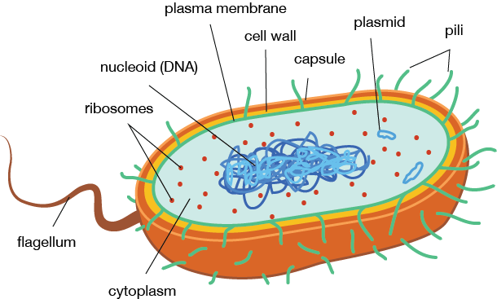
Prokaryotic
Cell (Bacteria)

Properties of Eukaryotic Cells
- Features shared with prokaryotic cells
  - Rigid cell wall
    - Plant cells, some Fungi, some Protists
    - Animal cells lack cell wall
  - Plasma membrane
  - Cytoplasm with ribosomes
  - Nuclear material
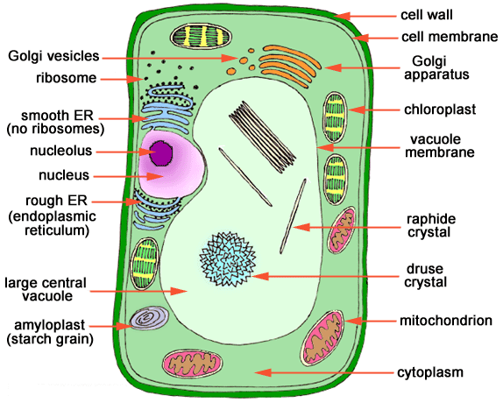

Eukaryotic Cell (Plant Cell)

- Cytoskeleton (Microfilaments, Intermediate filaments and Microtubules)
  - maintains cell shape and provides support
  - anchors organelles & enzymes to specific regions of the cell
  - contractility and movement (amoeboid movement)
  - intracellular transport - tracks for vesicle and organelle movement by motor proteins
- Cilia and Flagella - involved in cellular movement
- Nucleus - the information processing and administrative center of the cell.
- Endomembrane System
  - Endoplasmic Reticulum - an extensive membranous network continuous with the outer nuclear membrane.
    - Rough ER - has ribosomes and is involved in secreted protein synthesis
    - Smooth ER - lacks ribosomes and is involved in membrane lipid synthesis
  - Golgi Apparatus
    - Flattened vesicles in stacks which receive protein from ER
    - Form secretory vesicles to transport proteins to different parts of the cell (vacuole, lysosome, etc) or for secretion
    - cis face - "receiving" side of Golgi apparatus
    - trans face - "shipping" side of Golgi apparatus
  - Lysosome
    - found only in animal cells
    - contain enzymes for use in the hydrolytic breakdown of macromolecules
  - Peroxisome
    - Eukaryotic organelle that degrades fatty acids and amino acids
    - Also degrades the resulting hydrogen peroxide
- Plant Central Vacuole - major storage space in center of plant cell with many functions.
- Mitochondria
  - Found in all eukaryotic cells (yes, even in plant cells)
  - Site of aerobic respiration
    - sugars + O₂ ̶̶̶ ̶ ̶ ̶> ATP + CO₂ + H₂O
  - Contain DNA which codes for mitochondrial proteins, ribosomes, etc.
  - Divide by a process similar to binary fission when cell divides
  - Enclosed in a double membrane system
- Chloroplasts
  - Found only in plant cells
  - Site of photosynthesis
    - conversion of solar energy to chemical energy in the form of ATP and sugars
  - Contain DNA which codes for chloroplast proteins, ribosomes, etc.
  - Divide when plant cell divides
  - Enclosed in a double membrane envelope that does not invaginate into the chloroplast
- Ribosomes
  - Technically not an organelle, since there is no membrane, but they are prominent cellular structures and usually lumped with the organelles.
  - The "factories" of the cell - involved in protein synthesis.
  - Facilitate the specific coupling of tRNA anticodons with mRNA codons during protein synthesis.
  - Made up of two subunits, the large and the small subunit.
  - Both subunits are constructed out of protein and RNA (called rRNA).
  - The ribosomes of prokaryotes and eukaryotes vary slightly with regard to size and shape.
Table 1.1 Differences between prokaryotic and eukaryotic cells.
Characteristic | Prokaryote | Eukaryote
Nucleus | Absent | Present
Diameter of a typical cell | 0.1-5 µm | 10-100 µm
Cytoskeleton | Absent | Present
Cytoplasmic organelles | Absent | Present
DNA content (base pairs) | 1 x 10⁶ to 5 x 10⁶ | 1.5 x 10⁷ to 5 x 10¹¹
Chromosomes | Single circular DNA molecule | Multiple linear DNA molecules

Viruses
A virus is a small infectious agent that replicates only inside the living cells of other organisms. It is non-cellular but consisting of a core of DNA or RNA surrounded by a protein coat.
All viruses have a capsid or head region that contains its genetic material. The capsid is made of proteins and glycoproteins. Capsid construction varies greatly among viruses, with most being specialized for a particular virus's host organism.
Some viruses, mostly of the type infecting animals, have a membranous envelope surrounding their capsid. This allows viruses to penetrate host cells through membrane fusion. The virus's genetic material rests inside the capsid; that material can be either DNA, RNA, or even in some cases a limited number of enzymes. The type of genetic material of the virus is used in classification.
