**Experiment No. (11)**

**(( Determine The Dew Point Temperature ))**

**The theoretical part:**

Figure 7-1 shows the “ microweather “ of saturated air surrounding a beaker. This is similar to a valley with trapped , moist air surrounded by hills. An early morning fog could eventually cover the region when this moist air cools.

**Purpose :**

The purpose of this lab is to calculate the dew point of air inside a container filled with ice . ( Dew point is the temperature at which water vapor in the air begins to condense .)

**Materials needed :**

● one thermometer.

● one 500-milliliter beaker.

● Ice.

**Procedure :**

1- see Fig. 7-2 .

2- on Fig. 7-3, record the temperature of the air just inside the opening of the empty 500-milliliter beaker .

3- Hold the thermometer just inside the opening of the beaker for the next two steps.

4- Fill the beaker with several ice cubes. don`t let the thermometer bulb touch the ice cubes. See Fig. 7-4.

5- When drops of moisture appear on the outside of the container, record the temperature on Fig. 7-3. this is the dew point.

6- see Fig.7-5 and 7-6 to calculate the relative humidity of the air above the ice cubes.

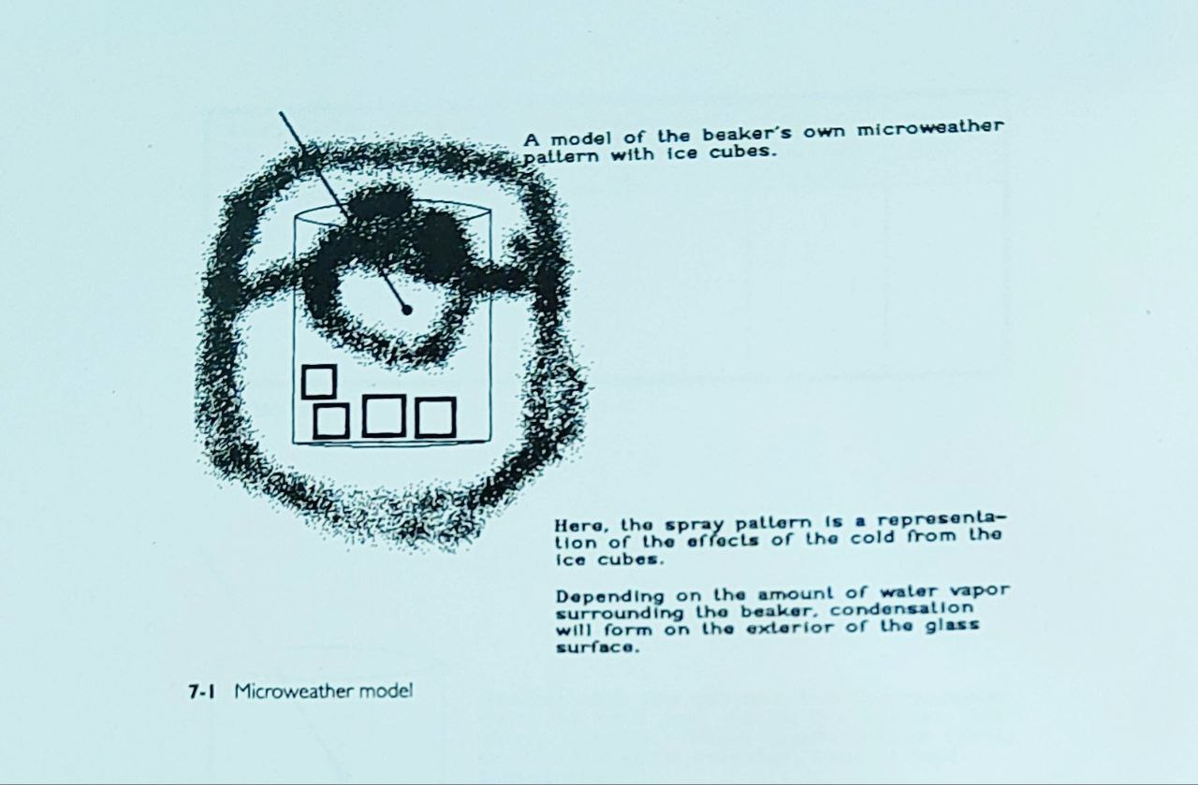

The thermometer hend by hand ↓

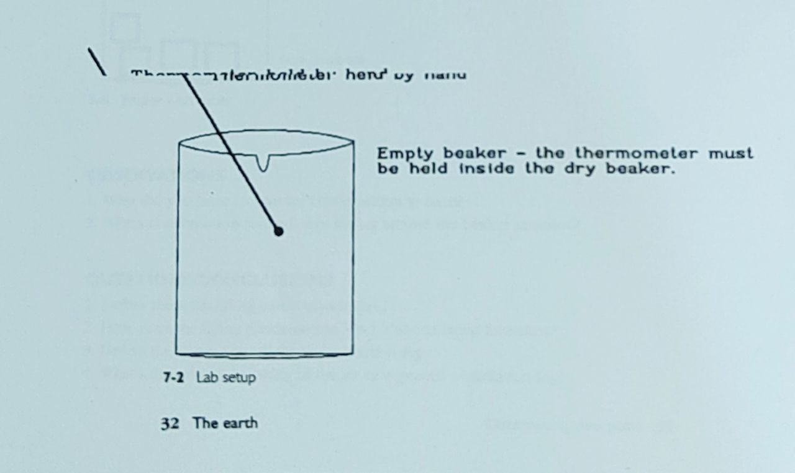

|  |  |  |  |
| --- | --- | --- | --- |
| **Relative humidity**  **( x )** | **Difference in both readings**  **( A-B )** | **Temperature when condensation forms**  **( deg. C )**  **B** | **Empty beaker temperature**  **( deg. C )**  **A** |
|  |  |  |  |

7-3 Data table

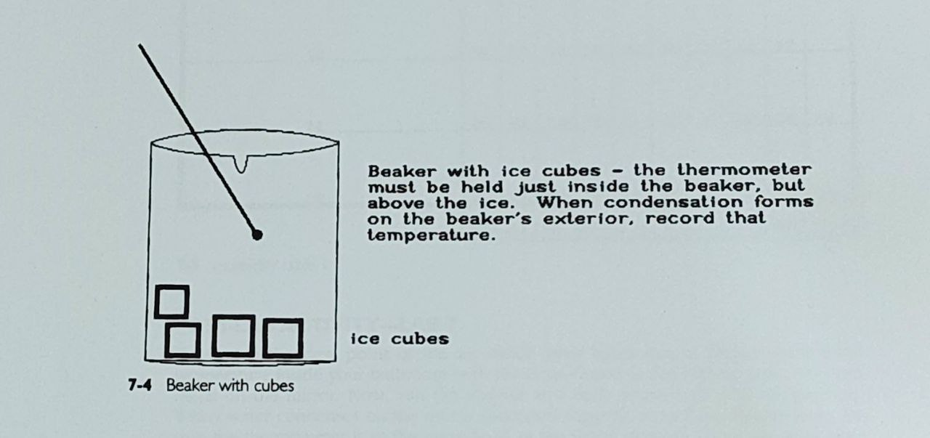

**Observations :**

1- Why did you have to wait for condensation to form ?

2- When condensation formed, was the air around the beaker saturated ?

**Questions/ conclusions :**

1- Define the term lifting condensation level ?

2- How does the lifting condensation level relate to cloud formation ?

3- Define the term ground fog and radiation fog ?

4- what`s the relative humidity of the air in a ground or radiation fog ?

|  |  |  |  |  |  |  |  |  |  |  |
| --- | --- | --- | --- | --- | --- | --- | --- | --- | --- | --- |
| **Temperature Difference**  **( deg. C )** | | | | | | | | | | **Empty beaker temperature**  **( deg. C )** |
| 10 | 9 | 8 | 7 | 6 | 5 | 4 | 3 | 2 | 1 |  |
|  |  |  | 11 | 24 | 35 | 48 | 60 | 73 | 86 | 6 |
|  |  | 8 | 19 | 29 | 40 | 51 | 63 | 75 | 87 | 8 |
|  | 6 | 15 | 24 | 34 | 44 | 55 | 66 | 77 | 88 | 10 |
|  | 12 | 21 | 29 | 39 | 48 | 58 | 68 | 78 | 89 | 12 |
| 10 | 18 | 26 | 34 | 42 | 51 | 60 | 70 | 79 | 90 | 14 |
| 15 | 23 | 30 | 38 | 46 | 54 | 63 | 71 | 81 | 90 | 16 |
| **Relative Humidity around beaker** | | | | | | | | | |  |

**7-5 Humidity table 1**

**Post-lab activity – lab 7:**

Determine the dew point of the air inside your bathroom at home. Record the temperature inside your bathroom with the door closed at the highest point you can reach on the mirror. Now , run the shower at a fairly warm ( not hot ) temperature. When water condenses on the mirror ( becomes fogged ), record the temperature . be sure the thermometer is at the same level as the initial reading . using the data table used in this experiment, determine the dew point . Dose size of the bathroom affect the dew point of the room ?

Also, try measuring the dew point under the level where the condensation forms on the mirror . take thermometer readings near the floor before and after the condensation forms. ( you might have to do this on separate days to allow the bathroom to “ dry out “ ) How different is this to the dew point above the condensation line ?

|  |  |  |  |  |  |  |  |  |  |  |
| --- | --- | --- | --- | --- | --- | --- | --- | --- | --- | --- |
| **Temperature Difference**  **( deg. C )** | | | | | | | | | | **Empty beaker temperature**  **( deg. C )** |
| 10 | 9 | 8 | 7 | 6 | 5 | 4 | 3 | 2 | 1 |  |
| 20 | 27 | 34 | 41 | 49 | 57 | 65 | 73 | 82 | 91 | 18 |
| 24 | 31 | 38 | 44 | 51 | 59 | 66 | 74 | 83 | 91 | 20 |
| 28 | 34 | 41 | 47 | 54 | 61 | 68 | 76 | 83 | 92 | 22 |
| 31 | 37 | 44 | 49 | 56 | 62 | 69 | 77 | 84 | 92 | 24 |
| 34 | 40 | 47 | 51 | 58 | 64 | 71 | 78 | 85 | 92 | 26 |
| 37 | 42 | 48 | 53 | 59 | 65 | 72 | 78 | 85 | 93 | 28 |
| **Relative Humidity around beaker** | | | | | | | | | |  |

**7-6 Humidity table 2**