**Experiment No. (9)**

**((Determine The Heat in The Atmosphere))**

**The theoretical part:**

An object closer to a heat source will heat faster than an object farther away from the same heat source . this lab shows that the angle of radiation is also important .

Objects at the north and south poles are heated more indirectly than objects at the equator . At the poles, there`s more atmosphere for light rays to travel through than there is at the equator.

**Purpose :**

The purpose of this lab is to observe the relationship between a heat source`s temperature and distance from the heated object.

**Materials needed :**

● Lamp with 100-watt bulb .

● Four thermometers.

● Meter stick.

● Tape.

● Watch or clock with second hand.

● Graph paper.

● Ruler.

● Pencil.

**Procedure :**

1- see Fig. 4-1 .

2- Tape the thermometers onto the meter stick at 25,50,75, and 100 centimeters. ( don`t cover the thermometer bulbs.

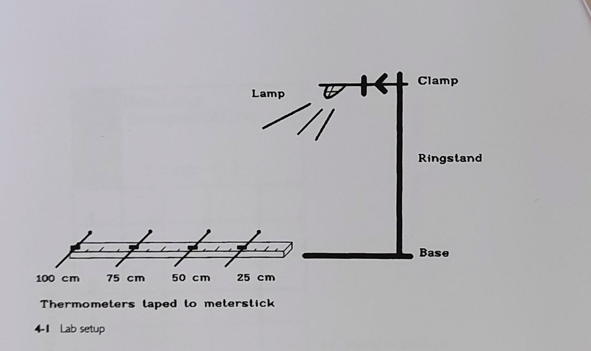

3- Record the beginning temperature for each thermometer on Fig. 4-2.

4- Turn on the lamp.

5- Record the heating temperatures from minute 1 to minute 9 on Fig. 4-3.

6- At minute 10, record the temperatures on Fig. 4-3.

Turn off the lamp.

7- Record the cooling temperatures from minute 11 to minute 20 on Fig. 4-4.

8- See Fig. 4-5 for a sample graph of similarly recorded data.

9- Graph your recorded data on graph paper using an appropriate scale.

|  |  |  |  |
| --- | --- | --- | --- |
| **Beginning temperatures**  **( deg. C.)** | | | |
|  |  |  |  |
|  |  |  |  |
| **Thermometer #** | | | |

4-2 **Beginning temperatures**

|  |  |  |  |  |  |
| --- | --- | --- | --- | --- | --- |
| **Heating Temperature**  **( deg. C.)** | | | |  | **Time minutes** |
|  |  |  |  | **1** |
|  |  |  |  | **2** |
|  |  |  |  | **3** |
|  |  |  |  | **4** |
|  |  |  |  | **5** |
|  |  |  |  | **6** |
|  |  |  |  | **7** |
|  |  |  |  | **8** |
|  |  |  |  | **9** |
|  |  |  |  | **10** |
| **4** | **3** | **2** | **1** |  |
| **Thermometer #** | | | | |

**4-3 Heating temperatures**

**Observations :**

1- which thermometer received the strongest light?

**Questions/ conclusions :**

1- In the northern hemisphere, the earth is closest to the sun in the winter, yet it`s colder in winter than in summer. Why is this?

2- what feature of the earth is crucial to the change of seasons throughout the year?

|  |  |  |  |  |  |
| --- | --- | --- | --- | --- | --- |
| **Cooling Temperature**  **( deg. C.)** | | | |  | **Time minutes** |
|  |  |  |  | **11** |
|  |  |  |  | **12** |
|  |  |  |  | **13** |
|  |  |  |  | **14** |
|  |  |  |  | **15** |
|  |  |  |  | **16** |
|  |  |  |  | **17** |
|  |  |  |  | **18** |
|  |  |  |  | **19** |
|  |  |  |  | **20** |
| **4** | **3** | **2** | **1** |  |
| **Thermometer #** | | | | |

**4-4 cooling temperatures**

**Post-lab activity – lab 4:**

Perform the lab this time with the meter stick/thermometers in a glass aquarium. ( if the aquarium is not of sufficient length, scale down the distances between the thermometers.)

Seal off the aquarium with plastic wrap or a glass cover, or turn the aquarium upside down on a lab table, covering the thermometers.

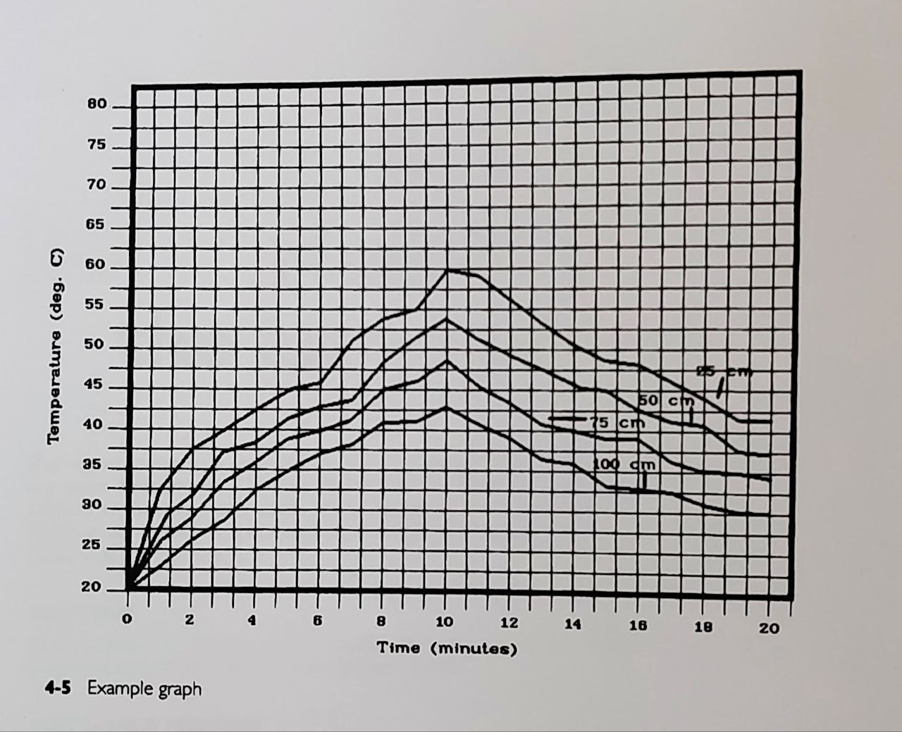

**4-5 Example graph**

Shine the light at the thermometers. ( see Fig. 4-1 for arrangement.)

Record the temperatures for the same time interval. Graph your results. How is this graph the same as the first one? How is it different? How is the glass of the aquarium affecting the rays of the heating light? How is this effect similar to a greenhouse? How is it different?