**Example 2**

Given the vectors

A=2i+6j and B=3i-2j, calculate C=A+B and D=A-B in the terms of polar coordants angles measured with respect to positive x-axis.

Solution:

C= (Ax+Bx) i + (Ay+ By) j

= (2+3) i + (6-2) j

= 5i + 4j

D= A – B

= A + (-B)

=(Ax+Bx) i + (Ay+ By) j

=(2-3)i + (6+2)j

= -i +8j

**2.3 Components of a Vector and Unit Vectors**

**2.3.1 Components of a Vector**

Any vector can be completely described by its components. Consider a vector (A ⃗ )lying in the (xy plane) and making an angle (Ѳ) with the positive (x-axis) as shown in the figure below. This vector can be expressed as the sum of two other component vectors (A ⃗x), which is parallel to the (x-axis), and (A ⃗y), which is parallel to the (y-axis).

A⃗= A⃗x + A⃗y

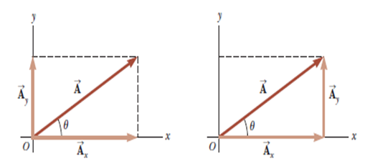

From the figure and the definition of sine and cosine, we see that

$(cos{θ}$ = A*x* / A) and that $(sin{θ= }$ A*y* / A). Hence, the components of $\vec{A}$

A*x* = A $\cos{θ}$ and A*y* = A $\sin{θ }$

The magnitude and direction of $\vec{(A}$) are related to its components through the expressions

A= $\sqrt{A_{x}^{2}+A_{y}^{2}}$ (magnitude of $\vec{A}$)

Ѳ = $\tan^{-1}({\frac{Ay}{Ax}}$) (direction of $\vec{A}$)

**2.3.2 Unit Vectors**

A **unit vector** is (a dimensionless vector having a magnitude of exactly one). Unit vectors are used to specify a given direction.

We shall use the symbols ( î , ĵ , and ƙ ) to represent unit vectors pointing in the positive (*x, y,* and *z*)directions, respectively.

The magnitude of each unit vector equals 1; that is, $ǀ î ǀ= ǀ ĵ ǀ= ǀ ƙ ǀ$ =1

*x* = î , *y* = . Therefore, the unit-vector notation for the vector $\vec{A}$ is:

$\vec{A}=$ î $A_{x}+ ĵ A_{y}$

i= a unit vector along x-axis

j= a unit vector along y-axis

k= a unit vector along z-axis

* Consider a point lying in the *xy* plane and having Cartesian coordinates (*x, y*) as in the figure below. The point can be specified by the **position vector $\left(\vec{r}\right)$** which in unit-vector form is given by:

$\vec{r}= î x+ ĵ y$

* 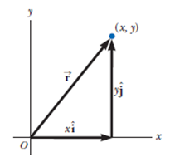The resultant vector ( $\vec{R}$ = $\vec{A}+ \vec{B}$) is:

$\vec{R}$ = (î $A_{x}+ ĵ A_{y}$) + (î $B_{x}+ ĵ B_{y}$) or

$\vec{R}$ = î ${(A}_{x}+B_{x})+ ĵ {(A}_{y}+ B_{y}$)

Because $\vec{R}= î R_{x}$ + $ĵ$ $R_{y}$, we see that the components of the resultant vector are: $R_{x}$ = ($A_{x}+ B_{x}$) and $R_{y}$ = ($A_{y}+ B_{y}$).

The magnitude of $\vec{R}$ and the angle it makes with the (*x*-axis) are obtained from its components using the relationships:

*R* = $\sqrt{R_{x}^{2}+R_{y}^{2}}$ = $\sqrt{{{(A}_{x}+ B_{x})}^{2} +{{(A}_{y}+ B_{y})}^{2} }$ Magnitude of $\vec{R}$

$\tan{θ= }\frac{R_{y}}{ R_{x}}$ = $\frac{A_{y}+ B_{y}}{A_{x}+ B_{x}}$ Direction of $\vec{R}$

* f $\vec{A} and \vec{B}$ both have three components ( *x,y,z* ), they can be expressed in the form:

$\vec{A}=$ î $A_{x}+ ĵ A_{y}+ƙ A_{z}$

$\vec{B}=$ î $B_{x}+ ĵ B_{y}+ƙ B_{z}$

The sum of $\vec{A} and \vec{B}$ is: $\vec{R}$ = $\vec{A}+ \vec{B}$ or

$\vec{R}$ = î ${(A}_{x}+B_{x})+ ĵ {(A}_{y}+ B_{y}$) + $ƙ ( A_{z}+ B_{z} )$

**Example (2-3):**

**Find the sum of two displacement vectors $\vec{A} and \vec{B}$ lying in the *xy* plane and given by: $\vec{A}=( 2î+2ĵ)$ m and $\vec{B}=( 2î-4ĵ)$ m.**

**Solution:**

The resultant vector $\vec{R}$ : $\vec{R}$ = $\vec{A}+ \vec{B}$ = î ${(A}_{x}+B_{x})+ ĵ {(A}_{y}+ B_{y}$)

= î $(2+2)+ ĵ (2-4$)

= 4î- 2 $ĵ$

The components of $\vec{R}$: $R_{x}=4$ m and $R_{y}=$-2 m

The magnitude of $\vec{R}$: *R* = $\sqrt{R_{x}^{2}+R_{y}^{2}}$ = $\sqrt{({4)}^{2}+({-2)}^{2}}$ = $\sqrt{20}$ = 4.5 m

The direction of $\vec{R}$: $\tan{θ= }\frac{R_{y}}{ R_{x}}$ = $\frac{-2}{ 4}$ = - 0.5

Ѳ = - 27 $°$

This answer is correct if we interpret it to mean 27° clockwise from the (*x* – axis).

**Example (2-4): A car travels 20.0 km due north and then 35.0 km in a direction 60° west of north . Find the magnitude and direction of the car’s resultant displacement.**

**Solution:**

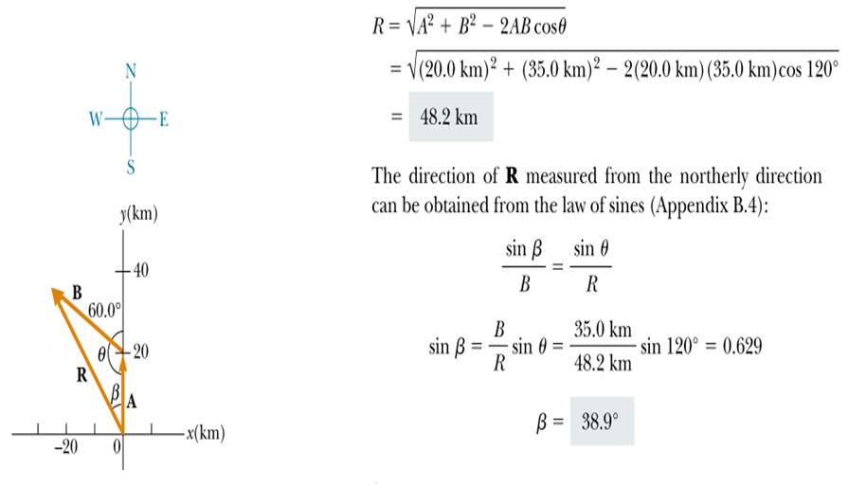

**Example (2-5): if**

**r1= 3i – 2j +K r2= 2i – 4j – 3K r3= -i +2j +2K**

**Find: 1- 2- r1+ r2 +r3 3-**

**Solutions:**

1. **2**

**= [(-1)2 + (2)2 + (2)2]1/2**

**=3 unit**

1. **r1+ r2 +r3 = (3i – 2j +K) + (2i – 4j – 3K ) + (-i +2j +2K)**

**= 4i -4j + 0k**

**= 4i -4j**

**3. r1 - 3 r2 -5 r3 = 2(3i – 2j +K) - 3 (2i – 4j – 3K ) -5(-i +2j +2K)**

**= 5i – 2j +k**

**4.= [ (5)2+ (-2)2 +(1)2]1/2**

**= (30)1/2**

**= 5.47 unit**