**Chapter 2**

**Vectors**

**2.1 Vector and Scalar Quantities**

**A scalar quantity is completely specified by a single value with an appropriate unit and has no direction.**

**Examples of scalar quantities are temperature, volume, mass, speed, and time intervals.**

**A vector quantity is completely specified by a number with an appropriate unit plus a direction.**

**Examples of vector quantity are displacement and velocity.**

**2.2 Some Properties of Vectors:**

**1- Adding Vectors**

**When two vectors (vector A ⃗ and vector B ⃗ ) are added, the sum is independent of the order of the addition. This property is known as the (commutative law of addition):**

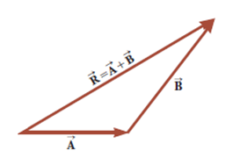

**A ⃗+B ⃗=B ⃗+ A ⃗**

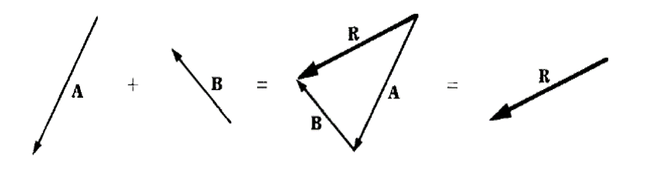

**Another property is called the associative law of addition:**

**A ⃗+(B ⃗+ C ⃗)=(A ⃗+B ⃗)+ C ⃗**

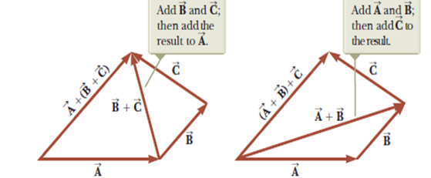

A vector quantity has both magnitude and direction and also obeys the laws of vector addition.

**2- Negative of a Vector:**

The negative of the vector A ⃗ is defined as the vector that when added to A ⃗ gives zero for the vector sum. That is, A ⃗+(-A ⃗ )=0. The vectors A ⃗ and

(-A ⃗) have the same magnitude but point in opposite directions.

**3- Subtracting Vectors:**

The operation of vector subtraction makes use of the definition of the negative of a vector. We define the operation ( A ⃗-B ⃗ ) as vector (-B ⃗) added to vector (A ⃗ ): A ⃗-B ⃗=A ⃗+(- B ⃗ )

The geometric construction for subtracting two vectors in this way is illustrated in the figure below:

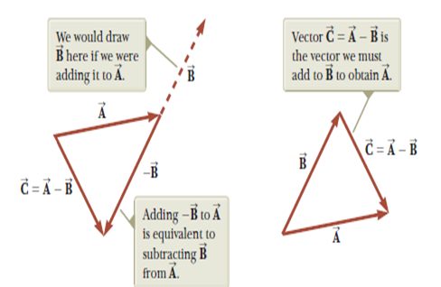

**Example (2-1):**

Find the sum of two vectors A and B lying in the xy plane and given by



**Solution:**

