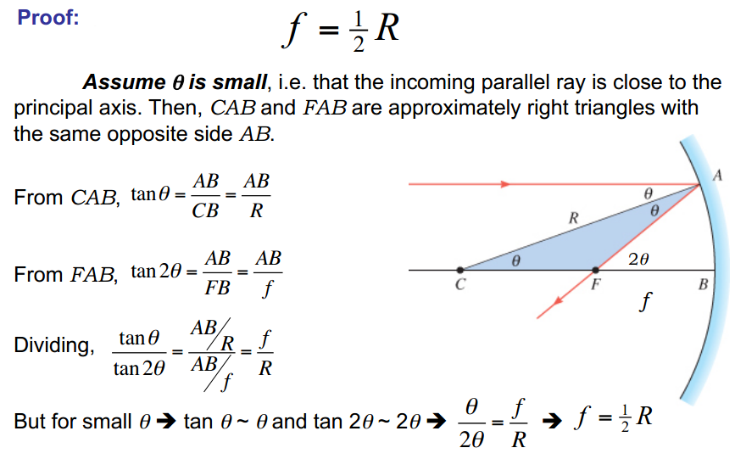

**Ray Diagrams for Concave Mirrors**

It depends on the location of the object relative to the center of curvature (*C*) and the focus point (*f*) of the mirror.

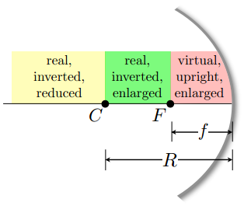

**Figure 14. Ray Diagrams for Concave Mirrors**

**Examples:**

1. a-  Object beyond the Centre of curvature

b-The image is;

– Real

– Inverted

– Smaller than the object (reduced)

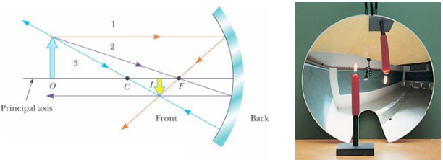

1. a- The object is between the mirror surface and the focal point

b- The image is;

– Virtual

– Upright

–Larger than the object (enlarged)

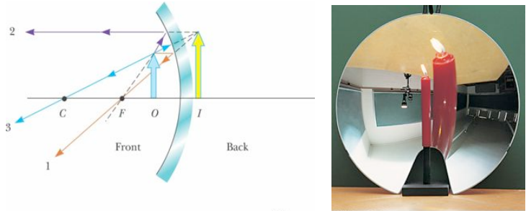

**HOMEWORK**

c- When Object is between Centre of Curvature and the Focus point

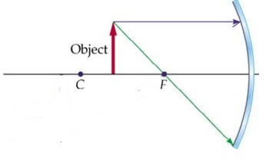

d-When the Object at the Focus point

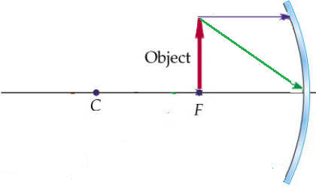

e- When Object is at the Centre of Curvature

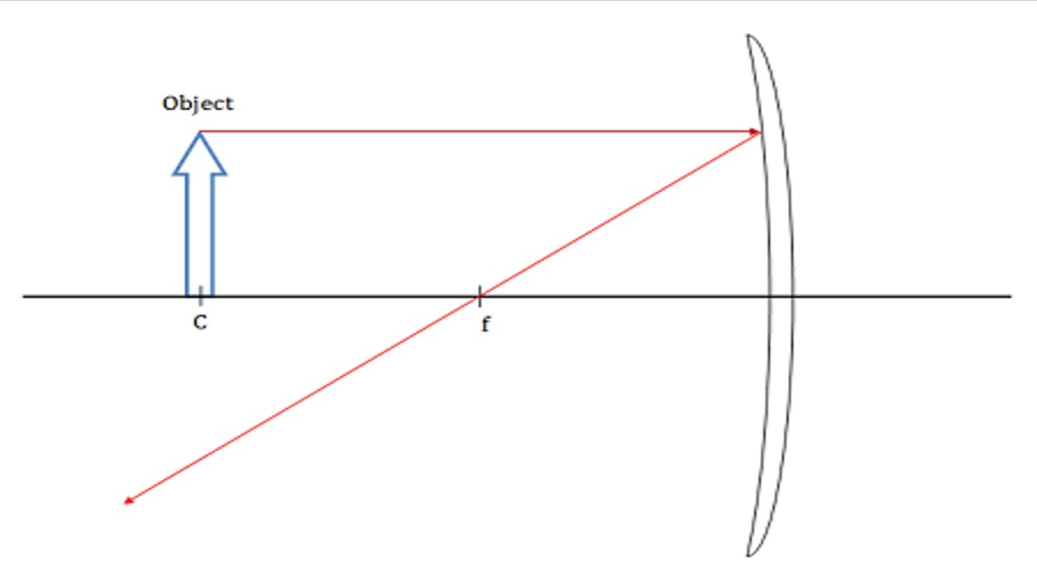

**Example**: A Real Image formed by a Concave Mirror. A 2.0 cm high object is placed 7.10 cm from a concave mirror whose radius of curvature is 10.20 cm. Find the location of the image and its size?

**Solution;**

*P*=7.10 cm , *h*=2.0 cm,  *R*= 10.20

$$\frac{2}{R}=\frac{1}{p}+\frac{1}{q}$$

$$\frac{2}{10.20}=\frac{1}{7.10 }+\frac{1}{q}$$

*q*=18 cm → Real image since positive

$$\frac{h'}{h}= -\frac{q}{p}$$

$$\frac{h'}{2.0}= -\frac{18}{7.10}$$

$h^{'}=$ 5.1 cm → Magnified and inverted

2. **Convex Spherical Mirrors**

It tends to diverge incident rays.

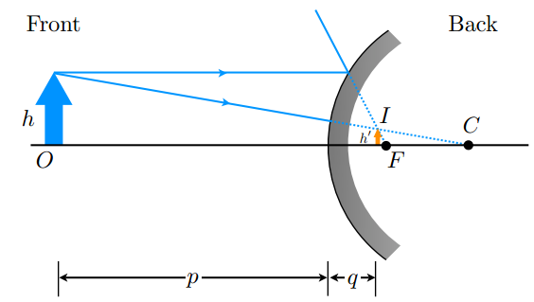

**Figure 15. Convex Mirror**

**Ray Diagrams for Convex Mirrors**

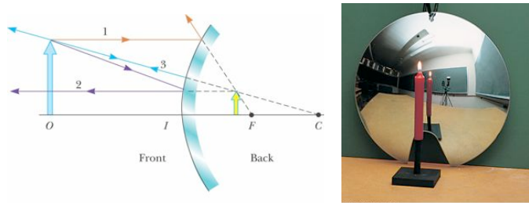

1. The object is in front of a convex mirror
2. The image is always;

– Virtual

– Upright

– Smaller than the object (reduced)

**Example**: A convex mirror is used to reflect light from an object placed 66 cm in front of the mirror. The focal length of the mirror is 46 cm in back of the mirror. Find the location of the image and the magnification?

**Solution;**

Since a the focal length of convex mirror is negative → *f* = -46 cm

$$\frac{1}{f}=\frac{2}{R}$$

$$\frac{1}{f}=\frac{1}{p}+\frac{1}{q}$$

$$\frac{1}{q}=\frac{1}{f}-\frac{1}{p}=\frac{1}{-46}-\frac{1}{66}=-0.037 {cm}^{-1}$$ q= -27 cm → Image is virtual since negative

$$M= -\frac{q}{p}= -\frac{\left(-27\right)}{66}=0.41$$

→ image is upright and reduced

Note : A negative *M* means that the image is inverted

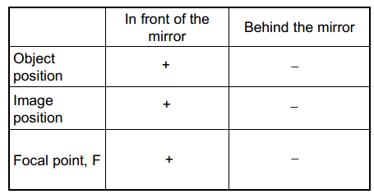 Positive *M* means an upright image.

Parabolic Mirrors

Spherically shaped (lenses and mirrors) share a problem: [their shape. Parallel light rays that reflected from the center of a [spherical](http://amazingspace.org/resources/explorations/groundup/lesson/glossary/term-full.php?t=spherical_lens_or_mirror) mirror focus farther away than light rays reflected from the edges]. This results in many [focal points](http://amazingspace.org/resources/explorations/groundup/lesson/glossary/term-full.php?t=focal_point), which produce a blurry image. To get a clear image, all rays need to focus at the same point. Changing the shape of a mirror from (spherical to [parabolic](http://amazingspace.org/resources/explorations/groundup/lesson/glossary/term-full.php?t=parabola_vs_sphere)) solves the problem ([Isaac Newton](https://2012grade10.wikispaces.com/Parabolic+Mirror+Applications#IN)’s reflecting telescope in the 17th century). All light rays focus at the same point and the resulting image is sharp and clear.

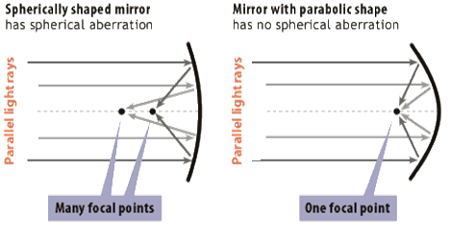

**Figure 16. Spherical and Parabolic Mirror**

Parabolic shapes can be used to correct for spherical aberration. The shorter the focal length, the more powerful the mirror; thus, P= 1 /f for a mirror, too. A more strongly curved mirror has a shorter focal length and a greater power. It has one of two directions:

1. A ray parallel to the mirror axis reflects through the focal point F, **(Satellite dishes)**.
2. A ray passing through the focal point reflects parallel to the mirror

axis ([**Car Headlights**](https://2012grade10.wikispaces.com/Parabolic+Mirror+Applications#CH)).