**Properties of light**

There are three ways in which light can travel from a source to another location:

1. **Refraction**: pass through various media, (air and glass)

2. **Reflection**: the return of light waves from a surface , the production of an image by a mirror

3. **Dispersion**: pass light through material medium will be separated according to wavelength.

**Velocity:** The speed of light in any material is less than its speed in

Vacuum. The standard value for the speed of light is 3.0 x 108 m/s

**Refractive Index (n) :**

It is the ratio of velocity of light in a vacuum to the velocity of light in a medium;

$$n=\frac{c}{v}$$

*C :* Velocity of light in a vacuum

$v$: Velocity of light in a medium

The refractive index is sometime referred to as "optical density", high refractive index equal high optical density.

The refractive index depends not only on the **substance** but also on the **wavelength** of the light. The dependence on wavelength called "**dispersion**".

The word “**ray**” comes from mathematics and here means a straight line that originates at some point.

**Optical Path Length (OPL)**

The shortest distance (L) between two points A&B called "geometric path". The length of geometric path is independent of the medium that

Surrounds the path AB.

If the light ray travels distance ( L), takes in account the delay caused by the refractive index ($n$) of the medium, we call this distance optical path;

$$OPL=nL= \frac{c}{v} L=cT$$

*T*: Traveling time in medium

1. **Refraction of light**

The changing of a light ray’s direction (loosely called bending) when it passes through variations in matter.

***The Law of Refraction***

The amount that a light ray changes its direction depends both on the incident angle and the amount that the speed changes. For a ray at a given incident angle, a large change in speed causes a large change in direction, and thus a large change in angle. The exact mathematical relationship is the law of refraction, or “Snell’s Law,” which is stated in equation form as;

***n*1 sinθ1 = *n*2 sinθ2**

Here *n*1 and *n* 2 are the indices of refraction for medium 1 and 2, and θ1and θ2 are the angles between the rays and the perpendicue in medium 1 and 2, as shown in Figure 6. The incoming ray is called the incident ray and the outgoing ray the refracted ray, and the associated angles the incident angle and the refracted (transmitting) angle. The law of refraction is also called Snell’s law after the Dutch mathematician "Snell" (1591–1626), who discovered it in 1621. Snell’s experiments showed that the law of refraction was obeyed and that a characteristic index of refraction *n* could be assigned to a given medium. Snell was not aware that the speed of light varied in different media.

**Table 1. Refractive index of different mediums**

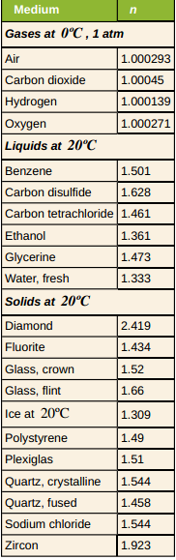

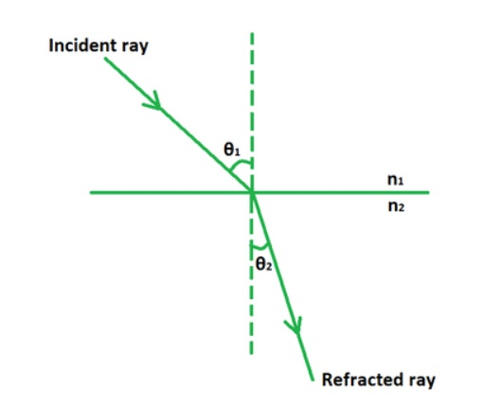

**Ex1**:( Speed of Light in Matter)

Calculate the speed of light in zircon, a material used in jewelry to imitate diamond. Strategy The speed of light in a material, v, can be calculated from the index of refraction *n* of the material using the equation *n=c/v*.

**Solution**

The equation fordetermine *v* gives;

$$v=\frac{c}{n}$$

The index of refraction for zircon is given as 1.923, and *c* is given in the equation for speed of light.

= 1.56×108 m/s.

***Discussion***

This speed is slightly larger than half the speed of light in a vacuum and is still high compared with speeds we normally experience. The substance has a greater index of refraction than zircon is diamond.

**Ex2**:

Find the index of refraction for medium 2 (a), assuming medium 1 is air and given the incident angle is 30.0ºand the angle of refraction is 22.0º.

**Solution**

*n*1 sinθ1 = *n*2 sinθ2

This is the index of refraction for water

**Ex3**:

Suppose that in a situation like that in **Ex 2**, light goes from air to diamond and that the incident angle is 30.0º. Calculate the angle of refraction θ2 in the diamond.

**Solution**

$$\sin{θ_{2}}=\frac{n_{1}}{n_{2}}\sin{θ_{1}= }0.207$$

$θ_{2}=\sin^{-1}$ 0.207 =11.9 °

For the same30ºangle of incidence, the angle of refraction in diamond is significantly smaller than in water (11.9ºrather than 22º). This means there is a larger change in direction in diamond. The cause of a large change in direction is a large change in the index of refraction (or speed). In general, the larger the change in speed, the greater the effect on the direction of the ray.