**Introduction**

The study of light’s vision is called optics**;** there are two types of optics:

(1) **Geometrical Optics** (the study of light as particles)

A-Rectilinear propagation (travels in straight lines)

B- Reflection (changes direction)

C- Refraction (bends in going from one material to another)

(2) **Physical Optics** (the study of light as waves)

A- Interference (waves "superpose" and pass right through each other)

B- Diffraction (waves "spill over" the edges of their obstructions)

C-Polarization (eliminating one of light's "fields")

**The Nature of Light**

Various scientists have attempted to explain the nature of light. Such as, the Greek theory “**collision of stuff theory**” claimed that when you looked at a candle flame, the flame and your eye were both sending out some kind of unknown stuff, and when your eye’s stuff collided with the candle’s stuff, the candle would become visible to your sight.

The most important theories are known as:

1. **Corpuscular Theory**

The ‘Corpuscular theory' was proposed by Newton in 1704. In this theory, he successfully explained the nature of light. According to this theory:

1. Light is made up of stream of tiny particles called ‘corpuscles’ having negligible mass.
2. These particles are elastic, travel in a straight line in all directions.
3. They were emitted from the luminous sources such as Sun, candle, electric lamp etc.
4. When the particles fall on the retina of the eye, they produce an image of the object (sensation of vision).
5. Failures of Newton’s corpuscular theory; it cannot explain the phenomena of diffraction, interference, and polarization of light.

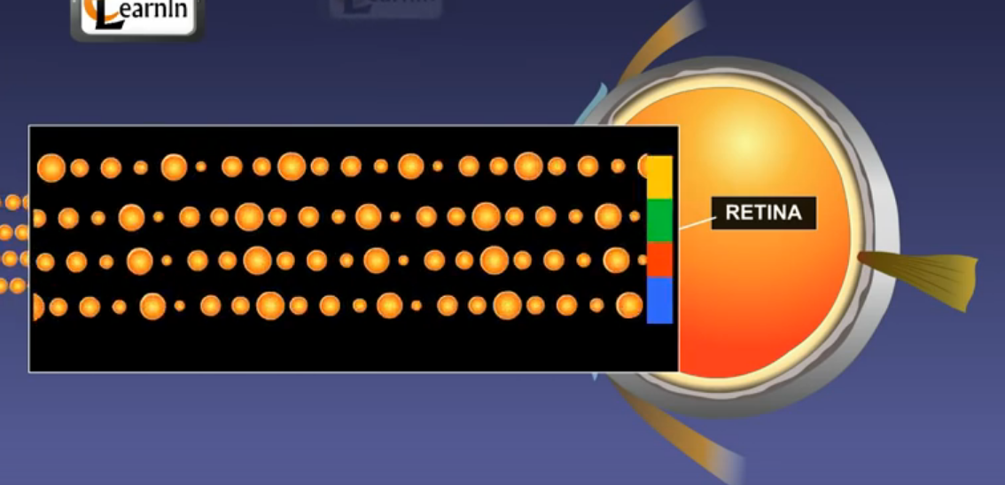

**Figure (1) Corpuscles of light fall on the retina produce an image**

1. **Wave theory of Huygens**

Huygens considered that light was propagated in longitudinal waves through a material called the **(ether)**. Huygens published his theory in 1690 as follow;

1. He compared the behaviour of light not with that of water waves but with the longitudinal waves of sound. Sound cannot travel through a vacuum but light does, and so Huygens proposed that the **(ether)** must fill all space and be transparent.
2. he argued that diffraction occurs because of the interference of wavefronts. When light is pushed through a small slit, waves are pushed together at different angles and this creates fringes of light and dark shadows, an interference pattern.
3. **(ether)** is imaginary elastic medium.

1. It was very useful to explain the diffraction, interference, and polarization of light
2. Failures of Wave theory; it could not Explains photoelectric effect, Compton Effect and the straight propagation of light, because it doesn't explain why there are no backwards-going wavelets.

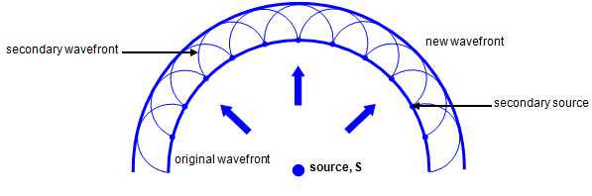

**Figure (2) Wave theory of Huygens where, the secondary waves are propagated in the forward direction only**

1. **Electromagnetic theory**

Maxwell’s most significant scientific achievement was his electromagnetic theory of light propagation which he first presented in 1864. Maxwell concluded that;

1. Light is a form of energy called electromagnetic energy
2. Light energy propagated in electric and magnetic waves, which vibrate perpendicular to one another.
3. electromagnetic waves could move through empty space
4. ALL electromagnetic radiation is light, but our eyes can only see a small portion – called visible light
5. Visible light is one millionth of one percent of the entire electromagnetic spectrum
6. The waves are different from each other in their lengths – called wavelength
7. The amplitude is how high the wave is
8. Frequency is the number of waves in a given period of time
9. 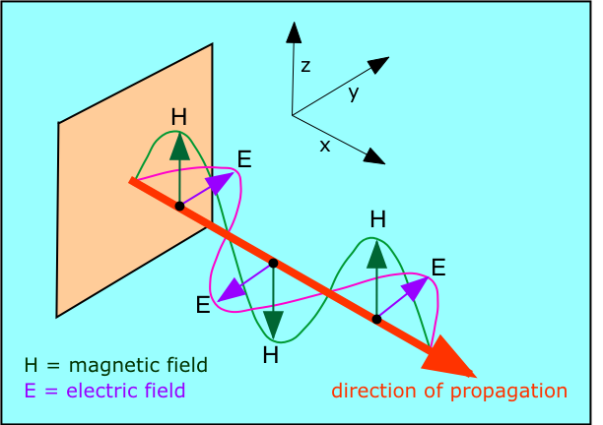

**Figure (3) electromagnetic wave**

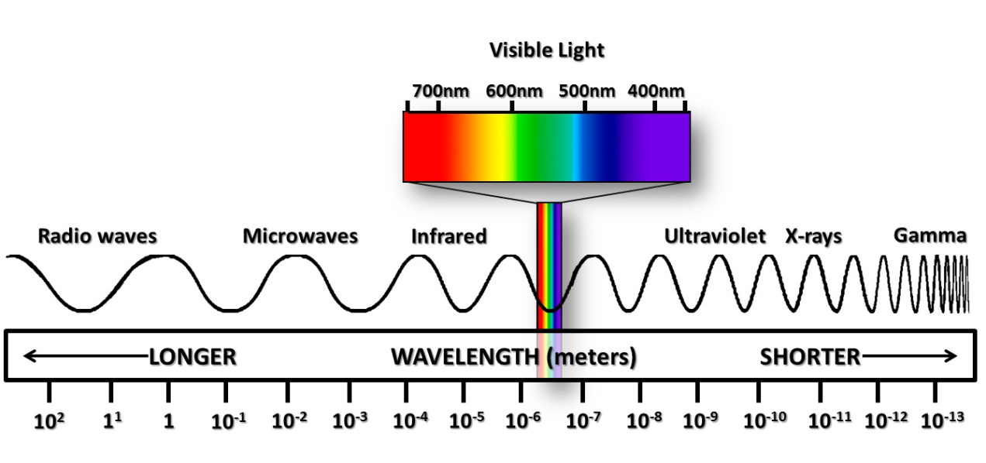

**Figure (4) electromagnetic spectrum**

1. **Quantum Theory of Light (Wave-Particle Duality)**

(Einstein & Plank) Light has a dual nature  
A.Sometimes it behaves like a particle (called a photon), which explains how light travels in straight lines  
  B.  Sometimes it behaves like a wave, which explains how light bends (or diffracts) around an object

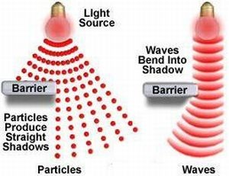

**Figure (4) Wave-Particle Duality**